|  |
| --- |
| Test document |

**«${NAME}»**

|  |
| --- |
|  |

|  |  |
| --- | --- |
| Some data | This is: «${SOMEDATA}» |

## Organigram

Some data...

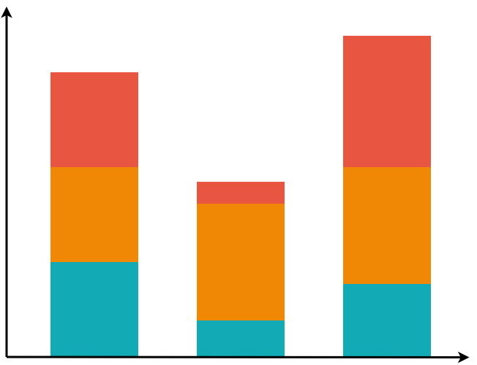

## some chart

Some other chart

**

# Some table

Lorem ipsem

|  |  |
| --- | --- |
| HEADER |  |

|  |  |
| --- | --- |
| «@before-row[#list LISTX as item]»  «${item.description}»  «@after-row[/#list]» |  |

# Some IFs

|  |  |  |
| --- | --- | --- |
|  | Bla bla… |  |

«[#if SOMEDATA='Y']»

|  |
| --- |
| SOME HEADER |
| Lorem ipsem |
| «${SOMEDATA_DESC!}» |

«[/#if]»