Ujian Akhir Praktikum - Semester Genap 2019/2020
Practicum Final Exam - Even Semester Year 2019/2020
Matakuliah  Subject |  |  | COMP6579 - Big Data Processing |  |  | 
Kelas  Class | : | BA01 / BB01 / BC01 / BD01 / BE01 / BF01 / BG01 / BH01 / BI01 / BJ01 / BK01 / BL01 / BM01 / BN01 |  | Tanggal Mulai  Start Date | : 15 June 2020
Kelas  Class | : |  |  | Waktu Mulai  Start Time | : 13.20
Dosen  Lecturer | : | D3338 - Dr. Ir. Edy Irwansyah, S.T., M.Si., IPM, ASEAN Eng.  D5403 - Dr. Sani Muhamad Isa, S.Si., M.Kom.  D5627 - I Gede Putra Kusuma Negara, B.Eng., PhD  D6198 - Fepri Putra Panghurian, S.Kom., M.T.I. |  | Tanggal Selesai  End Date | : 16 June 2020
Dosen  Lecturer | : |  |  | Waktu Selesai  End Time | : 13.20

PERATURAN UJIAN:
Exam Regulations:
- Mahasiswa tidak diperbolehkan berdiskusi dan/atau bekerja sama dengan peserta ujian lainnya
Student is not allowed to discuss and/or work together with other exam participants
- Mahasiswa tidak diperbolehkan menyalin jawaban dari intenet
Student is not allowed to copy answer from the intenet
- Asisten BERHAK memberi nilai 0 (NOL) bagi peserta ujian yang melakukan segala bentuk kecurangan
Assistant is able to give 0 (ZERO) score for exam participant who does any cheating actions
- Kumpulkan jawaban tepat pada waktunya di https://laboratory.binus.ac.id/lab
Submit the answer on time at https://laboratory.binus.ac.id/lab
- Bila Anda tidak membaca peraturan ini, maka Anda dianggap telah membaca dan menyetujuinya
If you have missed to read these regulations, so you are considered to have read and agreed on it

SOFTWARE YANG DIGUNAKAN:
Software will be used:
- VMware - Cloudera
- Jupyter Notebook

FILE YANG DIKUMPULKAN:
File must be collected:
- Case 1 (*.ipynb)
- Case 2 (*.ipynb)
- Case 3 (*.ipynb)

PERHATIAN!
Attention!
- Bagi yang mengerjakan tidak sesuai dengan soal, maka akan diberikan nilai NOL (0)
For those who do not work in accordance with the exam case will be marked as ZERO (0)
- Bagi yang mengerjakan tidak sesuai dengan software dan versi yang telah ditetapkan, maka akan tetap dikoreksi dengan software dan versi yang telah ditetapkan
For those who do not work in accordance with the software and specific version will be corrected by the predefined software and version
- Kompres semua jawaban yang akan diunggah. Pastikan format pengumpulan nama file dan ekstensi sesuai dengan format berikut: [NIM]-[NAMA].zip
Compress all file that will be uploaded. Make sure the format for collecting file name and extension according to the following format: [NIM]-[NAME].zip

Soal
Case

Case 1 (Query + Visualization)

DezzDryth Online
DezzDryth Online is an online game which is currently being popular in South East Asia. Since the popularity are going high, you are hired to make some analysis on the data they have. Below is the DezzDryth Online ERD that you are to analyze:
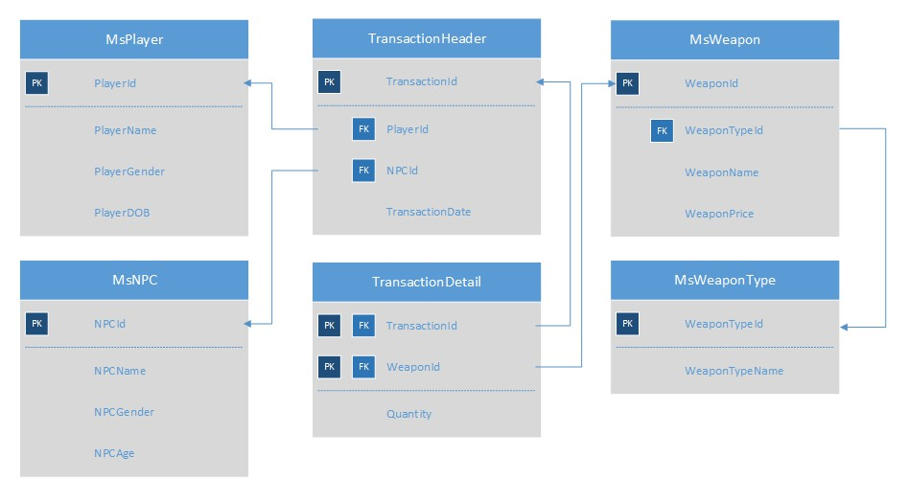
Figure 1. DezzDryth Online ERD

Below is the task you must do to analyze the data:
- Load Data from CSV to Spark
Using SparkSession, read the following files (“MsNPC.csv”, “MsPlayer.csv”, “MsWeapon.csv”, “MsWeaponType.csv”, “TransactionHeader.csv”, “TransactionDetail.csv”).
- Query Analysis and Visualization
You are asked to gain some sales insight about the data. Below are some statements you need to answer. Use SparkSQL to answer the question and pyplot package to visualize the answer.
- Show the percentage of weapon type sold for weapon type that is sold in 2019 using pie plot.
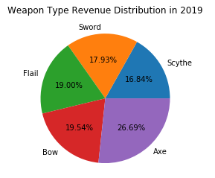
Figure 2. Weapon Type Revenue in 2019 Figure
- Show the total number of players who bought axe weapon type per month in 2019 using line plot. Multiple transaction within the same month will be counted as 1.
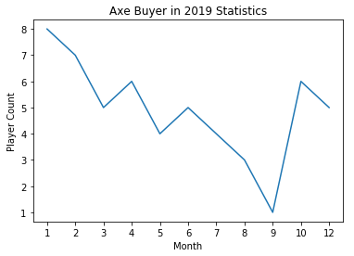
Figure 3. Axe Buyer in 2019 Figure
- Show the frequency of special weapon being distributed to female players in 2019 using bar plot. The player will receive special weapon if their monthly spending reached this following condition:
Special Weapon | Monthly Spending
Storm Breaker | 1000000 - 1499999
Nightfall | 1500000 – 1999999
Extinction | > 2000000
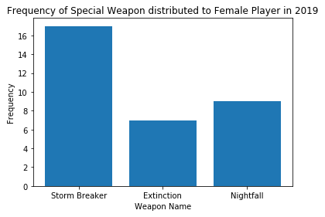
Figure 4. Frequency of Special Weapon Distribution Figure
- Show total number of players per month in 2019 who bought at least 3 different weapon type in a month using line plot.
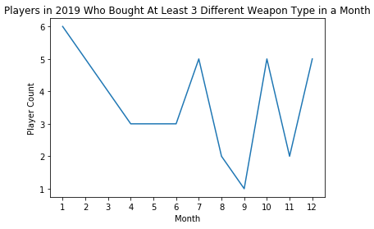
Figure 5. Players in 2019 Statistics Figure

- Show the frequency of NPC's popularity who has done at least transaction with 5 different player using bar plot. The popularity is determined based on the total income made by the NPC as follows:
Popularity | Total Income
Very Popular | >= 15,000,000
Popular | >= 7,500,000 – 14,999,999
Quite Popular | >= 2,500,000 – 7,499,999
Not Popular | < 2,500,000
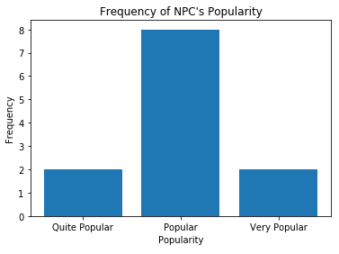
Figure 6. Frequency of NPC's Popularity Figure

Case 2 (Classification)

Etonic
Etonic is a competition held in an outer spaceship. The competition is about creating a predictive model that will classify whether a planet is likely to be habitable or not. You will be given Planet_Training.csv and Planet_Testing.csv, and your task is to make classification model and test it to Planet_Testing.csv.
Here is the description of the columns in Planet_Training.csv and Planet_Testing.csv:
Column Name | Description
Name | All planet names.
Temperature | All planet temperature in millikelvins.
Carbon | All planet carbon deposit.
Water | All planet water deposit.
Rhodium | All planet rhodium deposit.
Iron | All planet iron deposit.
Atmosphere Color | Determine the color of atmosphere viewed from orbit.  Red = Too Low, Blue = Normal, and Yellow = Too High.
Moons | Determine the number of moons orbiting the Planet.
Habitable | Planet habitable or not.  1 = Habitable and 0 = Not Habitable
Figure 7. Planet_Training.csv and Planet_Testing.csv
Below are the steps you are required to do to generate the model:
- Load Data
Given the file “Planet_Training.csv” and “Planet_Testing.csv”, you are asked to load the data using SparkSession.
- Select Features
After you load the data, you need to select important features that will be used for training. Pick three important features.
- Data Preprocessing
In this step, please remove any missing values in the data.
- Transform Data
In this step, transform the raw data so that it is suitable for training. For example, recode the ‘Iron’ column value to be either 0, 1, or 2.
- Normalization
After data preprocessing, you are required to normalize the data. Use the StandardScaler package to normalize the data.
- Generate Model
Next, you are required to generate a model from the data. Use the LogisticRegression package to generate the model with ‘10’ as the max iteration.
- Model Testing and Evaluation
After the model is generated, you can test the model to predict whether the planet will be habitable or not. Use BinaryClassificationEvaluator package to print the accuracy of your model. Get the model with minimum accuracy 90% or higher.

Case 3 (Clustering)
Grizzer
Grizzer is a wild animal hunting organization that is in Indonesia. They also want to prove myths about grizzly bears, because some people argue that grizzly bears are brown in fur, while some people argue that it is not. Due to that, they decided that they want to make a clustering model that will have 2 cluster, grizzly bear cluster and non-grizzly bear cluster. You will be given “BearTraining.csv” and “BearTesting.csv” and here is the description of the columns:
Column Name | Description
Weight | The bear’s weight in pounds.
Front Claws | The length of bear’s front claws.  Different type of bear uses their claws for survival such as to dig roots and excavating prey.
Pupillary Distance | Pupillary distance measured in cm.  Pupillary distance is measured based on the distance between the centers of eyes’ pupil.
Hair Color | The color of bear’s fur.  Some bears may have different type of hair color.
Ear Shape | The ear shape of the bear (Pointed, Broad, Rounded).  The shape may look different based on the angle you are seeing.
Length | The bear’s length in feet.
Figure 8. BearTraining.csv
Column Name | Description
Weight | The bear’s weight in pounds.
Front Claws | The length of bear’s front claws.  Different type of bear uses their claws for survival such as to dig roots and excavating prey.
Pupillary Distance | Pupillary distance measured in cm.  Pupillary distance is measured based on the distance between the centers of eyes’ pupil.
Hair Color | The color of bear’s fur.  Some bears may have different type of hair color.
Ear Shape | The ear shape of the bear (Pointed, Broad, Rounded).  The shape may look different based on the angle you are seeing.
Length | The bear’s length in feet.
Grizzly | Whether the bear is a grizzly bear or not (Yes, No).
Figure 9. BearTesting.csv
Below are the steps you are required to do to generate the model:
- Load Data
Given the file “BearTraining.csv” and “BearTesting.csv”, you are asked to load the data using SparkSession.
- Select Features
After you load the data, you need to select important features that will be used for training. Pick three important features.
- Data Preprocessing
In this step, please remove any missing values in the data.
- Transform Data
In this step, transform the raw data so that it is suitable for training. For example, recode the ‘Ear Shape’ column value to be either 0, 1, or 2.
- Normalization
After data preprocessing, you are required to normalize the data. Use the StandardScaler package to normalize the data.
- Generate Model
Next, you are required to generate a model from the data. Use the KMeans package to generate the model into 2 cluster.
- Visualization
After the model is generated, you can visualize the model using the pyplot package. Don’t forget to add x-label, y-label, and title for your plot.
- Model Testing and Evaluation
Then, you can test the model to check predict whether the data will be in grizzly bear cluster or in the non-grizzly bear cluster. Print the accuracy of your model and get the model with minimum accuracy 80% or higher.

Good Luck 😊

