Settings

1. Editable Role Names; not everyone goes by Provider, Service Coordinator, Assistant Director, Director, super admin, etc
2. Ability to assign staff in a hierarchical fashion for example; Director>assistant directors under director>service coordinators under Assistant Directors>Providers under service coordinators
3. Ability to bulk apply caseload or staff data to another role such as coordinator, director, or provider.
4. Ability to customize different rules based on agency preferences.
5. Ability to customize overbilling alerts
6. Ability to customize different alert settings.
7. Calendar setting to flip on for different services.

Provider Role (Home Page)

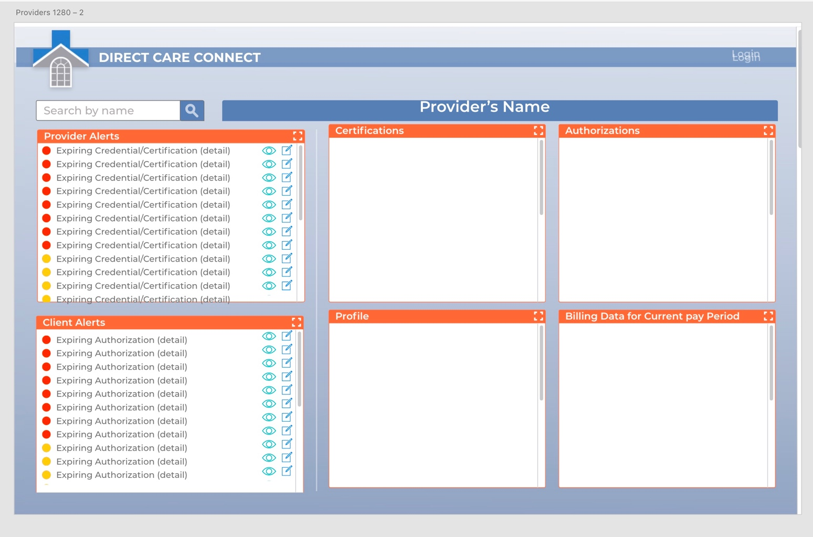

1. Screen Changes; above Providers name;
   1. Clients>Direct Link to providers client page.
   2. Billing (Provider Hours)>Direct quick link to their billing data, including archived data. Just pay period and hours worked per service.
   3. Profile; quick link to demographic profile info including certifications
   4. Calendar view; for group home integration. Calendar Icon Top right
   5. Message icon top right, ability to only message HR and service coordinator.
   6. Mileage integration(where should this go?
   7. Add Text to support option from home Screen.
2. Tiles/Boxes (landing page should default to providers own information
   1. Provider
      1. Certifications (ability to upload certifications into the system)
      2. New Authorizations (Leave Dashboard after 3 days)
      3. Billing Data for Current Pay Period
      4. Client List
      5. Pending Documentation
   2. Clients (from alerts)
      1. Authorizations
      2. Billing Data for current pay period (this is per the client chosen from alerts)
      3. Client Chart/Client Profile
         1. Includes ISP, Intake form, etc
      4. Documentation

Provider Role/abilities

* 1. Can only see their own caseload
  2. Can only see their own provider data
  3. Can only see their own billing data by pay period.
  4. Can direct message their service coordinator directly about authorizations and certifications that are expiring.
  5. Can also direct message assistant director in event service coordinator not doing job, maybe a contact Assistant director tab within the message functions
  6. Can also direct message Hr, again possibly an HR link for a direct message to HR staff.

1. Rules/alerts (customizable in settings)
   1. Certification Expirations
      1. Red 7 days until expiration
      2. Yellow 14 days until expirations
   2. Authorization Expirations
      1. Red 7 days until expiration
      2. Yellow 14 days until expiration
   3. Overbilling Alerts (customizable settings) Could be set to strict compliance.
      1. Ability for admin to put in hours from ISP and apply it against a service. The system should be smart enough to recognize when a provider is going over their allotted hours per week for a specified service. If a provider overbills a service there should be an alert that goes to the provider; the system warns of overbilling and sends alerts to the client alert list; there should be push notifications to the device when a provider is over their allotted average of hours.
      2. When a provider is billing a customized (maybe 10 percent) over their average based on focus authorizations; alerts will go to Provider and Service coordinator.
      3. When a provider is billing over 20 percent over their average, goes to assistant director task manager.
   4. Pending Documentation alerts
      1. Documentation is not counted unless done by the end of the next session.
      2. Provider should receive alerts (including push notifications) to their device every 6 hours (customizable setting)
      3. Pending documentation will display in the client alerts.
      4. Counting documentation in unique scenarios must be allowed, if provider has an excuse that is valid, the ability for the provider to complete that documentation that counts toward payroll and billing.

SERVICE COORDINATOR

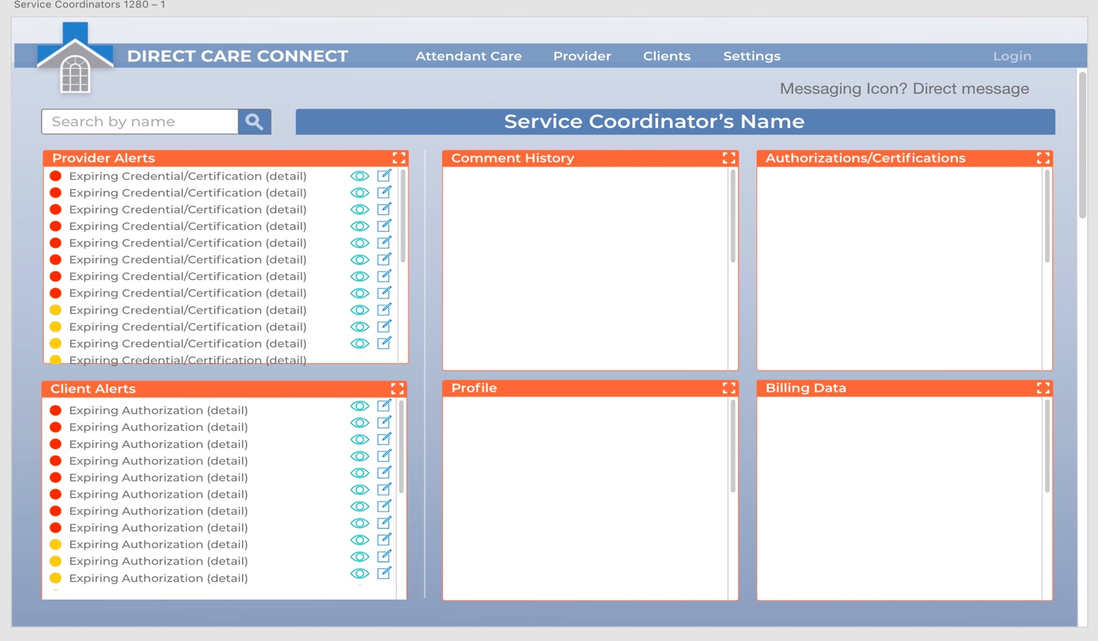

1. Screen Changes
   1. Remove Attendant Care
   2. Remove Settings
      1. Limited settings at this level.
   3. Providers>staff page (currently built out in test siite
   4. Clients>client page (currenlty built out in test site)
   5. Billing link; (provider Payroll if integrated with dddez)
   6. Calendar setting for group homes
   7. Tech support direct message link
   8. Message icon top right (direct message to HR, Assistant director, Director, Providers on caseload, tech support can be lumped in)
2. Tiles/Boxes (landing page defaults to their own data) This will include New Authorizations (leaves page after three days)
   1. Provider Alerts (when clicking on a provider alerts)
      1. Comment History (THIS IS NOT ON PROVIDER SCREEN) last comments made
      2. Certifications(viewable downloadable
      3. Billing Data for current pay period
      4. Authorizations; displayed when clicking Provider Alerts
         1. New Authorizations displayed when you hit home page.
      5. Provider ¬ist
      6. Client List
   2. Client Alerts (when clicking on Client Alerts)
      1. Authorizations
      2. Billing Data for current pay period
      3. Client Chart/client Profile
      4. Documentation (last two weeks) scrollable list
      5. Comment History
3. Service Coordinator Roles and Abilities
   1. Service Coordinators can only see their own caseload (this includes staff and Clients)
   2. Can direct message Provider, Assistant director, director, and HR.
   3. Can email from system to directly to case manager by clicking message icon from alert box
   4. Service coordinators have the ability to manipulate scheduled services via calendar function.
   5. Can attach clients to providers
4. Service coordinator Alerts
   1. Provider Alerts
      1. Red; 7 days until Expiration of a certification or credential
      2. Yellow 14 days until expiration of a certification or credential
      3. They will also get alerts for their own certifications or credentials
      4. Overbilling Alerts (should be measured on a weekly basis)
         1. Service coordinators get alerts based on overbilling of services. When staff has overbilled at 10 percent of their allotted hours, Service coordinator will get an alert to triage situation.
   2. Client Alerts
      1. Red; 7 days until expiration of an authorization
      2. Yellow; 14 days until expiration of an authorization
      3. Pending Attendant care monitoring's
         1. Red at 7 days until monitoring
         2. Yellow at 14 days until monitoring
      4. Pending documentation alerts
         1. Attendant care monitoring's to complete
         2. If they service their own clients, pending documentation alerts for hab notes
         3. Approval of all habilitation notes each month; due by 5th day of the month.

Assistant Director

Screen Changes

Provider Link>direct link to all Service Coordinators and Providers under their direct supervision.

Client Link>direct link to all clients that are below a specific Assistant Director.

Message Icon

Direct Message, ability to direct message service coordinators/Providers underneath them. Ability to direct Message HR and Tech support.

Billing Data; ability to see billing data of their Service Coordinator and provider staff underneath them. Ability to approve different odd items that come up by service coordinators.

Settings; Has limited settings control; however can bulk change service coordinators tied to caseloads.

Calendar Icon; for calendar functionality.

Tiles/Boxes; Landing page defaults to their own data; this will include new Authorizations for clients that are underneath the assistant director.

Provider Alerts (when clicking on provider alerts)

* + 1. Comment History; shows comment history of last 7 days for Service Coordinators.
    2. Certifications
    3. Billing Data for current pay period
    4. New Authorizations
  1. Client Alerts (when clicking on Client alerts)
     1. Authorizations
     2. Billing Data for current pay period
     3. Client Chart/client Profile
     4. Documentation (last two weeks) scrollable list

1. Provider Alerts to assistant Director
   1. Yellow 3 days over expiration date for a certification or credential
   2. Red 5 days over expiration date for a certification or credential
   3. Alerts for documentation done late after the rule of completion of documentation prior to the next session ending.
   4. Overbilling alerts; (measured on a weekly basis)
      1. 20 percent overbilling by a provider underneath an assistant director shows as RED alert on Assistant director.
   5. Habilitation notes past due (approval due on 5th day of month for prior month)
      1. Yellow 3 days past due
      2. Red 5 days past due
2. Client Alerts
   1. Yellow; 5 days after the expiration of an authorization
   2. Red; 10 days after the expiration of an authorization
   3. Yellow; 5 days after due date of attendant care monitoring
   4. Red; 10 days after due date of attendant care monitoring
3. Assistant Director Roles and Abilities
   1. Assistant Directors can only see Service Coordinators; the SC provider caseload, and all clients associated with that service coordinator
   2. Can direct message Provider, Assistant director, director, and HR.
   3. Can email from system to directly to case manager by clicking message icon from alert box
   4. Assistant directors have the ability to manipulate scheduled services via calendar function.
   5. Can attach Service coordinators to provider staff in bulk

Director

Screen Changes

Provider Link>direct link to all assistant directors, Service Coordinators and Providers under their direct supervision.

Client Link>direct link to all clients that are below a specific Assistant Director.

Message Icon

Direct Message, ability to direct message assistant directors service coordinators/Providers underneath them. Ability to direct Message HR and Tech support.

Billing Data; ability to see billing data of their Service Coordinator and provider staff underneath them. Ability to approve different odd items that come up by service coordinators.

Settings; Has limited settings control; however can bulk change service coordinators, assistant directors, providers, clients tied to caseloads.

Calendar Icon; for calendar functionality.

* + - 1. Director Roles and Abilities
  1. Directors can see Assistant Directors, Service Coordinators; the SC provider caseload, and all clients associated with that service coordinator
  2. Can direct message anyone
  3. Can email from system to directly to case manager by clicking message icon from alert box
  4. Directors have the ability to manipulate scheduled services via calendar function.
  5. Can attach Service coordinators to provider staff in bulk
  6. Directors add users to the system and attach them to a specific service coordinator; service coordinator can then attach provider to a specific client.

DOCUMENTATION REQUIREMENTS (Non Skilled)

Hab Notes

1. Habilitation Notes: Goals taken directly from the ISP and entered by a service coordinator or admin
2. Components of Habilitation Notes
   1. Client
   2. Provider
   3. Month/Year
   4. Scoring Key
      1. I; independent
      2. V; verbal prompt
      3. M; Modeling
      4. G; Gesture
      5. C; Chaining
      6. HOH; Hand over Hand
      7. R; Refused
      8. B; Barrier
3. Progress Notes
4. Teaching Strategy
5. when a user goes into log documentation, there should be a notification and acknowledgement of the ISP goals left to work on. It can be a simple popup and button that displays functional outcome and
   1. By doing this the user acknowledges what should be worked on and the available goals to be worked on.
   2. All goals are measurable, so the software should show the remaining goals to be worked on for that week/month.
6. Providers will choose the functional outcome and teaching strategies from Pop-up, then will score the session with the above scoring key. The system calculates the scoring and at the end of the month prompts the user to Create a progress summary
7. There should be an option to add a Daily Summary Note.
8. Scoring data should be calculated at end of each month with simple ratio of functional outcome and above scoring key referenced.
9. Potential auto upload of progress summaries into the FTP site (new process)

Attendant Care Monitoring Notes

\*Should be notification system for attendant care monitoring. Checkbox at provider level (ATC Monitor Check box to see if Super was available) Missed attendant care monitoring notifications to AD.

1. Demographic Info
2. SC Name
3. Service start date
4. Monitoring visit date
5. 8 questions (should be customizable so we can make changes when ddd makes changes
6. Monitors Name
   1. Client Family
   2. Providers name
7. Signature collection