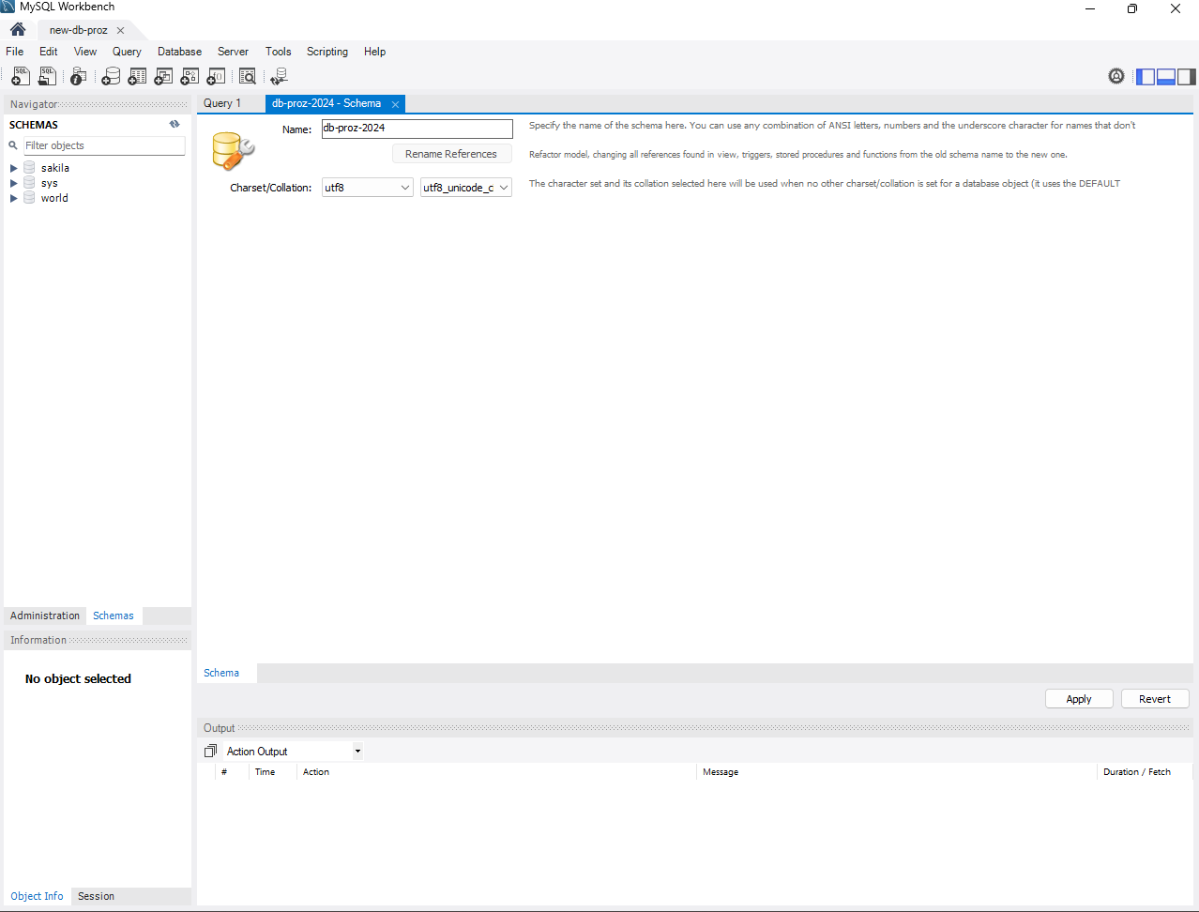

Criando o Banco de Dados

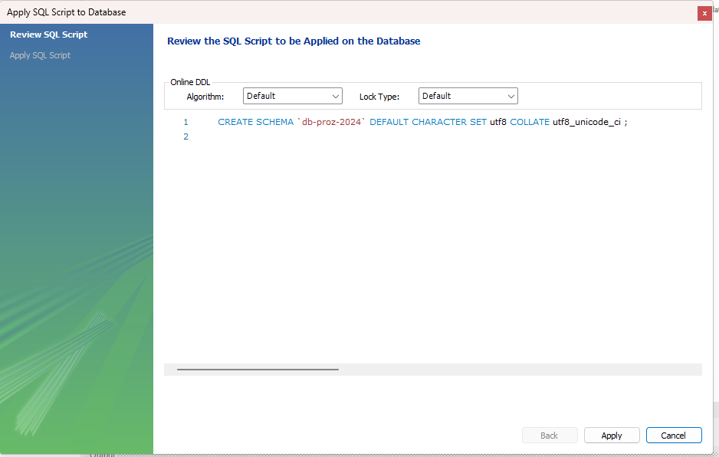

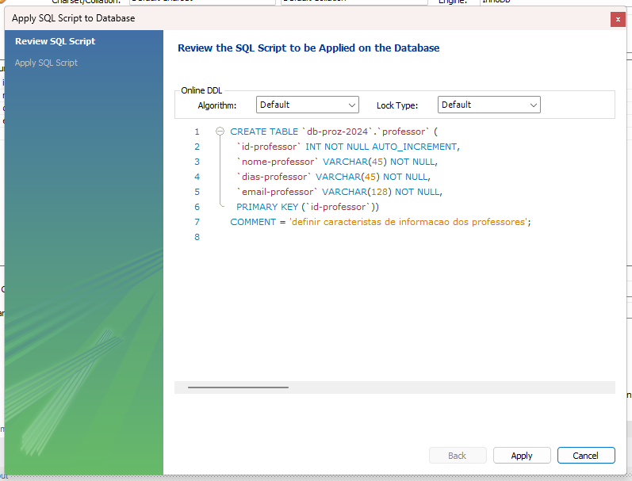

Criando tabela: Professor.

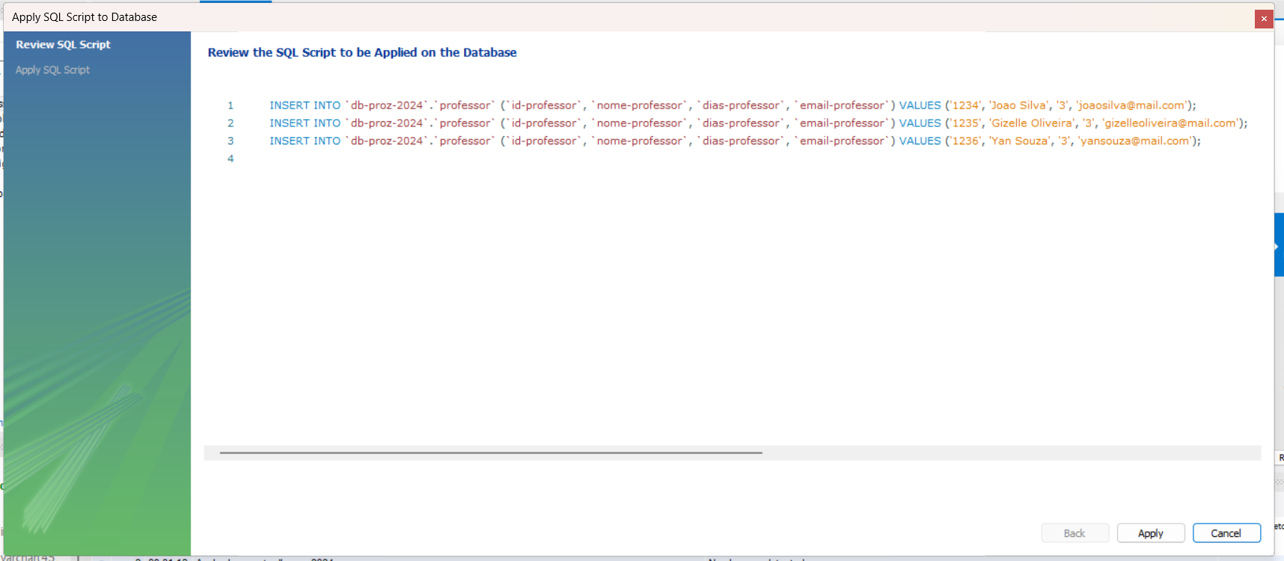

Inserindo registro dos Professoresc

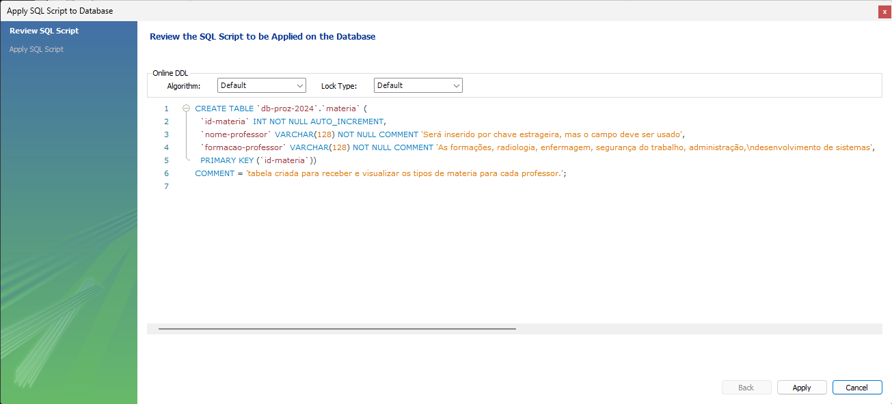

Criado a tabela Matérias

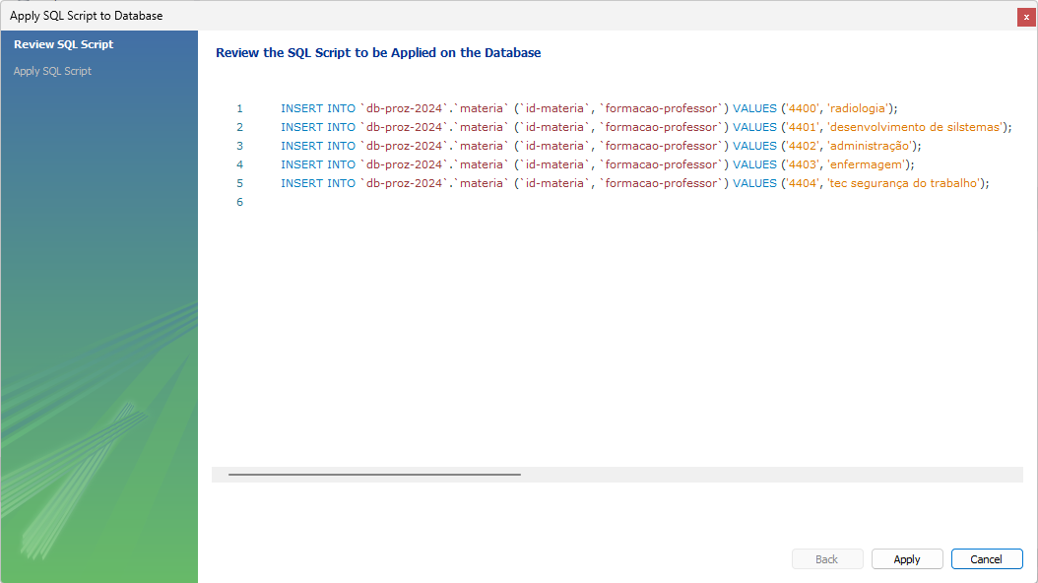

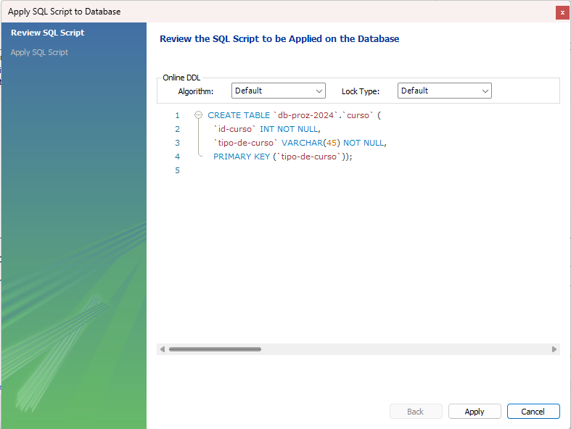

Criando a tabela principal – curso

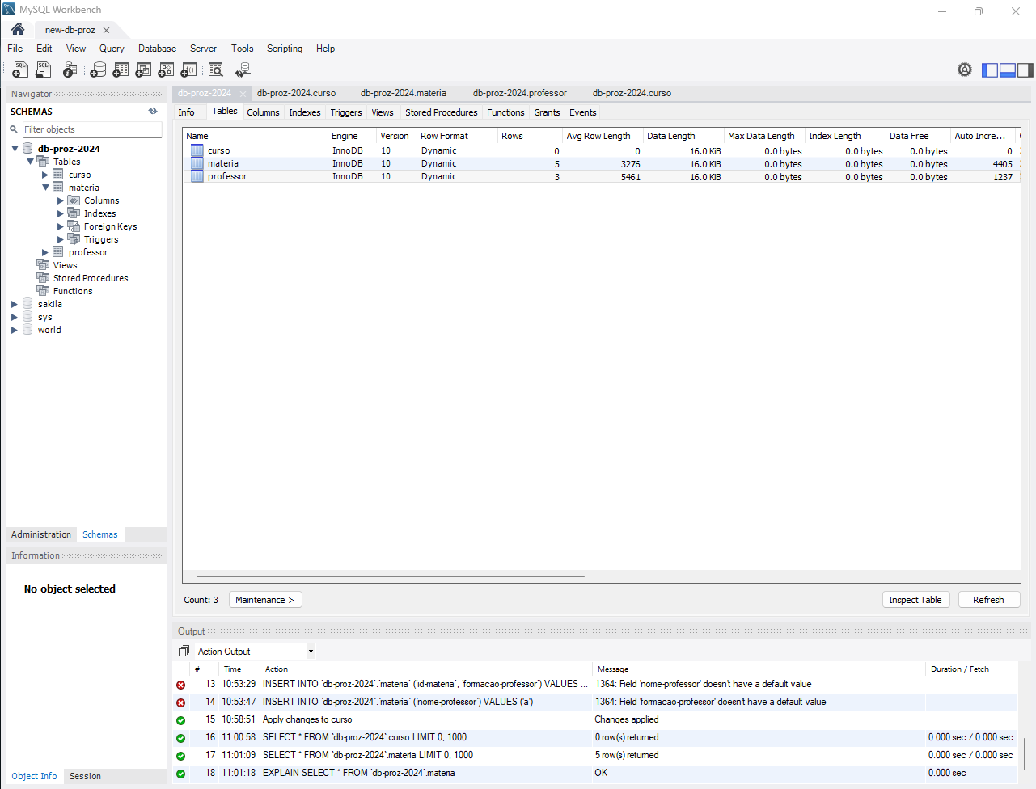

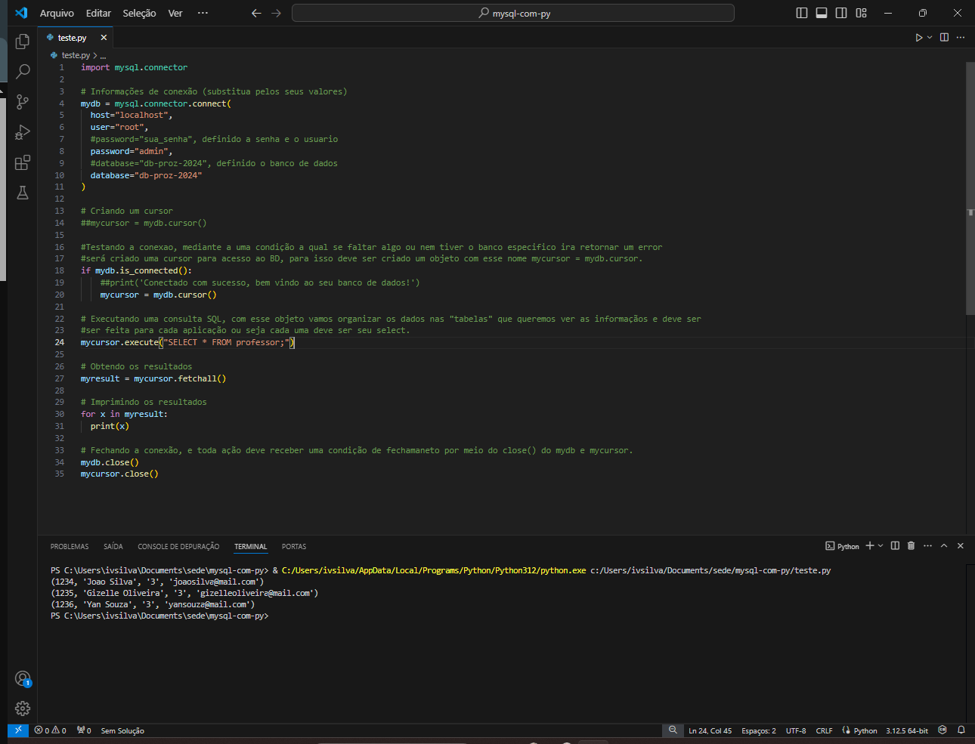

Referencias

<https://www.youtube.com/watch?v=ppKGw0LMqbc>

<https://www.youtube.com/playlist?list=PLajldpZX7WM0DVqKHpnRueBS7goyZOBpW>

<https://www.youtube.com/playlist?list=PLq-sApY8QuyeEq4L_ECA7yYgOJH6IUphP>

<https://www.youtube.com/watch?v=fjlbWB64fuE>

<https://www.youtube.com/playlist?list=PLbIBj8vQhvm2WT-pjGS5x7zUzmh4VgvRk>