0.1 Philzone.com usability

To begin with, we can observe and analyze that all the information on the website is on the left.
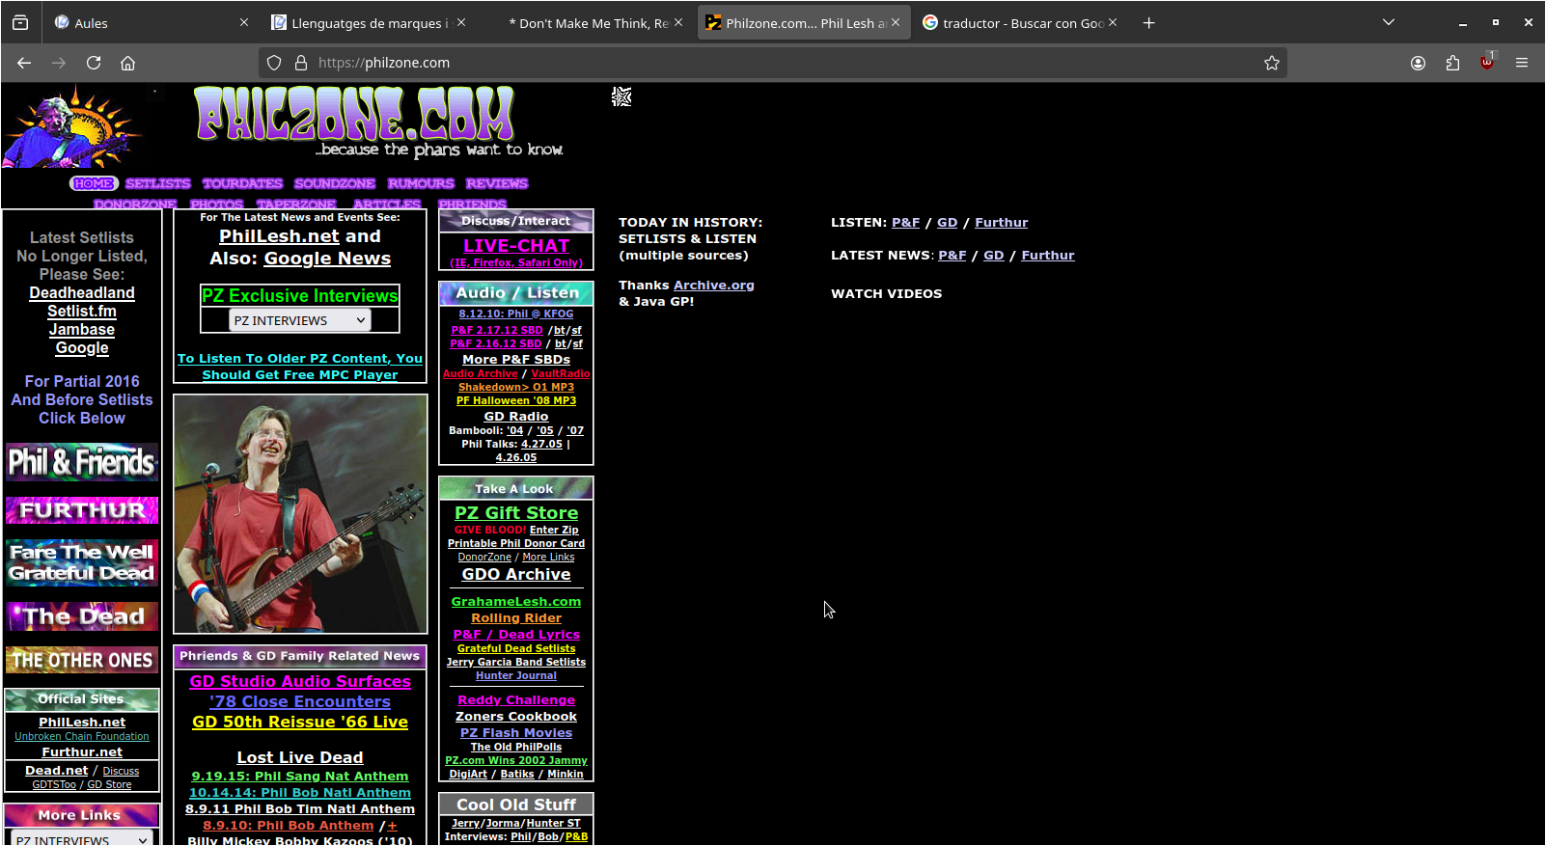
Next, we see that the typography of the title is illegible, it is not understood.


The website (philzone.com) is not self-intuitive, since there are too many colors, you cannot distinguish at a glance the links and buttons that you click on said website.
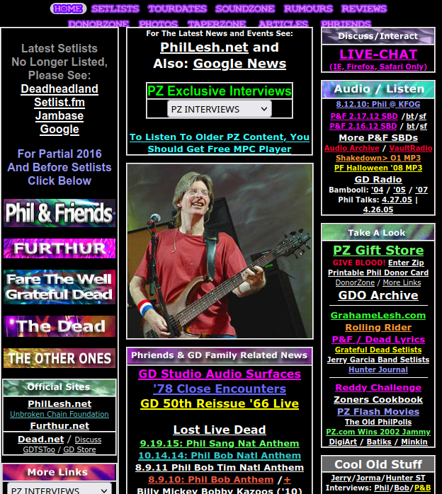

We also have to comment on the fact that the website's search engine is at the bottom and is not self-intuitive, since in most web pages the search engine is at the beginning.
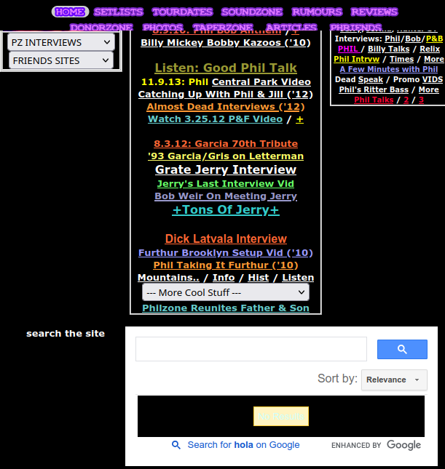

Finally, in conclusion the website have many things to improve. Thanks to chapter 1 of the book "Don't make me think" we have been able to detect that many of the errors mentioned in said book can be observed on this website.

Iván Espí y Pau López.

