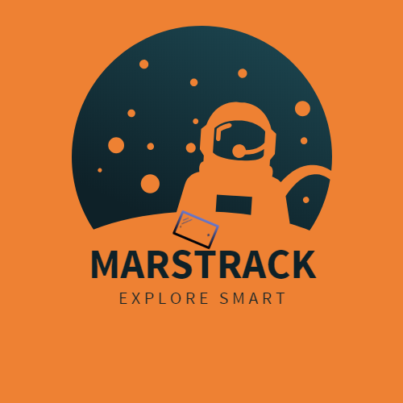

**Team of MarsTrack:**

Georgi Ivaylov Konstantinov, address: Sofia; mobile number: 089 683 4019; e-mail: [gogopro27@abv.bg](mailto:gogopro27@abv.bg); school: National Trade and Banking High School, grade: 10

Ivan Petrov Zlatanov; address: Sofia; mobile: 0882796927; e-mail: [ivanff1@abv.bg](mailto:ivanff1@abv.bg); school: National Trade and Banking High School, Sofia, grade: 10

Stanimir Georgiev Velichkov; address: Sofia; mobile number: 0889372307; e-mail: [stanimirgevel@gmail.com](mailto:stanimirgevel@gmail.com); school: National Gymnasium of Natural Sciences and Mathematics "Academician Lyubomir Chakalov", Sofia, grade: 12

**Facebook page of the team:** <https://goo.gl/3aNbGL>

Contents

Abstract 3

Introduction 3

Components of the first prototype 3

The functionalities that our product will offer are (and some plans for the future): 5

Other future plans of the prototypes 6

NASA resources 7

# Abstract

**The project is aimed at inventing a gadget whose main functionality is to be used on planet Mars. It is a smart watch, which can solve many problems related with the exploration of the planet.**

# Introduction

**Our mutual interest in exploring and colonisation of other planets deriving from the terrestrial type challenged us to show our ideas of exploring ‘the new world”. This is the reason why our team of scientists decided to experiment with invention of watch with multi sensors, which will provide the astronauts with better space orientation outside of their space campus.**

# Components of the first prototype

1. Ultrasonic sensor HC-SR04 – analyse for obstacles in front of the sensor

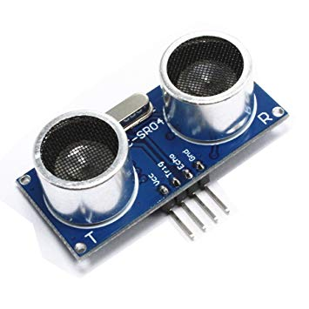

1. DHT22 – Humidity and temperature sensor – collects data about the humidity conditions

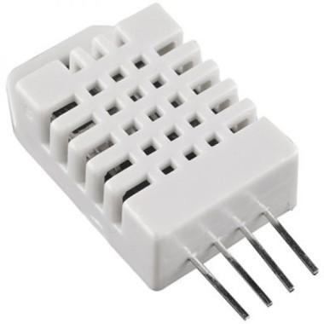

1. DS18B20 – temperature sensor - collects data about the humidity conditions

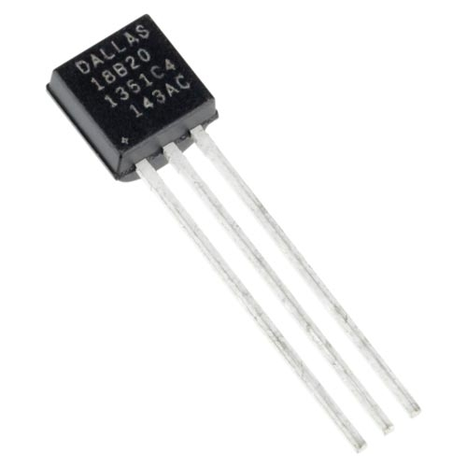

1. Soil moisture sensor – analyse the data of the qualities of the soil

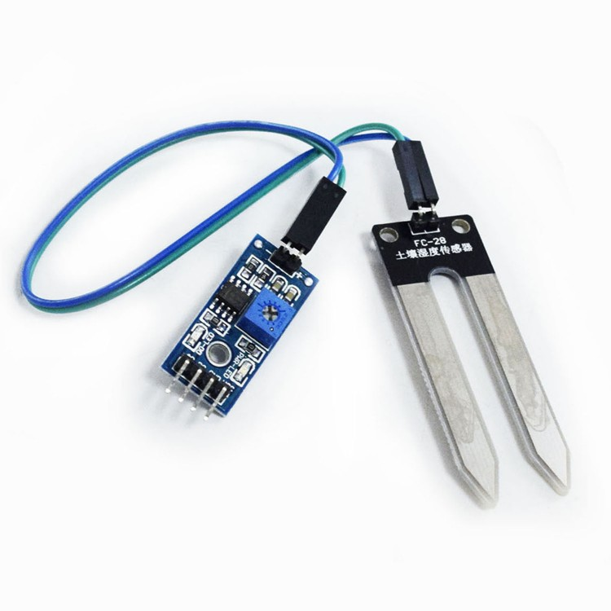

1. Arduino motherboard UNO R3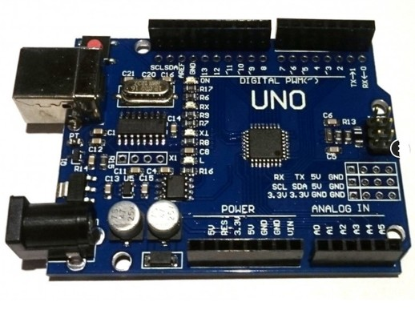

# The functionalities that our product will offer are (and some plans for the future):

* Sensors which can determine the environmental changes such as moisture, temperature of the soil, air and similar indicators to help the astronaut to insure that there is a possibility for him to live in such environment.
* Calculations of the life indicators of the astronaut and emergency alarm to stop the mission if there is immediate change in the environmental conditions, which could possibly harm the astronaut’s well-being.
* Transmitter locating the location of the astronaut as well as other astronauts, which can indicate any chance of danger. It could transmit SOS messages. Also, the already recorded location would accommodate better classification between the data.
* Satelite map to orientate the austraunaut.
* Laser which can cut some obstacles on his way while he is travelling from place to place
* Possibility of controlling drones, which can help the astronaut with his exploration of unapproachable areas whose indicators are dangerous for the astronaut’s life. The drones would have visualisation of the picture taken from the data extracted from the camera embedded in the drone and remote controller with large scope of managing the drone.

# Other future plans of the prototypes

Here we briefly presents some possible concepts of prototypes of our project, which include all of the enumerated components with their functions from the previous sections: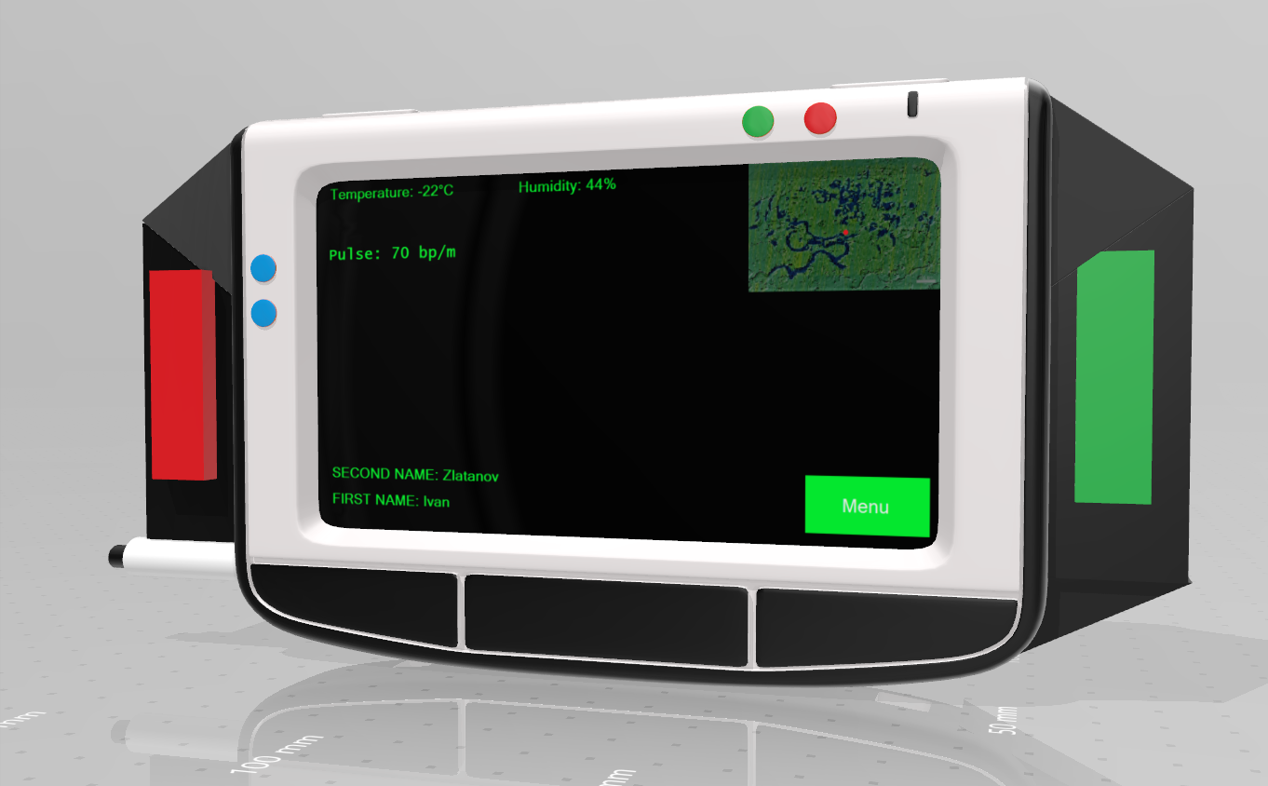

**Displays personal data of the astrounats**

**Temperature sensor**

**Data for the environment conditions**

**Soil humidity sensor**

**MAP**

**Laser**

# NASA resources

Our research is based on the data, collected from the NASA services, which could be found on: <https://mars.nasa.gov/>.