Appartaments

1. Main page

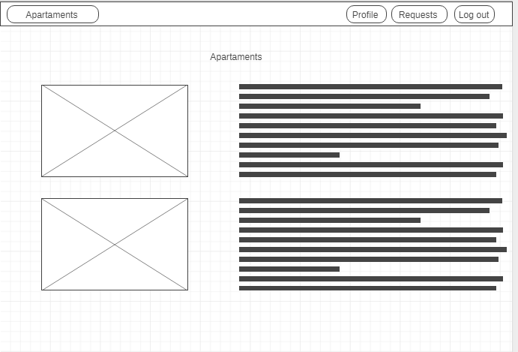

<https://wireframe.cc/RqMbML>

1. Log in page

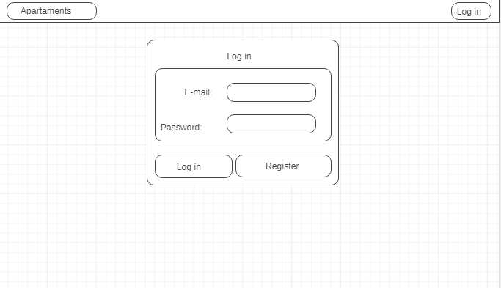

<https://wireframe.cc/HF0lGP>

3.Register page

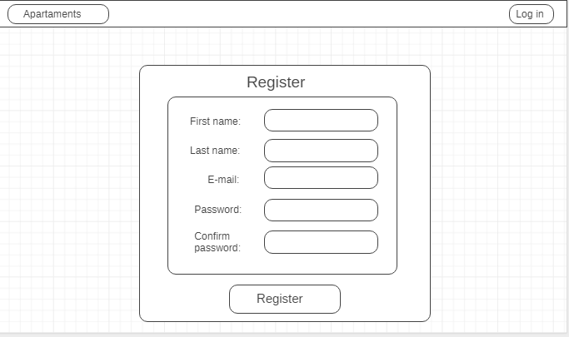

<https://wireframe.cc/DoLfAa>

4.Requests page

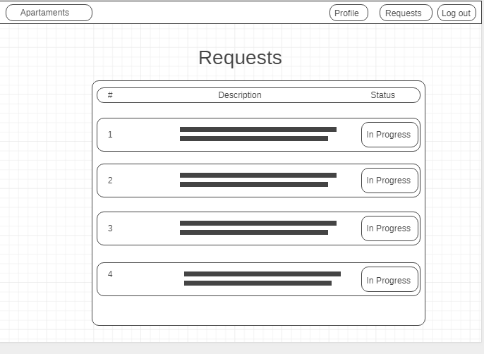

<https://wireframe.cc/OGqgOO>