# Design Document

## 1. Web application topic

Fitness/health supplement reviews

## 2. Target Audience

Specify age

Specify location

Describe more facts about the audience

Individuals. Men/women, interested in having a healthy lifestyle.

Why do they visit the site? – Individuals visiting the site are interested in information about various supplements from different brands and need unbiased supplement reviews in order to make an informed choice on which product to buy. The individuals also wish to use the website in order to choose a supplement from a brand based on various rating criteria and/review. Site users may also wish to research supplements based on category. Users may not already be familiar with the products presented on the website, so the introduction to new products is also a possibility. Users may also wish to rate a supplement they have used or comment on reviews. Users may also need up to date information about new supplements.

What do they want to reach? – The goal of the individuals visiting the site is to research a supplement/supplements offered by various companies/brands based on staff and other user’s reviews to eventually buy the supplement of their choice or simply for information.

What information do they need? – The information users require is the rating of a supplement from any given brand in addition to a review of the supplement. The rating system itself consists of several layers of depth. It includes the staff rating system, which is the overall rating, effectiveness of the supplement, value (for price) of the supplement, pros and cons, all of which the users may want to focus on. There is also a user rating system, because the users may wish to see the general opinion of other users. The user rating system itself is a simple 1-10 scale rating system. The users may also wish to acquire general information about a given supplement (through the rating system alone) or a more in-depth review. The users may also wish to research the best overall supplements or the best supplement in a given category.

## 3. Sitemap

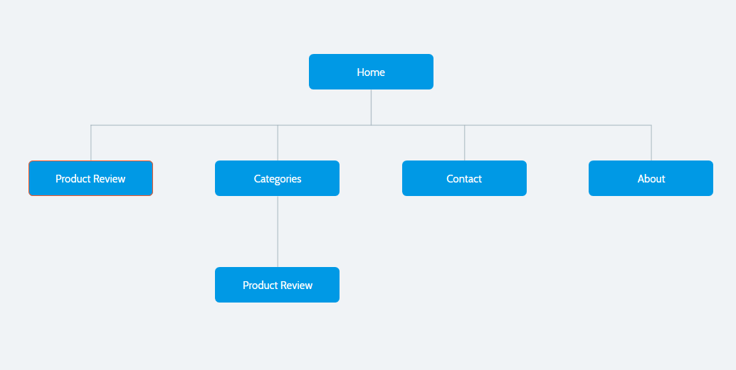

4. Wireframes

Home

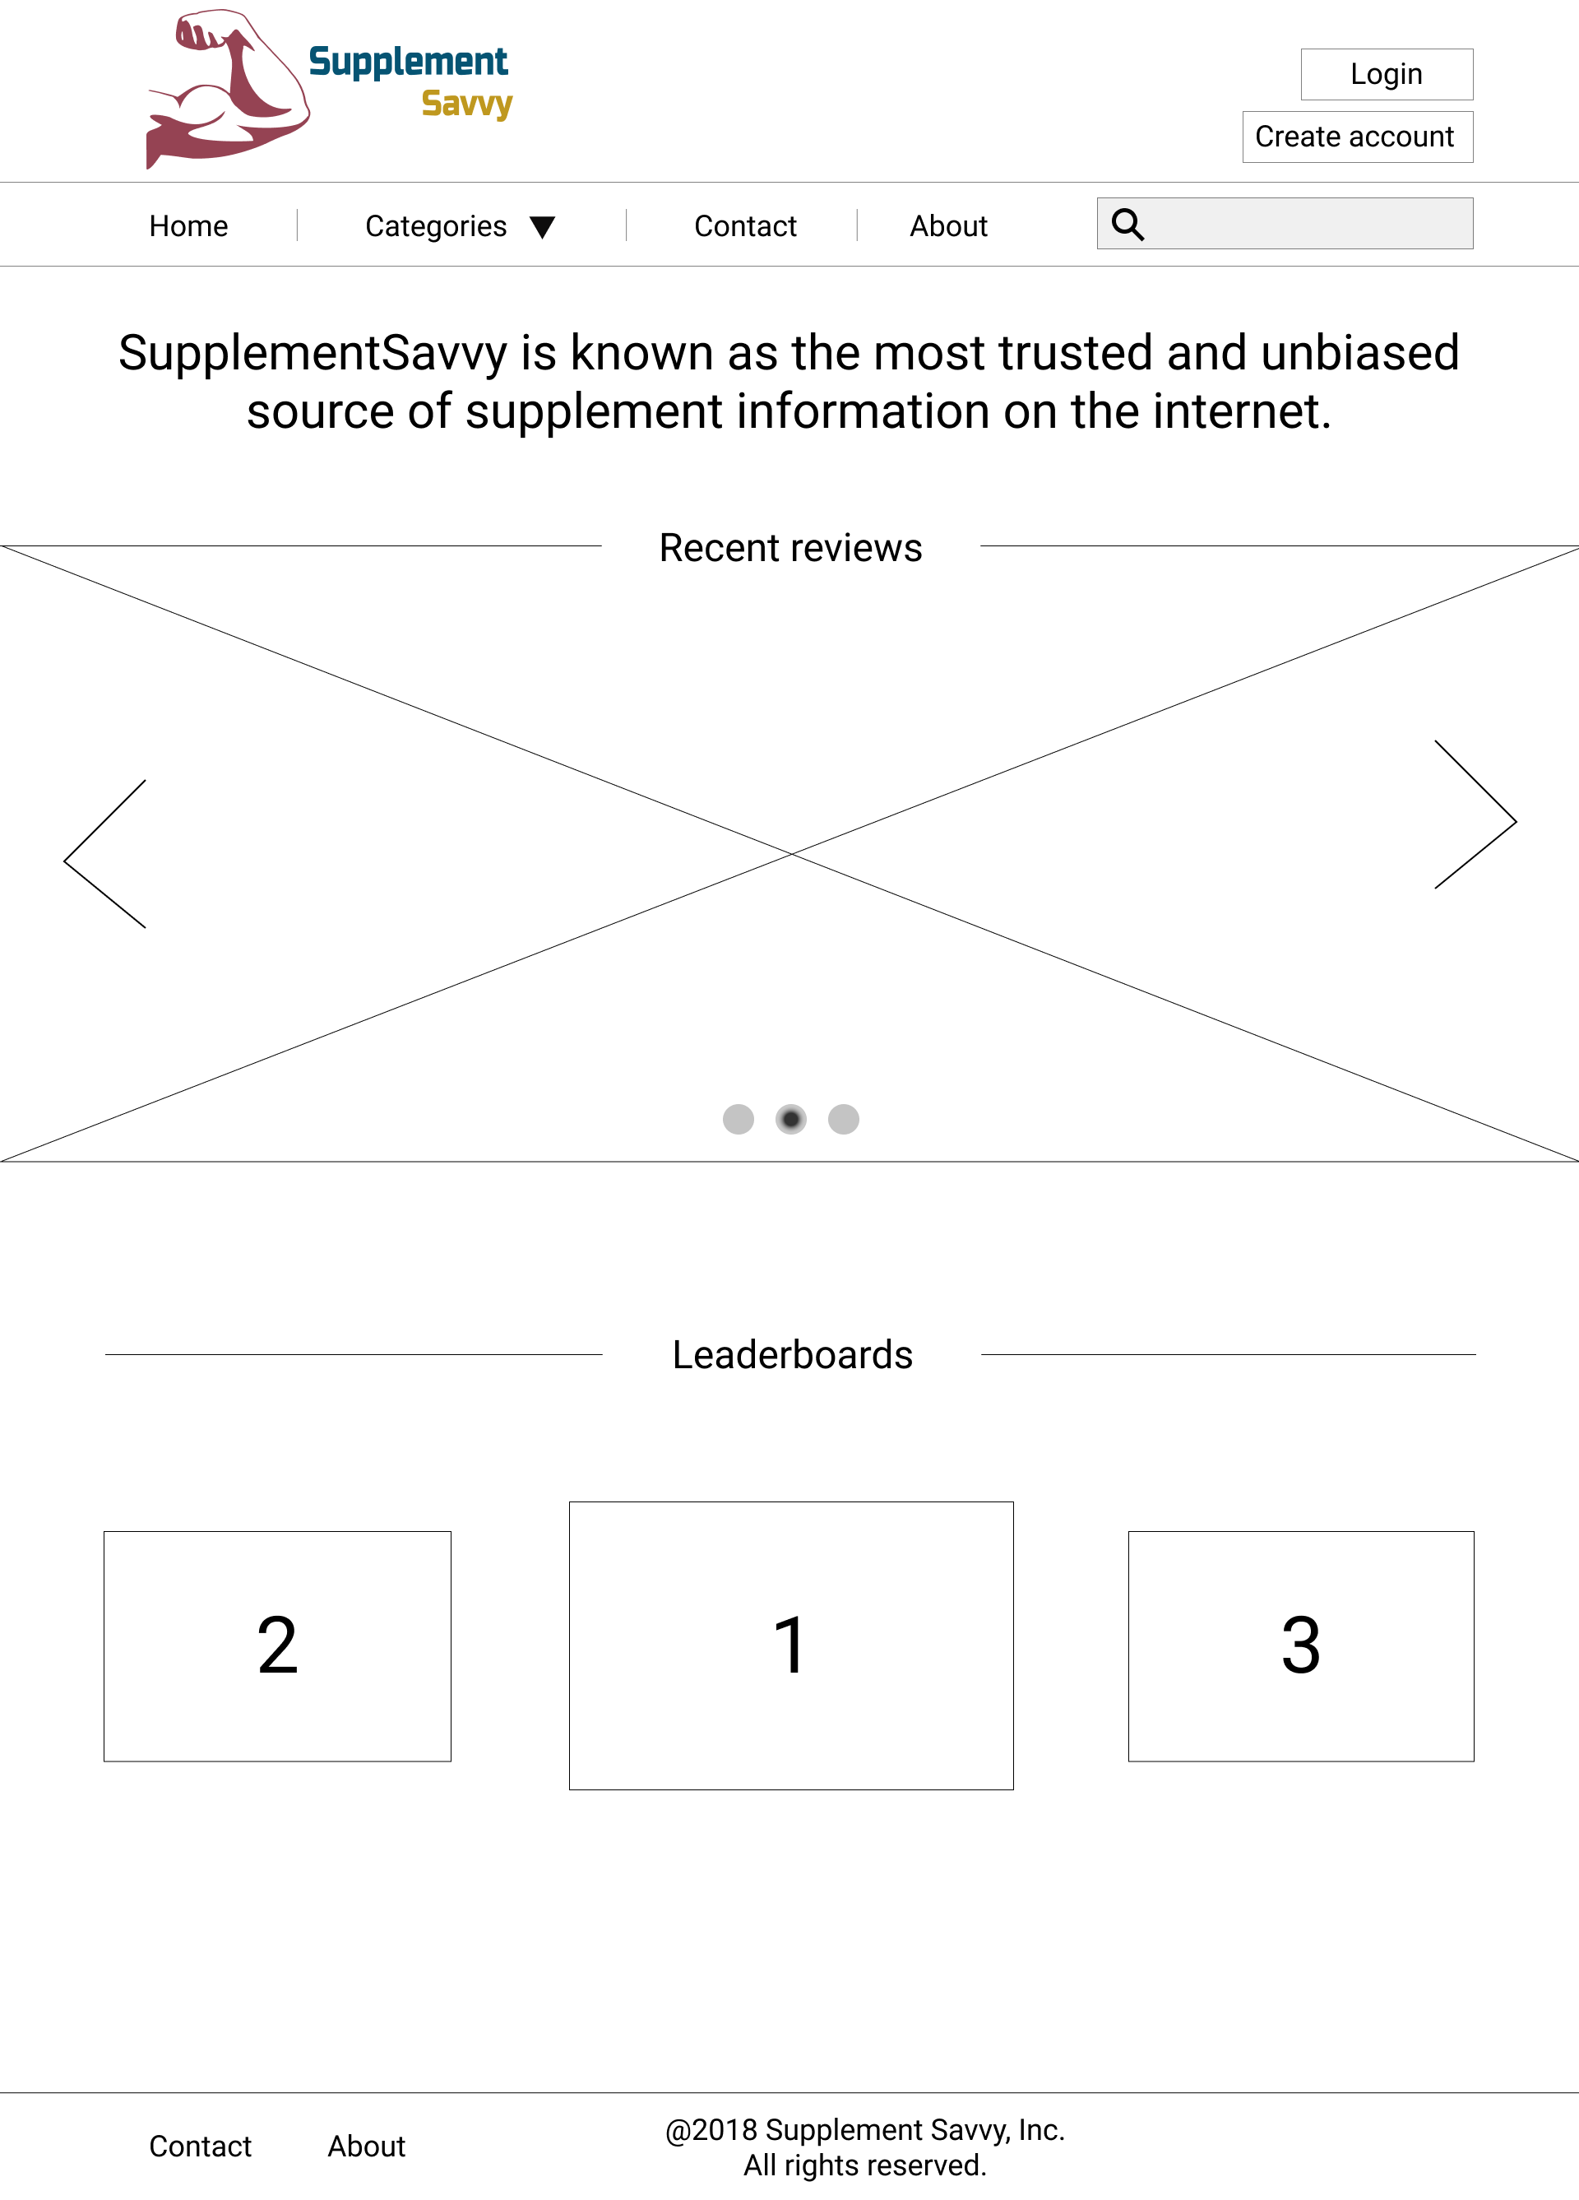

Create Account (overlay on Home)

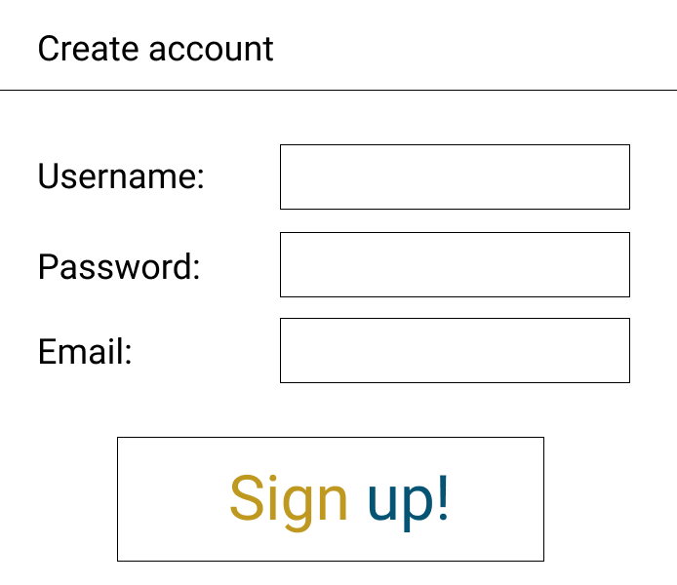

Login (overlay on Home)

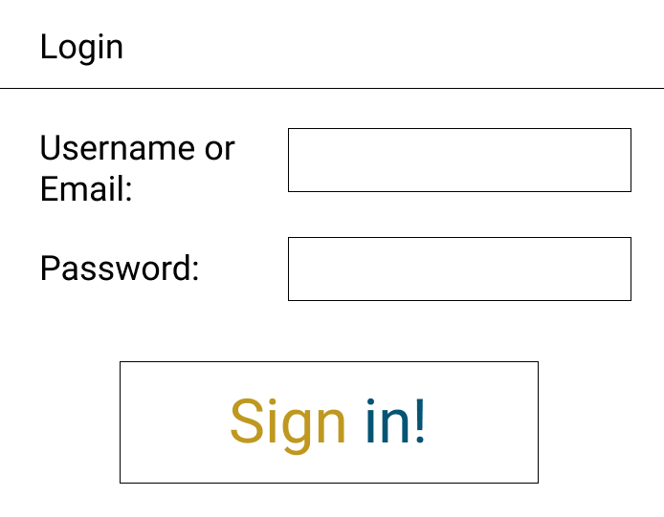

Category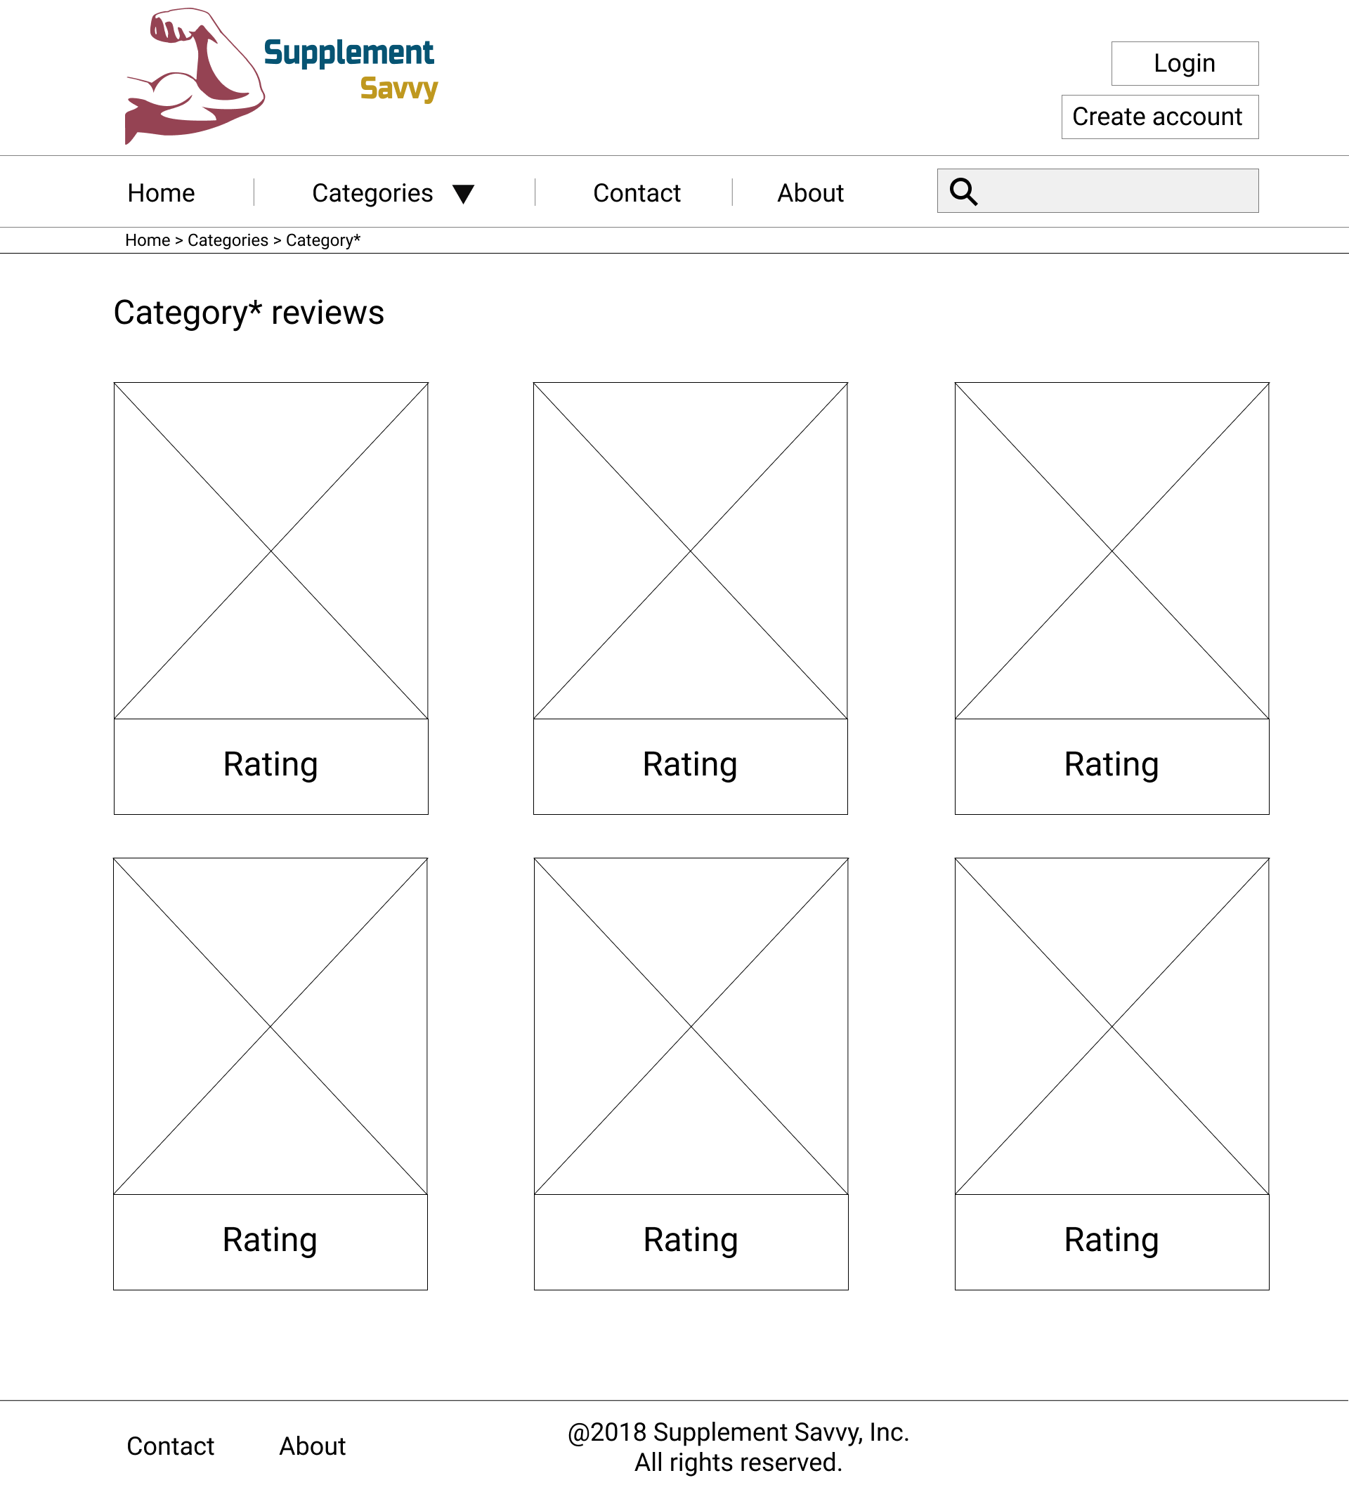

Contact

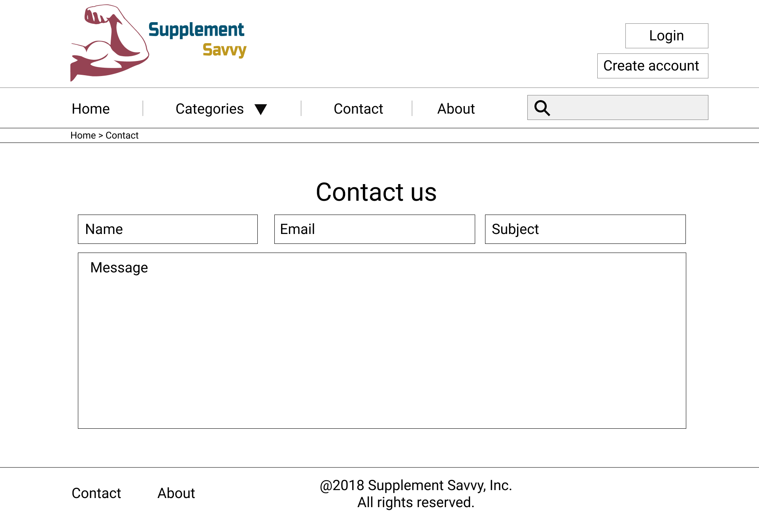

About



Product

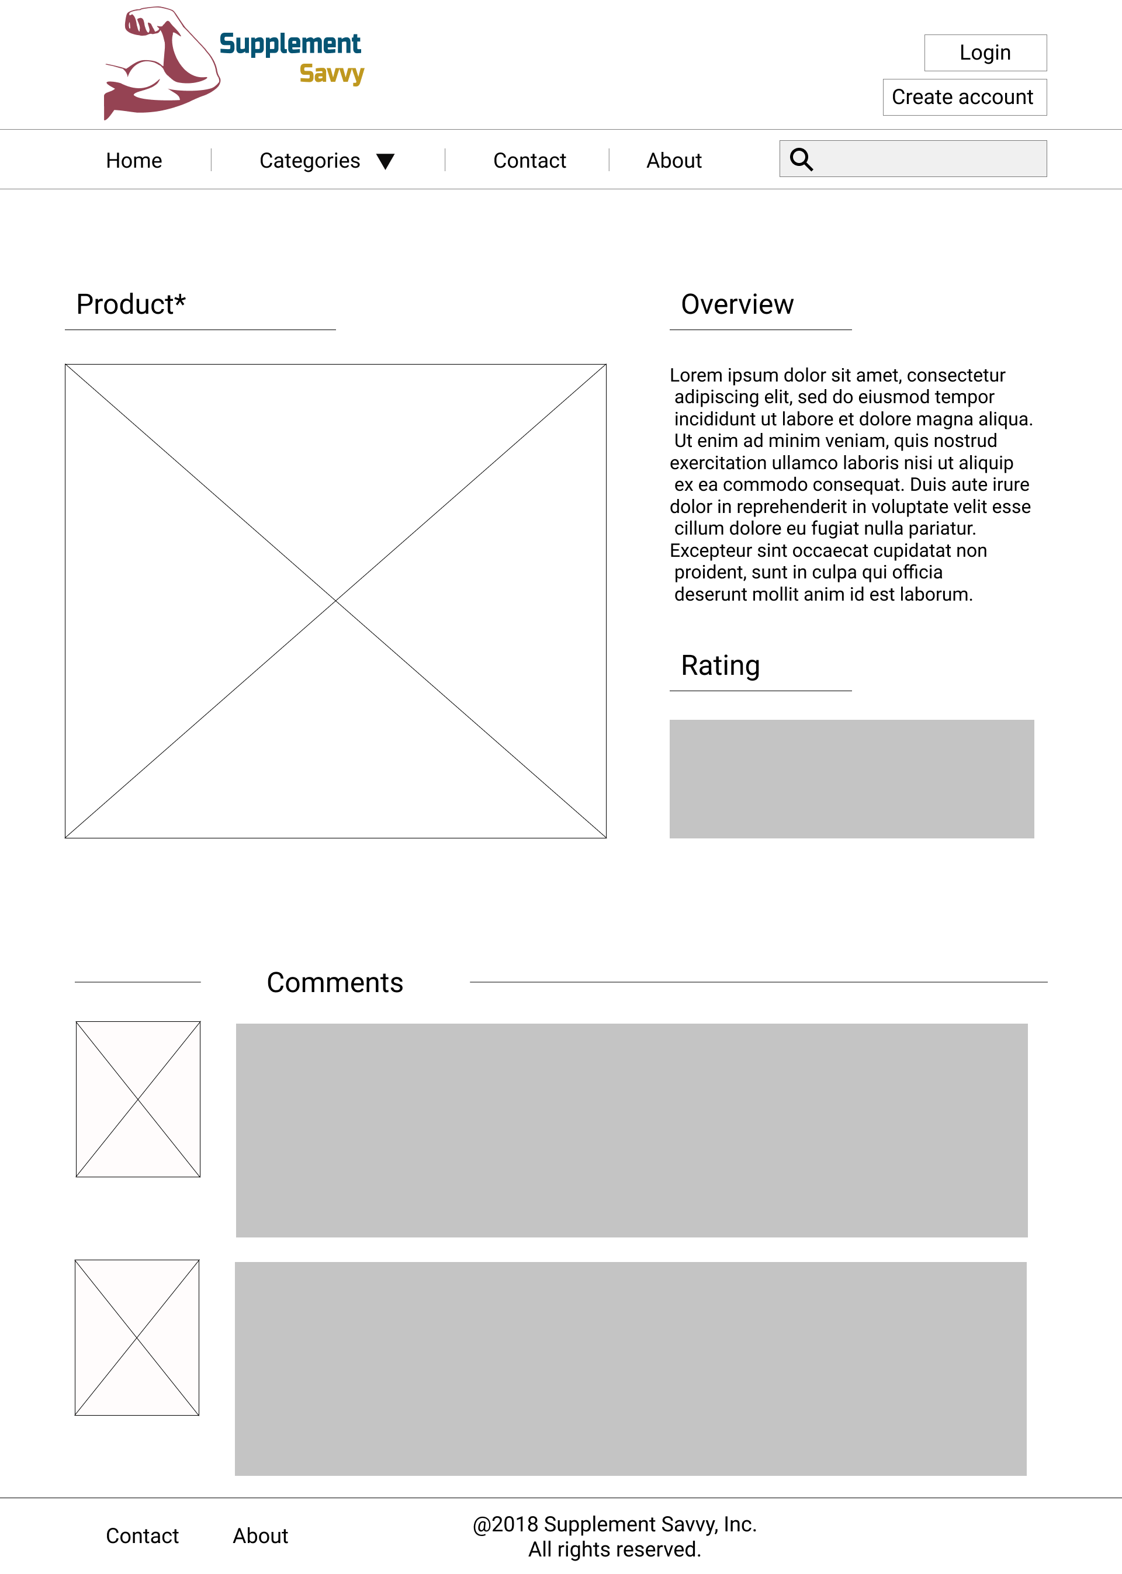

## 5. Visual Design

