Statistical Genetics - practical 3
2026-10-05
#install.packages(c("data.table", "HardyWeinberg", "genetics", "haplo.stats"))
library(data.table)
##
## Attaching package: 'data.table'
## The following object is masked from 'package:base':
##
## %notin%
library(genetics)
## Loading required package: combinat
##
## Attaching package: 'combinat'
## The following object is masked from 'package:utils':
##
## combn
## Loading required package: gdata
##
## Attaching package: 'gdata'
## The following objects are masked from 'package:data.table':
##
## first, last
## The following object is masked from 'package:stats':
##
## nobs
## The following object is masked from 'package:utils':
##
## object.size
## The following object is masked from 'package:base':
##
## startsWith
## Loading required package: gtools
## Loading required package: MASS
## Loading required package: mvtnorm
##
## NOTE: THIS PACKAGE IS NOW OBSOLETE.
##
## The R-Genetics project has developed an set of enhanced genetics
## packages to replace 'genetics'. Please visit the project homepage
## at http://rgenetics.org for informtion.
##
##
## Attaching package: 'genetics'
## The following objects are masked from 'package:base':
##
## %in%, as.factor, order
library(HardyWeinberg)
## Loading required package: mice
##
## Attaching package: 'mice'
## The following object is masked from 'package:stats':
##
## filter
## The following objects are masked from 'package:base':
##
## cbind, rbind
## Loading required package: nnet
## Loading required package: Rsolnp
## Loading required package: shape
library(parallel)
# install.packages('haplo.stats', repos = c('https://sinnweja.r-universe.dev', 'https://cloud.r-project.org'))
library(haplo.stats)
## Loading required package: arsenal
##
## Attaching package: 'haplo.stats'
## The following object is masked from 'package:genetics':
##
## locus

Linkage Disequilibrium
- (0.5p) Load the FOXP2.dat file into the R environment. How many individuals and how many SNPs are there in the database? What percentage of the data is missing?
foxp2 <- fread("FOXP2/FOXP2.dat")
cat("Individuals:", nrow(foxp2), "\n")
## Individuals: 104
cat("SNPs:", ncol(foxp2) - 1, "\n")
## SNPs: 543
geno <- foxp2[, 2:ncol(foxp2)]
all_values <- unique(unlist(geno))
print(all_values)
## [1] "T/G" "G/G" "T/T" "C/T" "C/C" "G/A" "A/A" "A/T" "G/T" "A/G" "A/C" "T/C"
## [13] "C/G" "T/A" "C/A" "G/C"
pct_missing <- mean(is.na(geno)) * 100
cat("Percentage missing:", round(pct_missing, 2), "%\n")
## Percentage missing: 0 %
- (1p) Using the function LD from the genetics package, compute the LD statistic D for the SNPs rs34684677 and rs2894715 of the database. Is there significant association between the alleles of these two SNPs?
snp1 <- foxp2[["rs34684677"]]
snp2 <- foxp2[["rs2894715"]]
g1 <- genotype(snp1, sep = "/")
g2 <- genotype(snp2, sep = "/")
ld_result <- LD(g1, g2)
print(ld_result)
##
## Pairwise LD
## -----------
## D D' Corr
## Estimates: -0.05493703 0.9986536 -0.3144048
##
## X^2 P-value N
## LD Test: 20.56088 5.77645e-06 104
cat("D:", ld_result$D, "\n")
## D: -0.05493703
cat("D':", ld_result$`D'`, "\n")
## D': 0.9986536
cat("r:", ld_result$`r`, "\n")
## r: -0.3144048
cat("R2:", ld_result$`X^2`, "\n")
## R2: 20.56088
cat("p-value:", ld_result$` P-value`, "\n")
## p-value:
There is a highly significant association.
- (1p) Given your previous estimate of D for SNPs rs34684677 and rs2894715, infer the haplotype frequencies. Which haplotype is the most common?
af1 <- summary(g1)$allele.freq
af2 <- summary(g2)$allele.freq
print(af1)
## Count Proportion
## G 174 0.8365385
## T 34 0.1634615
print(af2)
## Count Proportion
## T 138 0.6634615
## G 70 0.3365385
p_a1 <- af1[1, "Proportion"]
p_a2 <- af1[2, "Proportion"]
p_b1 <- af2[1, "Proportion"]
p_b2 <- af2[2, "Proportion"]
D <- ld_result$D
# Haplotype frequencies
f_a1b1 <- p_a1 * p_b1 + D
f_a1b2 <- p_a1 * p_b2 - D
f_a2b1 <- p_a2 * p_b1 - D
f_a2b2 <- p_a2 * p_b2 + D
haps <- c(
"G T" = f_a1b1,
"G G" = f_a1b2,
"T T" = f_a2b1,
"T G" = f_a2b2
)
print(round(haps, 4))
## G T G G T T T G
## 0.5001 0.3365 0.1634 0.0001
cat("Most common haplotype:", names(which.max(haps)), "\n")
## Most common haplotype: G T
cat("Frequency:", round(max(haps), 4), "\n")
## Frequency: 0.5001
- (1p) Determine the genotype counts for each SNP. For how many variants do you reject Hardy-Weinberg equilibrium using an ordinary chi-square test without continuity correction? Is this what you would expect by chance? (hint: you can read the .bim in R in order to determine the alleles of each SNP, and use function MakeCounts from the HardyWeinberg package to create a matrix of genotype counts).
bim <- fread("FOXP2/FOXP2.bim")
colnames(bim) <- c("chr", "snp", "cm", "bp", "a1", "a2")
geno <- foxp2[, 2:ncol(foxp2)]
count_allele <- function(genotype, allele) {
alleles <- strsplit(genotype, "/")
sapply(alleles, function(x) sum(x == allele))
}
geno_coded <- matrix(NA, nrow = nrow(geno), ncol = ncol(geno))
for (i in 1:ncol(geno)) {
geno_coded[, i] <- count_allele(geno[[i]], bim$a1[i])
}
colnames(geno_coded) <- colnames(geno)
counts <- MakeCounts(geno_coded, bim$a1, bim$a2)
counts <- counts[, 1:3]
p_values <- apply(counts, 1, function(x) {
result <- HWChisq(x, cc = 0, verbose = FALSE)
result$pval
})
## Warning in HWChisq(x, cc = 0, verbose = FALSE): Expected counts below 5:
## chi-square approximation may be incorrect
n_significant <- sum(p_values < 0.05, na.rm = TRUE)
pct_significant <- mean(p_values < 0.05, na.rm = TRUE) * 100
cat("Significant SNPs:", n_significant, "\n")
## Significant SNPs: 33
cat("Percentage:", round(pct_significant, 2), "%\n")
## Percentage: 6.08 %
cat("Expected by chance:", round(0.05 * length(p_values), 0), "\n")
## Expected by chance: 27
The observed number of significant SNPs (33) is close to what would be expected by chance (27), indicating no strong evidence of widespread deviation from Hardy-Weinberg equilibrium in this dataset.
- (1p) Compute the LD for all the marker pairs in this data base, using the LD function of the packages genetics. Be prepared that this make take a few minutes. Extract the R2 statistics and make an LD heatmap (hint: you can use the command image) using the R2 statistic.
geno <- foxp2[, 2:ncol(foxp2)]
geno_list <- lapply(geno, function(x) genotype(x, sep = "/"))
n_snps <- length(geno_list)
#r2_matrix <- matrix(NA, nrow = n_snps, ncol = n_snps)
#results <- lapply(1:(n_snps - 1), function(i) {
# sapply((i + 1):n_snps, function(j) {
# LD(geno_list[[i]], geno_list[[j]])$`R^2`
# })
#})
#saveRDS(results, "results_ld.rds")
#saveRDS(r2_matrix, "r2_matrix.rds")
r2_matrix <- readRDS("~/Documents/GitHub/sge-exercises/pract3/r2_matrix.rds")
results <- readRDS("~/Documents/GitHub/sge-exercises/pract3/results_ld.rds")
for (i in 1:(n_snps - 1)) {
idx <- (i + 1):n_snps
r2_matrix[i, idx] <- results[[i]]
r2_matrix[idx, i] <- results[[i]]
}
diag(r2_matrix) <- 1
rownames(r2_matrix) <- colnames(geno)
colnames(r2_matrix) <- colnames(geno)
r2_values <- r2_matrix[upper.tri(r2_matrix)]
summary(r2_values)
## Min. 1st Qu. Median Mean 3rd Qu. Max.
## 0.000000 0.004386 0.019533 0.097694 0.064301 0.999653
palette <- colorRampPalette(c("white", "yellow", "red"))(100)
image(1:n_snps, 1:n_snps, r2_matrix,
col = palette,
main = "LD Heatmap (R2)",
xlab = "SNP index", ylab = "SNP index",
axes = FALSE)
axis(1, at = seq(1, n_snps, by = 50), labels = seq(1, n_snps, by = 50))
axis(2, at = seq(1, n_snps, by = 50), labels = seq(1, n_snps, by = 50))
box()
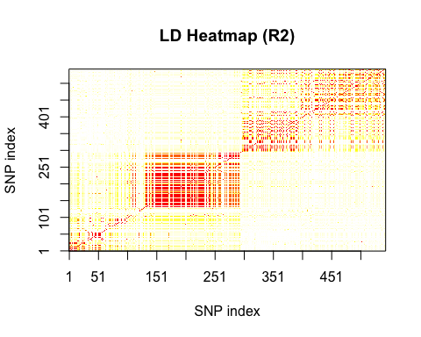
This pattern is expected: SNPs that are physically close on the chromosome tend to be in LD, while distant SNPs are independent due to recombination. Since the FOXP2 SNPs span a gene region, most pairs are far enough apart to be independent, but some are close enough to show strong LD.
- (1,5p) Make another heatmap obtained by filtering out all variants with a MAF below 0.35, and redoing the computations to obtain the R2 statistics in R. Can you explain any differences observed between the two heatmaps?
af_list <- lapply(geno_list, function(g) {
af <- summary(g)$allele.freq
# The minor allele frequency is the smaller proportion
min(af[, "Proportion"])
})
maf <- unlist(af_list)
names(maf) <- colnames(geno)
summary(maf)
## Min. 1st Qu. Median Mean 3rd Qu. Max.
## 0.01442 0.04808 0.21154 0.20313 0.27644 0.49519
keep <- maf >= 0.35
sum(keep)
## [1] 119
geno_list_filt <- geno_list[keep]
n_snps_filt <- length(geno_list_filt)
r2_matrix_filt <- matrix(NA, nrow = n_snps_filt, ncol = n_snps_filt)
results_filt <- mclapply(1:(n_snps_filt - 1), function(i) {
sapply((i + 1):n_snps_filt, function(j) {
LD(geno_list_filt[[i]], geno_list_filt[[j]])$`R2`
})
}, mc.cores = detectCores() - 1)
for (i in 1:(n_snps_filt - 1)) { r2_matrix_filt[i, (i + 1):n_snps_filt] <- results_filt[[i]] r2_matrix_filt[(i + 1):n_snps_filt, i] <- results_filt[[i]] }
diag(r2_matrix_filt) <- 1
palette <- colorRampPalette(c(“white”, “yellow”, “red”))(100)
image(1:n_snps_filt, 1:n_snps_filt, r2_matrix_filt, col = palette, main = “LD Heatmap (R2) — MAF >= 0.35”, xlab = “SNP index”, ylab = “SNP index”, axes = FALSE) axis(1, at = seq(1, n_snps_filt, by = 5), labels = seq(1, n_snps_filt, by = 5)) axis(2, at = seq(1, n_snps_filt, by = 5), labels = seq(1, n_snps_filt, by = 5)) box()
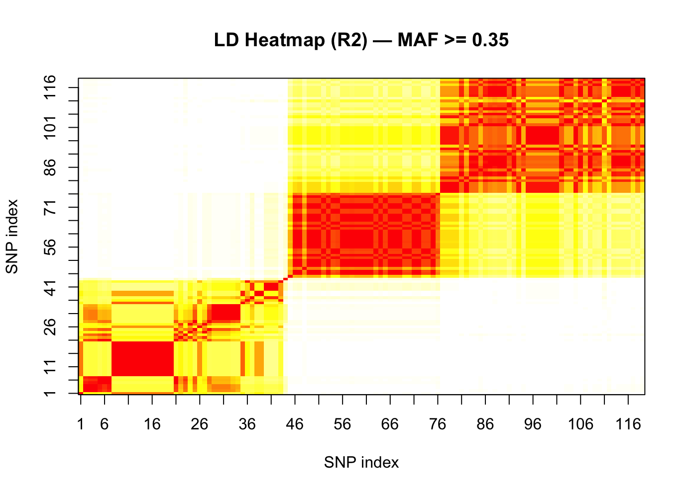
Filtering to MAF over 0.35 kept 119 SNPs. The filtered heatmap shows stronger LD block structure because common variants are older, more informative, and more likely to be in LD with their neighbours, while rare variants contribute mostly noise and low R2 values.
- (1p) Compute a distance matrix with the distance in base pairs between all possible pairs of SNPs, using the basepair position of each SNP given in the .bim file. Make a plot of R’s R2 statistics against the distance (expressed as the number of basepairs) between the markers. Comment on your results.
positions <- bim$bp
dist_matrix <- as.matrix(dist(positions))
r2_values <- r2_matrix[upper.tri(r2_matrix)]
dist_values <- dist_matrix[upper.tri(dist_matrix)]
valid <- !is.na(r2_values) & !is.na(dist_values)
r2_values <- r2_values[valid]
dist_values <- dist_values[valid]
plot(dist_values, r2_values,
pch = 19, cex = 0.3, col = rgb(0, 0, 1, 0.1),
log = "x",
main = "R2 vs Distance between SNPs",
xlab = "Distance (base pairs, log scale)",
ylab = "R2")
## Warning in xy.coords(x, y, xlabel, ylabel, log): 1 x value <= 0 omitted from
## logarithmic plot
bins <- cut(dist_values, breaks = 50)
mean_r2 <- tapply(r2_values, bins, mean)
midpoints <- tapply(dist_values, bins, median)
lines(midpoints, mean_r2, col = "red", lwd = 2)
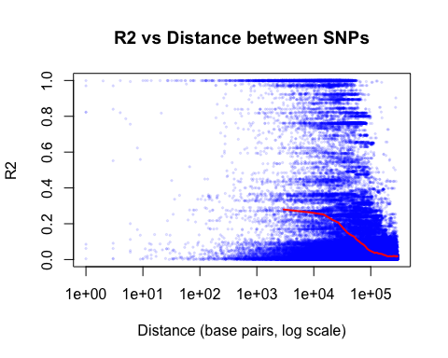
The plot shows a clear decay of linkage disequilibrium with physical distance, confirming the expected pattern: a monotonic decay of LD with physical distance.

Haplotype estimation
- (0,5p) How many individuals and how many SNPs are there in the database? What percentage of the data is missing?
apoe <- fread("APOE/APOE.dat")
n_individuals <- nrow(apoe)
cat("Individuals:", n_individuals, "\n")
## Individuals: 107
n_snps <- ncol(apoe) - 1
cat("SNPs:", n_snps, "\n")
## SNPs: 162
geno_apoe <- apoe[, 2:ncol(apoe)]
print(unique(unlist(geno_apoe)))
## [1] "C/C" "G/C" "G/G" "A/G" "A/A" "C/G" "T/T" "A/C" "C/T" "T/C" "G/A" "C/A"
## [13] "G/T" "T/A" "A/T" "T/G"
pct_missing <- mean(is.na(geno_apoe)) * 100
cat("Percentage missing:", round(pct_missing, 2), "%\n")
## Percentage missing: 0 %
- (0,5p) Assuming that all SNPs are bi-allelic, how many haplotypes can theoretically be found for this data set?
n_snps_apoe <- ncol(apoe) - 1
n_haplotypes <- 2^n_snps_apoe
cat("Number of SNPs:", n_snps_apoe, "\n")
## Number of SNPs: 162
cat("Possible haplotypes:", n_haplotypes, "\n")
## Possible haplotypes: 5.846007e+48
- (1p) Estimate haplotype frequencies using the haplo.em function that you will find in the haplo.stats package. How many haplotypes do you find? List the estimated probabilities in decreasing order. Which haplotype number is the most common?
apoe <- fread("APOE/APOE.dat")
bim <- fread("APOE/APOE.bim")
colnames(bim) <- c("chr", "snp", "cm", "bp", "a1", "a2")
geno <- apoe[, 2:ncol(apoe)]
convert_snp <- function(genotype, allele1, allele2) {
alleles <- strsplit(genotype, "/")
a1 <- sapply(alleles, function(x) {
if (length(x) < 2) return(NA)
if (x[1] == allele1) return(1)
if (x[1] == allele2) return(2)
return(NA)
})
a2 <- sapply(alleles, function(x) {
if (length(x) < 2) return(NA)
if (x[2] == allele1) return(1)
if (x[2] == allele2) return(2)
return(NA)
})
cbind(a1, a2)
}
geno_haplo <- NULL
for (i in 1:ncol(geno)) {
geno_haplo <- cbind(geno_haplo, convert_snp(geno[[i]], bim$a1[i], bim$a2[i]))
}
hap_result <- haplo.em(geno_haplo)
freqs <- hap_result$hap.prob
names(freqs) <- rownames(hap_result$haplotype)
freqs_sorted <- sort(freqs, decreasing = TRUE)
cat("Number of haplotypes:", sum(freqs > 0), "\n")
## Number of haplotypes: 34
print(round(freqs_sorted, 4))
## 34 11 8 32 25 13 28 21 15 17 33
## 0.4027 0.1308 0.0717 0.0682 0.0502 0.0455 0.0357 0.0350 0.0225 0.0191 0.0187
## 31 23 29 1 4 5 9 10 12 18 22
## 0.0158 0.0087 0.0072 0.0047 0.0047 0.0047 0.0047 0.0047 0.0047 0.0047 0.0047
## 24 27 19 26 6 16 30 7 3 2 14
## 0.0047 0.0047 0.0040 0.0035 0.0034 0.0030 0.0022 0.0019 0.0013 0.0012 0.0008
## 20
## 0.0000
cat("Most common haplotype:", names(freqs_sorted)[1], "\n")
## Most common haplotype: 34
cat("Frequency:", round(freqs_sorted[1], 4), "\n")
## Frequency: 0.4027
- (1p) Remove all genetic variants that have a minor allele frequency below 0.10 from the database, and re-run haplo.em. How does this affect the number of haplotypes? Comment on your results
geno_list_apoe <- lapply(geno, function(x) genotype(x, sep = "/"))
maf_apoe <- sapply(geno_list_apoe, function(g) {
af <- summary(g)$allele.freq
min(af[, "Proportion"])
})
summary(maf_apoe)
## Min. 1st Qu. Median Mean 3rd Qu. Max.
## 0.004673 0.269860 1.000000 0.776711 1.000000 1.000000
keep_apoe <- maf_apoe >= 0.10
sum(keep_apoe) # how many remain?
## [1] 141
geno_filt <- geno[, ..keep_apoe]
bim_filt <- bim[keep_apoe, ]
geno_haplo_filt <- NULL
for (i in 1:ncol(geno_filt)) {
geno_haplo_filt <- cbind(
geno_haplo_filt,
convert_snp(geno_filt[[i]], bim_filt$a1[i], bim_filt$a2[i])
)
}
dim(geno_haplo_filt)
## [1] 107 282
hap_result_filt <- haplo.em(geno_haplo_filt)
freqs_filt <- hap_result_filt$hap.prob
names(freqs_filt) <- rownames(hap_result_filt$haplotype)
freqs_filt_sorted <- sort(freqs_filt, decreasing = TRUE)
cat("Number of haplotypes:", sum(freqs_filt > 0), "\n")
## Number of haplotypes: 9
print(round(freqs_filt_sorted, 4))
## 9 1 6 4 2 7 3 5 8
## 0.6206 0.1308 0.1130 0.0748 0.0319 0.0187 0.0055 0.0047 0.0000
Filtering out rare variants dramatically reduces the number of haplotypes estimated by haplo.em. This is expected because rare SNPs contribute rare alleles that define rare haplotypes. When those SNPs are removed, the rare haplotypes can no longer be distinguished and disappear from the analysis.

