docker run -d --name bootcamp-web -v /root/web:/usr/share/nginx/html -p 9999:80 nginx:latest

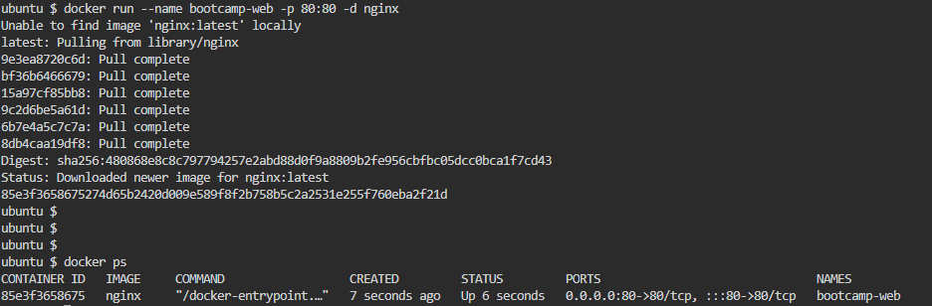

docker exec -it bootcamp-web /bin/bash

ls

ls /usr/share/nginx/html

