Extended OSCAR for DataScience

Abstract
In this paper we introduce an extended version of OSCAR, the OpenCitations RDF Search Application, after its first presentation at The 2018 Web Conference. OSCAR is a user-friendly search platform that can be used to search any RDF triplestore providing a SPARQL endpoint, while hiding the complexities of SPARQL, making the searching operations operable also by non experts in Semantic Web technologies. We present its basic features and the main extensions made to it, and demonstrate how it can be adapted to work with different SPARQL endpoints containing scholarly data, more precisely: OCC and COCI datasets provided by OpenCitations, and the Wikidata dataset. We conclude by discussing some usability statistics of OSCAR retrieved from the OpenCitations website while querying the OCC and COCI datasets.

Introduction
The amount of data available on the World Wide Web (the Web) keep increasing rapidly, and finding relevant information by searching the Web is a daily challenge. Traditional search techniques rely on a textual matching of words, and do not take into consideration the semantic information behind the textual content. The Semantic Web 1 is an approach which tries to overcome these disadvantages by representing knowledge on the World Wide Web in a way that can be interpreted by machines. In particular, these data are stored using RDF 3, a data model that enables one to express information in form of subject-predicate-object statements. Usually these RDF statements are stored in a particular kind of RDF database called a triplestore, and can be queried by means of SPARQL 5, the query language for RDF data.
We have previously presented at the SAVE-SD Workshop co-located with The Web Conference 2018, OSCAR, the OpenCitations RDF Search Application 4. OSCAR is a user-friendly search platform that can be used with any RDF triplestore providing a SPARQL endpoint, and which is entirely built without the integration of external application components. It provides a configurable mechanism that allows one to query a triplestore by means of a user-input and following definable rules, while in the background one or more SPARQL queries elaborate the upper requests. The main idea is to make the involvement of experts in Semantic Web technologies reduced to an initial once-for-all-time configuration of the system to work with a particular triplestore, by customizing the script that provides the text-search interface and enables users to filter the returned results by means of appropriate facets and values.
The OSCAR idea came along the OpenCitations project 6 7, which aims on building an open repository of scholarly citation data with accurate citation information (bibliographic references) harvested from the scholarly literature. The OpenCitations dataset is provided in RDF format and available for querying via a SPARQL endpoint. OSCAR was successfully configured and integrated inside the OpenCitations website to search its triplestore. So we have built a friendly interface that would permit ordinary Web users to compose easily definable queries to search into the datasets maintained by OpenCitations.
At that point, OSCAR was based only on accepting queries which take a free-textual input, and next try to understand the user intent and execute on background the corresponding SPARQL query. We have continue working on adding and developing new features according to users needs and the type of data stored in OpenCitations.
This paper extends the previous work through some significant additions made both on the OSCAR architecture and features, along with the final evaluations made on it.
The new features added are:
- Users now have the ability to create multiple field queries and combine them using logical connectors, therefore perform a much more complex query. A possible query for instance: “retrieving the articles published on 2015 having ‘John Michael’ as one of their authors”. The logical connectors available are: AND, OR, AND NOT.
- A set of heuristic functions could be applied on the initial input in order to modify it’s original format, and insert the new format variations inside the SPARQL queries. For instance: capitalizing the first letter of a word given as input.
- Extend the table of results with new columns/fields from additional data which does not appear inside the original set of results retrieved after the execution of the SPARQL query. The new data are retrieved by calling external services, for instance: a REST API.
- Mapping/modifying the values of the results table into a new form following a specific regular expression rule. For instance: rewriting a date value into an alternative format.
- The configuration file has been modified into a new much intuitive and comprehensive form. It also permits the customization of additional stylistic and filtering features.
To evaluate the quality and potentials of OSCAR:
- We have integrated the new version of OSCAR inside the OpenCitations website and excerpt some statistics regarding its usage.
- To test its adaptability to other SPARQL endpoints, we have taken the Wikidata 2 case, and configured OSCAR to query only scholarly domain resources.
In this paper, we present OSCAR and give a quick preview on its main features. Then we move on describing it generally and focusing on the new extensions made to it, after its first presentation on the SAVE-SD workshop. We show how its integrated right now inside the OpenCitations project, and test its adaptability on other SPARQL endpoints, by presenting a configuration made on three different corpuses: OCC, COCI, both maintained by OpenCitations, and the Wikidata corpus.
The rest of this paper is organized as follows. In Related works we describe some of the most important existing SPARQL-based searching tools. In OSCAR, the OpenCitations RDF Search Application, we describe OSCAR and discuss its model definition and architectural form, with a special focus on the new features. In Configuring OSCAR for OpenCitations and Wikidata, we demonstrate its usability for the OpenCitations datasets (COCI and OCC) and for WikiData, while, in Usage statistics from OpenCitations, we give some usability statistics taken from the OpenCitations website. Finally, in Conclusions, we conclude the paper and sketch out the most relevant outcomes.

Related works
In the past, several projects that customize SPARQL queries according to user needs have been released. They can be classified into two categories. The first type of tools generate and apply SPARQL queries starting from a free text or an oriented field input search, hiding the complexities of the SPARQL query behind a simple and familiar-looking search interface. We say that these interfaces are unaware-user tools, since they permit users to make textual queries without needing to understand the complexity of the languages used for storing and querying the data.
Scholia 12 is a tool which is in this category. It is a Web application to expose scientific bibliographic information through Wikidata. In particular, its Web service creates on-the-fly scholarly profiles for researchers, organizations, journals, publishers, individual scholarly works, and research topics, by querying the SPARQL-based Wikidata Query Service. A search field on the front page of Wikidata permits a user to look for a particular name and displays its data by means of well-structured visual interfaces.
Another tool of this type is BioCarian 13. It is an efficient and user-friendly search engine for performing exploratory searches on biological databases, providing an interface for SPARQL queries over RDF triplestores, and providing a graphical interface for the results based on facets. It allows complex queries to be constructed, and has additional features like filtering and ranking the results according to user-selected facet values.
OSCAR is, of course, also in this category of tools.
The other type of tools aim at helping the user to build a SPARQL query by using specific visual constructs that mimic the various operations made available by SPARQL (filters, values selections, etc.). In this case, the users are very aware that they are using Semantic Web technologies, and that the function of the tools is only to be a support for guiding the user in creating the particular query of interest. These tools are grouped under the label aware-user tools.
Within this category, we have the Wikidata Query Service (WDQS) 9, which is a Web interface that enable the creation of a SPARQL query by writing the actual label associated to each item and property, instead of employing the URL customarily used for identifying it. In addition, it makes available several visualisation interfaces for the results, from a simple table to very complex diagrams and graphs. The strategy adopted in WDQS is close to what have been proposed in another tool called: NITELIGHT 10, A Graphical Tool for Semantic Query Construction.
ViziQuer 11 is another tool example, which extract and visualize graphically the data schema of the endpoint. The user will be able to overview the data schema and use it to construct a SPARQL query according to the data schema.
Along the same lines is the Visual SPARQL Builder (VSB), a tool which allows users to create and run SPARQL queries with a browser's graphical interface. While WDQS exposes the SPARQL query to the user, VSB hides it entirely behind blocks which explicitly represent all the SPARQL constructs, including filters. Upon execution, the visual queries are translated to SPARQL code, which is made accessible to the user, and the results are shown in structured tables.

OSCAR, the OpenCitations RDF Search Application
OSCAR, the OpenCitations RDF Search Application, is an open source stand-alone javascript tool which can be embedded in a webpage so as to provide a human-friendly interface to search for data within RDF triplestores by means of SPARQL queries. It is possible to configure OSCAR to work with a particular SPARQL endpoint, by configuring a JSON document which specifies how the SPARQL queries are sent to that endpoint, and how the returned query results should be visualized, according to the predefined tabular view that OSCAR provides. The source code and documentation for OSCAR are available on GitHub at https://github.com/opencitations/oscar.
When OSCAR has been developed and first time presented at the SAVE-SD Workshop, we needed to follow a number of specific requirements, based on our experience and observation over the users requirements while requesting the corpuses maintained by the OpenCitations project.
- It must permit the client to operate and post process the results set OSCAR has returned from the SPARQL execution. These operations could be applied to one or more of the result fields presented in the tabular results interface, and need to be taken dynamically at real time without any further querying of the triplestore (using SPARQL);
- Each part of OSCAR: interface, functionalities and queries must be customizable according to the user needs. This operation should be easily handled through a specific configuration module.
- Although originally developed to work with the OpenCitations SPARQL endpoint, it must be easily configured to work with any other RDF triplestore providing a SPARQL endpoint address, and must also be easily integrated as a new module within that system's website.
Soon, thanks to the new observations and feedbacks gained from OSCAR usage, we have found out other import aspects which can significantly improve the searching experience, and potentials of OSCAR.
- Although the most basic searching option is a free text search, such as is common to many web search engines, we wanted to introduce a new and more sophisticated advanced search, which aims on connecting a number of rule-oriented queries together using logical connectors such as: And, Or, And Not.
- Introducing a pre-processing phase for the given input. This will enable us to re-format and alter the original form of the initial given textual input, for instance, by the application of some heuristics.
- Defining new additional post-processing operations. The possibility to integrate additional data on the table of results by calling external services, or through the mapping of the table values into a new form following a regular expression matching rule.
In the following subsections we describe the general architecture of OSCAR, its workflow, and how the customizations of it have effect. We will give a special focus on the additional components integrated already listed above.

Architecture of OSCAR
All the functionalities implemented by OSCAR are executed in the browser (client side), so as to make it easily reusable in different contexts and with different Web sites without the need of handling specific programming languages for running the back-end scripts. In particular, OSCAR is defined by three files:
- search.js, the main core of the tool to handle all its behaviour and define its model;
- search-conf.js, the configuration file which defines all the parameters and customizes OSCAR according to a specific SPARQL-endpoint;
- search.css, the stylesheet that defines the layout and other stylistic aspects of OSCAR user interface.
All these files need first to be imported into an HTML page that will provide the user with the text query interface. In addition, a skeleton HTML snippet should be included in such page, that will be populated with the result of such a search operation. This snippet is defined as follows:
<div id="search" class="search">
<div id="search_extra" class="search-extra"></div>
<div id="search_header" class="search-header">
<div id="rows_per_page"></div>
<div id="sort_results"></div>
</div>
<div id="search_body" class="search-body">
<div id="search_filters" class="search-filters">
<div id="limit_results"></div>
<div id="filter_btns"></div>
<div id="filter_values_list"></div>
</div>
<div id="search_results" class="search-results"></div>
</div>
</div>
The skeleton layout of the aforementioned OSCAR results interface (element div with attribute @id = search) is composed of three main sections, defined by specific div elements: the section extra (@id = search_extra), the section header (@id = search_header), and the section body (@id = search_body).
The extra section can be used for applying additional functionalities and operations to the results of a search operation. Currently, it includes a mechanism for exporting the results shown as a CSV file. The header section contains components that allow one to modify the table of results from a visual perspective – e.g. by specifying the maximum number of rows to be visualized per page, and by sorting the results according to a specific column or field. Finally, the body section is where the results are actually shown. It contains a table populated with the results obtained from the query execution, and a series of filters that enable a user to refine the results, so as to keep or excluding specific values.
The organisation of the structure of the aforementioned sections (and of all the subsections they contain) can be customized according to particular needs. In particular, one can decide which components are to be included within or excluded from the results Web page by keeping within that Web page the relevant HTML fragment, or by omitting it. Furthermore, while OSCAR provide a set of basic layout rules for all the components, these can be freely customized so as to align them with the particular style required by the Web site under consideration.

The Workflow
The workflow implemented by OSCAR is described in Figure 1, where we introduce all the operations that OSCAR enables, and the various steps it runs as consequences of such operations. The process starts with the generation of the search interface, which is the mechanism used to permit someone to decide between two searching options: (1) input a free textual query within in the text search box provided by the interface, (2) perform an advanced search using multiple field queries and connect them using the AND, OR, AND NOT, logical connectors. According to the searching choice made by the user we will have two different workflows.
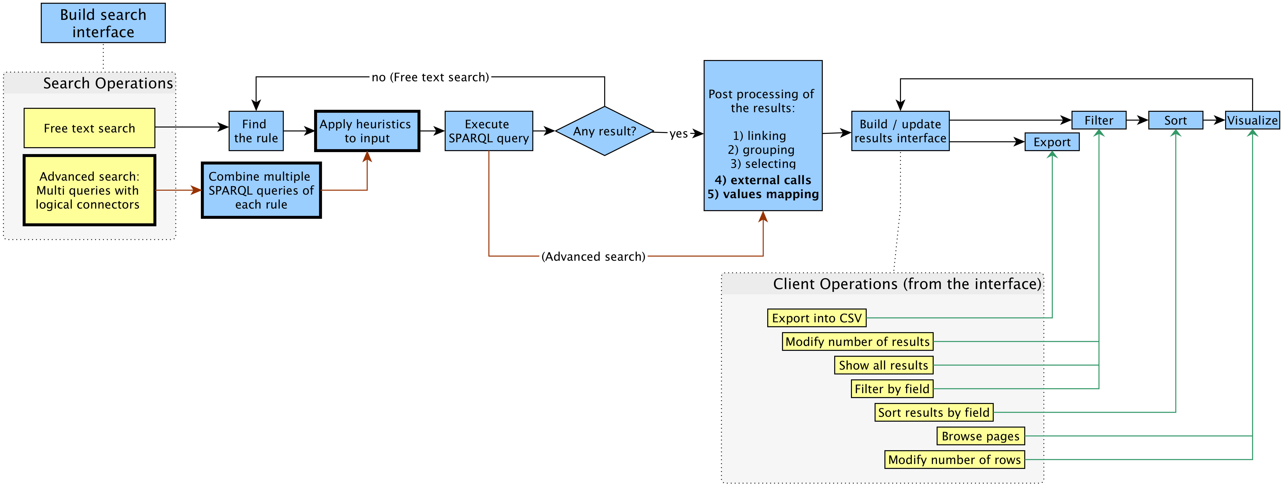Figure 1: The workflow implemented by OSCAR (in blue, at the top) and the set of operations that a user can perform by using the search interface and the results interface. The bold elements are the new extensions added after the SAVE-SD workshop. The red arrows define the specific workflow of the advanced search. Each operation is connected to the particular step within the workflow that will be executed as a consequence of that operation. The set of operations are possible only after precise steps in the workflow (the dashed lines specify these steps). After the execution of an operation, the workflow execution will move on the linked step.
In case of a free text search, when a query is run (by pressing the enter key or by clicking on the lens provided in the interface to the right of the free-text field), OSCAR determines which SPARQL query it has to execute in order to provide results to match the particular textual input specified. As described in more detail in Customizing OSCAR, the configuration file allows one to specify a sequence of rules, each defining a SPARQL query and a particular regular expression. OSCAR iterates each rule as they appear in the sequence, and it runs the related SPARQL query with the application of a number of heuristics (defined also in the configuration file), only if the input text matches the regular expression specified in the rule under consideration. If no results are returned by that particular SPARQL query, OSCAR iterates to the next rule and its associated SPARQL query until a result is returned, or until no result at all is found.
On the other hand, if a user chose an advanced search, then the workflow will directly start from the application of the heuristics and the execution of a complex SPARQL query statement, which is made through the combination of several SPARQL code blocks with a number SPARQL connectors (e.g: UNION statement) according to the logical connectors chosen from the user input interface. Once we have a set of results we move on the results post-processing phase, with no need to loop again searching for other corresponding rules. This workflow is shown through red-coloured arrows in Figure 1.
Once a result is returned, other additional possible post operations are executed. First, OSCAR can check if some fields returned in the result table actually represent URL links for values of other fields – as specified in the configuration file – and, if that is the case, it creates explicit links in the resulting Web page. For instance, if we consider a simple two-column table where each row describes the title of an article and the URL from which one can retrieve its full metadata, then OSCAR can be configured to show the article title as a clickable link that allows one to go to the descriptive page for that article, by incorporating into the title the related URL that would otherwise have been displayed in the second column.
OSCAR then, if indicated inside the configuration file, can perform two new operations we have built for this new version. (1) External Calls: OSCAR can call external services using as parameters values already present inside the result table, and return those values and integrate them inside the final results table in a new additional column. For instance, calling the Crossref API using the value of the DOIs (already in the table under the column ‘doi’) and retrieve the ISSN value for each of these DOIs, and integrate the new returned values inside the table under a new ‘issn’ column. (2) Value mapping: OSCAR can map the values of specific columns in the table into a new format following the indicated regular expressions inside the configuration file. For instance, the name of a person could be mapped into a new format which capitalizes the first letter of it.
After that, if needed, OSCAR can perform a grouping operation following the parameters indicated in the configuration file. This operation allows to group multiple rows of the results set according to a particular field (a key), all the other fields of the rows will be collected together, for example by concatenating their textual values. For instance, if we extend the two-column table mentioned previously with an additional field for expressing author names, in case a certain article has more than one authors, the SPARQL-endpoint would return several rows (one for each author of the article), each repeating the title and the article URL in the first two fields and listing one of its authors in the third field. This makes for uncomfortable reading of the table. The grouping operation performed by OSCAR allows us to group all these authors into one 'author' cell in the third column, so as to provide just one row per article in the result table.
Finally, OSCAR can selects only a specific subset of the fields returned by the SPARQL endpoint to display in the Web page, according to the specification given within the configuration file. For instance, using the same example given before for the linking operation, at this phase we can exclude the second column depicting the URLs of the articles, since those URL have already been incorporated into the clickable links added to the article titles in the first column.
All the data obtained by the aforementioned operations are initialized and stored internally in four different forms, called native data, filtered data, sorted data and visualized data respectively. Native data are the complete original result-set after the execution of the aforementioned operations. Filtered data are the subset of the native data after the application – brought about by a user interacting with the OSCAR interface – of filtering operations upon them (e.g. to show only the articles published in 2016). Sorted data are the subset of the filtered data after the execution – again brought about by a user interacting with the OSCAR interface – of sorting operations (e.g. sorting the rows in descending order according to the number of citations that the articles have received). Finally, visualized data are the subset of the sorted data that are displayed in the Web page (for example, the first twenty results), while the others are hidden behind a pagination mechanism so as to avoid filling up the entire page with all the results. It is worth mentioning that, in the initialization phase, before filtering and sorting, all the 'filtered' and 'sorted' data are equivalent to the native data, while the visualized results (i.e. those actually shown in the webpage) are a subset of the sorted data initially created using the display parameters specified in the configuration file. The filtered and sorted data are then subsequently modified as consequence of the filtering and sorting operations undertaken by using the OSCAR interface, as described above.
Once all the various data are initialized, OSCAR builds its layout and interface, and thus enables the user to interact with the results by executing certain type of operations on the data – i.e. exporting, filtering, sorting and visualizing, briefly introduced above. All the aforementioned operations, with the exception of the exporting operation, result in updating the user interface, which shows only the new subset of visualized data obtained as consequence of each operation, as summarized in the table below.
Step | Operation | Data modified | Description
Export | Export into a CSV file | Sorted data | The sorted data are exported into a CSV file.
Filter | Show all results | Filtered data | The filtered data are reset to the native data.
Filter | Modify number of results | Filtered data | Reduce the filtered data to a specified number of rows.
Filter | Filter by field | Filtered data | Exclude or show only the filtered data equal to some specific values of a certain field.
Sort | Sort results by field | Filtered data | Sort (in ascending or descending order) all the filtered data according to the value of a particular field.
Visualize | Browse pages | Visualized data | Show the visualized data, organized into pages, page by page.
Visualize | Modify number of rows | Visualized data | Increase or decrease the number of visualized data row shown at any one time in the Web page.

Customizing OSCAR
OSCAR offers a flexible way for customizing its behaviour according to different needs. In particular, an adopter has to modify a particular configuration file (search-conf.js, which contains a JSON object) so as to customize the tool – as illustrated in the documentation of the tool available on the GitHub repository. An excerpt of an exemplar configuration file is shown as follows:
{
"sparql_endpoint": "https://w3id.org/oc/sparql",

"prefixes": [
{ "prefix":"cito", "iri":"http://purl.org/spar/cito/" },
{ "prefix":"dcterms", "iri":"http://purl.org/dc/terms/" },
...
],

"rules": [
{
"name":"doi",
"advanced": true,
"freetext": true,
"heuristics": [[lower_case]],
"category": "document",
"regex":"(10.\\d{4,9}\/[-._;()/:A-Za-z0-9][^\\s]+)",
"query": [
"{",
"?iri datacite:hasIdentifier/literal:hasLiteralValue '[[VAR]]' .",
"}"
]
},
...
],

"categories": [
{
"name": "document",
"label": "Document",
"macro_query": [
"SELECT DISTINCT ?iri ?short_iri ?short_iri_id ?browser_iri ?doi …",
"WHERE {",
"[[RULE]]",
"OPTIONAL {",
],
"fields": [
{"iskey": true, "value":"short_iri", "label":{"field":"short_iri_id"}, "title": "Corpus ID","column_width":"15%","type": "text", "sort": {"value": "short_iri.label", "type":"int"}, "link": {"field":"browser_iri","prefix":""}
},
"group_by": {"keys":["iri"], "concats":["author"]},
"ext_data": {
"crossref4doi": {"name": call_crossref, "param": {"fields":["doi"]}, "async": true}
},
...
]
},
...
]
}

This configuration file allows one to specify the SPARQL endpoint to connect with for running SPARQL queries, and the SPARQL prefixes to use in the various queries. In addition, it enables the specification of the rules for executing the appropriate SPARQL queries. In particular, each rule includes a name, an activator (i.e. a regular expression shaping a particular string pattern), a category describing the types of data that will be collected (see below), and the SPARQL query to include into the macro query defined under the specified category in order to build the correct SPARQL block to execute once the activator matches with the textual input query provided by the user. In case it’s an advanced search, we might have multiple queries from several rules which need to be connected following the logical connectors used, with the corresponding SPARQL statements, and then moved inside the extended macro query defined under the corresponding category of the rule. A specific boolean flag can determine wether a specific rule should be taken in consideration for the free-text and/or the advanced search. The heuristic functions are also defined in the ‘rule’ block, here a list of functions will be called following their order in the list, the returned result will propagate and become the input of the next function in the list.
Finally, the configuration file also comprises the categories, i.e. particular descriptive operation that are applied to the results returned by the built SPARQL query defined inside them, after the combination of the queries for the selected rules. Each category includes a name and a set of SPARQL query SELECT variables. Each of these variables is accompanied by information about its presentation mechanisms (e.g. the label to use for presenting it in the Web page, and the width of the table column in which to put the related values) and about other filtering operations that can be applied to the values associated to that variable (e.g. the operations link, group and select described in The Workflow).

Configuring OSCAR for OpenCitations and Wikidata
An important aspect of OSCAR concerns its flexibility to be adopted for any triplestore that provide a SPARQL endpoint address. On the first version of OSCAR presented at the SAVE-SD workshop we have demonstrated three different situations for three different RDF datasets: OpenCitations Corpus, ScholarlyData 17 and Wikidata.
We have readapted the configuration of this new version of OSCAR to our OpenCitations project for two different datasets maintained in it: OCC, and COCI. In addition, for experimental reasons we have also defined a new configuration for the Wikidata dataset. Here we will analyse each case separately and show the configurations/adaptions made to OSCAR for each chosen searching strategy (free-text and advanced search), the features included, and the appearance of the final interface generated.

The OCC (OpenCitations Corpus)
The OpenCitations Corpus (OCC, http://opencitations.net) 7 8 is an open repository of scholarly citation data bibliographic information that we have developed, which has been the main target and incentive for the development of OSCAR. The OCC triplestore contains such open scholarly citation and bibliographic data. The current corpus contains over 3 hundred thousand citing bibliographic resources, with almost 14 million citation links.
The OSCAR search interface for the OpenCitations Corpus is available at http://opencitations.net/search . The use of OSCAR in this case enables the search for two basic entities included in the OCC: documents (bibliographic resources) and authors.
We have configured OSCAR for both the free-textual and advanced search, more precisely:
- Free-text search: it allows the recognition of two different types of input: unique global identifiers (DOIs and ORCIDs, that identify published articles and authors, respectively), and any other textual string which could be used to identify the title of a document or the name of an author. It is worth mentioning that this text search string do not match against the abstracts and the keywords of documents since these data are not currently stored within the OCC, therefore the matching field used in this case is the reference textual value. In Figure 2, we depict a screenshot of OSCAR after the execution of a free text search using the string ‘machine learning’.
- Advanced search: in case the results wanted are documents, three searching parameters are available and could be combined/connected in a complex query: The DOI value, a keyword to search for inside the title/subtitle, the author last name. In case the user is interested in getting author as results, three parameters are available: the ORCID, the last name, the first name. In Figure 3, we show a screenshot of the advanced search interface used in the OpenCitation website, in this example we are looking for all the documents containing the key words either ‘semantic’ or ‘open citations’ in their title/subtitle, and one of the authors last name is ‘shotton’. Once the button ‘Search in OC’ is clicked and the query is executed, the results will appear in a table which looks like the one in Figure 2.
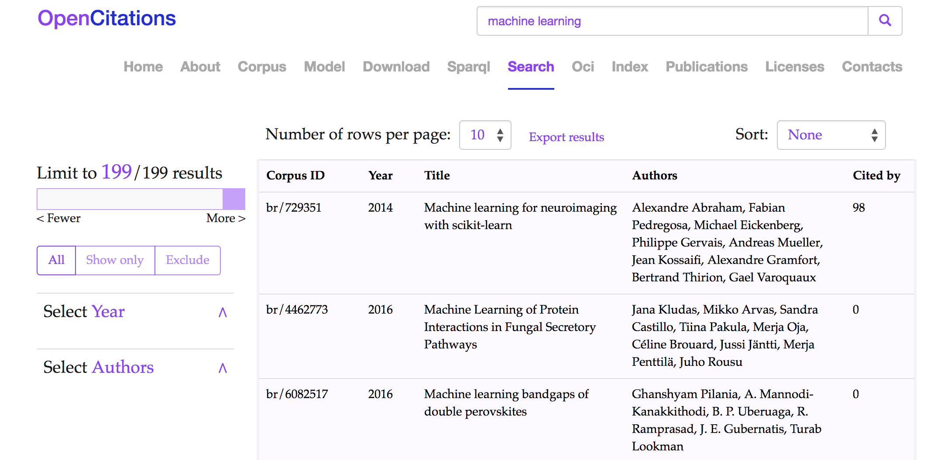Figure 2: The Results interface of the OSCAR tool in the OpenCitations website for OCC: the results shown are those obtained after the application of a free-text search using the string ‘machine learning’ (http://opencitations.net/search?text=machine+learning). Each row represents a publication, while the fields represent (from left to right): the resource identifier in the OpenCitations Corpus (Corpus ID), the year of publication (year), the title (title), the list of authors (Authors), and how many times the publication has been cited by other publications documented within the OCC (Cited by).
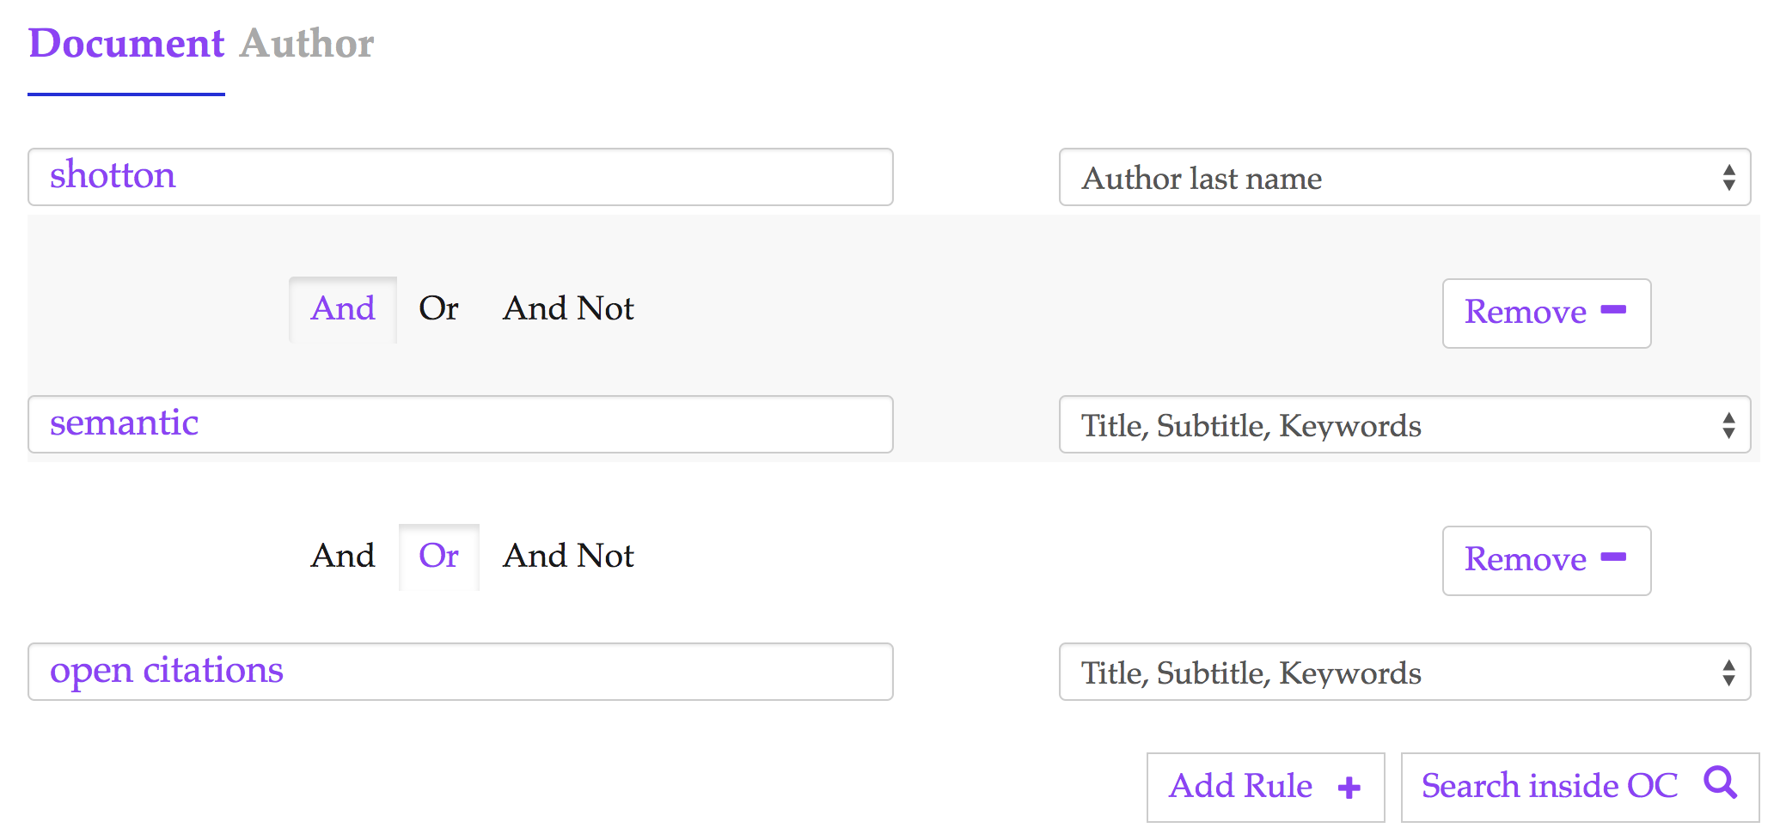Figure 3: The advanced search interface used inside the OpenCitations website for searching inside the OCC corpus. In this case we are looking for all the documents containing the key words either ‘semantic’ or ‘open citations’ in their title/subtitle, and one of the authors last name is ‘shotton’.

The COCI dataset
The OpenCitations Index of Crossref open DOI-to-DOI references, is an RDF dataset containing details of all the citations that are specified by the open references to DOI-identified works present in Crossref, as of the latest COCI update. These citations are treated as first-class data entities, with accompanying properties including the citations timespan, modelled according to the data model described in the Open Citation Indexes page. COCI was first created and released on June 2018, and currently contains almost 450 million citations link; and 46 million bibliographic resources.
In this case we have configured OSCAR to be used only through an advanced search interface, and its currently available at http://opencitations.net/index/coci/search. Users will have three possible searching parameters available to be combined: the value of the citing DOI, the value of the cited DOI, the ID of the resource (called OCI). These fields could be combined and connected in a complex query using the logical connectors: And, Or, AndNot. In Figure 4, we can see the result interface of OSCAR after searching for the value ‘10.1186/1756-8722-6-59’ as citing DOI.
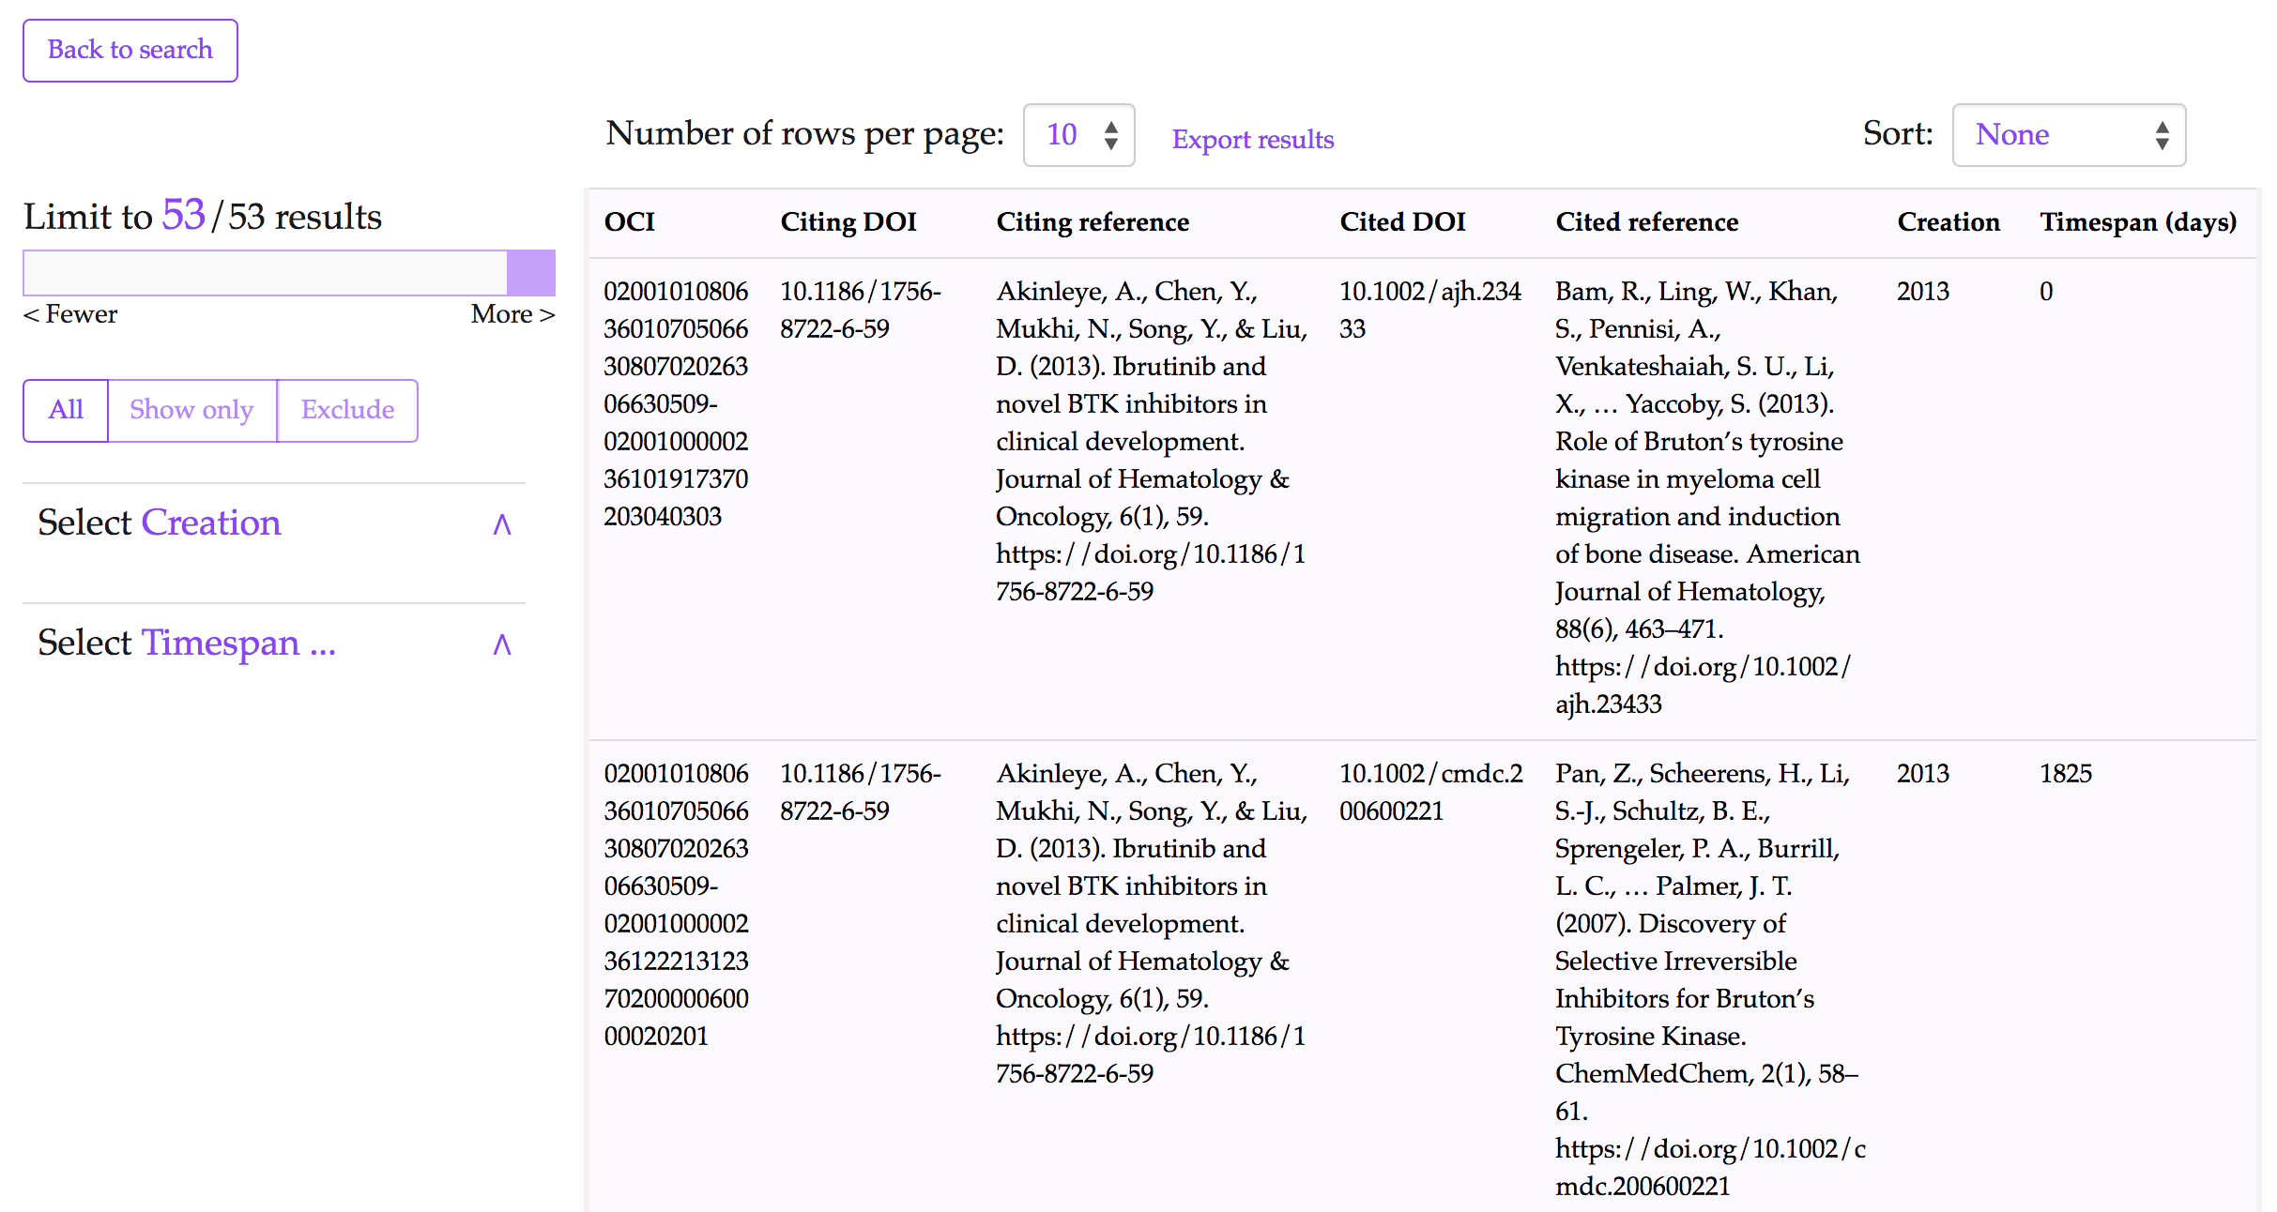Figure 4: The results interface for COCI in the OpenCitations website after using its advanced search option and executing a query to look for all the resources (citation entities) having the value ‘10.1186/1756-8722-6-59’ as citing DOI. (http://opencitations.net/index/coci/search?text=10.1186%2F1756-8722-6-59&rule=citingdoi )

Wikidata
Wikidata is a free open knowledge base which acts as a central store for the structured data of Wikimedia Foundation projects including Wikipedia, and of other sites and services. Wikidata offer a SPARQL query service and already has its own powerful Web graphical user interface for facilitating the users to construct SPARQL queries. Our OSCAR customisation to the Wikidata SPARQL endpoint is thus entirely made for demonstration purposes, rather than to provide new functionality for Wikidata users. While Wikidata contains a wide variety of information, we decided to limit our customisation of OSCAR to bibliographic entities within the scholarly domain.
We have consulted previous articles which talks about how to query the Wikidata dataset 14, and the actual data model used by Wikidata 15. We have built an entirely new interface dedicated to the Wikidata querying available at the following link https://opencitations.github.io/oscar/example/v2/wikidata.html. This demo has been also presented at the WikiCite 2018 conference in Berkeley, California 16.
The OSCAR configuration for the Wikidata case, includes both the advanced and free-text search option. Users can decide wether they want to search for articles or authors of scholarly materials. In case of scientific articles, users will have the ability to retrieve them by typing: (1) a DOI, (2) the name of the publishing journal, (3) the cited article, (4) the citing article, (5) the minimum publication year, (6) the wiki QID, or (7) a free textual input. These are all set of options which could also be combined to build a much complex query through the advanced searching option. For instance in Figure 5 the advanced query built asks to retrieve all the articles citing 10.1145/2362499.2362502, which are published in the 'Journal of Documentation'.
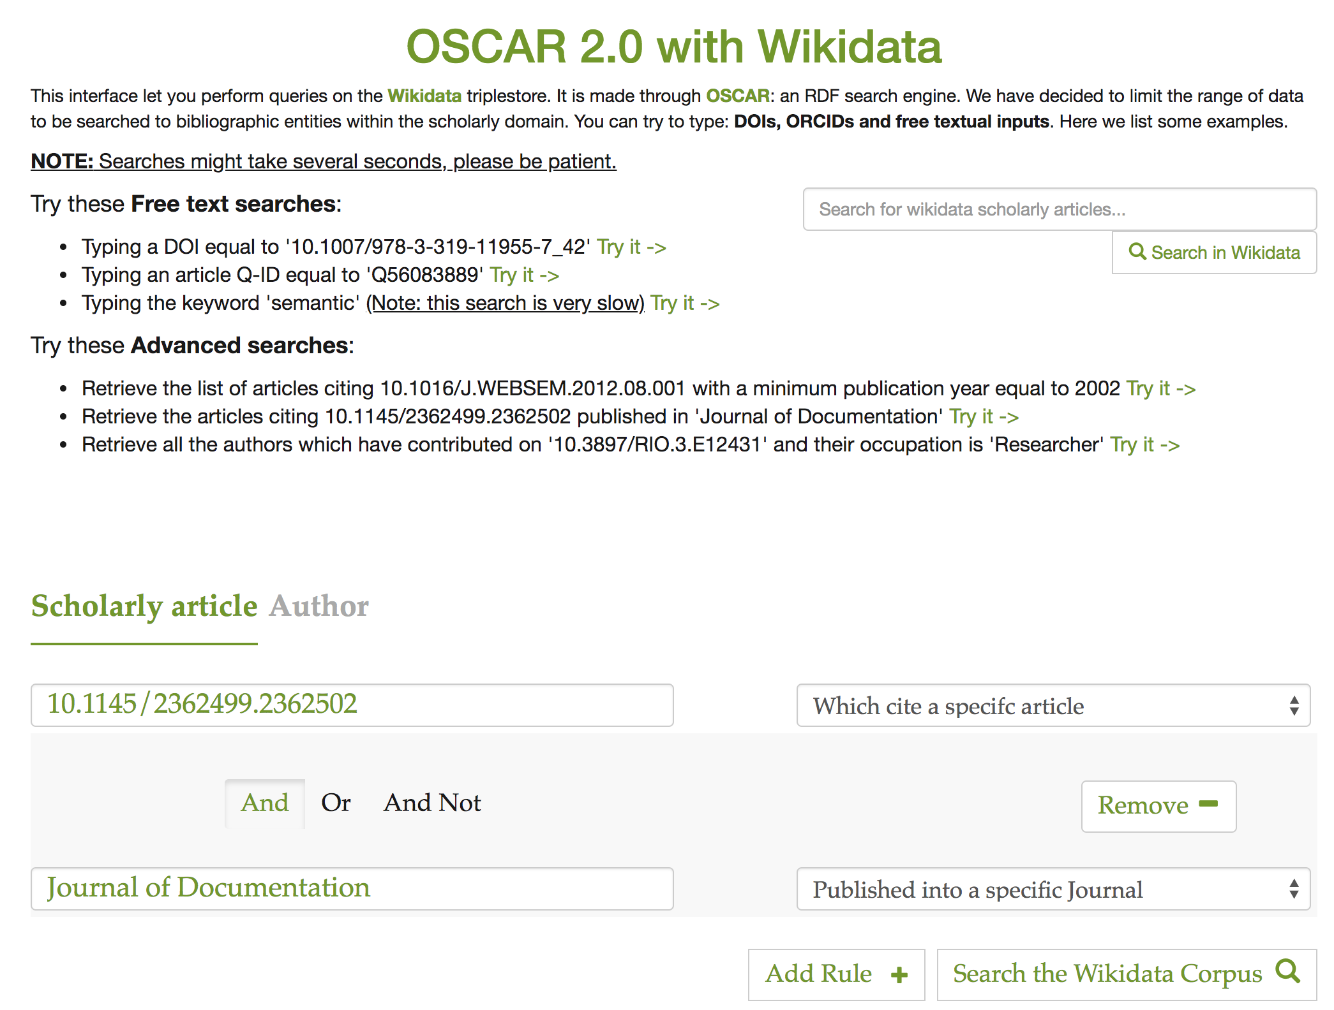Figure 5: The OSCAR interface for querying the Wikidata scholarly resources. On the top right of the page we have an input box dedicated for the free-text search, while on the bottom we have advanced search dedicated section. Here the built query asks to retrieve all the articles citing 10.1145/2362499.2362502 published in 'Journal of Documentation'.

In case the wanted results are authors, users can retrieve results by typing: (1) the ORCID, (2) a DOI of a specific work, (3) the occupation, (4) the last name, or (5) the first name. As for the articles, users can also decide to build a complex query and combine these options using the And/Or/AndNot logical connectors.
The current demo already presents a set of query examples to try. In Figure 6 we show how the interface shows the results retrieved after asking OSCAR for the list of articles citing 10.1016/J.WEBSEM.2012.08.001 with a minimum publication year equal to 2002. In this case the results retrieved are in the category of scholarly articles, in this case OSCAR has been configured to let users filter the table of results on the author and date values.
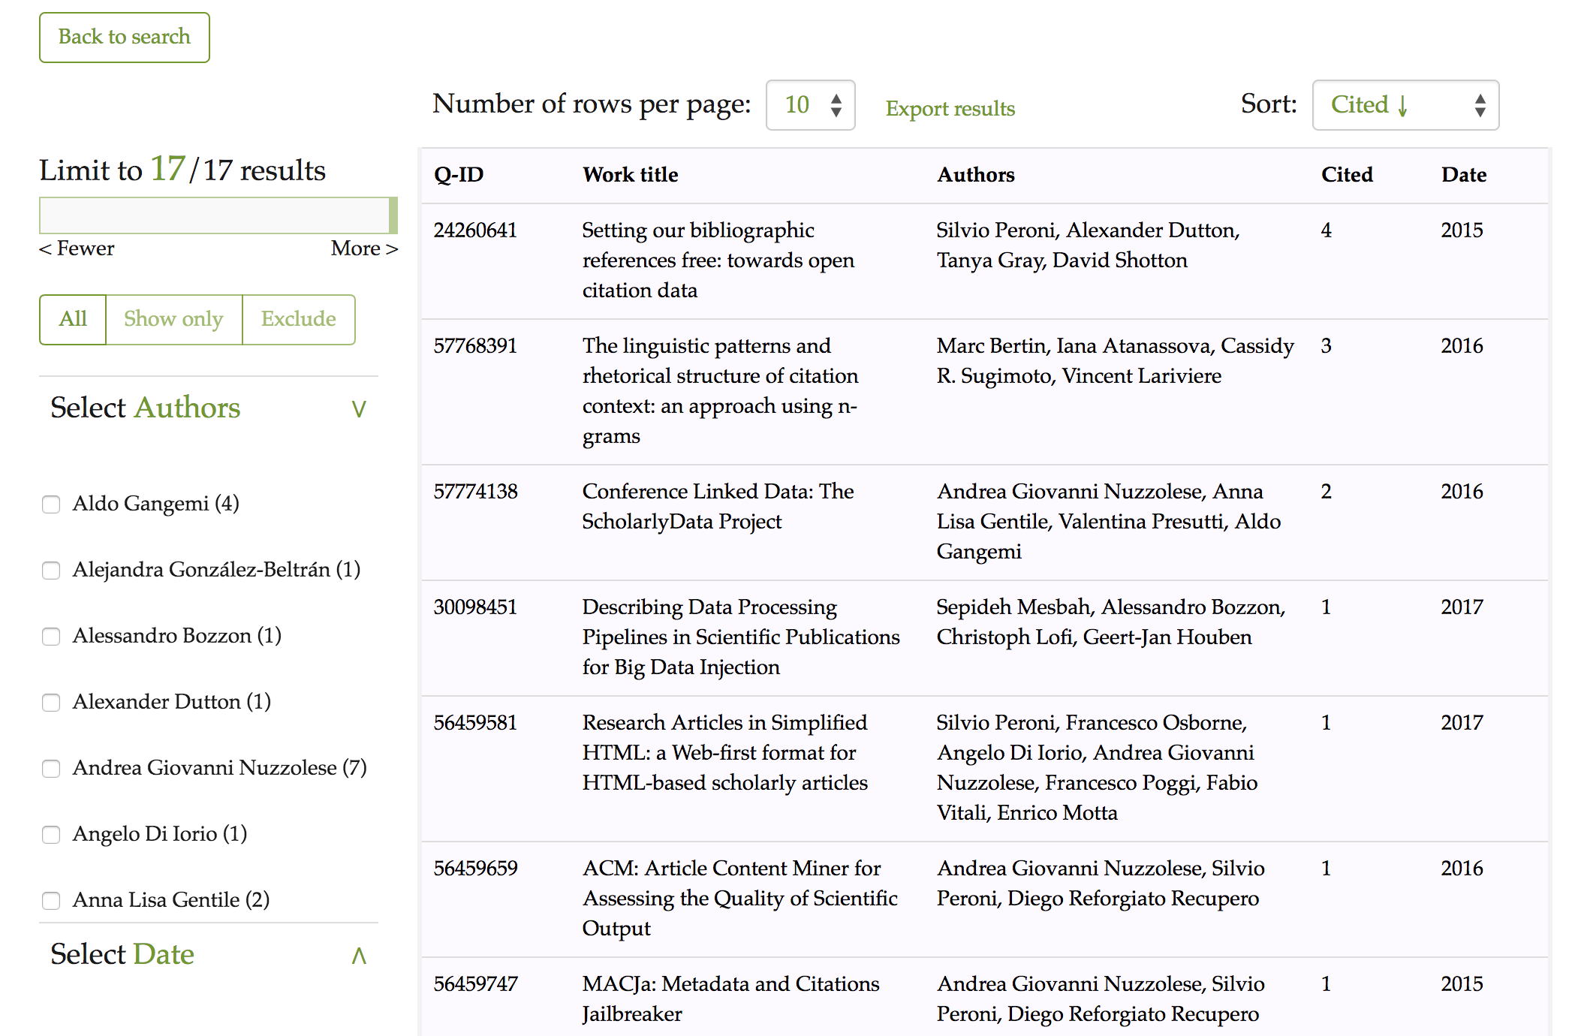Figure 6: The results interface of OSCAR for Wikidata after using its advanced search and after asking to retrieve the list of articles citing 10.1016/J.WEBSEM.2012.08.001 with a minimum publication year equal to 2002. Each row represents a publication, while the fields represent (from left to right): the resource identifier in Wikidata, the title (title), the list of authors (Authors), the number of citations (cited), and the year of publication (year).

Usage statistics from OpenCitations
We have been collecting and monitoring the usage of OSCAR inside the OpenCitations web site for both the OCC and COCI corpuses. The statistical data collection started from the first day when OSCAR has been launched and ready to use inside the web site. The stats and graphics we show in this section show the popularity that OSCAR has gained among the community, and how its used by the users. This section is divided in two parts, firstly we will elaborate on the general usage of OSCAR since its first integration inside the OpenCitations website. We will discuss separetly the OCC and COCI cases. On the second part we deepen discussing the queries typologies performed by the users.

General usage
We have collected stats regarding the general accesses made to OSCAR through the OpenCitations website on both the OCC and COCI datasets maintained by OpenCitations. In Figure 7 the graphic shows the number of queries launched for each different dataset, from February 2018 to September 2018. (the date when OSCAR has been launched and integrated inside the Open
Citations website). In addition to the total number of access made the graphic shows the number of queries that led to a further navigation to browse the resources that have been founded and listed in the results table, this redirection take effect by clicking on the shown contents of the results table. The resources are browsed using another tool called LUCINDA, which was developed to assist OSCAR and improve its potentials. The description of LUCINDA goes beyond the purpose of this work, for a further reading we suggest the repository and documentation of LUCINDA (https://github.com/opencitations/lucinda).
From Figure 7 we can notice a high pick on the usage of OSCAR for OCC on June 2018, a big reason to it is related to the integration of LUCINDA on the website, and the fact that the searched items could be browsed and visualized, as we can see a high number of access that led to a redirection on the resource browser page. In the COCI case the turn around point happened on July 2018, this phenomena is strictly connected to the OCC increasing popularity and the advertisement of OpenCitations to this dataset.
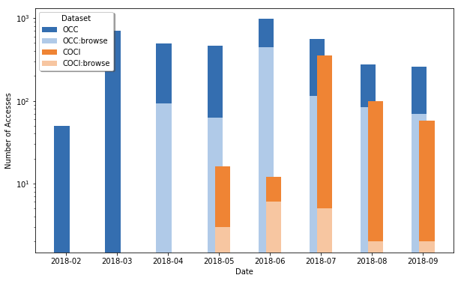Figure 7: The number of queries launched through OSCAR from the OpenCitations web site, searching for COCI or OCC resources, for each different month starting from February 2018 to September 2018. For each different dataset we show the number of queries that led to a further navigation to browse the searched resources.
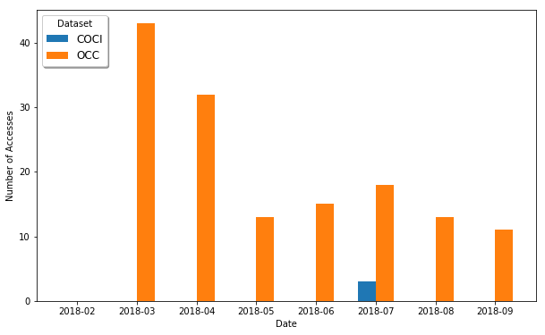Figure 8: The number of complex queries (with logical connectors) launched through OSCAR from the OpenCitations web site, searching for COCI or OCC resources, for each different month starting from February 2018 to September 2018.

In the previous sections we have discussed the new advanced search feature added to OSCAR, and the ability to build complex queries with multiple restrictions on the resources attributes and connect them through logical connectors. We wanted to monitor the usage of this specific new searching feature along the same date range. From Figure 8 we can notice that this new feature is still not so popular among the users searching the OpenCitations datasets. This stats are significant, and might suggest the need to make a further analysis on the usability of the advanced search and how we could improve it, to encourage users using it.

Queries
In this section we wanted to answer the question ‘what type of queries users do?’. We made two different analysis for the OCC and the COCI case.
In case of the OCC dataset we wanted to see which are the results category mostly searched by users. Since OCC contains both authors and documents, we build a graphic as it is in Figure 9 to show this difference for each month starting from February to September 2018. As we can see we have no corresponding values for February, this is due to the fact that the first version of OSCAR didn’t have any feature to distinguish between an author or a document query, since the input accepted was only free-text without any category attribution to it. From a general prospective we notice that users are much more interested in getting documents rather than authors. It’s worth mentioning the fact that the results retrieved for the documents case also include the corresponding authors, which could be further browsed, so users might want to search for authors indirectly by first looking at their works.
From the COCI point, we have no distinction between the category of results, since the only type of resources included in the dataset are ‘Citations’. Therefore, we made an analysis on the type of queries that users input. Inside OpenCitations there are 3 possible queries to perform in order to retrieve the COCI resources, by giving: (1) the citing DOI, (2) the cited DOI, or (3) the OCI ID of the wanted resource. As we can see from the graphic of Figure 10, the numbers start to get higher starting from the month of July (as it is also confirmed from the previous Figure 7), and we can notice that users prefer typing a citing DOI as input, and retrieve the list of all the citations made by it (the reference list). Beside this, it is normal to see a low number for the OCI input, since its more unusual to have the specific identifier of a the citation to browse.
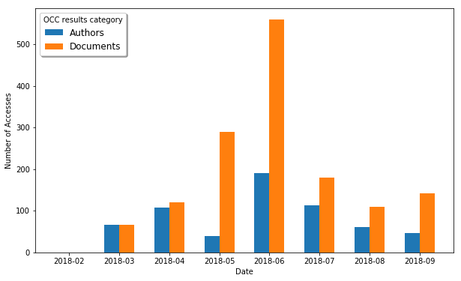Figure 9: The number of queries launched through OSCAR from the OpenCitations web site, searching for Author or Document resources inside the OCC corpus, for each different month starting from February 2018 to September 2018.
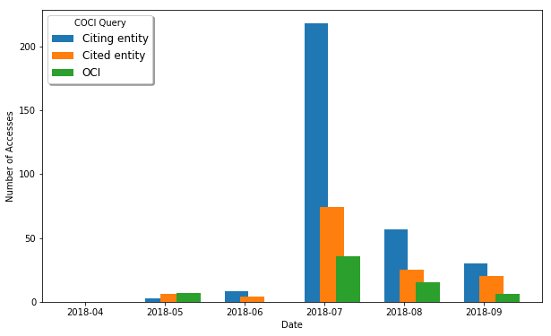Figure 10: The number of queries launched through OSCAR from the OpenCitations web site, searching for Citation resources inside the COCI dataset, by entering the Citing/Cited DOI, or the actual OCI of the resource, for each different month starting from April 2018 to September 2018.

Conclusions
In this paper we have introduced a new extended version of OSCAR, the OpenCitations RDF Search Application, after its first presentation on the SAVE-SD workshop. OSCAR is a user-friendly searching tool to use with RDF triplestores presenting a SPARQL endpoint. We have represented its main features and talked about the new extensions made to it, mainly concerning the new advanced searched searching option.
To test its adaptability to work with different SPARQL endpoints, we have defined three different configurations for three datasets: OCC and COCI both maintained by the OpenCitations project, and the Wikidata dataset for scholarly data domain. To monitor the usage of OSCAR we have retrieved some access statistics from the OpenCitations website, and we have deepen the analysis in the type of queries and results that users mostly look for.
Although just briefly mentioned in the ‘Usage statistics from OpenCitations’ section, we have developed a new related tool, named LUCINDA, to browse the resources inside a triplestore. In particular, LUCINDA will have the ability to visualize the resources attributes, and provide detailed information about bibliographic resources such as journal names, page numbers, and additional identifiers. As with OSCAR, this new browsing tool is already integrated within the OpenCitations Web site so as to provide human-readable descriptions of the OpenCitations Corpus entities, and its equally made publicly available for customization and implementation over the triplestores of other RDF data repositories. We are planning to present LUCINDA soon and to make it available for the community.
Finally, we recommend the use of OSCAR, which is a fully open source application provided by OpenCitations for general community use, to permit the definition of an interface to query over the SPARQL endpoints of other triplestores.

Acknowledgements
We gratefully acknowledge the financial support provided to us by the Alfred P. Sloan Foundation for the OpenCitations Enhancement Project (grant number G‐2017‐9800).

References
- Berners-Lee, T., Hendler, J., & Lassila, O. (2001). The semantic web. Scientific american, 284(5), 34-43.
- Vrandečić, D., & Krötzsch, M. (2014). Wikidata: a free collaborative knowledgebase. Communications of the ACM, 57(10), 78-85. DOI: https://doi.org/10.1145/2629489
- Cyganiak, R., Wood, D., Lanthaler, M. (2014). RDF 1.1 Concepts and abstract syntax. W3C Recommendation 25 February 2014. https://www.w3.org/TR/rdf11-concepts/
- Heibi I., Peroni S., Shotton D. (2018) OSCAR: A Customisable Tool for Free-Text Search over SPARQL Endpoints. In: González-Beltrán A., Osborne F., Peroni S., Vahdati S. (eds) Semantics, Analytics, Visualization. SAVE-SD 2017, SAVE-SD 2018. Lecture Notes in Computer Science, vol 10959. Springer, Cham. DOI: https://doi.org/10.1007/978-3-030-01379-0_9
- Harris, S., Seaborne, A. (2013). SPARQL 1.1 Query Language. W3C Recommendation 21 March 2013. https://www.w3.org/TR/sparql11-query/
- David Shotton (2013). Open citations. Nature, 502 (7471): 295-297. DOI: https://doi.org/10.1038/502295a
- Silvio Peroni, Alexander Dutton, Tanya Gray, David Shotton (2015). Setting our bibliographic references free: towards open citation data. Journal of Documentation, 71 (2): 253-277. DOI: http://dx.doi.org/10.1108/JD-12-2013-0166
- Peroni, S., Shotton, D., Vitali, F. (2017). One year of the OpenCitations Corpus - releasing RDF-based scholarly citation data into the public domain. In Proceedings of the 16th International Semantic Web Conference (ISWC 2017): 184-192. DOI: https://doi.org/10.1007/978-3-319-68204-4_19
- Malyshev, S., Krötzsch, M., González, L., Gonsior, J., & Bielefeldt, A. (2018, October). Getting the Most Out of Wikidata: Semantic Technology Usage in Wikipedia’s Knowledge Graph. In International Semantic Web Conference (pp. 376-394). Springer, Cham. DOI: https://doi.org/10.1007/978-3-030-00668-6_23
- Russell, A., Smart, P. R., Braines, D., & Shadbolt, N. R. (2008). Nitelight: A graphical tool for semantic query construction.
- Zviedris, M., & Barzdins, G. (2011, May). ViziQuer: a tool to explore and query SPARQL endpoints. In Extended Semantic Web Conference (pp. 441-445). Springer, Berlin, Heidelberg. DOI: https://doi.org/10.1007/978-3-642-21064-8_31
- Nielsen, F., Mietchen, D., Willighagen, E. (2017). Scholia, scientometrics and Wikidata. In Proceedings of the Satellite Events of the 14th Extended Semantic Web Conference (ESWC 2017): 237-259. DOI: https://doi.org/10.1007/978-3-319-70407-4_36
- Zaki, N., Tennakoon, C. (2017). BioCarian: search engine for exploratory searches in heterogeneous biological databases. BMC Bioinformatics 18: 435. DOI: https://doi.org/10.1186/s12859-017-1840-4
- Hernández, D., Hogan, A., Riveros, C., Rojas, C., & Zerega, E. (2016, October). Querying wikidata: Comparing sparql, relational and graph databases. In International Semantic Web Conference (pp. 88-103). Springer, Cham. DOI: https://doi.org/10.1007/978-3-319-46547-0_10
- Erxleben, F., Günther, M., Krötzsch, M., Mendez, J., & Vrandečić, D. (2014, October). Introducing Wikidata to the linked data web. In International Semantic Web Conference (pp. 50-65). Springer, Cham. DOI: https://doi.org/10.1007/978-3-319-11964-9_4
- heibi, ivan; Peroni, Silvio; Shotton, David (2018): OSCAR and LUCINDA with Wikidata (WikiCite2018 presentation). figshare. Presentation. DOI: https://doi.org/10.6084/m9.figshare.7396667.v1
- Nuzzolese, A. G., Gentile, A. L., Presutti, V., & Gangemi, A. (2016, October). Conference linked data: The scholarlydata project. In International Semantic Web Conference (pp. 150-158). Springer, Cham. DOI: https://doi.org/10.1007/978-3-319-46547-0_16

