Searching tool for SPARQL
Documentation - Version 0.2, October 30, 2015

Abstract

Introduction
The amount of data in the web keep increasing rapidly, and finding relevant resources is a daily life recurrent request. Traditional search techniques relay on a textual matching of words, these operations do not take in consideration the semantic information behind the textual content. The semantic web is an approach which tries to overcome these disadvantages by representing data on the World Wide Web as a linked database. The semantic information is stored in the form of ontology, which define the concepts and relationships used to describe and represent an area of concern. A very common form of language to store the data in semantic web is RDF (Resource Description Framework), a database like this is also called triplestore or RDF store. To query a triplestore we use an RDF query language called SPARQL, which can retrieve and manipulate data stored in RDF format.
With SPARQL we can ask an endpoint for any data that matches a specific pattern provided. To query a triplestore we need to have enough knowledge about the language syntax and how to use it. In addition to that, users need to fully understand the ontology terms and applications policies for each different triplestore case. This will limit the query execution only to expert users and those that have created the RDF store. This might turn out to be a major throwback to a lot of systems that wish to make their data easily accessible and searchable also to inexpert users.
To overcome this weakness we need to estrange the final users from understanding SPARQL and the ontologies used to define the datastore he would like to query. As for traditional search operations the only thing needed is to insert a textual input and ask the system to search. This mechanism could be emulated also for searching inside triplestore. The core idea is to let an expert define a query configuration module statically for a specific triplestore only once, and therefore let simple users have the ability to perform simple searching queries. The system uses the configuration file in order to map the users textual queries to their corresponding SPARQL query format.
In this paper we introduce a user friendly search platform applicable for any triplestore endpoint. This idea came out with regard to the OpenCitations project 3, which contains an open repository of scholarly citation data in RDF format, which we would like to make accesible through simple searching operations. The current version of the tool is integrated inside the OpenCitations web interface, and it’s fully accessible through its git repository.
The rest of this paper is organized as follows. In Related works we discuss and list some important SPARQL-based searching tools, right after that in Our tool: OSCAR we will deepen into our proposed tool and discuss its model definition and architectural form. In Evaluation we evaluate the tool, the evaluation tests two fundamental aspects: the tool reuse in different contexts and its usability. For the usability test we have involved people not involved in the OpenCitation project. Finally, in the last section we conclude the paper and sketch out some future developments.

Related works
In the past several projects worked on the generation of SPARQL queries according to the user needs. Two main different approaches have been adopted:
- Generating and applying SPARQL queries based on a free textual input. The SPARQL code used is hidden, and users will not see any of it.
- Showing and generating the SPARQL code according to several inputs (e.g: filters, values …etc), these inputs could be defined also through visual interfaces. Next users will have the possibility to execute the query built.
In this section we introduce some interesting project examples, by discussing their main characteristics.
- Scholia 1: a tool to handle scientific bibliographic information through Wikidata. Its Web service creates on-the-fly scholarly profiles for researchers, organizations, journals, publishers, individual scholarly works, and for research topics. It queries the SPARQL-based Wikidata Query Service. A search field on the front page provides a Scholia user with the ability to search for a name to retrieve all its relevant Wikidata.
- BioCarian 5: an efficient and user-friendly search engine for performing exploratory searches on biological databases. The search engine is an interface for SPARQL queries over RDF databases. The search engine provides a graphical interface based on facets. It allows complex queries to be constructed, and have additional features like ranking of facet values based on several criteria, therefore these features represent the possible filters that could be applied. The tool offers average users (without knowledge of SPARQL language) a free text search and the ability to navigate the results through these facets.
- DisGeNET 6: allows easy browsing and downloading of the information related to human diseases and their genes. The information contained in DisGeNET has been formally represented as RDF and linked to the Linking Open Data Cloud. It allows free text search of genes and diseases and rank results according to given criteria (e.g: number of publications or the data source). Data could also be accessed from a SPARQL endpoint or a Faceted browser.
- NeXtProt 7: is a knowledge platform that represents the current state of knowledge on human proteins. The website offers two different search variants: simple and advanced. The advanced search is a SPARQL editor, while the simple search is a free text input box which can accept any textual content combined with an additional attribute that should specify the type of the search (e.g: proteins, terms, publications).
- Visual SPARQL Builder (VSB) 2: is a tool which allows users to create and run SPARQL queries with a graphical interface within the browser. A user can easily create visual queries for any semantic database with an SPARQL endpoint. Complex queries with several filters are also handled. The visual queries will be translated to SPARQL code and executed and the results will be shown in structured tables.

Our tool: OSCAR
OSCAR (Open Citations Rdf Search Application) is a stand-alone java script tool which could be embedded in any system as a searching engine for Resource Description Framework (RDF) databases also known as RDF stores or triplestores. In order to permit the correct embedding of the tool some configuration parameters should be set in respect of the system that wish to embody it, for instance its triplestore URL. OSCAR sources and documentation are available on GitHub.
The need of such tool has raised in connection with the OpenCitations project, which provides an open repository of data in RDF format for citation information (bibliographic references) harvested from the scholarly literature. The tool needed to respect a series of essential principles, that we have been aware of while developing it:
- Enable a free text search, along with an oriented searching option if needed.
- Enabling some filtering operations on the values and attributes of the results obtained. These operations should be applied dynamically and handled without any further querying on the triplestore.
- The interface, functionalities, and queries must be customizable according to the user needs.
- Although the tool was meant for OpenCitations and integrated in its website, it must be easily used by any other system which works with RDF stores, and therefore also easily integrated as a new module on its website.
In the following subsections we talk about the general architecture of the system, next we will move on to discuss the configurations and usage of OSCAR.

Architecture
In order to make our tool be a component which could be integrated inside any website as a supplemental module regarding its backend and server implementation, all its files and modules are executed at the client side and none of its features are handled by backend scripts. OSCAR is basically defined by three files:
- The main core of the tool which will handle all its behavior and define its model.
- A configuration file to define the parameters of the tool.
- A module to handle the stylistic aspect of the interface.
These files will operate in two macro areas: the layout/interface and in the model definition. Lets deepen our discussion by analyzing these areas, and show how the several modules will cooperate with each other.

Layout and interface
The skeleton layout of our tool is composed by three main sections: results, header, filters. These sections will enclose additional sub containers which wil be dynamically populated with the tool components:
- Results: contains a table populated with the results obtained from the query execution.
- Header section: it mainly contains components that alter the table of results from a visual perspective, for instance two operations are handled in this section: the possibility to decide the maximum number of rows to visualize per page, sort the results according to a specific column/field and with a descendent or ascendent order.
- Filters section: contains components that can refine/filter the results obtained, for instance: alter the total number of results in the table, filter the result-set by keeping or exluding some specific values.
The above sections (and inner components) structure could be altered, the hosting system decides the set of components is willing to integrate in its webpage. A system developer can decide which components to include/exclude inside its webpage interface by keeping or dropping out the related block from a structured HTML scheme.
All the sections and inner components could be redefined from a stylistic point of view. A system developer will have a full control over the decisions to take regard the visual aspect and positions of the elements in the interface, therefore he can eventually change their default layout. These configurations are all adaptable from a CSS file which defines a list of classes for all the components that will be dynamically created inside the page (the third file of the tool previously listed).

The Model
The core of our tool resides in a one javascript file which contains three submodules each one with its own closure:
- search: the behavior and logics of the tool are handled/defined in this sub-module and its internal functions
- util: this sub-module contains all the general utility functions needed by the other submodules
- htmldom: contains functions that will dynamically generate the html components to add on the webpage
The entire process will start with one call handled by the search sub-model: do_sparql_query. The only parameter needed by the system to build the interface is a textual input. This call will elaborate the input and produce results according to the parameters previously set inside the configuration file. Later we will discuss all the possible configurations which could be set and what effects they have on the processing phases.
Lets list the processing stages of the model that will take place right after the first call:
- Finding the corresponding rule: iterate through a list of rules and identify the one which defines a specific regular expression format that matches the textual input given.
- Apply the query: call the triplestore and apply the corresponding SPARQL query defined for that specific rule and save the results locally inside the tool module. The given textual input is added inside the query structure by replacing all the ‘[[VAR]]’ tags with it.
- Process the results: once all the results are retrieved, three additional important operations need to be done:
  - Linking: to associate a link to the values of a specific column in the results retrieved. The corresponding links values belong to another column of the result-set, we just need to specify it to the linker.
  - Grouping: the process of grouping the data works like a traditional group-by statement, we use it to group the result-set and concatanate the values of a fields sub-set. We need to specify the keys that stand as distinct identifiers and group the result-set rows according to that.
  - Selecting: once the two previous operations are accomplished, only a subset of the results are selected while the rest of the columns are discarded, for instance in this phase we can exclude the columns used to associate the links in the linking process.
- Init tool data: the data in the system will be represented and stored in three different forms:
  - Native: this data contain the complete original result-set after stage 3 is done, thanks to this no further calls to the triplestore are made, unless we change the initial textual query.
  - Filtered data: a subset of the native data after the application of filtering operations on them, for instance after excluding some fields values.
  - Visualized data: a subset of the filtered data after the application of visual operations, for instance after ordering the rows according to a specific column/field.
Note that in the initialization stage all the three data types are equivalent, since no filtering or visual alterations have taken place. Once one of these data formats changes it will have a recursive modification effect on the data that depends on it.
- Build the interface: the layout components previously defined in Layout and interface, are built at this stage. Since part of the components created relay on the data we have initialized, this operation must be executed right after stage 4, for instance a table will be populated with the data visualized (entirely or in part depending on the visual operation applied). All the operations at this stage are handled by the “htmldom” sub-module. The final components generated are HTML elements that will take place inside their corresponding containers.
- Apply default operations: at this stage we will apply the default filtering and visual operations on the data, as a result the filtered and visualized data will be altered respectively. Along with the data also the interface will be adapted graphically to the default operations settings.
All the previous stages enumerated are made once at the initialization of the tool, next we can classify the possible dynamic operations a user can do as filter, visual or extra. The Illustration 1 shows an activity diagram which describes these processing phases, and their connection with the list of operations. lets discuss separately each category and list the specific operations that could be done.

Filtration
Any operation under this category modifies only the filtered data, all the filter activators will appear under the filter section already defined in Layout and interface. These operations are handled by the core module “search” previously defined:
- Show all results: resets the filtered data, so it will contain all the original result-set (native data).
- Modify the number of total results: this operation will limit the set of results retrieved to a given value. This operation will select the first N values out of all the native data set. Note that for the OpenCitations case, the native data were already ordered according to their relevance to the query, therefore this operation will select the N first most relevant rows.
- Filter by column values: this operation let us exclude or show only some specific values from the table. We consider it as a macro operation which needs the execution of three sub-operations sequentially, following this specific order:
  - Show field values: shows a list of all distinct values belonging to specific column/field. For each value we calculate the number of occurrences inside the current filtered data. These values are all selectable, and since the list could be very large, for usability reasons a paging option is available.
  - Select a value: this operation is called once a value of a specific column/field is selected. A list in the system will keep track of all the values that have been selected.
  - Exclude or Show only: this is the final operation a user can do once the previous two have been done. This will rebuild the filtered data by excluding or keeping only the selected values in it. Note that this operation is not enabled if the list of selected values is empty. In case multiple items are selected this operation retrieves results that matches all the values checked (“and” operator).

Visualization
The operations under this category modify the visualized data and the final table, the activators of these category are present in several sections of the layout, mostly in the header (See Layout and interface). Same as for the filtration operations, also in this case all operations are handled by the core model:
- Page navigator: it contains all the sub-operations that handle the paging behavior: moving on the next or previous page, selecting and directly moving to a specific page index.
- Rows per page: limits the number of maximum rows to visualize per page to a given value.
- Sort the result-set: sorts the visualized data with respect to a specific column/field and following a descendent or ascendent order.

Extra
Currently the tool provide the possibility to export and download the table results in a CSV format. Note that in this case the CSV file is populated with the exact values of the visualized dataset, following all the filtering and visual operations applied.
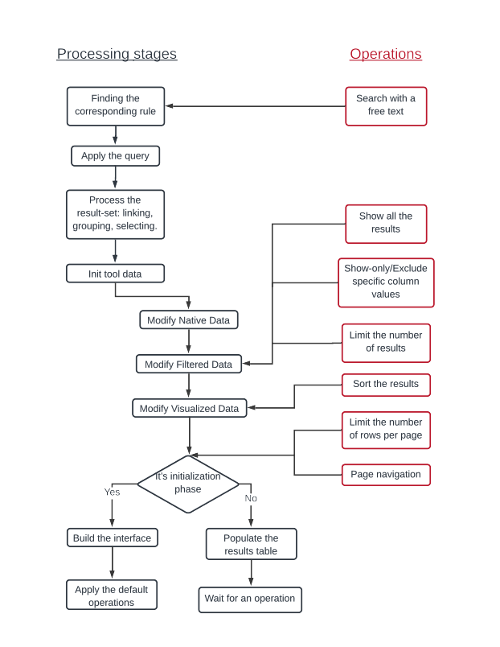Illustration 1: An activity diagram to show the model processing phases and their connection with the list of operations a user can perform

Configuration and usage
In order to customize the tool according to the hosting system needs, the configuration file should be modified. The attributes assignment inside it will specify how the processing phases previously listed in The Model are executed:
- SPARQL endpoint: the tool will connect to this URL and execute the SPARQL query on this specific SPARQL endpoint
- Prefixes: the first part of SPARQL queries is represented by a list of one or more prefixes, they are used to save rewriting the namespace each time needed inside the query, and make the query easier to read. The configuration file gives the possibility to list all the prefixes that will further be used in the queries.
- Rules: the first phase of the model initialization (see The Model) iterates through this list to find the corresponding rule. The model concept is based on the fact that the textual input should belong to a specific rule which will handle it. The system need to find this specific rule from a list and apply its policies. Each rule entry have several internal attributes which defines it:
  - Name: an identifier name for the rule.
  - Category: each rule will retrieve a result-set belonging to a specific category. This will enable the system to view the information needed according to the category the selected rule belongs to.
  - Regex rule: this is the value used in order to detect the correct rule. A rule entry belongs to a specific query if the searching textual input matches the regular expression defined by this parameter.
  - The query: each different rule defines its corresponding SPARQL query to execute.
- Categories: each one of the rule entries previously defined should specify a category, this category determines which results are selected from the query and what are the polices that should be applied on them. The phases in stage 3 of the model initialization (see The Model) should access the attributes defined here in order to be accomplished. Each category entry is defined by the following attributes:
  - Name: the category identifier. This value is mentioned in the rule-entries which aim is to generate results belonging to this specific category.
  - A set of fields: specify the set of fields to select from the SPARQL results. The subset of fields should appear in the original SPARQL query selection. Each field entry have several possible attributes:
    - Value: the field name, this should exactly matche the variable name inside the SPARQL query.
    - Title: the header value that will appear at the top of the final table.
    - Width: specifies the table column width. Note that the sum of all fields column widths should be 100%.
    - Data type: the data type of the field values.
    - Sorting option: in case we want the tool to enable users sort the table according to this field (for both descendent and ascendent order).
    - Filtering option: in case we want the tool to enable filtering operations on this field values.
    - Linking option: here we can associate a link to all the field values, by specifying another field which contains the link values.
    - Group by option: in case we want to group by the result-set obtained from the SPARQL query, we should define this option with the keys and the field names we want to group together.

Evaluation
The tool evaluation is made on two fronts: its reuse/adaptability to other systems, and its usability. To test the adaptability of the tool in other contexts we need to try embed it inside other systems that use triplestore databases. Our second aim is to test the usability of the tool, so we need to take in consideration its effectiveness, efficiency and the users satisfaction. In this section we will treat separately both these aspects and show the final results obtained.

Tool reuse
One fundamental characteristic of our tool is its ability to adapt to the hosting system and its applicability to other triplestores. To test this we have taken in consideration three different examples:
- OpenCitations 3: our anchor project, OpenCitations stores an open triplestore data containing scholarly citation data. Our tool in this case query the triplestore for two basic entities: documents and authors. We have included the tool interface in the OC website, users now have the possibility to query the scholarly citation data with basic free text searches. Three different type of searches are supported: DOIs, ORCIDs and a free textual input which can refer to document titles (and subtitle) along with authors family name. In Illustration 2 we show a screenshot of our tool in OC after the application of a free text search “machine learning”.
- ScholarlyData 4: is a project that works on providing a refactored and cleaned SWDF dataset, SWDF (Semantic Web Dog Food) is an RDF store of the Semantic Web community about papers, people, organisations, and events related to its academic conferences. The current version of the project have its SPARQL endpoint but without any searching interface integrated in the website. We have adapted the configurations of our tool to ScholarlyData needs and defined new query rules the system should follow: <XX>. As for OpenCitations the integration of a tool like this helped simple users interact with dataset maintained by the project.
- Wikidata 11: a free open knowledge base which acts as a central storage for the structured of Wikimedia projects (e.g: Wikipedia) and other sites and services. Wikidata offer a SPARQL query service and its endpoint for users who want to perform SPARQL queries on its database. Currently Wikidata offers also a powerful web GUI and a SPARQL editor for expert users who want to extract information from the stored triplestore. Wikidata is a perfect example to use into our tool, since it offers the possibility to perform GET operations on its SPARQL endpoint. There is a high variety of information we can retrieve, we decided to take in consideration queries that aim scholarly data. The configuration file was redefined according to this. We added rules which detects DOIs, ORCIDs and free textual inputs, and classify the information returned into two categories: documents and authors. These rules definition are close to what we have done in OpenCitations, so the results are interesting also from a comparison point of view.
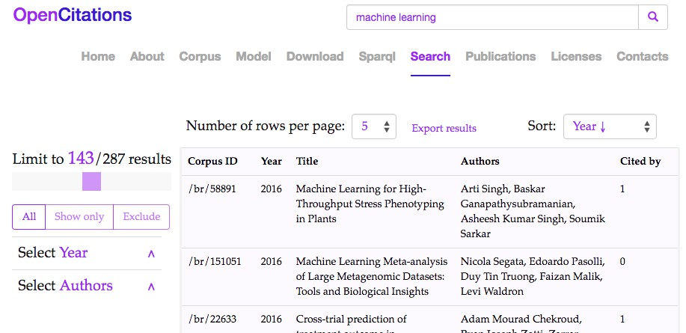Illustration 2: The tool in OpenCitations website: results after the application of a free text search

Empirical evaluation
To measure the perceived usability of our tool, we have approached <XX> different subjects and involved them in a user testing session. The test adopted is a Discount Usability Test (DUT): a low cost test with few participants. Past studies 8 9 have demonstrated that even when involving only 5 people a test can find up to 80% of the main system problems. We will first discuss the settings of our tests and then move on to show the outcomes.

Settings
We asked <XX> different subjects to perform <XX> unsupervised tasks. We have given a small explanation about the test and presented the scenario, then just left the testers execute their tasks individually, without observing them while performing the tasks. Finally when the test was done, we asked the participants to fill two questionaries and answer some questions according to their experience. The first questionary is a SUS (System Usability Scale) 10, while the second one captures a textual report about the user experience while using OSCAR to accomlish the tasks.

Outcomes
The usability score for our tool was computed using SUS, a questionnaire used to measure the perception of the usability of a system. SUS is technology independent and has been tested on a large variety of systems (e.g: software, websites, cell-phones …etc), it has become an industry standard and it is highly referenced in a lot of publications.
<XX Talk about SUS scores>

Conclusions
In this paper we introduced OSCAR a user friendly searching tool for RDF stores. The need to develop such tool raised while working on the OpenCitations project which contains an open repository of scholarly citation data in RDF format, and requires a searching platform to integrate on its website to query its dataset. The main characteristic of the tool are: its applicability and easily integration for any other system that works on triplestores and want to query it, enable any user with little information on SPARQL and the system ontologies perform queries, allow dynamic filtering operations on the results obtained after executing the queries on the triplestore. We have tested OSCAR on two different aspects: its reuse on other system contexts and its perceived usability. In the first part of the evaluation we integrated the system in three different systems, while in the second part we have involved <XX> participants and measured the tool usability with a SUS type of test.
We are currently working on an advanced search interface to include in our tool. This will enable users to perform complex combinations of rules with logical connections (e.g: OR, AND). Along with this, we are also developing a new tool that will work beside the current one. The main purpose of the new tool is creating a visual interface for browsing the resources inside the triplestore. It will have the ability to visualize the resources attributes, detailed information, and additional computed metrics. Same as for OSCAR, the new tool will be ready to be integrated in other system that wish to browse its triplestore resources.

Acknowledgements
We gratefully thank the financial support provided to us from the Alfred P.Sloan Foundation.

References
- Nielsen, Finn & Mietchen, Daniel & Willighagen, Egon. (2017). Scholia and scientometrics with Wikidata.
- Visual SPARQL Builder, https://leipert.github.io/vsb/
- Silvio Peroni, Alexander Dutton, Tanya Gray, David Shotton (2015). Setting our bibliographic references free: towards open citation data. Journal of Documentation, 71 (2): 253-277.
- Nuzzolese A.G., Gentile A.L., Presutti V., Gangemi A. (2016) Conference Linked Data: The ScholarlyData Project. In: Groth P. et al. (eds) The Semantic Web – ISWC 2016. ISWC 2016. Lecture Notes in Computer Science, vol 9982. Springer, Cham
- Zaki, Nazar, and Chandana Tennakoon. "BioCarian: search engine for exploratory searches in heterogeneous biological databases." BMC bioinformatics 18.1 (2017): 435.
- Piñero, Janet, et al. "DisGeNET: a discovery platform for the dynamical exploration of human diseases and their genes." Database 2015 (2015).
- Lane, Lydie, et al. "neXtProt: a knowledge platform for human proteins." Nucleic acids research 40.D1 (2011): D76-D83.
- Nielsen J. Why You Only Need to Test with 5 Users (2000) https://www.nngroup.com/articles/why-you-only-need-to-test-with-5-users/
- Nielsen, J. (2009). Discount Usability: 20 Years. https://www.nngroup.com/articles/discount-usability-20-years/
- Sauro, Jeff. A practical guide to the system usability scale: Background, benchmarks & best practices. Measuring Usability LLC, 2011.
- Wikidata, https://www.wikidata.org

