The SCI Framework

Abstract

Introduction
The Semantic Web intent is to try representing the knowledge on the World Wide Web in a way that can be interpreted by machines. In particular, these data are stored using a data model called RDF 9 which enables the expression of information in form of subject-predicate-object statements. An RDF database is also called triplestore, and it could be queried by using SPARQL 10, the query language for RDF data. SPARQL is a very powerful query language, that can be used to look for data that follow specific patterns.
Many projects and institutions such as for example the British Library 11, Wikidata 12 and Dbpedia 13, make available their RDF datasets to the public by providing a particular web interface to a SPARQL endpoint which queries their triplestores.
Beside a SPARQL editor interface, recently additional services/applications have been developed which use SPARQL as their core model, For instance, Scholia 14, Sparklis 15.Usually, these services try to hide the complexity of the SPARQL language to the final user, and provide a more simplistic and comprehensive interface to interact with. This approach is very beneficial, since it opens up the ability to query triplestores also for non expert users. This will benefit both the triplestore providers, and the final users.
The OpenCitations project is dedicated to open scholarship and the publication of open bibliographic and citation data by the use of Semantic Web (Linked Data) technologies, and engaged in advocacy for semantic publishing and open citations. One of our goals is to continuously provide new services for users that want to explore the OpenCitations datasets.
Taking in consideration this necessity, we have worked on providing a general framework for building SPARQL based applications. The framework we propose is the SCI-Framework (SPARQL endpoint, Configuration, Interface) which is a general architectural model that could be used for any triplestore providing a SPARQL endpoint address. We have successfully used it in the implementation of three new services already integrated inside the OpenCitations web site: (1) OSCAR: an RDF search engine, (2) LUCINDA: a resource browser, (3) RAMOSE: a REST API service.
In this paper, we present the SCI-framework and its logistic architectural scheme, explaining the intent of each of its parts. As a concrete example we show the implementation we used inside OpenCitations by introducing three different services: OSCAR, LUCINDA, and RAMOSE, and their integration with two different corpuses currently maintained in OpenCitations: OCC and COCI. Finally, we evaluates the efficiency and the impact of our applications into the community through a statistical monitoring of the accesses made to these services and how users are using them.

Related works
Several applications are still adopting the popular Model-View-Controller (MVC) as an
architectural pattern. Specially for web applications this approach is still very common 4. The framework we propose resume the MVC model basics. The ‘Model’ in our case is
represented by the SPARQL endpoint which holds the actual data. The ‘View’ is the
interface used by the final user to interact with the service functionalities and launch his requests. The ‘Controller’ is the bridge between these two layers, and in the architecture we present this part is handled by the ‘Configuration’ layer.
The ‘Configuration’ layer holds other micro components which work as controllers on the visual and logistic behaviour of the application. The communication with the SPARQL endpoint is handled by one of its sub-component, which acts as a parser, since it will translate the final user requests into understandable queries to execute on the SPARQL endpoint. The SPARQL statements should therefore be dynamically modelled and populated with the inputs given by the user interface. The output of the ‘Configuration’ layer will be represented in a comprehensive format to the interface, for instance, HTML in case it’s a web page.
The translation mechanism just described has also been adopted in other previous tools.
In 5 the same approach has worked for the conversion of RDF statements into recursively producing HTML blocks to integrate inside a web page. In this case a new and simple transformation language for RDF data have been developed, RSLT. This language has been tested through the implementation of a prototype based on AngularJs.
Another developed language based on the same idea is XSPARQL 7, it combines XQuery and SPARQL, which allows to query XML and RDF data using the same framework and to transform the data from one format into the other.
Another interesting project has developed STTL 8, which is a generic RDF transformation rule language, independent from the output language. It is a syntactic extension to SPARQL that aims on facilitating the writing of transformation rules and an implementation of a generic transformation rule engine. The feasibility of this approach is shown with several RDF transformers defined for various output languages.
Although it’s much rare to find the above mentioned applications for the semantic web technologies, in case of traditional SQL-based applications these type of services are much more common. One particular interesting topic is to translate natural language queries into a sequence of SQL queries to execute on databases, and there are several methods to apply this principle 17. This natural search capability has become more common over the past year and many companies worked on it, some notable examples are the search platform of ThoughtSpot 20 and Tableau 21.
In these previous examples, users can write down a query sentence and the application will translate it into executable SQL statements. Moving into the speech, other interesting works have analysed and proposed methods which aims on its translation into SQL executable queries is 18 19.
Looking on a general framework to implement such services, FORWARD 16 is a very good example. FORWARD is a rapid web application development framework. The web application’s pages are defined and customized using a page configurations, in addition also the logics and the running applications are all defined inside a configuration module. The architectural scheme of FORWARD is based on the common MVC model.
On the other hand, moving back on RDF dataset, a close architectural model for the development of RDF dataset query based web application, has been proposed in 6. In this case, the framework supports SPARQL-DL query language, and its object is to shield the complexity of ontology from the simple users that wish to develop applications in this field. As for the framework we propose, it’s fully customizable for different fields of study (e.g: education, meteorology and geographic) as long as they provide a querying endpoint address.

The SCI Framework
The framework we propose is composed by three different layers, as we can see in Illustration 1.
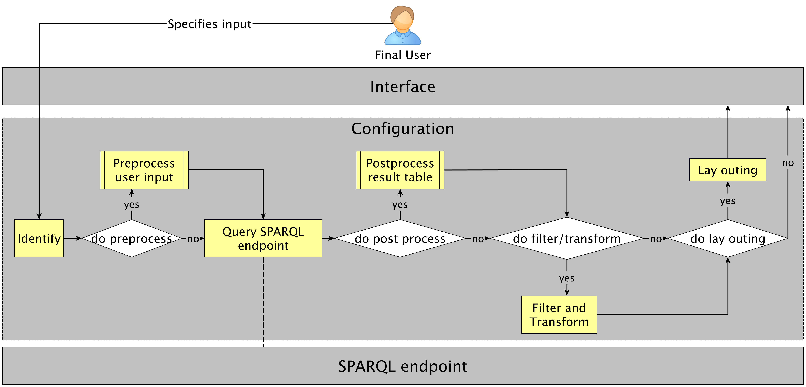Illustration 1: The SCI framework skeleton represented in three macro layers: The SPARQL endpoint, the configuration, and the final user interface. The configuration layer is the core of the framework with two required sub-operations: “identify”, and “Query SPARQL endpoint”. Along with other optional operations: “Preprocess user input”, “Postprocess result table”, “Filter and transform”, and “Lay outing”.
The first layer (starting from the bottom of the scheme) is the SPARQL endpoint. The definition of this layer is made by an expert in semantic web technologies and data management. This level represents the actual database of the built applications. This level needs to prove a link to a particular triplestore. The upper level services will use such link to query and retrieve the triplestore data.
Next we have the “Configuration” layer, it’s the core and principle controller of our SCI framework. The definition and creation of this second layer, is still a task that only a particular expert in querying semantic web data can do. A SPARQL programmer at this stage will be asked to write the queries according to the information he would like to retrieve and present to the final user. Several types of services/applications could be created at this layer, these services will all call the same SPARQL endpoint link of the first level. Each service can define different procedures and analysis to do on the triplestore data following a particular workflow.
This “Configuration” layer represent the bridge between the data (SPARQL endpoint on the first level) and the interface used by the final user. The configuration parameters of all the services to integrate, are made only at this point, all the other upper components are generated automatically as a consequence according to the values given at this stage. The applications we define represent the combination of an interface component along with its model and logistic behaviour. The person who wants to configure them, can alter these aspects only by modifying the configuration parameters. Therefore, the core idea is to let the expert define the services behaviour through the modification of a one particular configuration file. This is the most direct and easy way to customize each different application, and it will abstract the expert from the implementation parts.
The chosen configurations could be applied on different stages of the workflow, we will divide them in 6 micro operations, as shown in Illustration 1. The “Identify” and “Querying the SPARQL endpoint” are two essential operations, while the rest are optional, and will be integrated only for the services which need them. Let’s analyse each sub-component and look at the aspects controlled by each one of them:
- Identify: here are defined the first steps to accomplish once an initial input is given and the service has been triggered. Identifying the intent of the user is the first and main thing to do. Typically this operation is made through matching the textual input with some regular expression rules. For each different case the service will associate a corresponding workflow.
- Preprocess user input: some applications might need to re-elaborate and format differently the initial textual input given by the user. At this stage we can define methods which work on this aspect, and return a new modified output. The definition of these methods are integrated as an external parts, and have no connection with the inner code of the applications. For instance, searching for a text which includes a person name, could be re-elaborated and the first letter of it capitalized.
- Query SPARQL endpoint: this part defines the actual data retrieval process from the dataset. Technically, It’s all made through a SPARQL query. SPARQL permits the definition of complex queries, therefore the operations defined at this point are vast and an expert have a large variety of options. This is an essential operation to accomplish for each defined service, and it’s the only stage of the elaboration where an actual connection with the SPARQL endpoint at the lower level happens.
- Post process result table: once the SPARQL operations are executed and we have a set of results, we might look forward to integrate new data inside the current results set. To make this happen we can define new methods which do that and integrate their results inside the final table. For instance, a possible method can call an external REST API service and integrate the returned data in the table of results.
- Filter and transform: the current table of results could still be modified for a final version. In this case at this point additional re-elaborations on the table contents can happen. Values could be filtered or transformed into a new form, following the options that the service guarantee. For instance, we can decide to map some values of a specific column/field of the table, to a lower case form, or remove all the rows that don’t respect a specific upper bound limit.
- Lay outing: some of the services created could (or need to) build a graphical layout to the final user. The configuration of such aspects should also be possibile, this part will permit a customization of the application GUI. Like the previous operations also in this case we will have specific parameters which will control these aspects.
Along with the technical and logical aspects of the applications defined at this level, also a graphical restyling if needed and made available by some applications, can take place. In this case, the suitable person needed, is a web technology expert, who knows some CSS programming language. This part anyway, and in many cases, is not a necessary component, since the application can already provide a predefined default aspect without making available further modification, or does not integrate any visual interface to the final user. Its important to note that the framework is meant to be simple and controllable only through the configuration parameters given, therefore, these additional aspects are automatically built as default. Anyway, further stylistic re-adaptions are not forbidden.
Finally, we have the “Interface” layer. At this level, following all the workflow parameters applied at the lower “Configuration” layer, this part will be automatically generated. The components built at this stage are those that will be shown to the final user, thus this is the portal, users will interact with in order to use the applications defined. The applications need to expose there functionalities, in a simple and easy way which will not need a further knowledge and special capacities in semantic web technologies. This level does not necessarily have a graphical layout.
In Illustration 2 we show a possible adaption of the framework just described, with the definition of three different services at the configuration layer. In this case we have defined a ‘search’, ‘browse’, and REST API application. In this example both the ‘search’ and the ‘browse’ applications implement a graphical layout, so in this case both need an additional micro operation in the configuration level which will customize it, the “lay outing”.
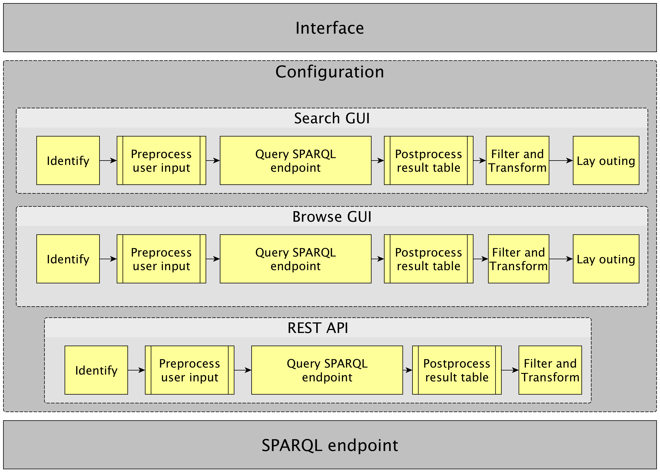Illustration 2: A SCI Framework implementation example with three different services in the configuration layer: search GUI, browse GUI, and a REST API. Each one will use only the required/needed sub-components from the configuration layer. For instance, the “REST API” application does not integrate a “Lay Outing” phase.

Implementation
We have built three different services which respectively implement the configuration shown in Illustration 2: OSCAR, LUCINDA, and RAMOSE. Each one have a different scope, usage and initial input, all these services will use/query the same SPARQL endpoint defined on the lower layer. This section will analyse separately each service and talk about its workflow and the configuration parameters needed to correctly define it and customize each of its stages.

OSCAR
OSCAR is a user-friendly search platform that can be used with any RDF triplestore providing a SPARQL endpoint, and which is entirely built without the integration of external application components 1. It provides a configurable mechanism that allows one to query a triplestore by means of a user-input free-text string, along with an advanced multi-field combination connected with logical expressions. On the OSCAR background one or more SPARQL queries are executed according to the upper level user requests.
The configuration module of OSCAR defines all its logics and behaviour. Only a semantic web expert can correctly define the right SPARQL queries to execute and extract the information needed. In the configuration module there is also the need to define the graphical layout of OSCAR and how the information should be visualized, since OSCAR builds a final GUI. The source code and documentation of OSCAR are free and available on GitHub at https://github.com/opencitations/oscar.
Following our framework scheme, OSCAR will have 6 different micro components inside the configuration layer. Each sub-component will have its corresponding configuration parameters which will change OSCAR behaviour at a particular step of its workflow. Here we list and analyse each sub-component separately:
- Identify: users can perform two type of searches: free text search, and a multi-field search combination of different values. According to the user choice OSCAR needs to identify the further associated workflow operations. In case the user perform a free-text search and OSCAR will try to find and associate a SPARQL query for the corresponding input intent. Technically, this operation is executed through a regular expression matching. Once the corresponding rule has been found OSCAR will also define the category of the expected results. On the second searching option, users can fill some textual inputs belonging to chosen rules, so there is no need for automatic identification. These rules will be combined together through the application of logical connectors to connect them. E.g: searching for documents published in year “2015”, and one of its authors is “Harry Robert”.
- Preprocess user input: At this level we can define new methods which are completely external to the core program of OSCAR and work on the initial textual input given by the user. These methods will modify the original input and re-form it differently. This stage can become crucial in case we need to cover all the possible small variations in the textual input. For instance, rewriting the textual input with the capitalization of the first letter in case we are looking for the name of a person.
- Query SPARQL endpoint: all the dataset query operations are made through the SPARQL statements defined at this level. A SPARQL expert is free to write the query and operations he wants to execute on the dataset, and extract the information he needs. SPARQL is a powerful language, it’s possible to combine several commands and perform complex operations on the triplestore data, and apply several filtering and ordering options, or grouping the values in a smaller set of rows. OSCAR have no limitations at this stage, and the SPARQL programmer can retrieve values that further will be excluded from the final results table. OSCAR gives the possibility to fill some variable parts of the query with the values given previously by the users.
- Post process result table: in addition to the data retrieved through the SPARQL query application, other extra information could be integrated and added to the results set. OSCAR permits the definition of methods which can call external resources with the application of parameters extracted from the previous step, and integrate the new retrieved results in the final table. For instance, calling an external REST API service which takes as parameter a specific column value of the SPARQL results table, and returns a new field/column to integrate in the results table.
- Filter and transform: once we have all the final set of data, OSCAR can further apply new modification to the current values. Some possible applications are: the grouping of the rows, the link association to some specific values of the table, or mapping some values of the table which match a given regular expression, to some new values.
- Lay outing: once all the previous steps of the workflow are accomplished, OSCAR will visualize the final set of results in a graphical table view. Users will have the ability to alterate the visualized data through filtering and sorting options. The table data could be filtered to contain only certain values, or be limited to a maximum number of rows. The rows in the table could also be ordered according to a specific column (field), and users have also the ability to decide the maximum number of table rows to show for each page.

LUCINDA
Is a resource browser platform meant to visualize information regarding a specific resource in a customizable graphical layout, the resource should belong to a triplestore which provides a SPARQL endpoint address. LUCINDA core logic and overall architecture is based on the strategies already adopted in OSCAR. It provides a configurable mechanism that allows one to query a triplestore and search for a specific resource ID given as input.
As for OSCAR, a semantic web expert is also needed in order to correctly define the suitable SPARQL queries to execute and extract the resource information needed. In the configuration module there is also the need to define the graphical layout and disposition of the information and contents to visualize.
LUCINDA can also integrate OSCAR in it. This integration is also fully customizable, and it will allow to search and list additional correlated information for a specific resource. The source code and documentation for LUCINDA are free and available on GitHub at https://github.com/opencitations/lucinda.
Taking in consideration the framework scheme, LUCINDA will have 6 components inside the configuration layer. Each component will have its customizable configuration parameters which will change LUCINDA behaviour on a specific step of its workflow. Here we list and analyse each configurable operation separately:
- Identify: once we have an initial input, LUCINDA needs to identify the type of resource the user is looking for. Using regular expression text matching we will map the correct intent of the user. It’s essential to identify the correct resource, since the rest of the workflow and final layout will be different according to this choice, e.g: the SPARQL query will use different ontology predicates.
- Preprocess user input: before putting the given input value inside the corresponding SPARQL query, some preprocessing methods could be applied to it in order to convert it in another suitable form. For instance, in case we are looking for the precise name of a city, we can define a method which capitalizes the first letter.
- Query SPARQL endpoint: A SPARQL expert is free to write the query and operations he wants to execute on the dataset, and extract the information he needs for a specific resource.
- Post process result table: in addition to the data retrieved through the SPARQL query application, other extra information could be integrated and added to the results set. LUCINDA permits the definition of methods which can call external resources with the application of parameters extracted from the previous “SPARQL query” step, and integrate the new retrieved results in the final results table. For instance, calling an external REST API service which takes as parameter a specific column value of the results table, and give us new information about the browsed resource.
- Filter and transform: once we have all the final set of data, LUCINDA can further apply new modification to the current values, using the same approach of OSCAR. The options available are identical to those that OSCAR give.
- Lay outing: the final view page will contain a sub-set of information taken from the results table. The page is divided in three sections: header, details, and metrics. Through the configuration file these area could be customizable and the inner contents populated. In addition at the bottom of the page OSCAR table of results will be shown, in case in the previous configuration steps this option has been set on.

RAMOSE
[[INTRO]]
Taking in consideration the framework scheme, RAMOSE will have 5 components inside its configuration layer. Each component will have its customizable configuration parameters which will define RAMOSE behaviour on a specific step of its workflow. Here we list and analyze each configurable operation separately:
- Identify:
- Preprocess user input:
- Query SPARQL endpoint:
- Post process result table:
- Filter and transform:
- Lay outing:

Case of Studies
The first layer of the SCI framework defines the actual data the applications will query. Considering the three services we have introduced in Implementation, those have been configured to be part of the OpenCitations project, and therefore we made them work on two different RDF datasets currently maintained by the OpenCitations project. These services are currently available and ready to use on the OpenCitations website (http://opencitations.net/).
- The OpenCitations Corpus (OCC) 2 3: an open repository of scholarly citation data made available under a Creative Commons public domain dedication (CC0), which provides accurate bibliographic references harvested from the scholarly literature that others may freely build upon, enhance and reuse for any purpose, without restriction under copyright or database law. As of July, 2018, the OCC has ingested the references from 302758 citing bibliographic resources and contains information about 12830347 citation links to 6549665 cited resources.
- COCI the OpenCitations Index of Crossref open DOI-to-DOI references: is an RDF dataset containing details of all the citations that are specified by the open references to DOI-identified works present in Crossref, as of the latest COCI update. These citations are treated as first-class data entities, with accompanying properties including the citations timespan, modelled according to the data model described in the Open Citation Indexes page. COCI was first created and released on June 2018, and currently contains: 316,243,802 citations; and 45,145,889 bibliographic resources.
The SCI framework implementation has been accurately integrated inside the OpenCitations website, and currently all the three services introduced in Implementation: OSCAR, LUCINDA and RAMOSE, work on both the OCC and COCI triplestores. Here we analyse separately each triplestore and show the configuration choices made to define each service, along with showing the final interface that has been generated (for LUCINDA and OSCAR) at the end of the workflow.

OCC
The identification phase of OSCAR in this case has been configured to distinguish between two types of data: authors and documents. We integrated both the free text search and the advanced search. In the second search possibility, users have several searching input options: DOIs, ORCIDs, Author name/sir name, title/subtitle, keywords. The preprocess operations will reformat the original input into a lowercase and a first letter capitalization form, no post processing operation are defined in this case. Finally, the rows of the results table are grouped, and the common authors of a specific document collapsed in one row, along with the association of external links for the DOIs and ORCIDs. The values contained inside the results table will point to there browsing representation, this part is handled by LUCINDA, which we will explain soon in this section.
The results table is still alterable by the user at runtime. While configuring this part we choose to give the possibility to apply filters and keep only the results containing some specific values, or limit the total number of results to include in the table. In Illustration 3 we show how does OSCAR look like inside the OpenCitations website, in this image the results shown are those obtained after the application of a free text search giving the input “semantic publishing”.
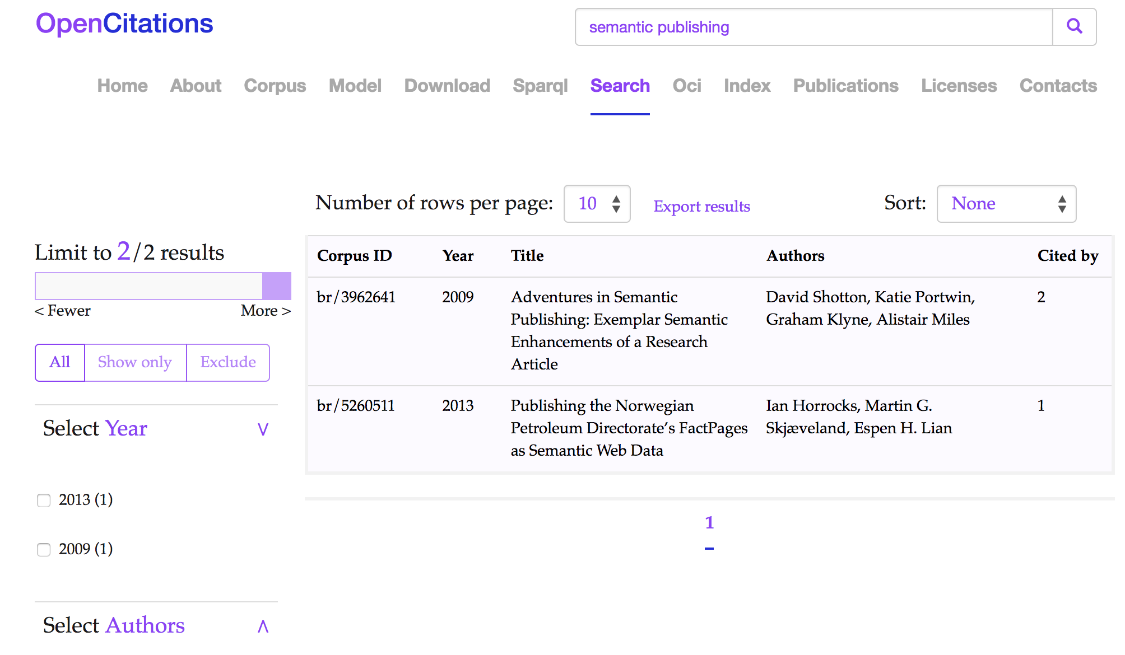Illustration 3: The Results interface of the OSCAR tool in the OpenCitations website for OCC: the results shown are those obtained after the application of a search using a free text string “semantic publishing”. Each row represents a publication, while the fields represent (from left to right): the resource identifier in the OpenCitations Corpus (Corpus ID), the year of publication (Year), the title (Title), the list of authors (Authors), and how many times the publication has been cited by other publications documented within the OCC (Cited by).
LUCINDA will identify and browse documents and authors. In this case we have no preprocessing operations on the initial input, since the text given correspond to the actual URL address written in a specific one valid format, the users have no input box inside the website to free input and use LUCINDA, therefore LUCINDA is triggered only with predefined automatically generated links. Once the SPARQL query has been accomplished and we have some results, as for OSCAR we will group the authors of the browsed document all together, and create external links to DOIs and ORCIDs. In addition, we applied some mapping rules for null and non suitable values.
Finally, with LUCINDA we have customized the contents in its layout sections. On the ‘Metrics’ section we wrote down the number of citations and references for documents, while when browsing authors, we wrote down the number of contributions (documents) and the total number of citations others have made on his publications. We have also incorporated OSCAR inside, it will search for and list the information mentioned in the ‘Metrics’ section. In Illustration 4 we show how does LUCINDA look like inside the OpenCitations website.
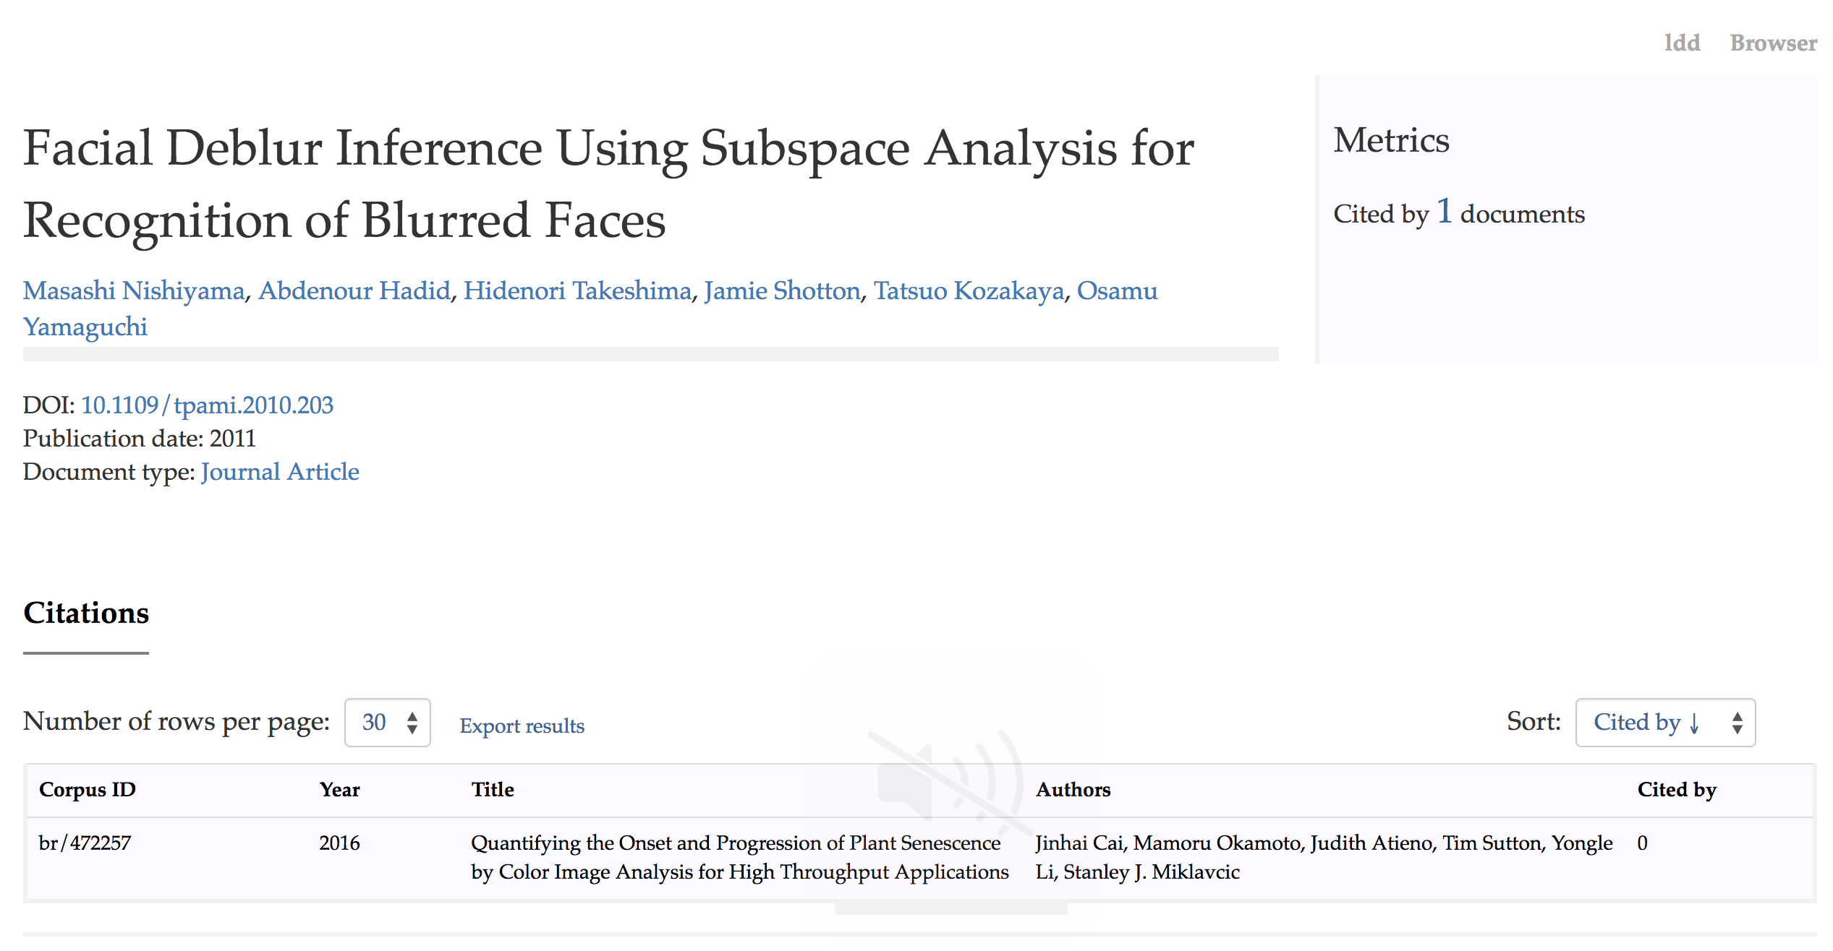Illustration 4: The Results interface of LUCINDA in the OpenCitations website for OCC: the results shown are those obtained after browsing the resource ‘br/472299’. The table on the bottom of the page is generated through OSCAR, which shows the information contained in the ‘Metrics’ section, in this case the number of ‘Citations’.
[[RAMOSE]]

COCI
The identification phase of OSCAR in this case recognizes and matches only one type of entity: the ‘Citations’. We have integrated only the advanced search version of OSCAR, users in this case can decide to search for citations by typing the citing/cited DOI. There is no preprocessing phase, instead in this case new values are integrated in the post processing phase, in particular, we made external calls to Crossref in order to retrieve the full reference entry for the citing and cited DOIs. On the final results table we associate external links to the DOI values.
The layout of OSCAR permits a further filtering of the table for a specific timespan and publication year value, along with limiting the total number of rows in it. In Illustration 5 we show how does OSCAR for COCI look like inside the OpenCitations website.
LUCINDA in COCI needs to identify and browse all the “Citation” resources, and the related information. Basically, all the table fields of OSCAR will again be returned and be part of LUCINDA final layout. In Illustration 6 we show how does LUCINDA for COCI look like inside the OpenCitations website. In this case OSCAR was not integrated inside LUCINDA.
[[RAMOSE]]

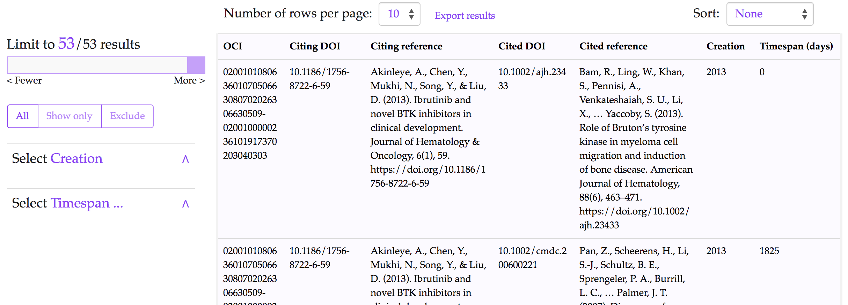Illustration 5: The Results interface of OSCAR in the OpenCitations website for COCI: the results shown are those obtained after searching for a citing DOI equal to “10.1186/1756-8722-6-59”. Each row represents a ‘Citation’.
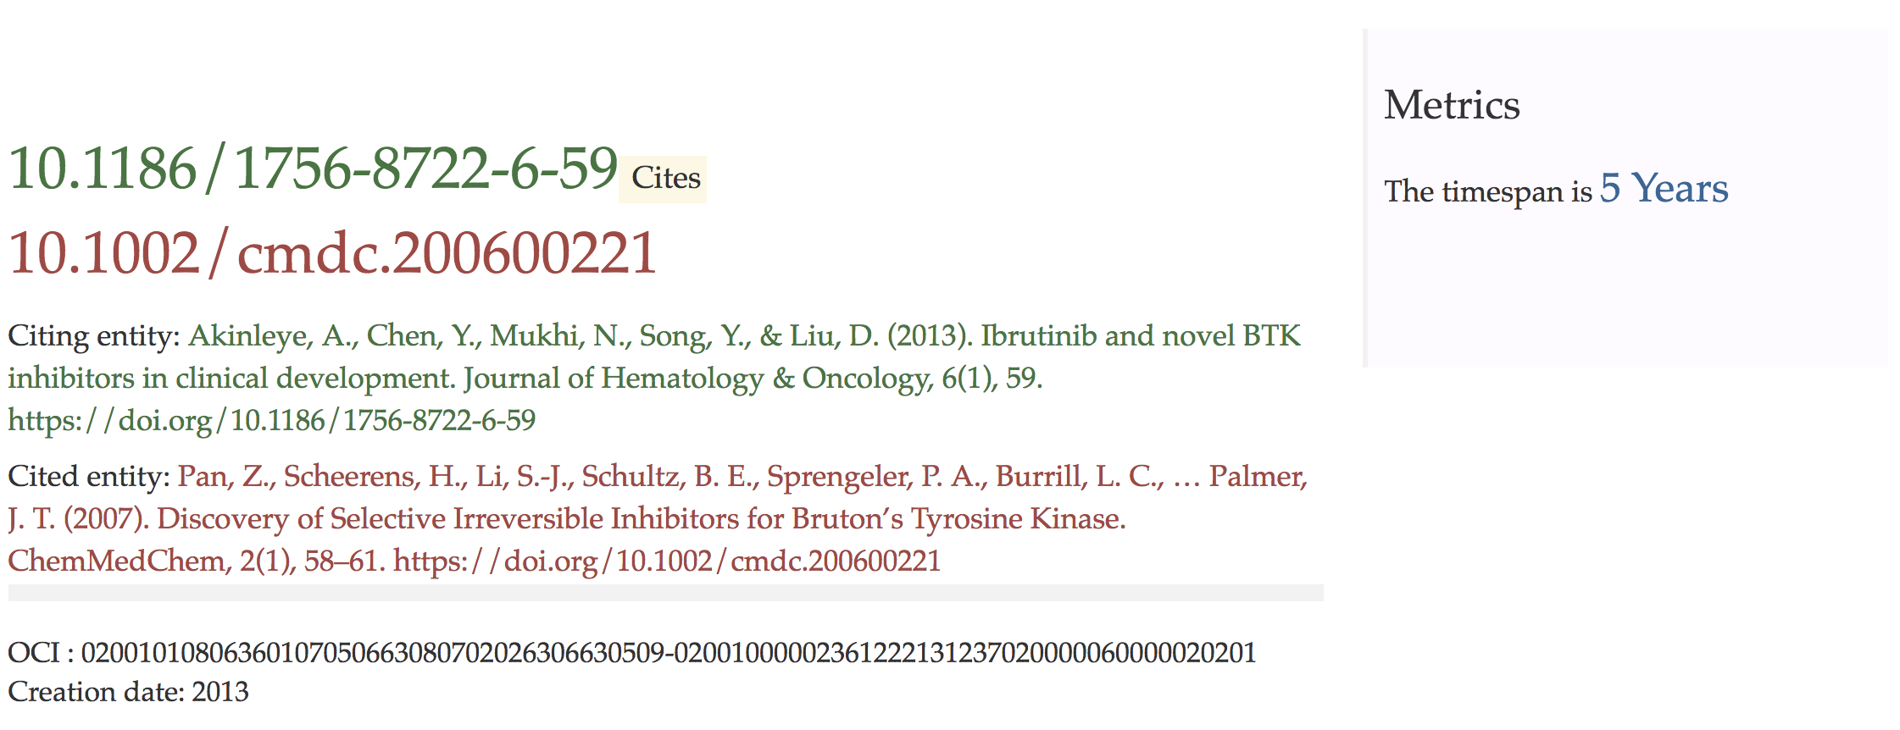Illustration 6: The results interface of LUCINDA in the OpenCitations website for COCI: the results shown are those obtained after browsing the resource ‘ci/02001010806360107050663080702026306630509-02001000002361222131237020000060000020201’.

Evaluation and usage statistics
We have been collecting and monitoring the usage of the developed services inside the OpenCitations web site for both OCC and COCI. The statistics collection started from the first day when these services have been integrated in the web site and ready to use.
The statistics we provide here show the clear evidence of the interest that the scholarly communication community is showing in the new services we have integrated inside the OpenCitations web site (http://opencitations.net/).
On the graphic representation of Illustration 7 we have monitored the number of accesses made to each one of the three services: OSCAR, LUCINDA, and RAMOSE that have been integrated inside the OpenCitations web site. As we can see OSCAR have a very steady number of accesses through the time, and we can also say the same thing for LUCINDA, despite the unusual high pick reached on august. We will give an explanation to this value later with a direct analysis on LUCINDA. On the other hand, despite the fact that RAMOSE is the latest service developed, and we still have not a large log history on it, we can see that its popularity increased rapidly, specially on august, and this success is gaining a solid confirmation on september too.
The stats regarding RAMOSE enforce our premise: an API service is highly requested and needed by a lot of users who wish to query the corpus mantained by OpenCitations and use such data.
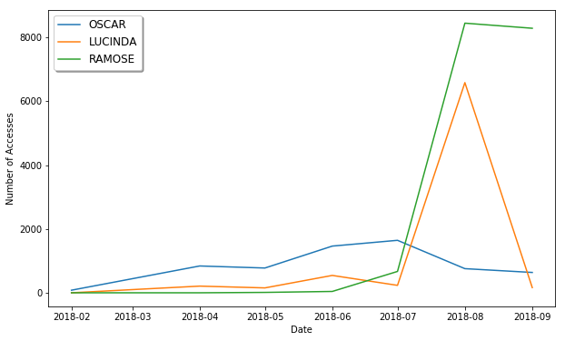Illustration 7: The number of accesses OSCAR, LUCINDA and RAMOSE received inside the OpenCitations web site, for each different month starting from February 2018 to September 2018.
Since LUCINDA is a resource browser we wanted to know how people are reaching it: (1) By directly entering a specific address and move to it, (2) By clicking on the results given by OSCAR, (3) From the basic standard and basic resource viewer (the LDD), in this case we would also like to monitor the inverse direction (from LUCINDA to LDD). On the graphic representation of Illustration 11 we have monitored inside the OpenCitations web site the above movements. We represent the ‘Y’ axis on a logaritimic scale, while the ‘X’ axis represent the months from february 2018 to september 2018. As we can see, we are starting to get some values just after April 2018, since its the date when LUCINDA has been launched. The dominant way to access LUCINDA is by first using OSCAR and search for something. The movements from/to LUCINDA and LDD are almost equivalent, with a slightly better results for LUCINDA to LDD, which means that users first want to browse the resource the way LUCINDA makes it (with a higher friendly interface) and then move to the basic resource viewer of OpenCitations, to get other details on the specific resource.
On the previous graphic of Illustration 7 we have pointed out the anomalous number of accesses LUCINDA have reached on the month of august, through the observations made on the analyzes of the LUCINDA movements we have discovered that this value has been made up through direct access to LUCINDA by one single source. Our conclusions are that the intent of such user was to scrape the HTML page of LUCINDA.
Finally, we wanted to focus on the OCC and COCI corpuses. From Illustration 8 we can see that since its integration the COCI corpus gained a rapid increase in its usage through the SCI framework services. On the other hand the OCC corpus usage was almost steady between 1000 to 2000 accesses per month. The pick on august is still related to the phenomena just described above on the LUCINDA movements. The next graphs will enforce this theory.
On Illustration 9 and Illustration 10 we show how the number of accesses are distributed along all the services for both COCI and OCC seperately. For the COCI case people are very much interested in getting its data through the API of RAMOSE, while OSCAR and LUCINDA numbers are very steady, and as expected people slightly prefer to search and then eventually browse the resources retrieved in the results table. Also in the case of OCC, RAMOSE usage is increasing rapidly, although its numbers are much less than those observed for the COCI corpus. From Illustration 10 we can deduce that the HTML scraping over LUCINDA was made to the OCC corpus, as we can clearly see from the pick of accesses it reaches on august.
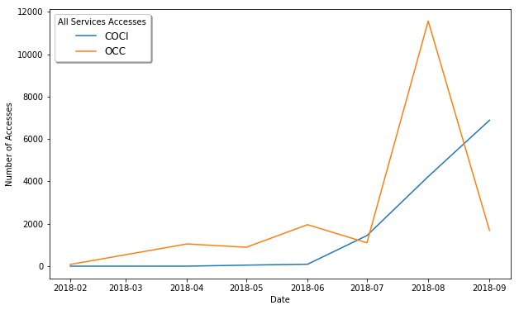Illustration 8: The number of accesses made generally to all the services for the OCC and COCI corpuses separetly. Starting from february to september 2018.
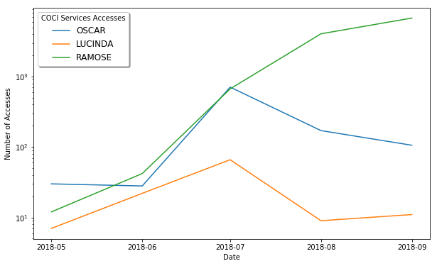Illustration 9: The number of accesses made for each different service when querying the COCI corpus. The 'y' axis is in logaritmic scale, while the 'x' axis represents the timeline starting from february to september 2018.

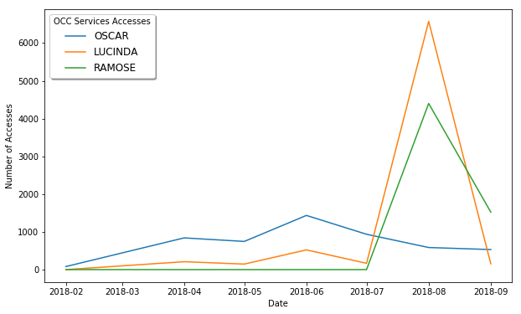Illustration 10: The number of accesses made to each different service for querying the OCC corpus. The 'x' axis represents the timeline starting from february to september 2018.
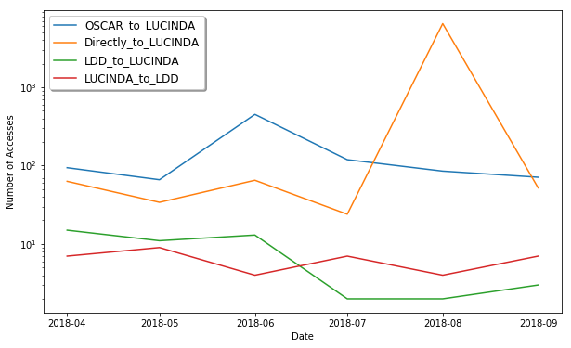Illustration 11: Monitoring the movements made from/to LUCINDA inside the OpenCitations web site, with 4 different options: (1) OSCAR to LUCINDA, (2) Directly to LUCINDA, (3) LDD to LUCINDA, (4) LUCINDA to LDD. LDD is the standard and basic resource viewer of OpenCitations.

Conclusions
In this paper we have introduced the SCI-Framework, a general architectural model for building SPARQL based applications. The applications which follow the framework scheme hide the complexity of the SPARQL language to the final user, and provide a more simplistic and comprehensive interface to interact with. This approach is meant to benefit both the triplestore providers, and the final users.
We have successfully used the SCI-Framework to implement three services that query the OCC and COCI corpuses of the OpenCitations project: (1) OSCAR: an RDF search engine, (2) LUCINDA: a resource browser, (3) RAMOSE: a REST API service. The architecture of SCI is very close to the more traditional MVC model: the "Model" is the SPARQL endpoint, the "View" is the interface given to the final user, and the "Controller" is the configuration layer. We have tested the usability of the services integrated inside OpenCitations through monitoring the accesses and behaviour of the users when using them.
Although the main intent when we have started was building new services for our OpenCitations triplestore, the proposed framework is completely configurable for querying any other triplestore providing a SPARQL endpoint address. Therefore we recommend to follow the SCI-Framework as a model for building SPARQL based applications, and we fully provide it for the community usage.
We are working on configuring the SCI services we have implemented, to work on the Wikidata triplestore, therefore, we will modify the configuration files and adapt them accordingly. While Wikidata contains a wide variety of information, for this customisation we decided to limit the range of data to be searched to bibliographic entities within the scholarly domain.

Acknowledgements
We gratefully acknowledge the financial support provided to us by the Alfred P. Sloan Foundation for the OpenCitations Enhancement Project (grant number G‐2017‐9800).

References
- OSCAR: A customisable tool for free-text search over SPARQL endpoints, https://essepuntato.github.io/papers/oscar-savesd2018.html
- Peroni, S., Dutton, A., Gray, T., & Shotton, D. (2015). Setting our bibliographic references free: towards open citation data. Journal of Documentation, 71(2), 253-277. http://dx.doi.org/10.1108/JD-12-2013-0166
- Peroni, S., Shotton, D. M., & Vitali, F. (2017). One Year of the OpenCitations Corpus-Releasing RDF-Based Scholarly Citation Data into the Public Domain. In The Semantic Web-ISWC (pp. 21-25). https://doi.org/10.1007/978-3-319-68204-4_19
- Leff, A., & Rayfield, J. T. (2001). Web-application development using the model/view/controller design pattern. In Enterprise Distributed Object Computing Conference, 2001. EDOC'01. Proceedings. Fifth IEEE International (pp. 118-127). IEEE. https://doi.org/10.1109/EDOC.2001.950428
- Peroni, S., & Vitali, F. (2015, June). RSLT: RDF Stylesheet Language Transformations. In ESWC Developers Workshop (Vol. 1361, pp. 7-13).
- Tankashala, S. (2010). A Framework Supporting Development of Ontology-Based Web Applications.
- Bischof, S., Decker, S., Krennwallner, T., Lopes, N., & Polleres, A. (2012). Mapping between RDF and XML with XSPARQL. Journal on Data Semantics, 1(3), 147-185. https://doi.org/10.1007/s13740-012-0008-7
- Corby, O., & Zucker, C. F. (2015, May). STTL: a SPARQL-based transformation language for RDF. In 11th International Conference on Web Information Systems and Technologies.
- World Wide Web Consortium. (2014). RDF 1.1 concepts and abstract syntax.
- Harris, S., Seaborne, A., & Prud’hommeaux, E. (2013). SPARQL 1.1 query language. W3C recommendation, 21(10).
- Deliot, C. (2014). Publishing the British national bibliography as linked open data. Catalogue & Index, 174, 13-18.
- Erxleben, F., Günther, M., Krötzsch, M., Mendez, J., & Vrandečić, D. (2014, October). Introducing Wikidata to the linked data web. In International Semantic Web Conference (pp. 50-65). Springer, Cham. https://doi.org/10.1007/978-3-319-11964-9_4
- Auer, S., Bizer, C., Kobilarov, G., Lehmann, J., Cyganiak, R., & Ives, Z. (2007). Dbpedia: A nucleus for a web of open data. In The semantic web (pp. 722-735). Springer, Berlin, Heidelberg. https://doi.org/10.1007/978-3-540-76298-0_52
- Nielsen, F. Å., Mietchen, D., & Willighagen, E. (2017, May). Scholia, scientometrics and wikidata. In European Semantic Web Conference (pp. 237-259). Springer, Cham. https://doi.org/10.1007/978-3-319-70407-4_36
- Ferré, S. (2017). Sparklis: an expressive query builder for SPARQL endpoints with guidance in natural language. Semantic Web, 8(3), 405-418. https://doi.org/10.3233/SW-150208
- Fu, Y., Ong, K. W., Papakonstantinou, Y., & Petropoulos, M. (2011, January). The SQL-based all-declarative FORWARD web application development framework. In CIDR (pp. 69-78).
- Posevkin, R., & Bessmertny, I. (2015, October). Translation of natural language queries to structured data sources. In Application of Information and Communication Technologies (AICT), 2015 9th International Conference on (pp. 57-59). IEEE. https://doi.org/10.1109/ICAICT.2015.7338516
- Kumar, S., Kumar, A., Mitra, P., & Sundaram, G. (2013). System and Methods for Converting Speech to SQL. arXiv preprint arXiv:1308.3106.
- Nareshkumar, N. K. S., Mariappan, N., & Thirumoorthy, K. (2014). Database interaction using automatic speech recognition. International Journal of Innovative Research in Science, Engineering and Technology, 3.
- Gupta, S., Prakash, A., Singh, A., Agarwal, S., Chauhan, S., & Shekhar, S. (2015). U.S. Patent Application No. 14/252,553.
- Brooks, J. (2009). Review: Talend open studio makes quick work of large data sets.

