In the folder:

- index.php - php-page for the user database and work with it.

- index-header.php - php-file with scripts to process GET and POST requests from the index.php.

- index.js - JavaScript file for processing button presses and passing parameters to the php-script.

- index-table.php - php-file to display table with users.

- login.php - php file for logging into the database.

- login-header.php - php-file with scripts to process GET and POST requests from login.php

- noadmin.php - technical php-page that shows those users who are trying to log in to the account without administrator rights.

- noadmin.js - JavaScript file for processing button actions.

- params.php - file with parameters to connect to the database and the site address.

- styles.css - styles css file.

- users.sql - MySQL user database dump.

To perform the task I used a local web-server XAMPP (Apache + MySQL + phpMyAdmin), for testing I used Yandex.Browser version 22.11.0.2500.

To test the operation by yourself, you need to install xampp, then put the folder with all files (sibers) into the folder htdocs and export the dump "users" in phpmyadmin. After that the site will be available for usage at http://localhost/sibers/login.php.

Home page (login.php)

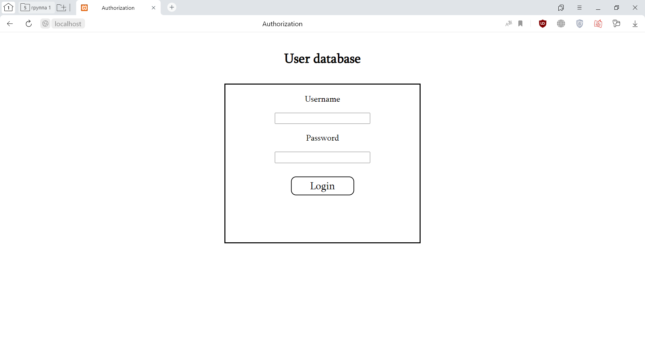

Authorization attempt (login doesn't exist)

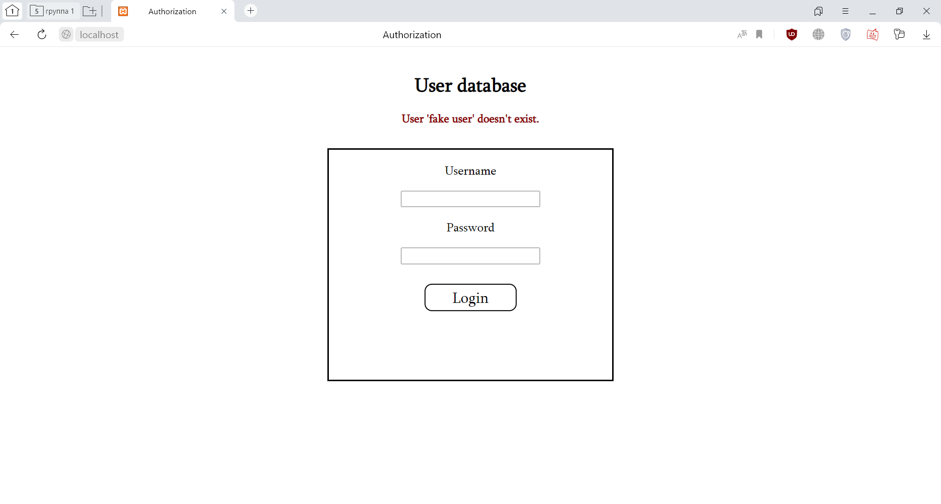

Authorization attempt (wrong password):

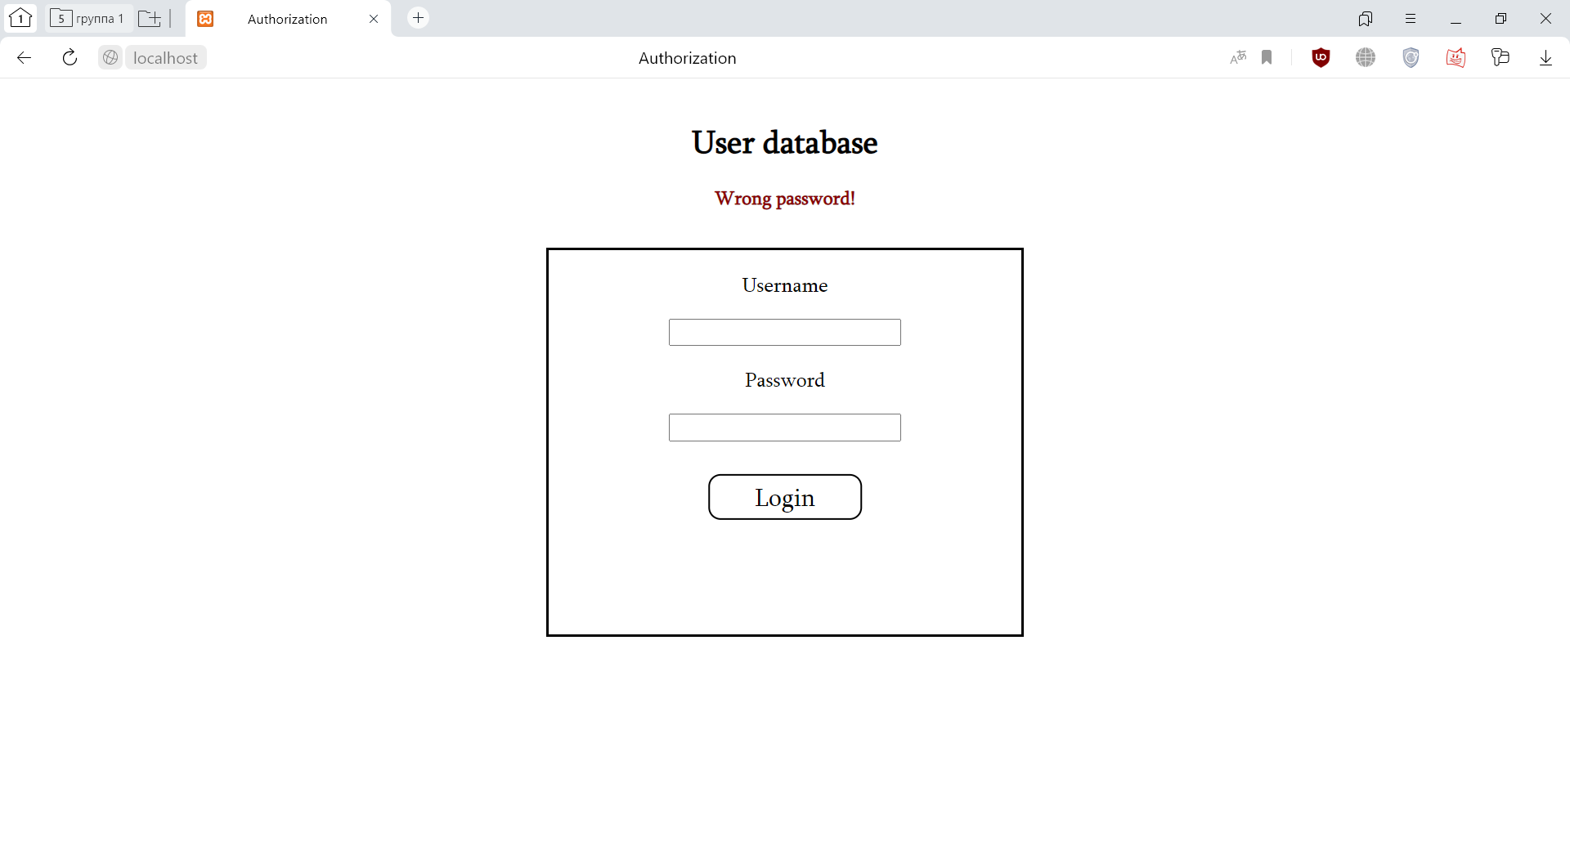

Attempt to use database without authorization:

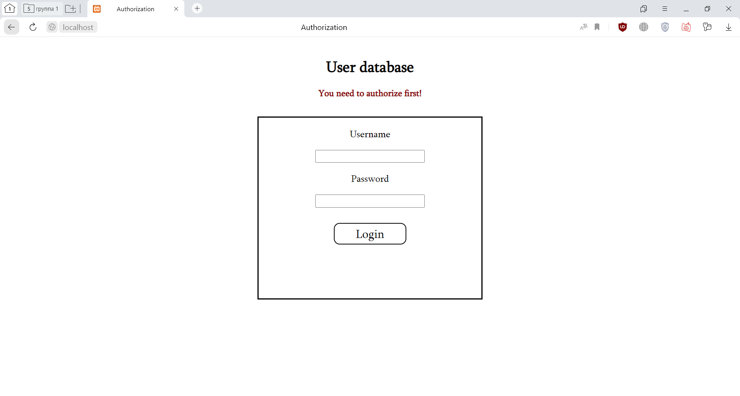

Logging into account without admin rights:

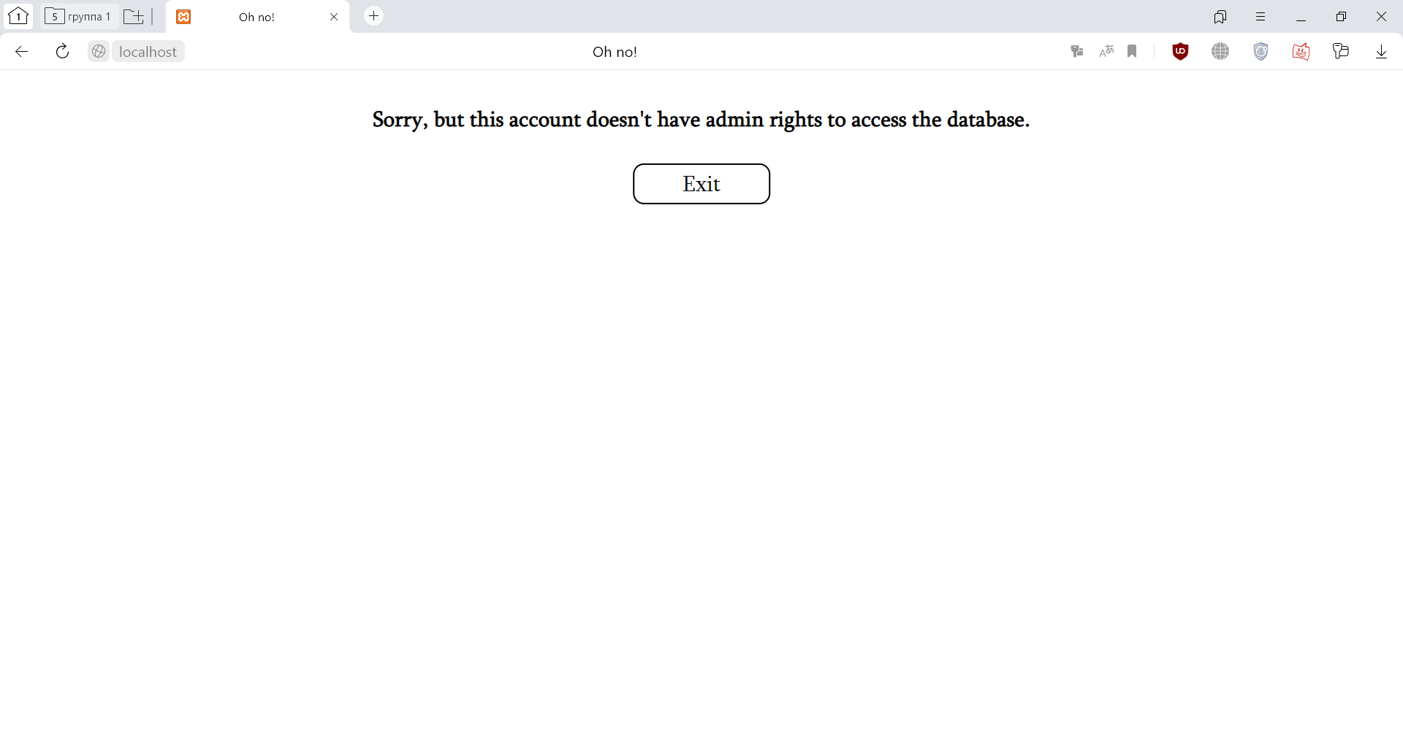

Normal login:

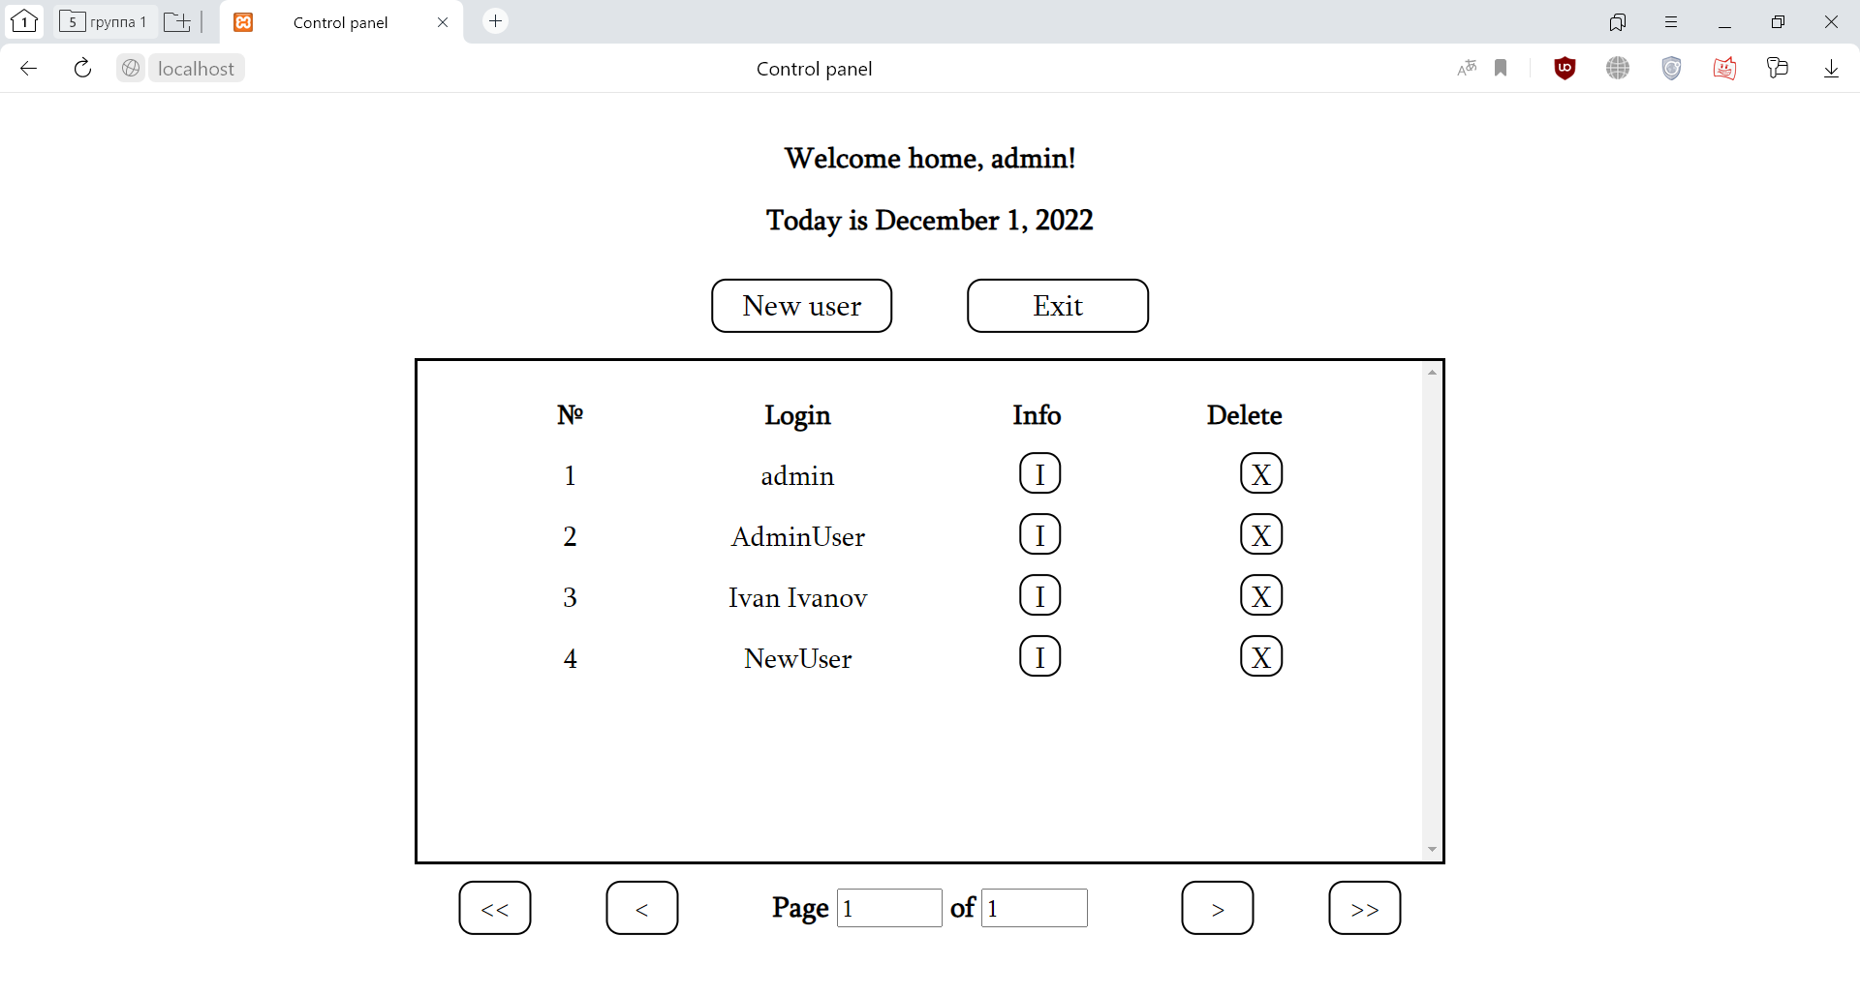

Creating a new user:

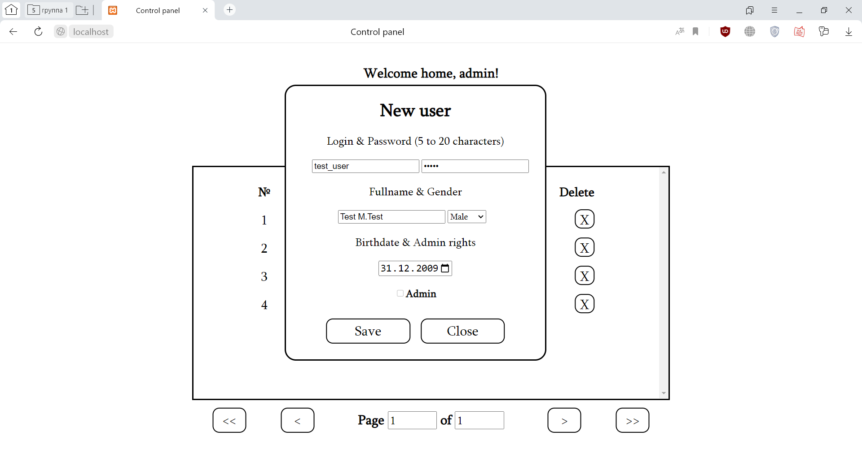

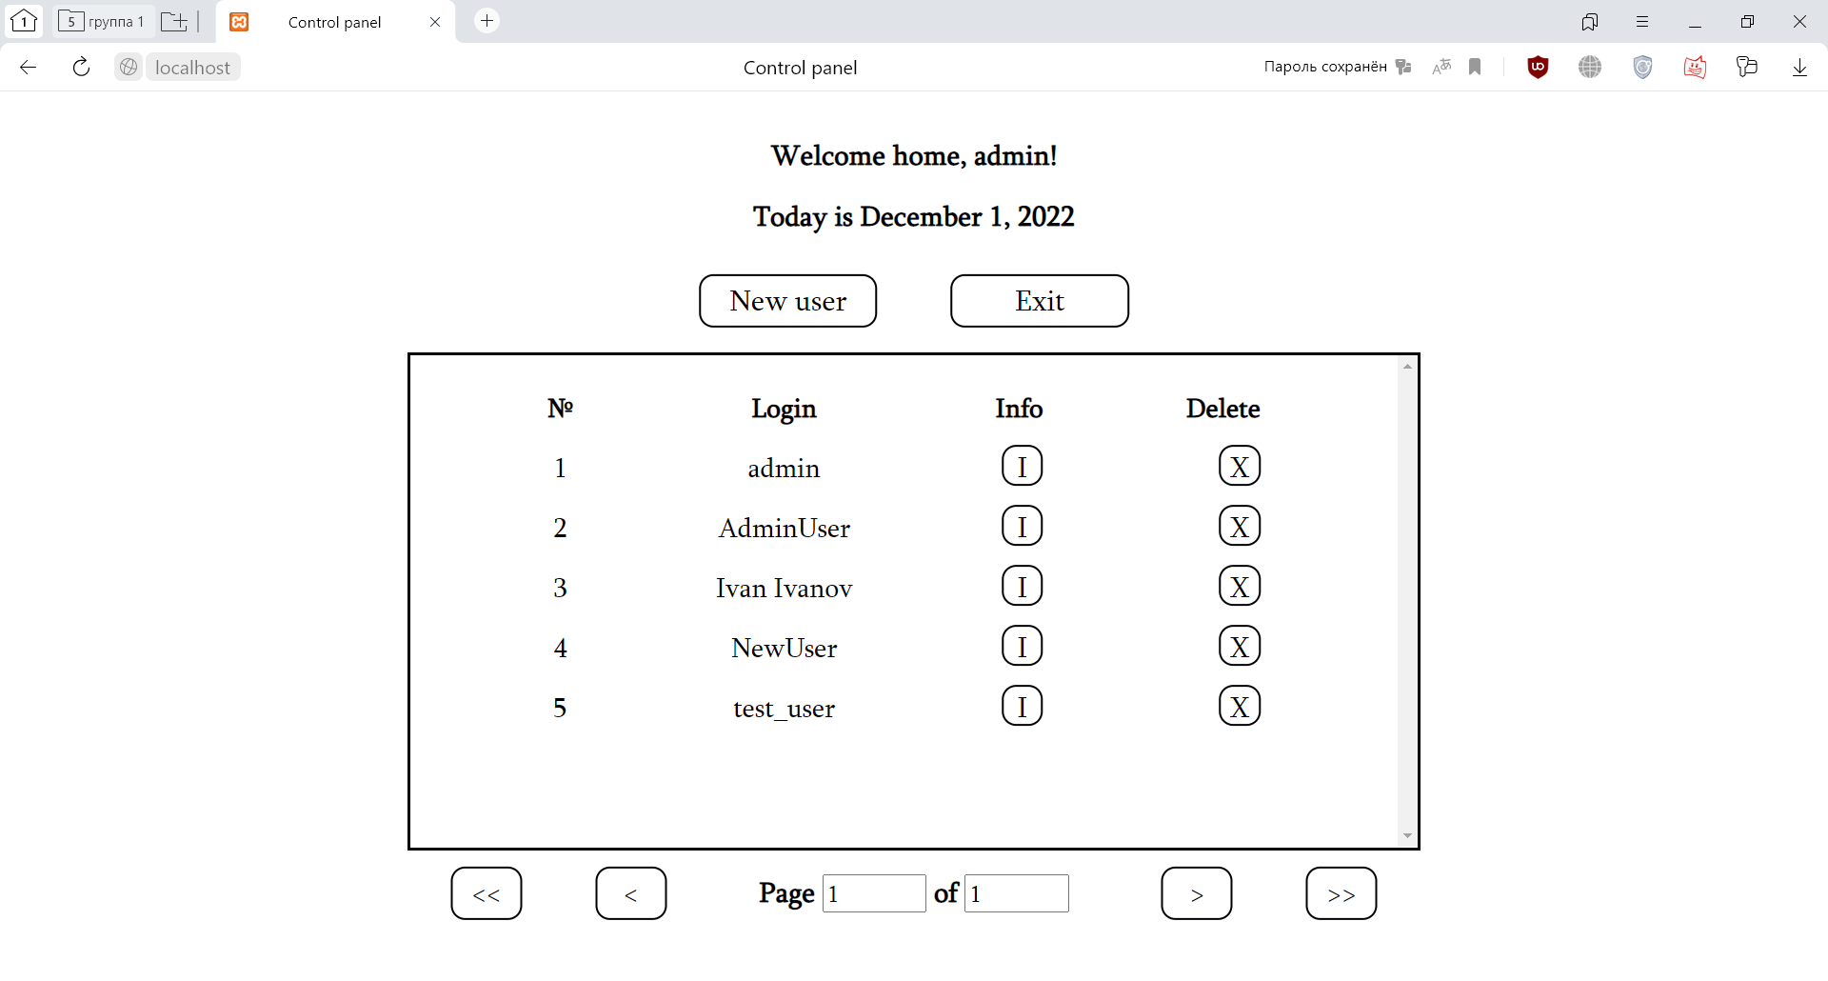

Validation of form fields:

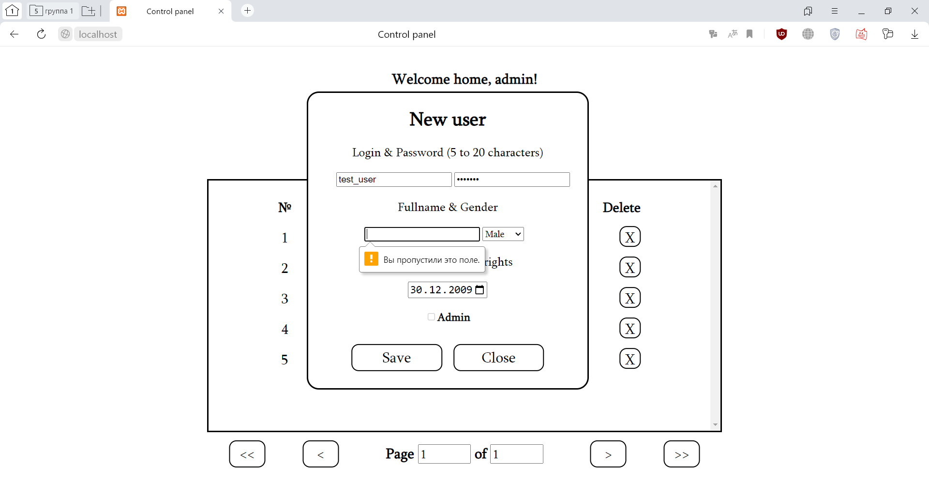

Attempting to create a user with an existing login (or change the current login to an existing login):

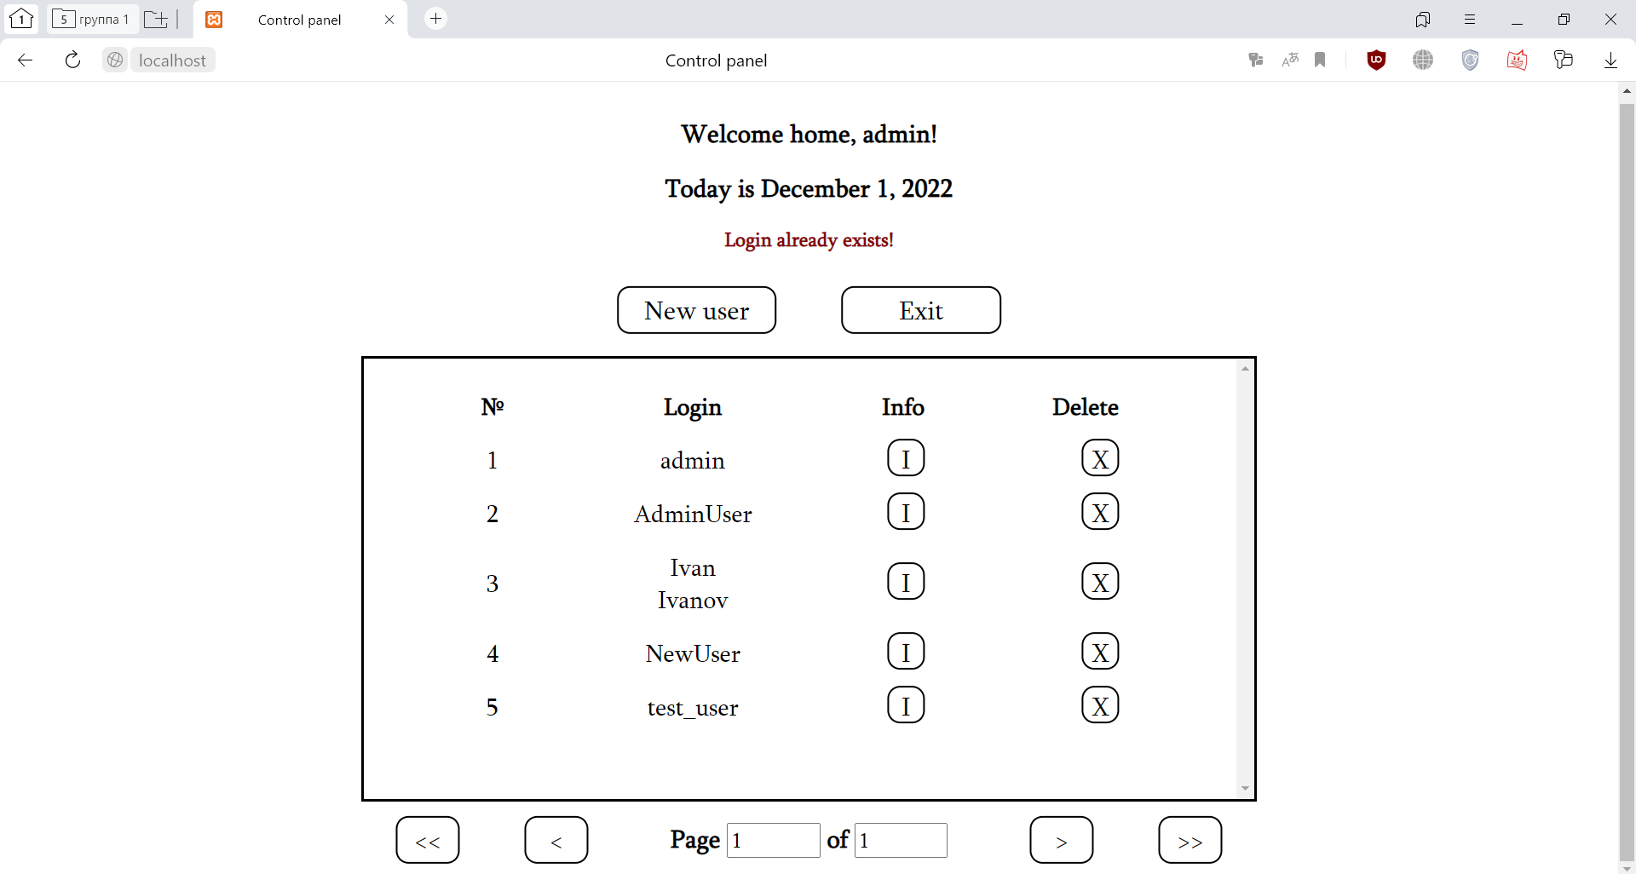

User Information:

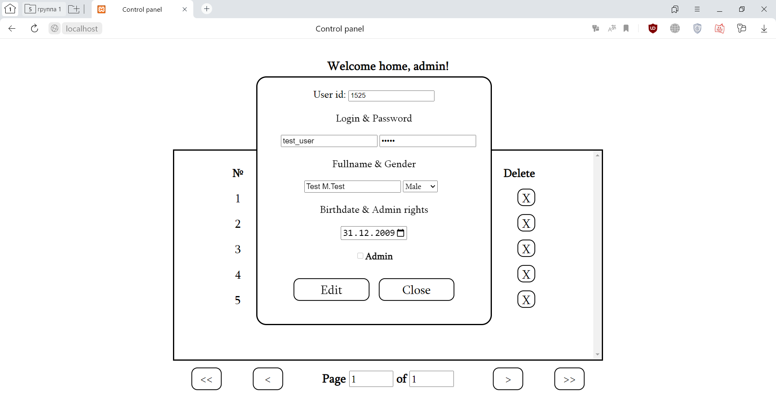

Let’s change login and grant our user administrator rights:

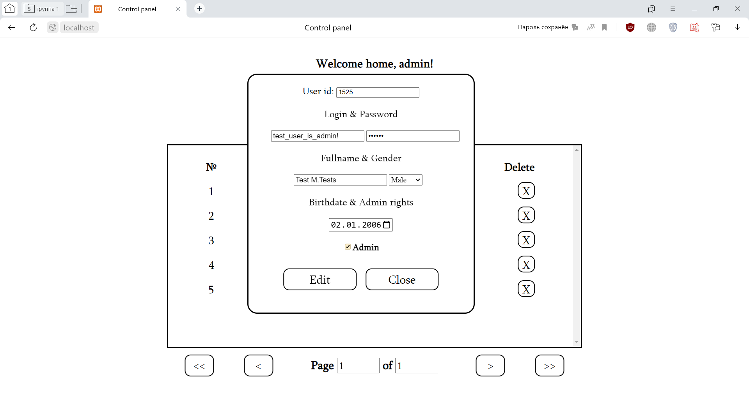

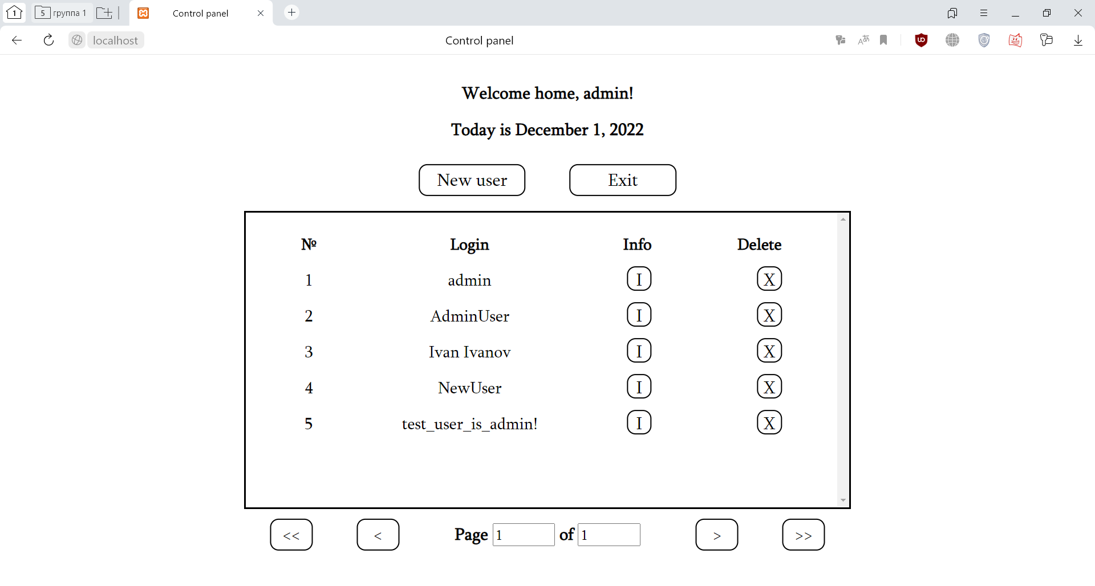

Navigating with a large number of users:

