Title: Product List Page *(Home page);* Moving to next page

Severty: 4

Priority: 4

Environment: UAT

Feature (PBI): Home page

Repro Steps:

1. Go to <https://practicesoftwaretesting.com/#/>
2. Scroll to bottom of page
3. Click to “Next” button to change page

Error: The number of page will be switched from 1 to 2 but all product will not change (same product are present in borh page)

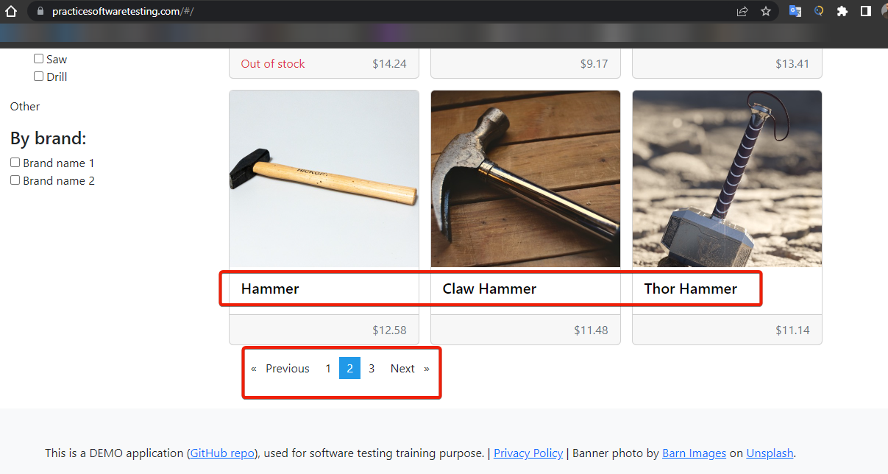

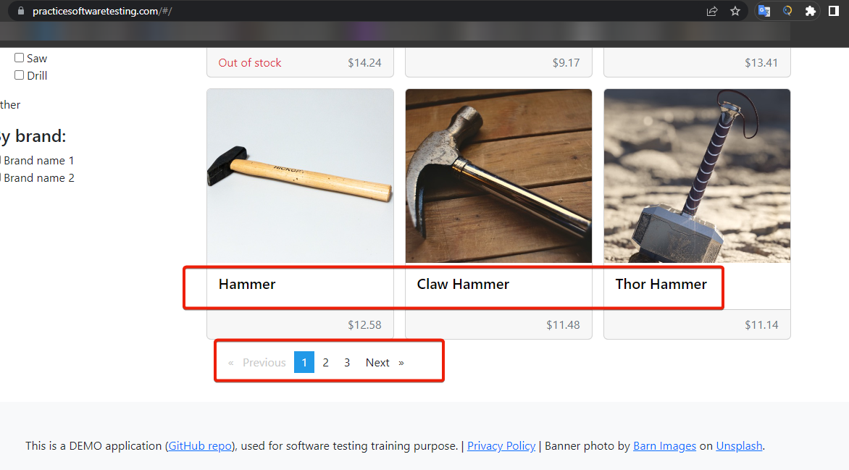

Title: Register your account; Possible to insert five digit in year of birth

Severty: 4

Priority: 4

Environment: UAT

Feature (PBI): Customer registration

Repro Steps:

1. Go to <https://practicesoftwaretesting.com/#/>
2. Click to “Sign In” button (upper right corner on header)
3. Click to Register your account
4. In “Date of birth” enter 24/07/275760

Error: Possible to insert five digit in “Date of birth”

