**IT255 – DZ03**

LINK: http://echo.jsontest.com/title/ipsum/content/blah

Get metoda:

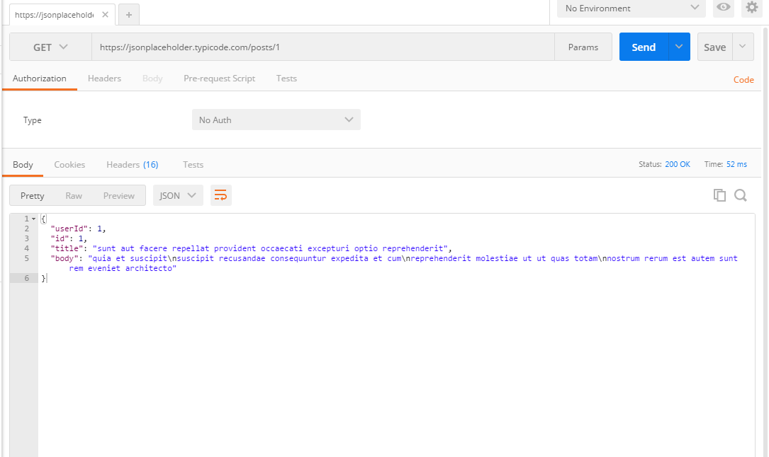

Post metoda:

