HW 8.3

a)

mx0=2;

my0=2;

mx1=-2;

my1=-2;

sx=2;

sy=1;

rxy=0;

a=(2*(mx0-mx1))/(sx)^2+(2*rxy*(my1-my0))/sx*sy;

b=(2*(my0-my1))/(sy)^2+(2*rxy*(mx1-mx0))/sx*sy;

c=((mx1)^2-(mx0)^2)/(sx)^2+(2*rxy*(mx0*my0-mx1*my1))/sx*sy+((my1)^2-(my0)^2)/(sy)^2;

x=-10:0.1:10;

y=-(a*x+c)/b;

plot(parta_H0_data(:,1),parta_H0_data(:,2),'o',parta_H1_data(:,1),parta_H1_data(:,2),'+',x,y)

xlabel('x')

ylabel('y')

legend('H0','H1')

H0_decision=(a*parta_H0_data(:,1)+b*parta_H0_data(:,2)+c)>0;

missH0=length(H0_decision)-sum(H0_decision);

H1_decision=(a*parta_H1_data(:,1)+b*parta_H1_data(:,2)+c)>0;

missH1=sum(H1_decision);

fracmiss=(missH1+missH0)/2000

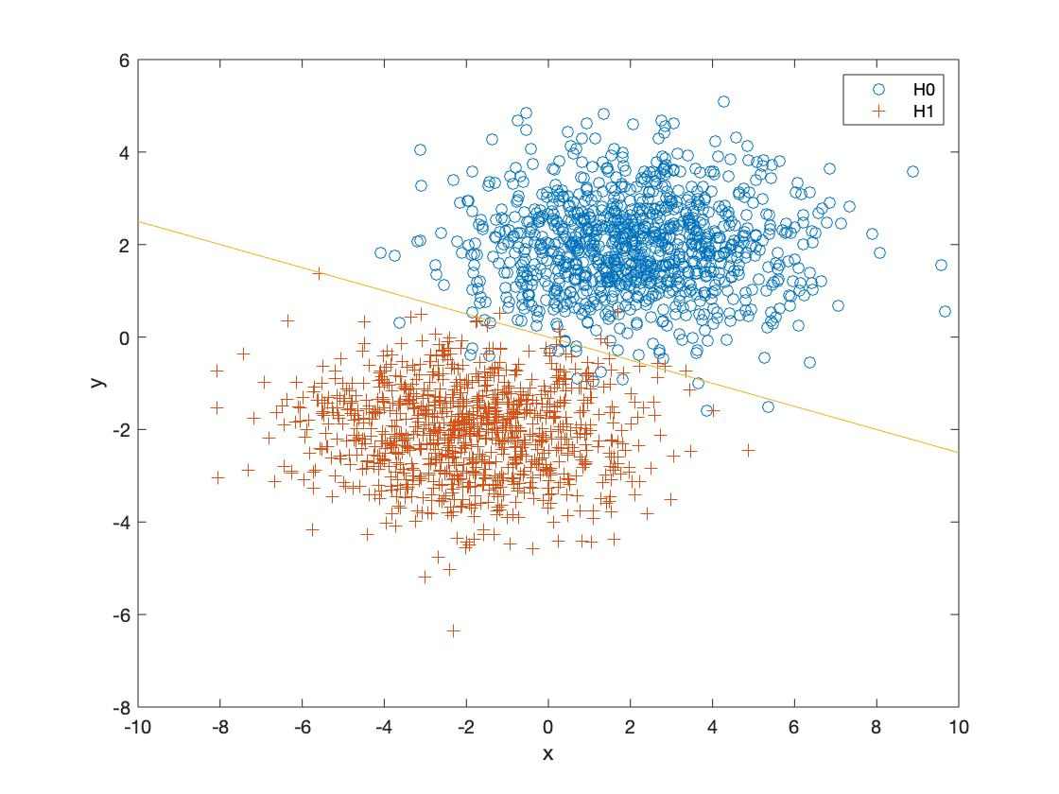

fracmiss =

0.0130

b)

mx0=1;

my0=1;

mx1=3;

my1=-1;

sx=sqrt(3/2);

sy=sqrt(2);

rxy=1/sqrt(3);

a=(2*(mx0-mx1))/(sx)^2+(2*rxy*(my1-my0))/sx*sy;

b=(2*(my0-my1))/(sy)^2+(2*rxy*(mx1-mx0))/sx*sy;

c=((mx1)^2-(mx0)^2)/(sx)^2+(2*rxy*(mx0*my0-mx1*my1))/sx*sy+((my1)^2-(my0)^2)/(sy)^2;

x=-10:0.1:10;

y=-(a*x+c)/b;

plot(partb_H0_data(:,1),partb_H0_data(:,2),'o',partb_H1_data(:,1),partb_H1_data(:,2),'+',x,y)

xlabel('x')

ylabel('y')

legend('H0','H1')

H0_decision=(a*partb_H0_data(:,1)+b*partb_H0_data(:,2)+c)>0;

missH0=length(H0_decision)-sum(H0_decision);

H1_decision=(a*partb_H1_data(:,1)+b*partb_H1_data(:,2)+c)>0;

missH1=sum(H1_decision);

fracmiss=(missH1+missH0)/2000

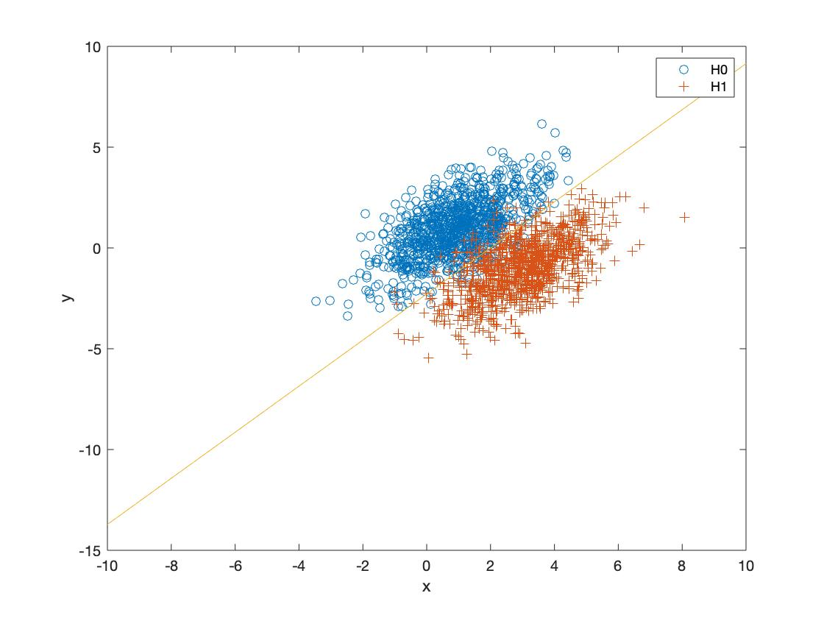

fracmiss =

0.0460

c)

mx0=mean(partc_H0_data(:,1));

my0=mean(partc_H0_data(:,2));

mx1=mean(partc_H1_data(:,1));

my1=mean(partc_H1_data(:,2));

sx=sqrt(2);

sy=1;

rxy=0;

a=(2*(mx0-mx1))/(sx)^2+(2*rxy*(my1-my0))/sx*sy;

b=(2*(my0-my1))/(sy)^2+(2*rxy*(mx1-mx0))/sx*sy;

c=((mx1)^2-(mx0)^2)/(sx)^2+(2*rxy*(mx0*my0-mx1*my1))/sx*sy+((my1)^2-(my0)^2)/(sy)^2;

x=-10:0.1:10;

y=-(a*x+c)/b;

plot(partc_H0_data(:,1),partc_H0_data(:,2),'o',partc_H1_data(:,1),partc_H1_data(:,2),'+',x,y)

xlabel('x')

ylabel('y')

legend('H0','H1')

H0_decision=(a*partc_H0_data(:,1)+b*partc_H0_data(:,2)+c)>0;

missH0=length(H0_decision)-sum(H0_decision);

H1_decision=(a*partc_H1_data(:,1)+b*partc_H1_data(:,2)+c)>0;

missH1=sum(H1_decision);

fracmiss=(missH1+missH0)/2000

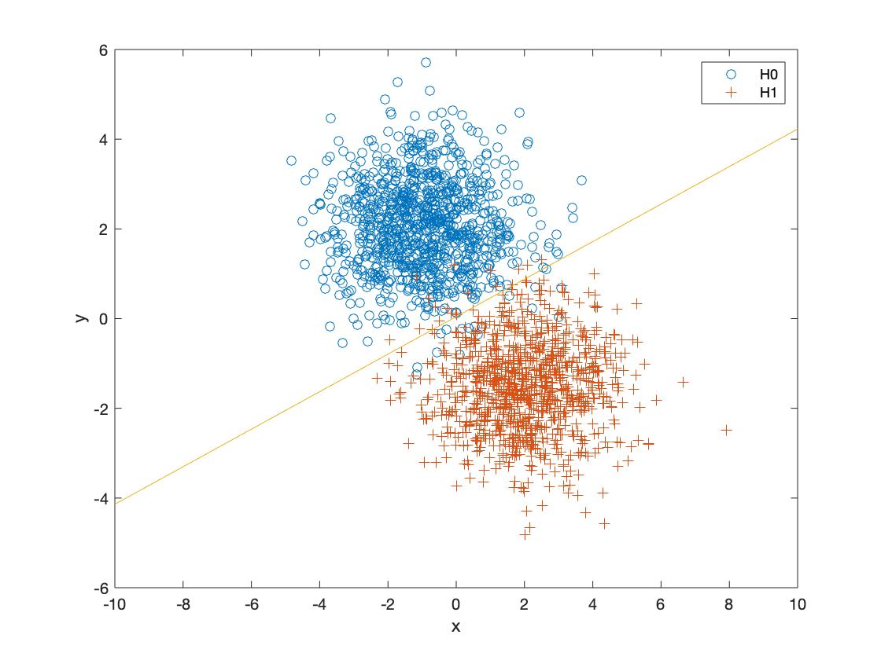

fracmiss =

0.0180