**MVC application for Maze problem**

I have used Eclipse Mars with Maven to create a web application.

**JDK version : 1.8**

**Tomcat7-maven-plugin** to run the application

Create a Maze.zip file on the github.

Kindly download,extract and import in eclipse as maven existing project.

**Basic Workflow :**

**The View maze.jsp is calling the Maze Servlet,send the maze question request to servlet which is in turn calling the Maze Service to provide the maze solution and then the html response is flushed back to the browser.**

Once it is deployed on the server :

Type in URL : [**http://localhost:8080/maze.do**](http://localhost:8080/maze.do) **on the browser**

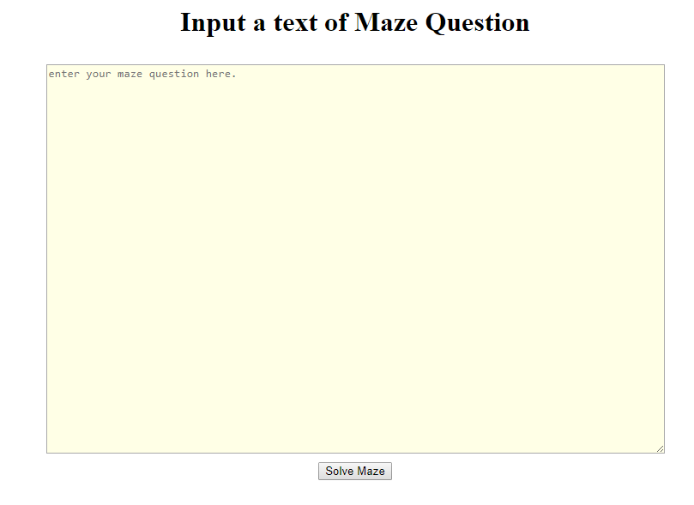

**Enter or Copy/Paste the maze question as shown below.**

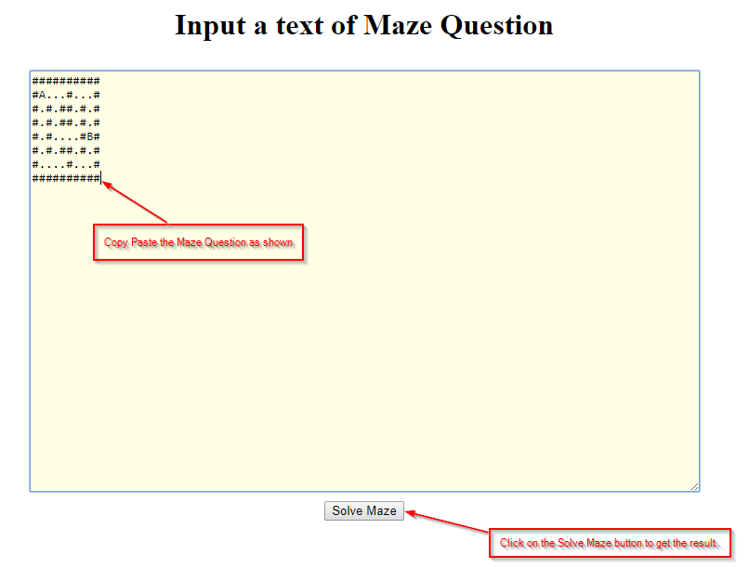

**Result displayed :**

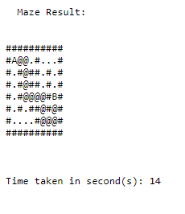

**Also you can run in Dos :**

**java com.intvw.test.MazeSolution "C:\software\peopleNet\maze3.txt"**

**To test the service independent of UI..**

**Both the version is zipped into Maze.zip i.e DOS and the WebApplication**

