Ivan Josh R. Masongsong

BSIT-MI 181

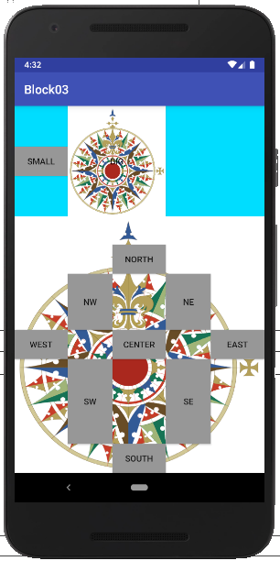

Main Activity:

package com.example.myapplication;

import android.support.v7.app.AppCompatActivity;

import android.os.Bundle;

import android.widget.Button;

public class MainActivity extends AppCompatActivity {

@Override

protected void onCreate(Bundle savedInstanceState) {

super.onCreate(savedInstanceState);

setContentView(R.layout.activity_main);

Button button_big = (Button) findViewById(R.id.button_big);

button_big.setBackgroundResource(R.drawable.compass);

}

}

Activity main:

<?xml version="1.0" encoding="utf-8"?>

<RelativeLayout xmlns:android="http://schemas.android.com/apk/res/android"

xmlns:tools="http://schemas.android.com/tools"

android:layout_width="match_parent"

android:layout_height="match_parent">

<TextView

android:layout_width="wrap_content"

android:layout_height="wrap_content"

android:text="@string/textView_prompt"

android:id="@+id/textView" />

<ListView

android:layout_width="wrap_content"

android:layout_height="wrap_content"

android:id="@+id/listView"

android:layout_below="@+id/textView"

android:layout_alignParentLeft="true"

android:layout_alignParentStart="true" />

</RelativeLayout>