Ivan Josh R. Masongsong

BSIT-MI181

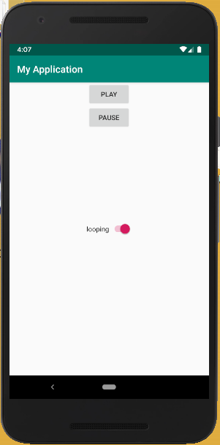

MainActivity:

package fr.centralesupelec.galtier.block04;

package com.example.myapplication;

import android.media.MediaPlayer;

import android.support.v7.app.AppCompatActivity;

import android.os.Bundle;

import android.view.View;

import android.widget.CompoundButton;

import android.widget.Switch;

public class MainActivity extends AppCompatActivity {

MediaPlayer pianoMusic;

@Override

protected void onCreate(Bundle savedInstanceState) {

super.onCreate(savedInstanceState);

setContentView(R.layout.activity_main);

pianoMusic = MediaPlayer.create(this, R.raw.piano);

Switch switch_looping = (Switch) findViewById(R.id.switch_looping);

switch_looping.setOnCheckedChangeListener(new CompoundButton.OnCheckedChangeListener() {

@Override

public void onCheckedChanged(CompoundButton buttonView, boolean isChecked) {

pianoMusic.setLooping(isChecked);

}

});

}

public void playMusic (View v) {

pianoMusic.start();

}

public void pauseMusic (View v) {

if(pianoMusic.isPlaying())

pianoMusic.pause();

}

@Override

protected void onPause() {

super.onPause();

pianoMusic.release();

}

}

Activity_main:

<?xml version="1.0" encoding="utf-8"?>

<RelativeLayout xmlns:android="http://schemas.android.com/apk/res/android"

xmlns:tools="http://schemas.android.com/tools"

android:layout_width="match_parent"

android:layout_height="match_parent">

<Button

android:layout_width="wrap_content"

android:layout_height="wrap_content"

android:text="play"

android:id="@+id/button_play"

android:layout_alignParentTop="true"

android:layout_centerHorizontal="true"

android:onClick="playMusic" />

<Button

android:layout_width="wrap_content"

android:layout_height="wrap_content"

android:text="pause"

android:id="@+id/button_pause"

android:layout_below="@+id/button_play"

android:layout_centerHorizontal="true"

android:onClick="pauseMusic" />

<Switch

android:layout_width="wrap_content"

android:layout_height="wrap_content"

android:text="looping"

android:id="@+id/switch_looping"

android:layout_centerVertical="true"

android:layout_centerHorizontal="true"

android:checked="false" />

</RelativeLayout>