Ivan Josh R. Masongsong

BSIT-MI181

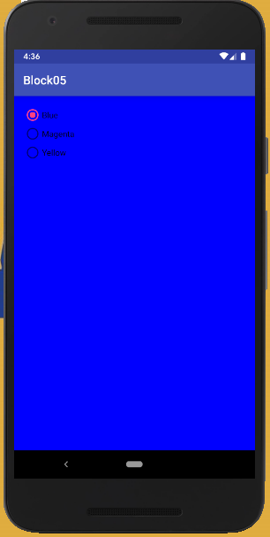

Main Activity:

package com.example.myapplication;

import android.content.Context;

import android.content.SharedPreferences;

import android.graphics.Color;

import android.support.v7.app.AppCompatActivity;

import android.os.Bundle;

import android.widget.RadioGroup;

import android.widget.RelativeLayout;

public class MainActivity extends AppCompatActivity {

@Override

protected void onCreate(Bundle savedInstanceState) {

super.onCreate(savedInstanceState);

setContentView(R.layout.activity_main);

SharedPreferences preferences = getSharedPreferences("COLOR_PREF", Context.MODE_PRIVATE);

final SharedPreferences.Editor editor = preferences.edit();

final RelativeLayout layout = (RelativeLayout)findViewById(R.id.layout);

if (preferences.contains(("colorId")))

layout.setBackgroundColor(preferences.getInt("colorId", 0));

RadioGroup radioGroup_colors = (RadioGroup) findViewById(R.id.radioGroup_colors);

radioGroup_colors.setOnCheckedChangeListener(new RadioGroup.OnCheckedChangeListener() {

@Override

public void onCheckedChanged(RadioGroup group, int checkedId) {

int colorCode = 0;

switch (checkedId) {

case R.id.radioButton_blue:

colorCode = Color.BLUE;

break;

case R.id.radioButton_magenta:

colorCode = Color.MAGENTA;

break;

case R.id.radioButton_yellow:

colorCode = Color.YELLOW;

break;

}

layout.setBackgroundColor(colorCode);

editor.putInt("colorId", colorCode);

editor.commit();

}

});

}

}

Activity_main:

<?xml version="1.0" encoding="utf-8"?>

<RelativeLayout xmlns:android="http://schemas.android.com/apk/res/android"

xmlns:tools="http://schemas.android.com/tools"

android:layout_width="match_parent"

android:layout_height="match_parent"

android:paddingBottom="@dimen/activity_vertical_margin"

android:paddingLeft="@dimen/activity_horizontal_margin"

android:paddingRight="@dimen/activity_horizontal_margin"

android:paddingTop="@dimen/activity_vertical_margin"

tools:context="fr.centralesupelec.galtier.block05.MainActivity"

android:id="@+id/layout">

<RadioGroup

android:layout_width="match_parent"

android:layout_height="match_parent"

android:layout_alignParentTop="true"

android:layout_alignParentLeft="true"

android:layout_alignParentStart="true"

android:id="@+id/radioGroup_colors">

<RadioButton

android:layout_width="wrap_content"

android:layout_height="wrap_content"

android:text="Blue"

android:id="@+id/radioButton_blue"

android:checked="false" />

<RadioButton

android:layout_width="wrap_content"

android:layout_height="wrap_content"

android:text="Magenta"

android:id="@+id/radioButton_magenta"

android:checked="false" />

<RadioButton

android:layout_width="wrap_content"

android:layout_height="wrap_content"

android:text="Yellow"

android:id="@+id/radioButton_yellow"

android:checked="false" />

</RadioGroup>

</RelativeLayout>