- all the source file are located in src/main/java/[package_name].
- to run the service, run ___Application.java
- the application.properties stores the properties required to run the service. located as below: src/main/resources
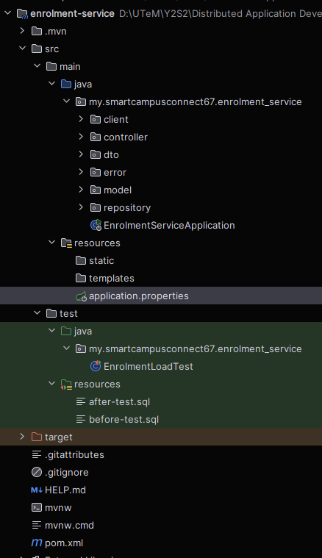
The ONLY field u can modify in application.properties is the 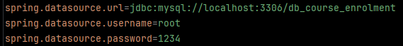Match the username, port and password to yours.
- Each service has its own pom.xml. inside there are all the dependencies. DO NOT MODIFY that file.
- Only enrolment-service has the load test. The loadtestApplication is located in /src/test/java/[packagename].
- Both the sql required for the load test is in resources. Unless you know what you are doing, else don’t modify the file.
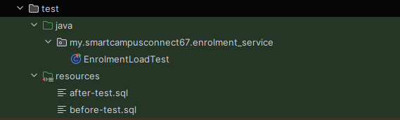
- To run load test, CLOSE THE ENROLMENT-SERVICE FIRST. Else it cannot run.
- Database we use MySQL. Use MySQL workbench and MySQL connector.
- If encounter port problems running the service, go task manager, details, search for the port: 8081, 8082, 8083, 8084, 8085, 9091(wsdl), 9090(tcp socket), then end that task.
- DON’T CHANGE THE PORT NUMBER IN THE APPLICATION.PROPERTIES
- To test using Postman, first RUN ALL SERVICES. Then only you can send requests.
- If show dependencies error, sync the Maven Project. I dunno how to do that in eclipse.

