**CSCI 145 Homework 3**

Due Wednesday, 5/24/2023

Name: Ivan Leung

Chapter 9

Ex 9.1

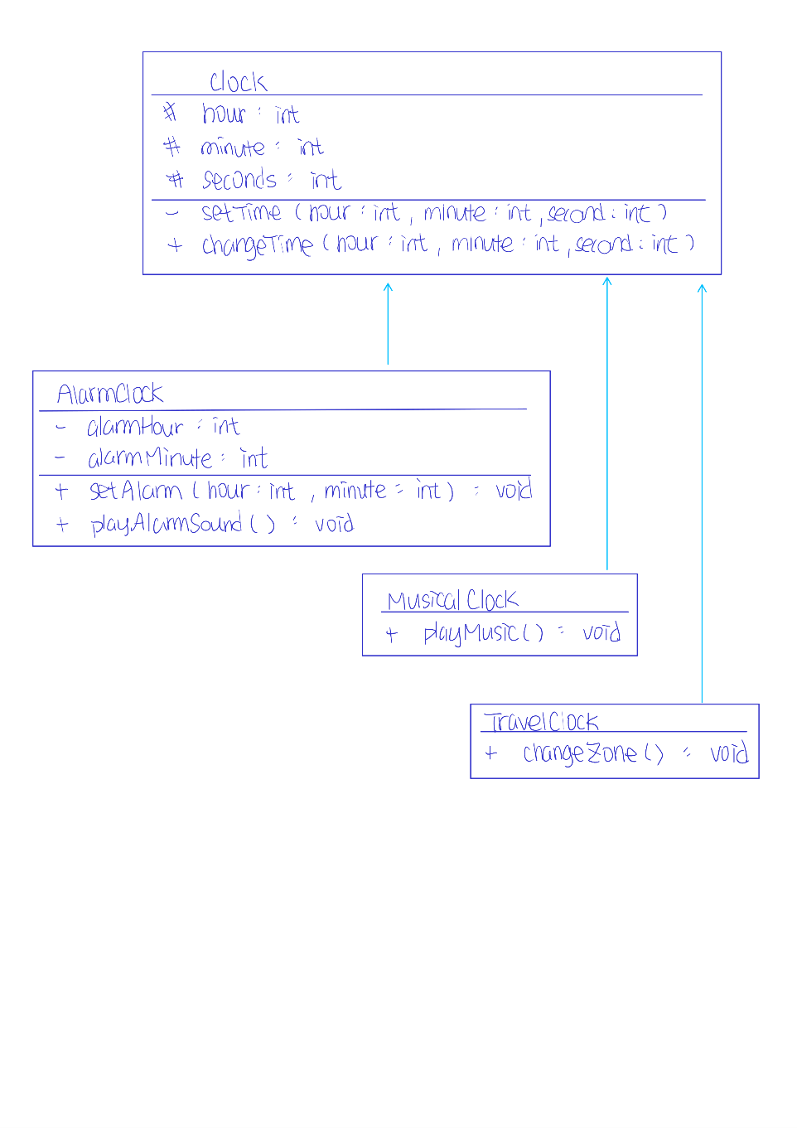



Ex 9.7

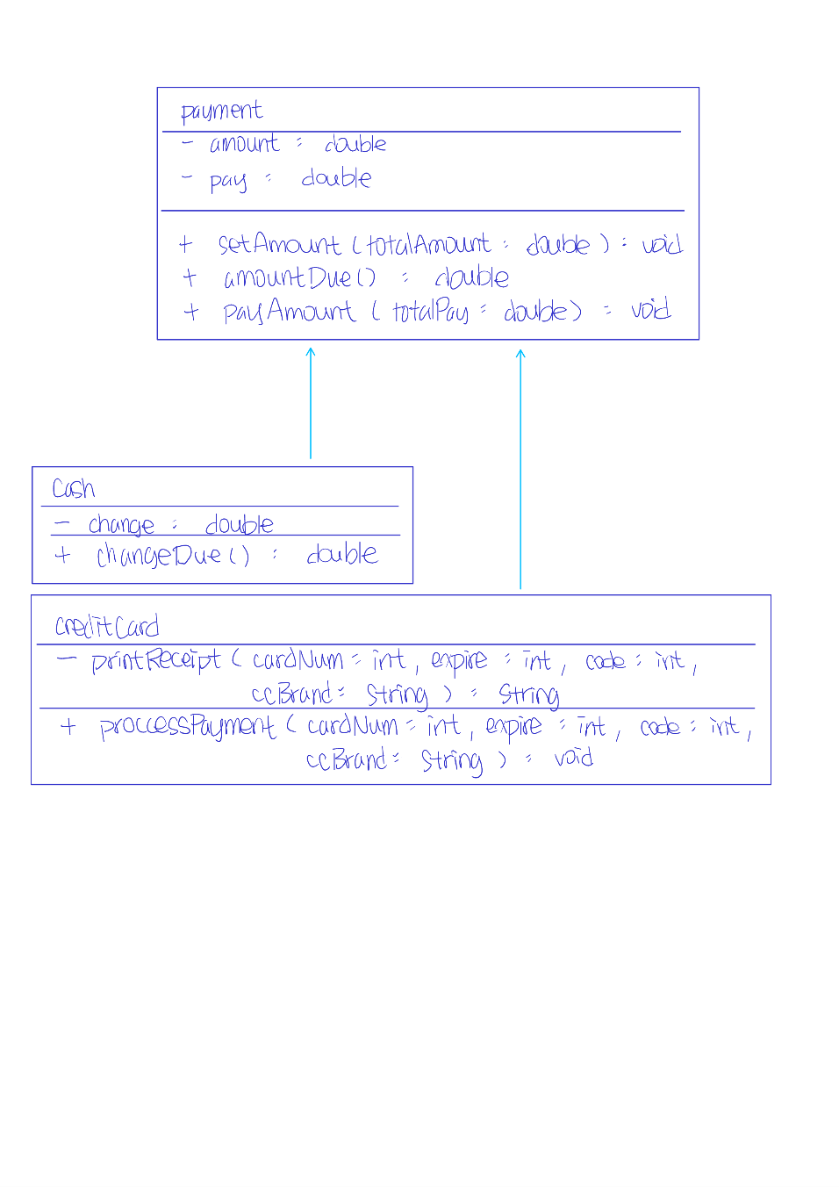



Ex 9.8

The chid class calls the constructor in the parent class implicitly even if I did not call the constructor of the parent class explicitly. When I call the constructor of the parent class explicitly, there is no difference at all. I believe that the child class is able to call the constructor of the parent class is due to fact that the constructor does not take in any parameters, otherwise there will be compilation errors.

PP 9.1

Source code below:

**package** hw3;

/* Java Class: CSCI 145

Author: Ivan Leung

Class: Mon/Wed

Date: May 07 2023

Description:

`

I certify that the code below is my own work.

Exception(s): N/A

*/

**public** **class** MonetaryCointTest {

**public** **static** **void** main(String[] args) {

**final** **int** PENNY = 1;

**final** **int** NICKEL = 5;

**final** **int** DIME = 10;

**final** **int** QUARTER = 25;

MonetaryCoin mc1 = **new** MonetaryCoin(PENNY);

MonetaryCoin mc2 = **new** MonetaryCoin(NICKEL);

MonetaryCoin mc3 = **new** MonetaryCoin(DIME);

MonetaryCoin mc4 = **new** MonetaryCoin(QUARTER);

System.***out***.println("Flips four coins...");

mc1.flip();

mc2.flip();

mc3.flip();

mc4.flip();

System.***out***.println("Penny lands a " + mc1);

System.***out***.println("Nickel lands a " + mc2);

System.***out***.println("Dime lands a " + mc3);

System.***out***.println("Quarter lands a " + mc1);

System.***out***.print("The total value of all coins is ");

System.***out***.println((mc1.getValue() + mc2.getValue() + mc3.getValue() + mc4.getValue()) + " cents");

}

}

**package** hw3;

/* Java Class: CSCI 145

Author: Ivan Leung

Class: Mon/Wed

Date: May 07 2023

Description:

`

I certify that the code below is my own work.

Exception(s): N/A

*/

**public** **class** MonetaryCoin **extends** Coin {

**private** **int** monetaryValue;

MonetaryCoin(**int** value) {

monetaryValue = value;

}

**public** **int** getValue() {

**return** monetaryValue;

}

}

Input/output below:

Flips four coins...

Penny lands a Heads

Nickel lands a Tails

Dime lands a Tails

Quarter lands a Heads

The total value of all coins is 41 cents

Chapter 10

Ex 10.2

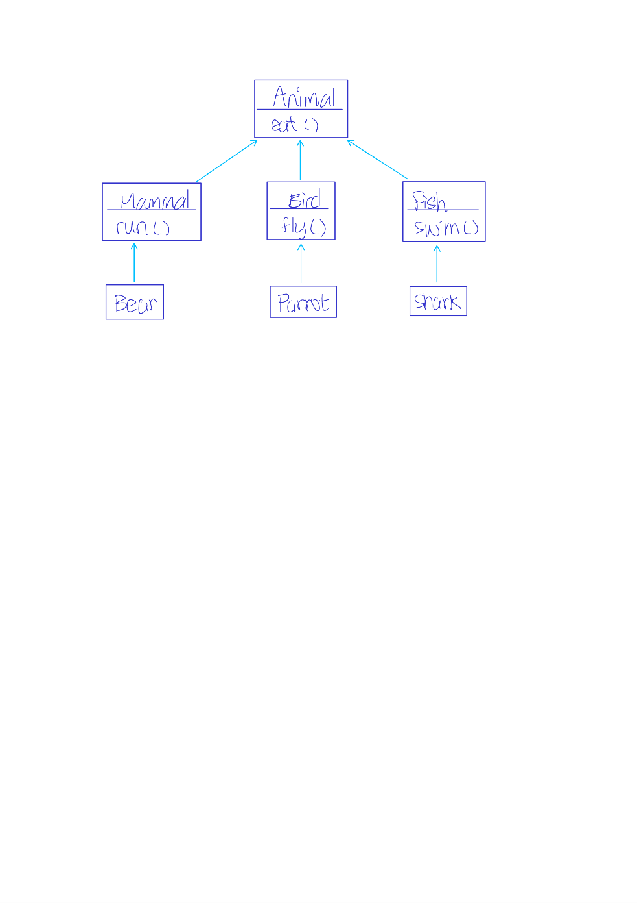



The eat() method in Animal class is an abstract method that in each of the derived classes, Bear, Parrot, and Shark must implement their own version of eat() since in real life, bears are omnivorous, parrots are herbivore, and Sharks are carnivore.

Ex 10.3

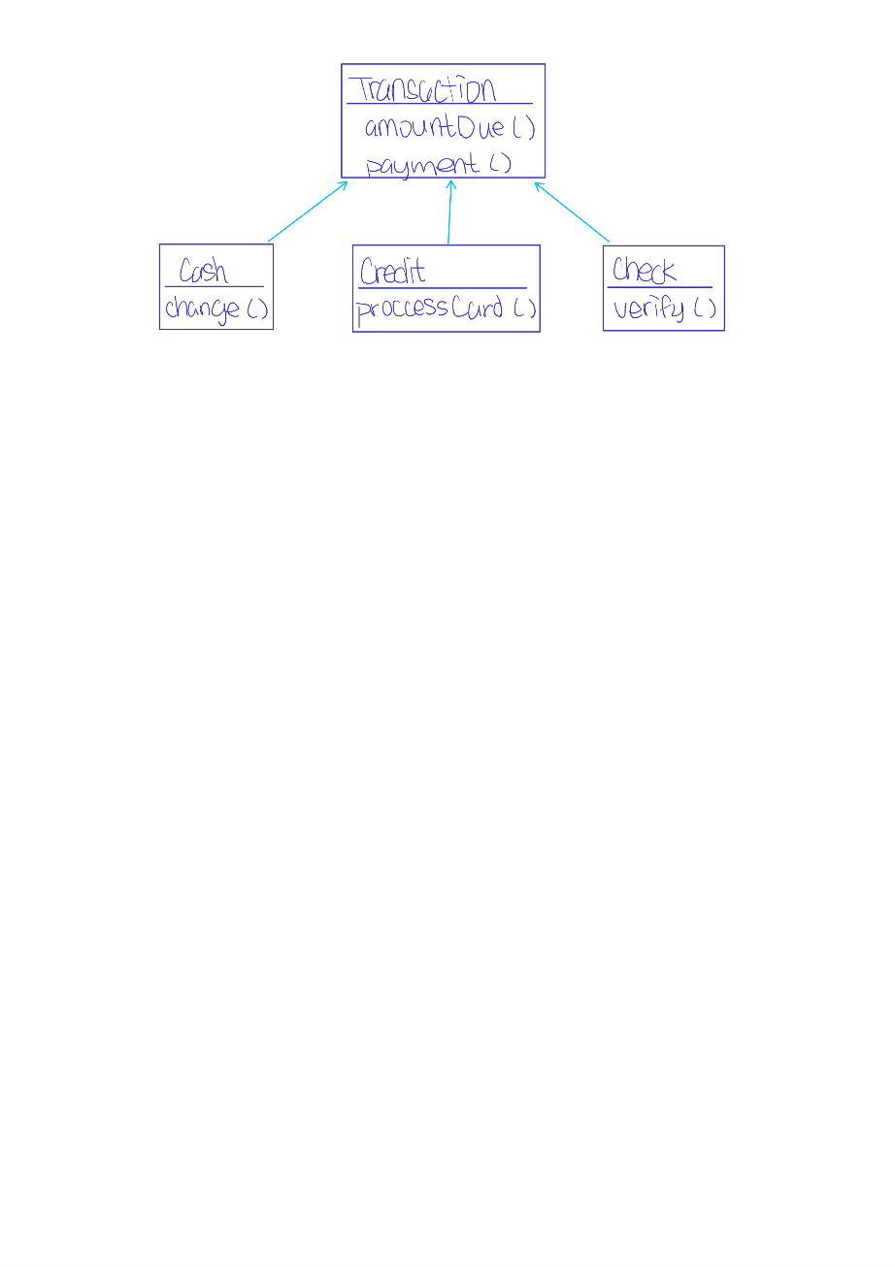

Each subclass of Transaction must utilize their own method in order to make payment() method work properly. For example, Credit must use processCard() in payment() to process a credit card payment.

Ex 10.4

If the pay method were not defined as an abstract method, all StaffMember may end up being getting pay the same way including Volunteer which are not supposed to get paid. Also, payRate has to be defined in StaffMember class. However, payRate should not be inherited by Volunteer which are not supposed to get paid.

PP 10.4

Source code below:

**package** hw3;

/* Java Class: CSCI 145

Modified by: Ivan Leung

Class: Mon/Wed

Date: May 07 2023

Description:

`

I certify that the code below is my own work.

Exception(s): N/A

*/

**public** **class** SortingTest {

**public** **static** **void** main(String[] args) {

Contact[] friends = **new** Contact[8];

friends[0] = **new** Contact("John", "Smith", "610-555-7384");

friends[1] = **new** Contact("Sarah", "Barnes", "215-555-3827");

friends[2] = **new** Contact("Mark", "Riley", "733-555-2969");

friends[3] = **new** Contact("Laura", "Getz", "663-555-3984");

friends[4] = **new** Contact("Larry", "Smith", "464-555-3489");

friends[5] = **new** Contact("Frank", "Phelps", "322-555-2284");

friends[6] = **new** Contact("Mario", "Guzman", "804-555-9066");

friends[7] = **new** Contact("Marsha", "Grant", "243-555-2837");

Sorting<Contact> sorts = **new** Sorting<Contact>();

sorts.selectionSort(friends);

**for** (Contact friend : friends)

System.***out***.println(friend);

System.***out***.println();

sorts.insertionSort(friends);

**for** (Contact friend : friends)

System.***out***.println(friend);

}

}

**package** hw3;

/* Java Class: CSCI 145

Modified by: Ivan Leung

Class: Mon/Wed

Date: May 07 2023

Description:

`

I certify that the code below is my own work.

Exception(s): N/A

*/

//********************************************************************

//Sorting.java Author: Lewis/Loftus

//

//Demonstrates the selection sort and insertion sort algorithms.

//********************************************************************

**public** **class** Sorting<T> {

// -----------------------------------------------------------------

// Sorts the specified array of objects using the selection

// sort algorithm.

// -----------------------------------------------------------------

@SuppressWarnings("unchecked")

**public** **void** selectionSort(Comparable<T>[] list) {

**int** max;

Comparable<T> temp;

**for** (**int** index = 0; index < list.length - 1; index++) {

max = index;

**for** (**int** scan = index + 1; scan < list.length; scan++)

**if** (list[scan].compareTo((T) list[max]) > 0)

max = scan;

// Swap the values

temp = list[max];

list[max] = list[index];

list[index] = temp;

}

}

// -----------------------------------------------------------------

// Sorts the specified array of objects using the insertion

// sort algorithm.

// -----------------------------------------------------------------

@SuppressWarnings("unchecked")

**public** **void** insertionSort(Comparable<T>[] list) {

**for** (**int** index = 1; index < list.length; index++) {

Comparable<T> key = list[index];

**int** position = index;

// Shift larger values to the right

**while** (position > 0 && key.compareTo((T) list[position - 1]) > 0) {

list[position] = list[position - 1];

position--;

}

list[position] = key;

}

}

}

Input/output below:

Smith, Larry 464-555-3489

Smith, John 610-555-7384

Riley, Mark 733-555-2969

Phelps, Frank 322-555-2284

Guzman, Mario 804-555-9066

Grant, Marsha 243-555-2837

Getz, Laura 663-555-3984

Barnes, Sarah 215-555-3827

Smith, Larry 464-555-3489

Smith, John 610-555-7384

Riley, Mark 733-555-2969

Phelps, Frank 322-555-2284

Guzman, Mario 804-555-9066

Grant, Marsha 243-555-2837

Getz, Laura 663-555-3984

Barnes, Sarah 215-555-3827

Chapter 11

Ex 11.2

The program will be terminated and all the statement at and after, System.out.println(“Level 1 ending.”), will not be executed, since the exception is not handled in level1().

Ex 11.3

The exception will be handled in level2() therefore, the statements in and after level2() will be executed.

Ex 11.4

a) ArithmeticException indicates that an irregular arithmetic condition has occurred such divide by zero.

b) NullPointerException is thrown when an application tries to access an object’s data but the object is null.

c) NumberFormatException indicates when an application tries to convert a string to a numeric type, but the string does not have the correct format.

d) PatternSyntaxException is thrown when there is a syntax error.

PP 11.2

Source code below:

**package** hw3;

/* Java Class: CSCI 145

Author: Ivan Leung

Class: Mon/Wed

Date: May 07 2023

Description:

`

I certify that the code below is my own work.

Exception(s): N/A

*/

**import** java.util.Scanner;

**public** **class** ExceptionTest {

**public** **static** **void** main(String[] args) {

**final** **int** MAX_STRING_LENGTH = 20;

String str;

Scanner scan = **new** Scanner(System.***in***);

**do** {

System.***out***.println("Enter a string:");

str = scan.nextLine();

**try** {

**if** (str.length() >= MAX_STRING_LENGTH)

**throw** **new** StringTooLongException("String is too long!");

}

**catch** (StringTooLongException strExcept) {

System.***out***.println(strExcept.getMessage());

}

} **while** (!str.equalsIgnoreCase("DONE"));

scan.close();

}

}

**package** hw3;

/* Java Class: CSCI 145

Author: Ivan Leung

Class: Mon/Wed

Date: May 07 2023

Description:

`

I certify that the code below is my own work.

Exception(s): N/A

*/

@SuppressWarnings("serial")

**public** **class** StringTooLongException **extends** Exception {

StringTooLongException(String errorMsg) {

**super**(errorMsg);

}

}

Input/output below:

Enter a string:

hello

Enter a string:

what sup

Enter a string:

this string is really longgggg

String is too long!

Enter a string:

good bye

Enter a string:

done

Chapter 12

Ex 12.2

public int power(int x, int y) {

if (y == 0)

return 1;

if (y > 1)  
 return x * power(x, y -1);

else

return x;

}

Ex 12.3

public int mul(int i, int j) {

if (i == 0)

return 0;

if (i > 1)

return j + mul(i – 1, j);

else

return j;

}

Ex 12.5

public int sum(int n, int start) {

int m = (n + start) / 2;

if (start > n)

return 0;

if (start == n)

return n;

return sum(m, start) + sum(n, m + 1);

}

PP 12.1

Source code below:

**package** hw3;

/* Java Class: CSCI 145

Author: Ivan Leung

Class: Mon/Wed

Date: May 07 2023

Description:

`

I certify that the code below is my own work.

Exception(s): N/A

*/

**import** java.util.Scanner;

**public** **class** PalindromeTester {

**public** **static** **void** main(String[] args) {

String str;

Scanner scan = **new** Scanner(System.***in***);

**do** {

System.***out***.println("Enter a pontential palindrome:");

str = scan.nextLine();

System.***out***.println("\nThat string " + (*isPalindrome*(str) ? "IS" : "is NOT") + " a palindrome.\n");

} **while** (*getChar*(scan, "Test another palindrome (y/n)? ") == 'y');

scan.close();

}

// Checks a string if it is a palindrome.

// It ignores any whitespace and punctuation.

// It is also not case-sensitive.

**public** **static** **boolean** isPalindrome(String str) {

str = str.replaceAll("[^a-zA-Z]", ""); // Discards all whitespace and punctuation.

str = str.toLowerCase(); // Converts all characters to lower-case characters.

**return** *isPalindrome*(str, 0, str.length() - 1);

}

// Recursive helper method to check for palindrome.

**private** **static** **boolean** isPalindrome(String str, **int** start, **int** end) {

**if** (start >= end)

**return** **true**;

**if** (str.charAt(start) != str.charAt(end))

**return** **false**;

**return** *isPalindrome*(str, start + 1, end - 1);

}

// Get a char from user input

**private** **static** **char** getChar(Scanner scan, String prompt) {

**char** choice;

// Input validation

**do** {

System.***out***.print(prompt);

choice = scan.nextLine().charAt(0);

choice = Character.*toLowerCase*(choice);

**if** (Character.*compare*(choice, 'y') == 0 || Character.*compare*(choice, 'n') == 0)

**return** choice;

System.***out***.println("Invalid input! Try again!\n\n");

} **while** (**true**);

}

}

Input/output below:

Enter a pontential palindrome:

radar

That string IS a palindrome.

Test another palindrome (y/n)? y

Enter a pontential palindrome:

radAr

That string IS a palindrome.

Test another palindrome (y/n)? y

Enter a pontential palindrome:

Iam,Hereh.mai

That string IS a palindrome.

Test another palindrome (y/n)? y

Enter a pontential palindrome:

abcbz

That string is NOT a palindrome.

Test another palindrome (y/n)? n