Exercise 9.1

2.

a) List all the ordered pairs in the relation R = {(a, b) | a divides b} on the set {1, 2, 3, 4, 5, 6}.

b) Display this relation graphically, as was done in Example 4.

c) Display this relation in tabular form, as was done in Example 4.

4. Determine whether the relation R on the set of all people is reflexive, symmetric, antisymmetric, and/or transitive, where (a, b) ∈ R if and only if

a) a is taller than b.

b) a and b were born on the same day.

c) a has the same first name as b.

d) a and b have a common grandparent.

10. Give an example of a relation on a set that is

a) both symmetric and antisymmetric.

b) neither symmetric nor antisymmetric.

Exercise 9.3

2. Represent each of these relations on {1, 2, 3, 4} with a matrix (with the elements of this set listed in increasing order).

a) {(1, 2), (1, 3), (1, 4), (2, 3), (2, 4), (3, 4)}

b) {(1, 1), (1, 4), (2, 2), (3, 3), (4, 1)}

c) {(1, 2), (1, 3), (1, 4), (2, 1), (2, 3), (2, 4), (3, 1), (3, 2),

(3, 4), (4, 1), (4, 2), (4, 3)}

d) {(2, 4), (3, 1), (3, 2), (3, 4)}

4. List the ordered pairs in the relations on {1, 2, 3, 4} corresponding to these matrices (where the rows and columns correspond to the integers listed in increasing order).

a)

b)

c)

8. Determine whether the relations represented by the matrices in Exercise 4 are reflexive, irreflexive, symmetric, antisymmetric, and/or transitive.

24. List the ordered pairs in the relations represented by the directed graphs.

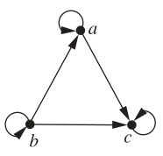

Exercise 9.5

2. Which of these relations on the set of all people are equivalence relations? Determine the properties of an equivalence relation that the others lack.

a) {(a, b) | a and b are the same age}

b) {(a, b) | a and b have the same parents}

c) {(a, b) | a and b share a common parent}

d) {(a, b) | a and b have met}

e) {(a, b) | a and b speak a common language}

Exercise 10.1

For question 4 – 8, determine whether the graph shown has directed or undirected edges, whether it has multiple edges, and whether it has one or more loops. Use your answers to determine the type of graph in Table 1 this graph is.

4.

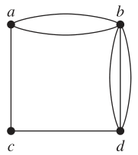

6.

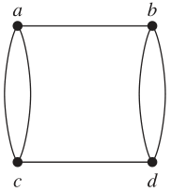

8.

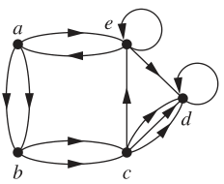

18. Who can influence Fred and whom can Fred influence in the influence graph in Example 2?

32. Which statements must be executed before S6 is executed in the program in Example 8? (Use the precedence graph in Figure 10.)

Exercise 10.2

6. Show that the sum, over the set of people at a party, of the number of people a person has shaken hands with, is even. Assume that no one shakes his or her own hand.

14. What does the degree of a vertex in the Hollywood graph represent? What does the neighborhood of a vertex represent? What do the isolated and pendant vertices represent?

20. Draw these graphs.

a) K7

b) K1,8

c) K4,4

d) C7

e) W7

f) Q4

58. Find the union of the given pair of simple graphs. (Assume edges with the same endpoints are the same.)

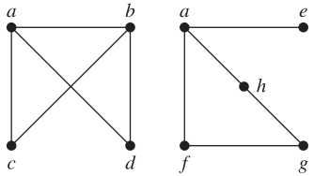

Exercise 10.3

For question 2 – 4, use an adjacency list to represent the given graph.

2.

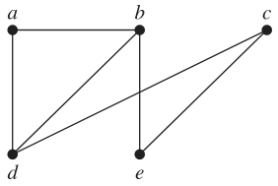

4.

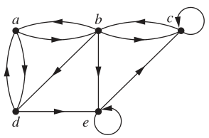

6. Represent the graph in Exercise 2 with an adjacency matrix.

8. Represent the graph in Exercise 4 with an adjacency matrix.

12. Draw a graph with the given adjacency matrix.

14. Represent the given graph using an adjacency matrix.

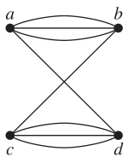

26. Use an incidence matrix to represent the graphs in Exercises 1 and 2.

For question 38 and 42, determine whether the given pair of graphs is isomorphic. Exhibit an isomorphism or provide a rigorous argument that none exists.

38.

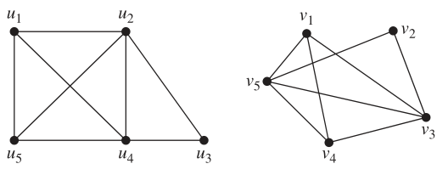

42.

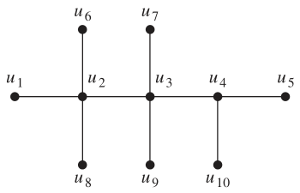

Exercise 10.4

2. Does each of these lists of vertices form a path in the following graph? Which paths are simple? Which are circuits? What are the lengths of those that are paths?

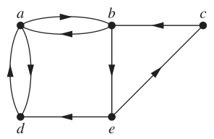

a) a, b, e, c, b

b) a, d, a, d, a

c) a, d, b, e, a

d) a, b, e, c, b, d, a

8. What do the connected components of a collaboration graph represent?

14. Find the strongly connected components of each of these graphs.

a)

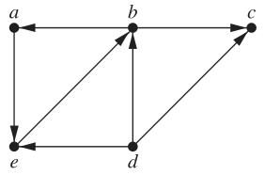

b)

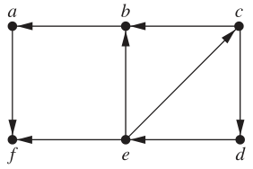

c)

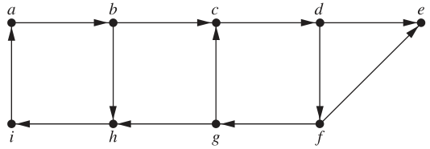

Exercise 10.5

2. Determine whether the given graph has an Euler circuit. Construct such a circuit when one exists. If no Euler circuit exists, determine whether the graph has an Euler path and construct such a path if one exists.

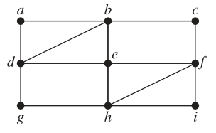

Exercise 11.1

2. Which of these graphs are trees?

a)

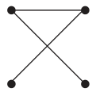

b)

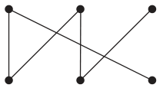

c)

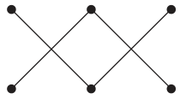

d)

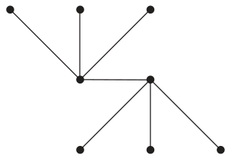

e)

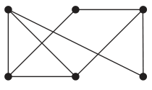

f)

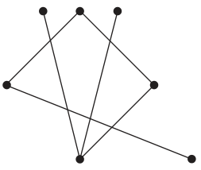

4. Answer the same questions as listed in Exercise 3 for the rooted tree illustrated.

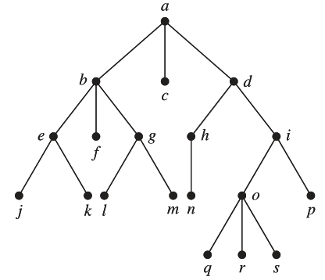

6. Is the rooted tree in Exercise 4 a full m-ary tree for some positive integer m?

10. Draw the subtree of the tree in Exercise 4 that is rooted at

a) a.

b) c.

c) e.

18. How many vertices does a full 5-ary tree with 100 internal vertices have?

20. How many leaves does a full 3-ary tree with 100 vertices have?

Exercise 11.3

8. Determine the order in which a preorder traversal visits the vertices of the given ordered rooted tree.

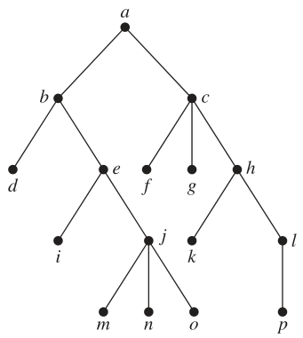

12. In which order are the vertices of the ordered rooted tree in Exercise 9 visited using an inorder traversal?

14. In which order are the vertices of the ordered rooted tree in Exercise 8 visited using a postorder traversal?

16. a) Represent the expression ((x + 2) ↑ 3) ∗ (y −(3 + x)) − 5 using a binary tree. Write this expression in

b) prefix notation.

c) postfix notation.

d) infix notation.

22. Draw the ordered rooted tree corresponding to each of these arithmetic expressions written in prefix notation. Then write each expression using infix notation.

a) + ∗ + − 5 3 2 1 4

b) ↑ + 2 3 − 5 1

c) ∗ / 9 3 + ∗ 2 4 − 7 6

24. What is the value of each of these postfix expressions?

a) 5 2 1 − − 3 1 4 ++ ∗

b) 9 3 / 5 + 7 2 − ∗

c) 3 2 ∗ 2 ↑ 5 3 − 8 4 / ∗ −

Exercise 11.4

4. Find a spanning tree for the graph shown by removing edges in simple circuits.

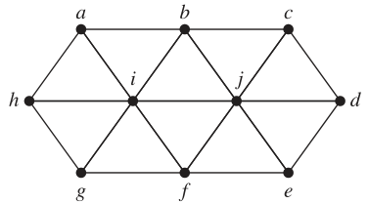

For question 8 and 10, draw all the spanning trees of the given simple graphs.

8.

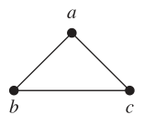

10.

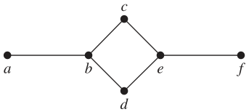

14. Use depth-first search to produce a spanning tree for the given simple graph. Choose a as the root of this spanning tree and assume that the vertices are ordered alphabetically.

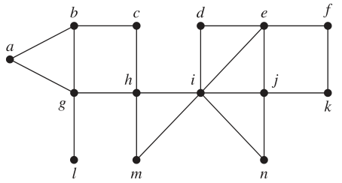

16. Use breadth-first search to produce a spanning tree for each of the simple graphs in Exercises 13–15. Choose *a* as the root of each spanning tree.

Exercise 12.1

2. Find the values, if any, of the Boolean variable x that satisfy these equations.

a) x · 1 = 0

b) x + x = 0

c) x · 1 = x

d) x · x = 13

6. Use a table to express the values of each of these Boolean functions.

a) F(x, y, z) = z

b) F(x, y, z) = xy + yz

c) F(x, y, z) = xyz + (xyz)

d) F(x, y, z) = y(xz + x z)

10. How many different Boolean functions are there of degree 7?

12. Show that F(x, y, z) = xy + xz + yz has the value 1 if and only if at least two of the variables x, y, and z have the value 1.

24. Simplify these expressions.

a) x ⊕ 0

b) x ⊕ 1

c) x ⊕ x

d) x ⊕ x

28. Find the duals of these Boolean expressions.

a) x + y

b) $\overline{x}$ $\overline{y}$

c) xyz + $\overline{x}$ $\overline{y}$ $\overline{z}$

d) x $\overline{z}$ + x · 0 + $\overline{x}$· 1

Exercise 12.2

2. Find the sum-of-products expansions of these Boolean functions.

a) F(x, y) = $\overline{x}$ + y

b) F(x, y) = x $\overline{y}$

c) F(x, y) = 1

d) F(x, y) =

4. Find the sum-of-products expansions of the Boolean function F(x, y, z) that equals 1 if and only if

a) x = 0.

b) xy = 0.

c) x + y = 0.

d) xyz = 0.

6. Find the sum-of-products expansion of the Boolean function F(x1, x2, x3, x4, x5) that has the value 1 if and only if three or more of the variables x1, x2, x3, x4, and x5 have the value 1.

Exercise 12.3

For question 2 and 4, find the output of the given circuit.

2.

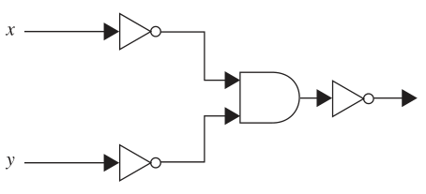

4.

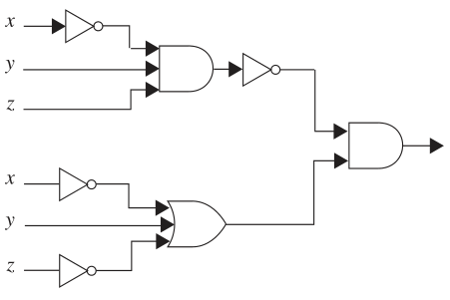

6. Construct circuits from inverters, AND gates, and OR gates to produce these outputs.

a) $\overline{x}$ + y

b) $\overline{(x + y)}$ x

c) x y z +

d)

16. Use NOR gates to construct circuits for the outputs given in Exercise 15.

a) $\overline{x}$

b) x + y

c) xy