Exercise 11.1

1. Which of these graphs are trees?

a)

b)

3. Answer these questions about the rooted tree illustrated.

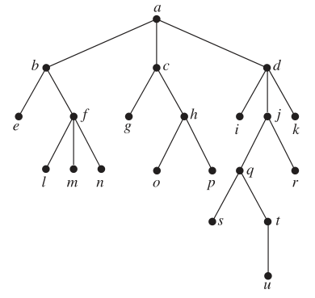

Exercise 11.3

7. Determine the order in which a preorder traversal visits the vertices of the given ordered rooted tree.

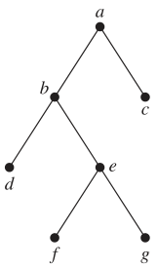

11. In which order are the vertices of the ordered rooted tree in Exercise 8 visited using an inorder traversal?

13. In which order are the vertices of the ordered rooted tree in Exercise 7 visited using a postorder traversal?

Exercise 11.4

3. Find a spanning tree for the graph shown by removing edges in simple circuits.

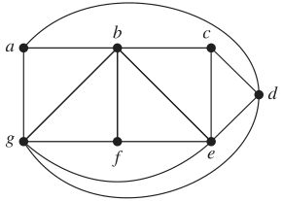

9. Draw all the spanning trees of the given simple graphs.

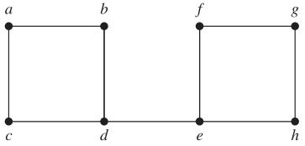

13. Use depth-first search to produce a spanning tree for the given simple graph. Choose a as the root of

this spanning tree and assume that the vertices are ordered alphabetically.

