Exercise 11.1

1. Which of these graphs are trees?

a)

Yes, it is a tree.

b)

No, it is not a tree.

3. Answer these questions about the rooted tree illustrated.

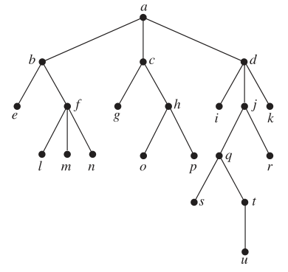

a) Which vertex is the root?

Vertex a.

b) Which vertices are internal?

Vertex a, b, c, d, f, h, j, q, t.

c) Which vertices are leaves?

Vertex e, g, i, k, l, m, n, o, r, s, u.

d) Which vertices are children of j?

Vertex q, r.

e) Which vertex is the parent of h?

Vertex c.

f ) Which vertices are siblings of o?

Vertex p.

g) Which vertices are ancestors of m?

Vertex a, b, f.

h) Which vertices are descendants of b?

Vertex e, f, l, m, n.

Exercise 11.3

7. Determine the order in which a preorder traversal visits the vertices of the given ordered rooted tree.

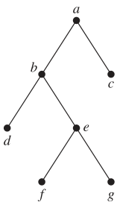

root, left, right

a, b, d, e, f, g, c

11. In which order are the vertices of the ordered rooted tree in Exercise 8 visited using an inorder traversal?

left, root, right

d, b, i, e, m, j, n, o, a, f, c, g, k, h, p, l

13. In which order are the vertices of the ordered rooted tree in Exercise 7 visited using a postorder traversal?

left, right, root

d, f, g, e, b, c, a

Exercise 11.4

3. Find a spanning tree for the graph shown by removing edges in simple circuits.

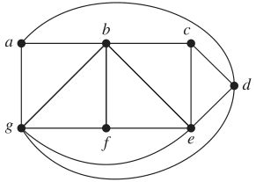



9. Draw all the spanning trees of the given simple graphs.

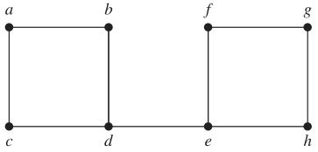



13. Use depth-first search to produce a spanning tree for the given simple graph. Choose a as the root of

this spanning tree and assume that the vertices are ordered alphabetically.



