Exercise 12.1

1. Find the values of these expressions.

a) 1 ·

= 1 · 1

= 1

b) 1 +

= 1 + 0

= 1

c) · 0

= 1 · 0

= 0

d)

=

= 0

5. Use a table to express the values of each of these Boolean functions.

a) F(x, y, z) = y

|  |  |  |  |  |
| --- | --- | --- | --- | --- |
| x | y | z |  | y |
| 1 | 1 | 1 | 0 | 0 |
| 1 | 1 | 0 | 0 | 0 |
| 1 | 0 | 1 | 0 | 0 |
| 1 | 0 | 0 | 0 | 0 |
| 0 | 1 | 1 | 1 | 1 |
| 0 | 1 | 0 | 1 | 1 |
| 0 | 0 | 1 | 1 | 0 |
| 0 | 0 | 0 | 1 | 0 |

Exercise 12.2

1. Find a Boolean product of the Boolean variables x, y, and z, or their complements, that has the value 1 if and only if

a) x = y = 0, z = 1.

z

3. Find the sum-of-products expansions of these Boolean functions.

a) F(x, y, z) = x + y + z

|  |  |  |  |
| --- | --- | --- | --- |
| x | y | z | x + y + z |
| 1 | 1 | 1 | 1 |
| 1 | 1 | 0 | 0 |
| 1 | 0 | 1 | 0 |
| 1 | 0 | 0 | 0 |
| 0 | 1 | 1 | 0 |
| 0 | 1 | 0 | 0 |
| 0 | 0 | 1 | 0 |
| 0 | 0 | 0 | 0 |

xyz + xy + xz + x + yz +y + z

5. Find the sum-of-products expansion of the Boolean function F(w, x, y, z) that has the value 1 if and only if an odd number of w, x, y, and z have the value 1.

|  |  |  |  |  |
| --- | --- | --- | --- | --- |
| w | x | y | z | Odd number of value 1 |
| 1 | 1 | 1 | 1 | 0 |
| 1 | 1 | 1 | 0 | 1 |
| 1 | 1 | 0 | 1 | 1 |
| 1 | 1 | 0 | 0 | 0 |
| 1 | 0 | 1 | 1 | 1 |
| 1 | 0 | 1 | 0 | 0 |
| 1 | 0 | 0 | 1 | 0 |
| 1 | 0 | 0 | 0 | 1 |
| 0 | 1 | 1 | 1 | 1 |
| 0 | 1 | 1 | 0 | 0 |
| 0 | 1 | 0 | 1 | 0 |
| 0 | 1 | 0 | 0 | 1 |
| 0 | 0 | 1 | 1 | 0 |
| 0 | 0 | 1 | 0 | 1 |
| 0 | 0 | 0 | 1 | 1 |
| 0 | 0 | 0 | 0 | 0 |

wxy + wxz + wyz + w + xyz + x + y + z

Exercise 12.3

For 1 and 5, find the output of the given circuit.

1.

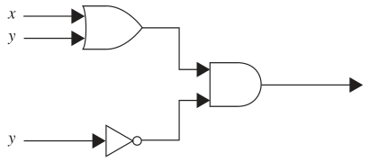

(x + y) ·

3.

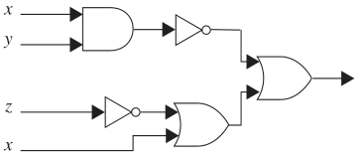

+ ( + x)