Dolendar System Requirements

Inf 43 – Homework 1

###### Oct 17, 2023

Ivan Leung

ID# 67485846

##### Table of Contents

**Introduction………………………………………………………………..2**

**Executive Summary……………………………………...………………..2**

**Application Context / Environment Constraints………………………..3**

**Functional Requirements………………………………………..………..4**

**Non-Functional Requirements…………………………………………...8**

**Other Requirements………………………………………………………8**

**Glossary……………………………………………………………………9**

**Assumptions / Risks…………………………………………………….....9**

**Priorities / Implementation Phases……………………………………....9**

**Future Directions and Expected Changes………………………………10**

##### Introduction

This document outlines the requirements specification for a new productivity suite of software, Dolendar, a revolutionary calendar that is developed by the INF43 Software Engineering group and contracted by the founder and president of DoMore Software corp., Dom Dones. What makes Dolendar apart from other calendar apps is that the tasks in Dolendar will flow around the calendar as time moves. If a task is completed, it will disappear from the calendar and the next task will slide up and all of the following tasks will also slide up. If a task is not completed within its duration, the current task and all other tasks will be pushed back.

By investing in the development of Dolendar, Dom Dones, the founder and president of DoMore Software corp., aims to combine a typical calendar app with a to-do list manager to help users manage their time more efficiently and combat procrastination.

##### Executive Summary

Dolendar is a combination of a calendar and a to-do list. Its primary goal is to help its users manage their time more efficiently and combat procrastination.

Dolendar has two views, calendar view and to-do list view. The to-do list view outlines all tasks the user has. The calendar view also has two different views, weekly view and day view.

What makes Dolendar different than other calendar apps are that when users complete their tasks, the next task will slide up to the current time block. However, if a task is not completed before it is due, the task will stay at the current time and all the following tasks will get pushed back. This way can help users to visualize the effect of procrastination. Users can put tags on their tasks, and they can filter out other tasks and have tasks with the appropriate tag only.



The first version of Dolendar will be available on mobile devices such as iOS and Android. It will be able to sync with Google Calendar and iCalendar. The second version will support desktop platforms such as Windows, Mac, Linux, etc.

The app is free to use so user data is stored locally on users’ devices and there is no need to maintain cloud service. The app offers subscription where users can sync their data to the cloud. The subscription also allows users to share, create and assign new tasks to other users.

App integration with other calendar apps such Microsoft Outlook, etc., is planned in the future. Weekly summary may be implemented in the future.

##### Application Context / Environmental Constraints

The first version of Dolendar is going to be available on mobile devices only such as Apple iPhone(iOS), Android phones and tablets. The app is installed on the devices themselves. At the time of release, the app will be compatible with the current version of iOS and Android and the one prior.

The desktop version of Dolendar will be available in the second version. The app will be available on desktop platforms such as Windows, Mac and Linux.

There is no specific programming language required.

The app is expected to be run primarily on mobile devices as most people would track their daily tasks on their mobile phones. Users can store their data on their phones locally. For desktop users, they are expected to be run in office where employers can assign tasks to their employers with collaborate features. The app is free to use, and it is not necessary to create an account. Users have the option to create an account which can potentially unlock paid tier features where users can work collaboratively. Users can share their tasks with other users. Users can create new tasks for other users.

The UI provides calendar view and to-do list view. The calendar view has both weekly view and day view. The to-do list view outlines all tasks. The UI should be elegant, intuitive and easy to use. Further details will be discussed with the UI engineers.

Additional app integration is planned in the future where it can sync with other calendar apps such as Microsoft Outlook, etc.

##### Functional Requirements



Introduction:

This section describes the features of Dolendar. It includes how the actors interact with the system, and how the system behaves from these interactions.

In the user case diagram, there are three actors. The actors are the user without subscription, users with subscription and the backend server. Both users with or without subscription share most of common functionality except that the user with subscription can assign task, share view and calendar sync. The backend server handles assign task, share view and calendar sync on the cloud. Also, the backend server handles data encryption.

Use Case Diagram:

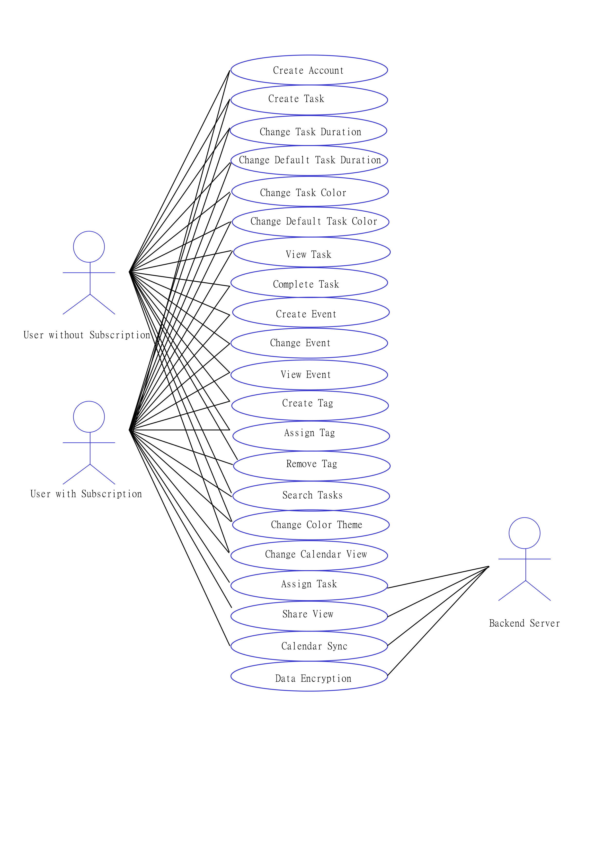

User with/without subscription:

* Create Account: Every user has the opportunity to create an account. The subscription requires the users to have an account to synchronize their data to the cloud.
* Create Task: The user can create a new task in the task view. When creating a new task, the user can choose a title for the task, write a description of what the task is about, set the duration of the task, and set the starting time of the task.
* Change Task Duration: The user can click on a task and change that task’s duration. The time block the task occupies will enlarge or shrink depending on if the duration is being increased or decreased.
* Change Default Task Duration: The user can change the default duration for the newly created tasks in the option menu.
* Change Task Color: The user can change the color of task where it displays as a time block in the calendar.
* Change Default Task Color: The user can change the default task color in the option menu.
* View Task: The user can click on task in task view or calendar in order to view the details of the task.
* Complete Task: When the user completes a task, the user can remove the task by clicking the completed button in the task. The pending task, if available, should slide up to the current time block.
* Create Event: The user can create an event in the calendar view.
* Change Event: The event can be changed if needed.
* View Event: The user can click on an event to view the details of the event.
* Create Tag: The user can create a tag which can be assigned to a task. A tag simply has a name.
* Assign Tag: Tags can be assigned to tasks which can be searched using filters.
* Remove Tag: Tags can be removed from tasks.
* Search Tasks: The user can search tasks by applying tags to the search filter. Only tasks with appropriate tags will show up.
* Change Color Theme: The color theme of the app can be changed in the option menu.
* Change Calendar View: The user can switch between calendar view and task view.

User with subscription:

* Assign Task: With subscription, the user can assign tasks to other users who also have subscription.
* Share View: User can share what tasks he/she has with other users.
* Calendar Sync: With subscription, all of user’s tasks and events are synchronized to the cloud server. It is done automatically without the need for user action.

Backend server:

* Assign Task: The user can assign a task to another user. The backend server will process the task and assign the task to another user’s calendar.
* Share View: Upon the user’s permission, the user can share his/her task list with another user through the backend server.
* Calendar Sync: The backend server will sync all of the user’s data periodically without user’s action.
* Data Encryption: All user data is encrypted on the backend server.

Use Case 1: Create Task

* Basic Flow:

1. User opens Dolendar app.
2. User navigates to the calendar view.
3. User navigates to and selects the time and date he/she wants to create a new task.
4. User selects the “Create Task” option.
5. Dolendar app prompts the user to enter the details of the task.
6. User enters the task title.
7. User enters the task description.
8. User enters the start time of the task.
9. User leaves the task duration and task color as default setting.
10. User selects “Confirm” to confirm the details he/she entered.
11. Dolendar check if the time block is available for the task.
12. Since the time block is available, the task has been created.

* Alternative Flow:

9.a. User wants to change the task color.

1. User selects “Task Color” option.

2. User chooses a color he/she wants for the task.

3. User selects “Confirm” to confirm the change of task color.

4. The flow continues from step 10 in Basic Flow.

* Exception Flow:

8.a. User enters an invalid start time for the task.

1. Dolendar warns user that the start time is invalid.

2. Start time is not added to the task.

Use Case 2: Share View

* Basic Flow:

1. User opens Dolendar app.
2. User navigates to the calendar view.
3. User selects “Share Calendar” option.
4. User selects “Find User” option.
5. User chooses another user in the list.
6. User selects "Confirm” to confirm that he/she wants to share his calendar with selected user.
7. The request is sent to the backend server.
8. Backend server validates both users’ subscriptions.
9. Backend server processes the request.

**Non-functional Requirements**

Usability:

Creating new tasks and events should be straightforward. All tasks must have a default duration without the need to set duration each time creating a new task. Tasks also have the option to have a due date. Sub-tasks can be created to form a task.

Security and Privacy: All user data is encrypted on our server. Users can mark their tasks private, and no one shall see others’ private tasks in collaboration mode. There is no parental control. The app is suitable for all ages.

Subscription:

The subscription allows users to sync their data to the cloud which then can be synced between different devices. The app also has collaboration features that are subscription based. Without the collaboration features, all user data stores locally on their own devices. The subscription is the primary source of income. Users will get notification if they are assigned new tasks.

Quality:

Efficiency:

Adaptability:

Portability:

##### Other Requirements

We often feel we have more to say, in other words somehow the previous two sections did not cover all requirements. This is the place to do it! Any requirements that you are aware of can be described here; you can also add diagrams or other visuals that did not fit in previous sections.

Budget:

$1,000,000 for the first version of the software.

$1,000,000 for the second version of the software.

Total Budget: $2,00,000

Projected Timeline:

First version: October 31st, 2024

Second version: April 30th, 2025

User Interface:

The UI has two different views. The calendar view and to-do list view. The to-do list view outlines all tasks you have. The calendar view also has two different views, the weekly view and the day view. All the events are displayed in the calendar view. The weekly view displays Sunday to Saturday from left to right with time stamps from top to bottom. The day view also displays the time stamp from top to bottom. However, it can display more details of each task with the extra room. When a task is completed, the task will disappear from the calendar and the next task will flow forward and form a new time block. The length of the new time block might be different than the completed task because every task may have a different duration. Users can use tags to mark their tasks with different labels. Users can filter out tasks and only see the tasks with specific tags.

Users should take minimum effort to create a task. The app has a default color theme and a dark theme. The app also has user-defined color theme that users can customize their own color. Users can also customize their tasks with different color.

**Glossary**

* Dolendar: a revolutionary calendar which combines a to-do list and traditional events one may find in a calendar app.
* Task: an item in the to-do list. It has duration which should be completed within its specific time windows. If it is not completed within its specific time window, it automatically flows down to the next time windows.
* Sub-task: an item exists in a main task. A main task can have multiple sub-tasks. All sub-tasks’ duration make up the duration of the main task.
* Event: a traditional event in most calendar apps. It only happens at a specific time. It does not flow around the calendar unlike tasks.
* Tag: tag is a label on a task. It allows users to filter their tasks with specific tags.
* Time block/window: it indicates how long a task should take and when it should start and end.

##### Assumptions / Risks

* The collaborate features may not attract enough users to pay for the subscription.
* The market is already flooded with many calendar apps and to-do lists apps.
* Competitors may steal our ideas and implement them in their own apps.
* The cloud has a risk of being hacked and user data being leaked and potentially having legal issues.

##### Priorities / Implementation Phases

First version:

The first version will focus on the development of mobile platforms. It includes calendar view and to-do list view. Sub-tasks can be created to form a task. It also includes the collaborate features. It is expected to be released October 31st, 2024.

Second version:

The second version will focus on the development of desktop platforms. It is expected to be released 6 months after the release of the first version which is April 30th, 2025.



##### Future Directions and Expected Changes

Calendar apps integration:

It will be able to sync with other calendar apps such Microsoft Outlook, etc. It will also have integration with Canvas app in the future.

Weekly Summary:

Weekly summary displays how the users managed their data on a weekly basis. It might be made available later.

Mobile widget:

It might be made available later.

Accessibility:

Font size is changeable.