Exercise 10.1

For 3 – 9, determine whether the graph shown has directed or undirected edges, whether it has multiple edges, and whether it has one or more loops. Use your answers to determine the type of graph in Table 1 this graph is.

3.

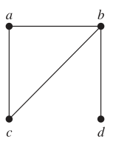

It has undirected edges and no loops nor multiple edges.

∴ it is a simple graph.

5.

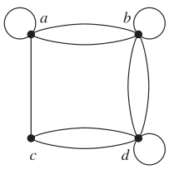

It has undirected edges, loops and no multiple edges.

∴ it is a pseudograph.

7.

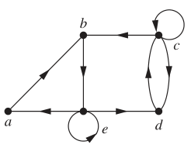

It has directed edges, loops and no multiple edges.

∴ it is a directed graph.

9.

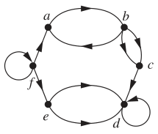

It has directed edges, loops, and multiple edges.

∴ it is a directed multigraph.

Exercise 10.2

3. Find the number of vertices, the number of edges, and the degree of each vertex in the given undirected graph. Identify all isolated and pendant vertices.

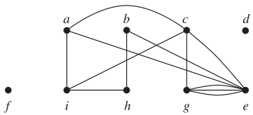

vertices = 9

edges = 12

deg(a) = 3

deg(b) = 2

deg(c) = 4

deg(d) = 0

deg(e) = 6

deg(f) = 0

deg(g) = 4

deg(h) = 2

deg(i) = 3

d and f are isolated.

7. Determine the number of vertices and edges and find the in-degree and out-degree of each vertex for the given directed multigraph.

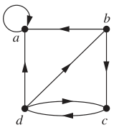

vertices = 4

edges = 7

deg-(a) = 3

deg-(b) = 1

deg-(c) = 2

deg-(d) = 1

deg+(a) = 1

deg+(b) = 2

deg+(c) = 1

deg+(d) = 3

Exercise 10.3

For 1 and 3, use an adjacency list to represent the given graph.

1.

|  |  |
| --- | --- |
| Vertex | Adjacent Vertices |
| a | b, c, d |
| b | a, d |
| c | a, d |
| d | a, b, c |

3.

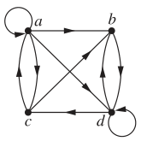

|  |  |
| --- | --- |
| Vertex | Terminal Vertices |
| a | a, b, c, d |
| b | d |
| c | a, b |
| d | b, c, d |

13. Represent the given graph using an adjacency matrix.

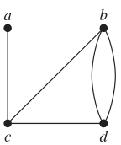

$\left[\begin{matrix}0 & 0 & 1 & 0 \\ 0 & 0 & 1 & 2 \\ 1 & 1 & 0 & 1 \\ 0 & 2 & 1 & 0\end{matrix}\right]$

Exercise 10.4

1. Does each of these lists of vertices form a path in the following graph? Which paths are simple? Which are circuits? What are the lengths of those that are paths?

a) a, e, b, c, b

Forms a path

Not simple

Not circuit

Length of 4

b) a, e, a, d, b, c, a

Does not form a path

11. Determine whether each of these graphs is strongly connected and if not, whether it is weakly connected.

a)

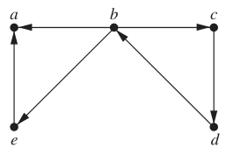

Weakly connected.

b)

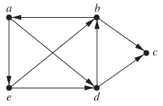

Weakly connected.

c)

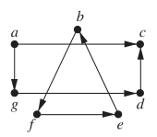

Not strongly nor weakly connected.

Exercise 10.5

1. Determine whether the given graph has an Euler circuit. Construct such a circuit when one exists. If no Euler circuit exists, determine whether the graph has an Euler path and construct such a path if one exists.

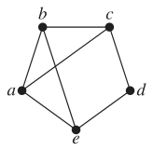

Neither Euler circuit nor Euler path exist.