Exercise 12.1

1. Find the values of these expressions.

a) 1 ·

b) 1 +

c) · 0

d)

5. Use a table to express the values of each of these Boolean functions.

a) F(x, y, z) = $\overline{x}$ y

Exercise 12.2

1. Find a Boolean product of the Boolean variables x, y, and z, or their complements, that has the value 1 if and only if

a) x = y = 0, z = 1.

3. Find the sum-of-products expansions of these Boolean functions.

a) F(x, y, z) = x + y + z

5. Find the sum-of-products expansion of the Boolean function F(w, x, y, z) that has the value 1 if and only if an odd number of w, x, y, and z have the value 1.

Exercise 12.3

For 1 and 5, find the output of the given circuit.

1.

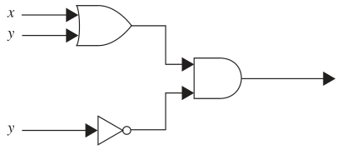

5.

