# Activity Monitoring Devices

### 1.Loading and preprocessing the data

Code:

setwd("C:/Users/Ivan.Liuyanfeng/Desktop/Data_Mining_Work_Space/Reproducible_research/")  
act.zip <- "activity.zip"  
act.csv <- "activity.csv"  
if(file.exists(act.zip)) unzip(act.zip)  
act.data <- read.csv(act.csv, header=TRUE)  
library(data.table)  
tb.data <- data.table(act.data)  
act.total <- tb.data[,sum(steps,na.rm=T),by=date]  
head(act.total,n=5)

## date V1  
## 1: 2012-10-01 0  
## 2: 2012-10-02 126  
## 3: 2012-10-03 11352  
## 4: 2012-10-04 12116  
## 5: 2012-10-05 13294

### 2.What is mean total number of steps taken per day?

2.1 Make a histogram of the total number of steps taken each day.

library(ggplot2)  
setnames(act.total, "V1","steps")  
hist.s <- qplot(steps, data=act.total)  
hist.s + labs(title="Total Number of Steps")

## stat_bin: binwidth defaulted to range/30. Use 'binwidth = x' to adjust this.

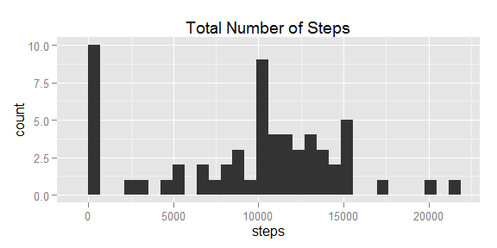

2.2 Calculate and report the mean and median total number of steps taken per day.

step.mean <- mean(act.total$steps,na.rm=T)  
step.median <- median(act.total$steps, na.rm=T)

##### The mean and median total number of steps taken per day are 9354.2295 and 10395, respectively.

### 3.What is the average daily activity pattern?

3.1 Make a time series plot of the 5-minute interval and the average number of steps taken, averaged across all days.

act.avg <- tb.data[,mean(steps,na.rm=T),by=interval]  
setnames(act.avg, "V1","steps")  
ts <- ggplot(act.avg, aes(x=interval,y=steps))  
ts + geom_line() + labs(title = "Average Number of Steps across All Days")

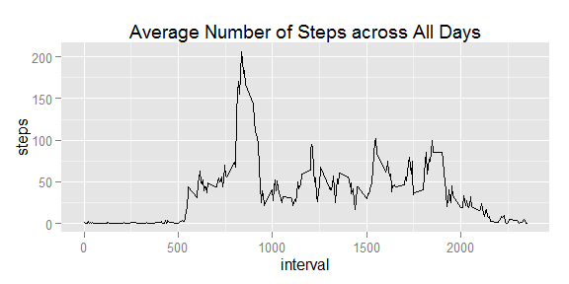

3.2 Which 5-minute interval, on average across all the days in the dataset, contains the maximum number of steps?

step.max <- act.avg$interval[act.avg$steps==max(act.avg$steps)]

##### The 5-minute interval: 835, contains the maximum number of steps on average across all the days in the dataset.

### 4.Imputing missing values

4.1 Calculate and report the total number of missing values in the dataset.

num_missing <- sum(is.na(act.data[,1]))

##### The total number of missing values in the data set is: 2304!

4.2 Devise a strategy for filling in all of the missing values in the dataset.

imputed.data <- act.data  
for (i in 1:nrow(act.data)){  
 if (is.na(imputed.data[i,1])){ imputed.data[i,1] <- mean(act.data$steps, na.rm=T)}  
}

4.3 Create a new dataset that is equal to the original dataset but with the missing data filled in.

tb.imputed <- data.table(imputed.data)  
imputed.total <- tb.imputed[,sum(steps,na.rm=T), by=date]

4.4 Make a histogram of the total number of steps taken each day and Calculate and report the mean and median total number of steps taken per day.

#colnames(imputed.total)  
setnames(imputed.total, "V1","steps")  
hist.s.2 <- qplot(steps, data=imputed.total)  
hist.s.2 + labs(title="Total Number of Steps (Imputed)")

## stat_bin: binwidth defaulted to range/30. Use 'binwidth = x' to adjust this.

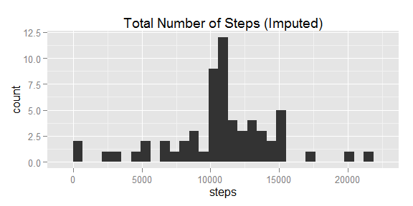

step.mean.imputed <- mean(imputed.total$steps, na.rm=T)  
step.median.imputed <- median(imputed.total$steps, na.rm=T)

The mean and median total number of steps taken per day are 1.0766 × 104 and 1.0766 × 104 !

### 5.Are there differences in activity patterns between weekdays and weekends?

5.1 Create a new factor variable in the dataset with two levels.

a <- as.character(imputed.data$date)  
b <- strptime(a,"%Y-%m-%d")  
c <- weekdays(b)  
imputed.data$weekday <- c  
imputed.data$wd_indicator[imputed.data$weekday == "Monday"]="Weekday"  
imputed.data$wd_indicator[imputed.data$weekday == "Tuesday"]="Weekday"  
imputed.data$wd_indicator[imputed.data$weekday == "Wednesday"]="Weekday"  
imputed.data$wd_indicator[imputed.data$weekday == "Thursday"]="Weekday"  
imputed.data$wd_indicator[imputed.data$weekday == "Friday"]="Weekday"  
imputed.data$wd_indicator[imputed.data$weekday == "Saturday"]="Weekend"  
imputed.data$wd_indicator[imputed.data$weekday == "Sunday"]="Weekend"  
imputed.data$wd_indicator <- as.factor(imputed.data$wd_indicator)  
head(imputed.data)

## steps date interval weekday wd_indicator  
## 1 37.38 2012-10-01 0 Monday Weekday  
## 2 37.38 2012-10-01 5 Monday Weekday  
## 3 37.38 2012-10-01 10 Monday Weekday  
## 4 37.38 2012-10-01 15 Monday Weekday  
## 5 37.38 2012-10-01 20 Monday Weekday  
## 6 37.38 2012-10-01 25 Monday Weekday

5.2 Make a panel plot containing a time series plot of the 5-minute interval and the average number of steps taken.

imputed.avg <- data.table(imputed.data)  
imputed.avg.weekday <- imputed.avg[wd_indicator=="Weekday",]  
imputed.avg.weekend <- imputed.avg[wd_indicator=="Weekend",]  
imputed.avg.weekday <- imputed.avg.weekday[,mean(steps, na.rm=T), by=interval]  
imputed.avg.weekend <- imputed.avg.weekend[,mean(steps, na.rm=T), by=interval]  
imputed.avg.weekday$wd_indicator <- "Weekday"  
imputed.avg.weekend$wd_indicator <- "Weekend"  
imputed.avg <- rbind(imputed.avg.weekday,imputed.avg.weekend)  
#imputed.avg <- imputed.avg[,mean(steps, na.rm=T), by=interval]  
g <- ggplot(imputed.avg, aes(interval, V1))  
g + geom_line() + facet_grid(wd_indicator~.) + labs(y="Number of steps") + labs(x="Interval") + labs(title="Time Series Plot of Interval * Steps") + theme(panel.background = element_rect(colour = "blue"))

