Lab 2: Flutter Hello World Application

Objective: Install Flutter SDK and create a basic Flutter application displaying 'Hello World'.
Tasks:
- Install Flutter SDK and verify using flutter doctor.
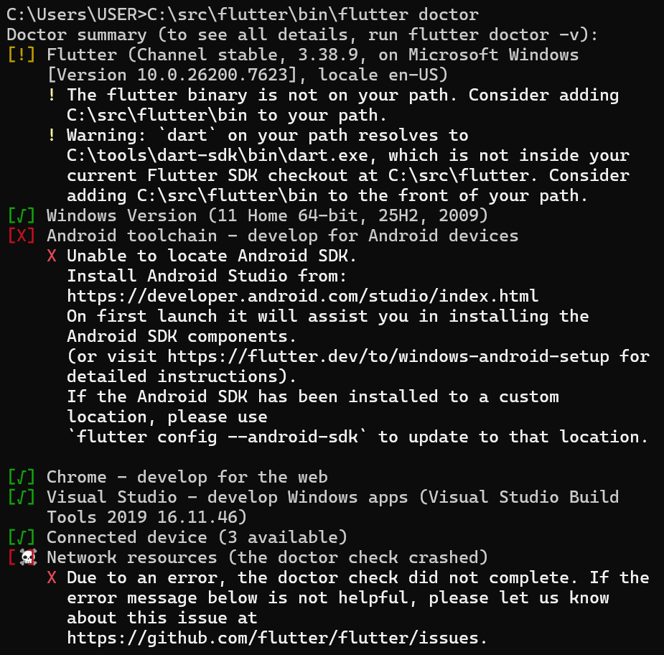
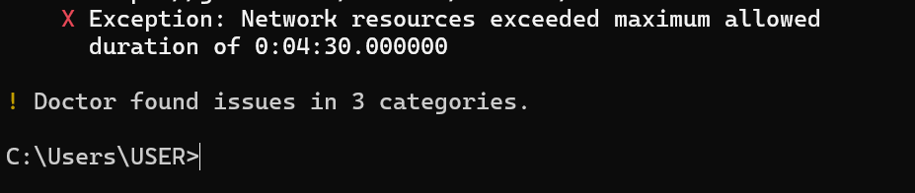

- Install VS Code or Android Studio with Flutter & Dart plugins.
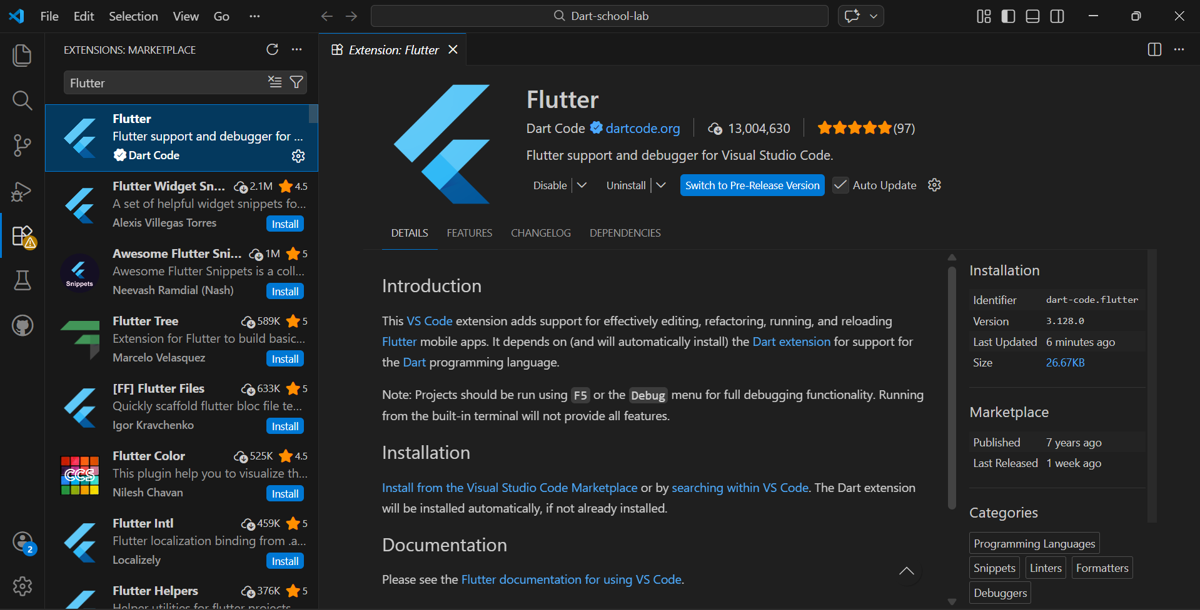
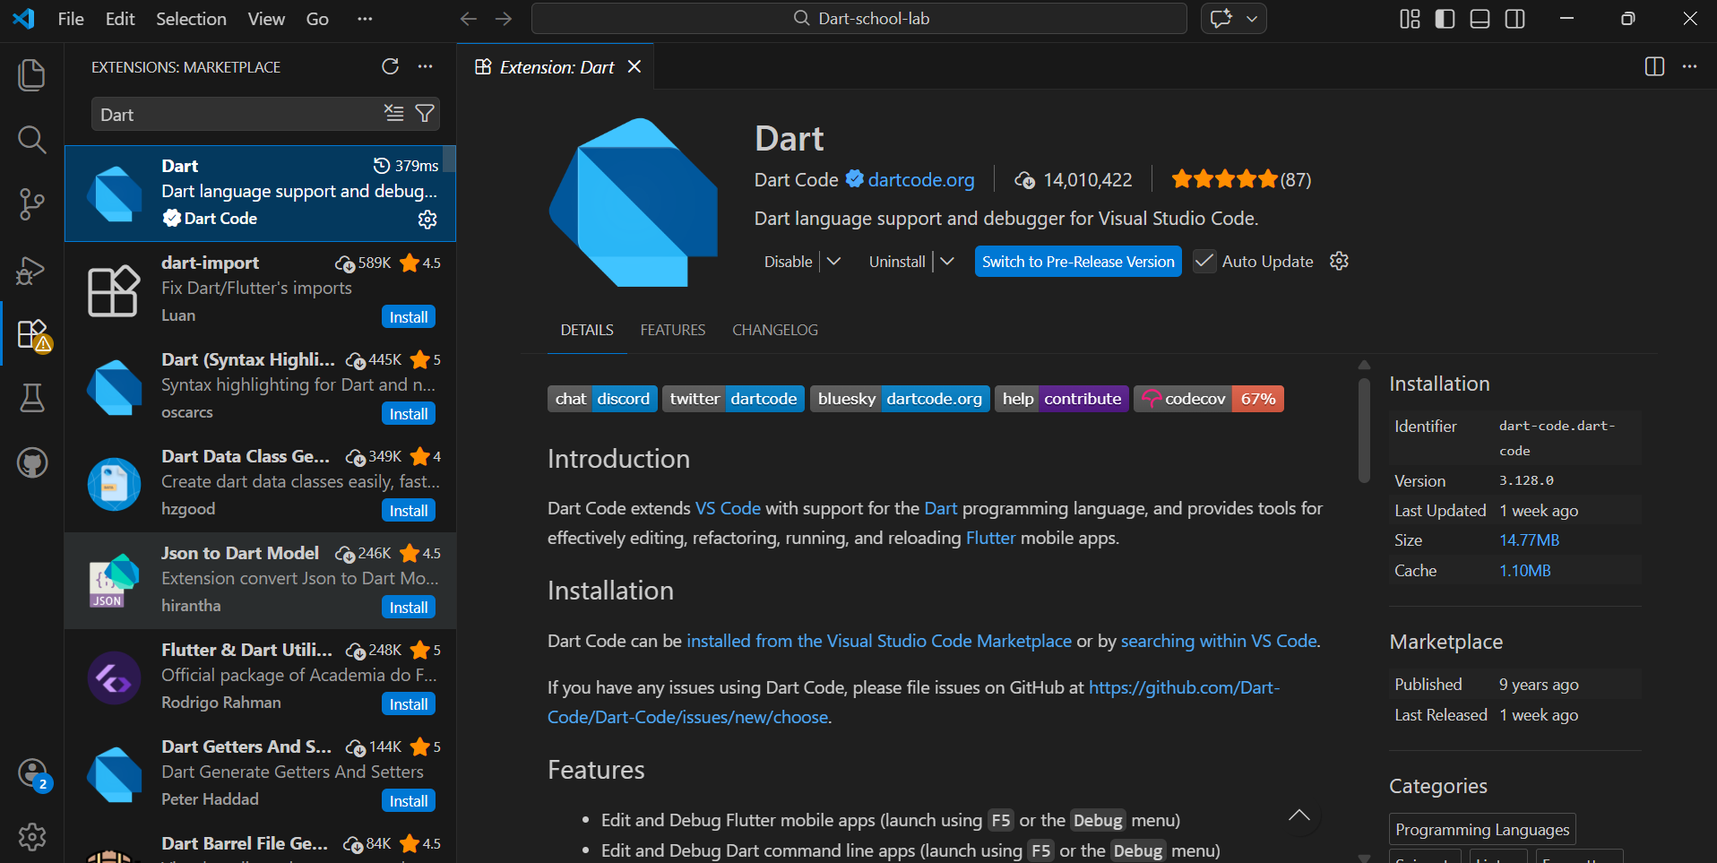

- Create a new Flutter project named hello_world.
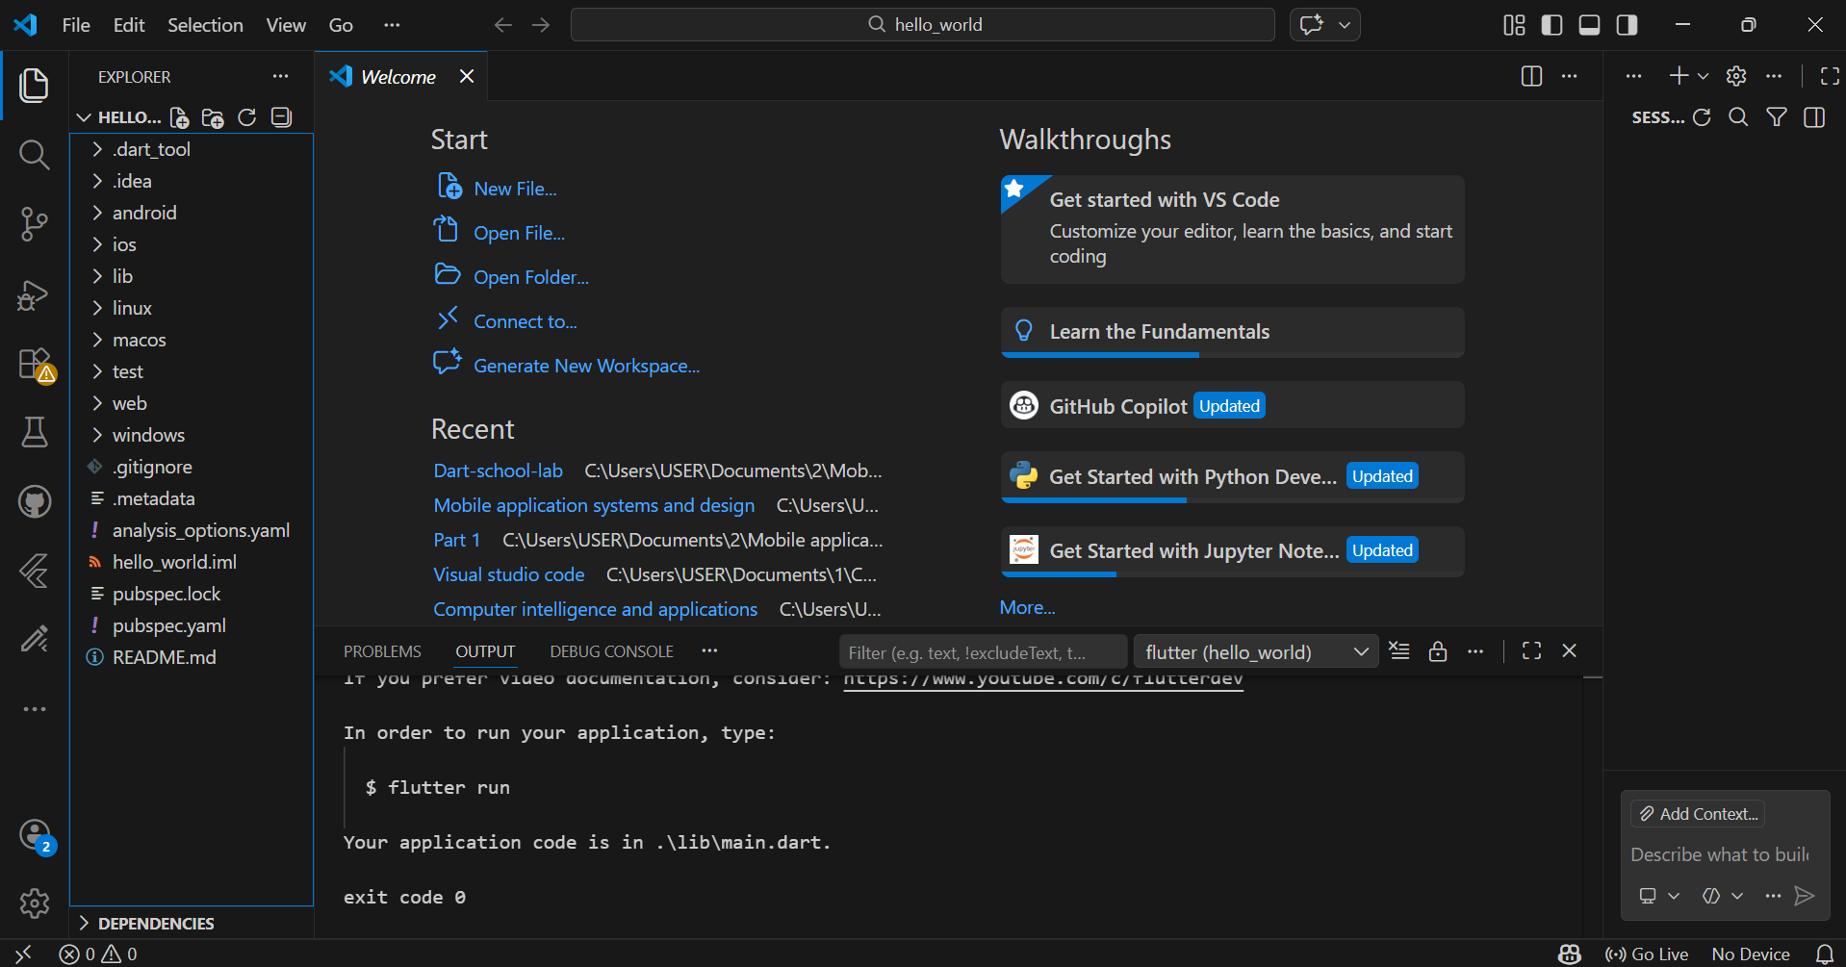

- Modify main.dart to display 'Hello World' on screen.
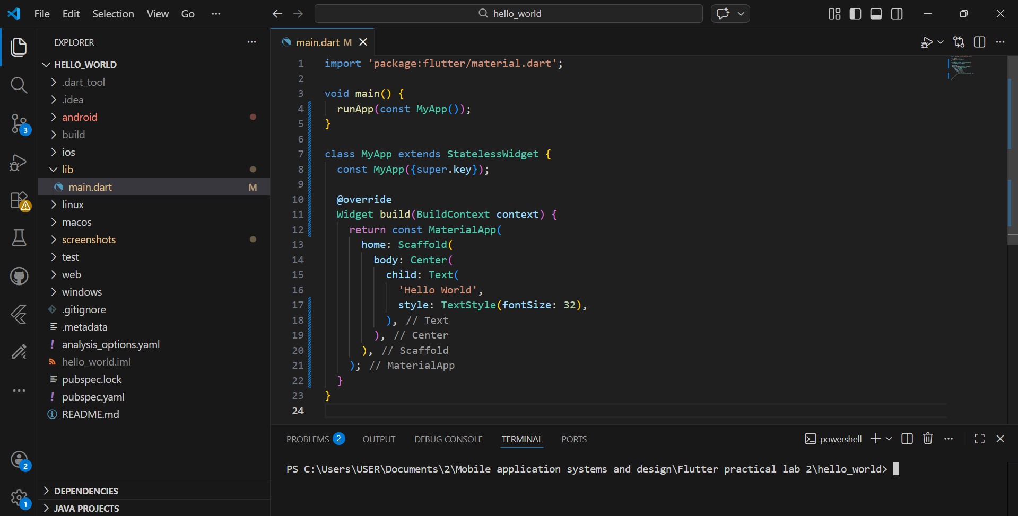

- Run the application on emulator or physical device.
