DIGITAL PUBLIC SAFETY
PRAHARI
Stop the scam before the money moves.
Privacy-first live scam intervention and fraud-ring intelligence
PROJECT OUTCOME A working web prototype that detects digital-arrest coercion while a call unfolds, interrupts before payment, and converts only citizen-approved evidence into ranked fraud-ring intelligence.

Hackathon Project Report | 22 July 2026
Web prototype: localhost:3000/check | Officer command: localhost:3000/command

Executive Summary
PRAHARI is a privacy-first digital public-safety prototype designed for the decisive moment in a digital-arrest scam: before the victim transfers money. It combines live transcript capture, on-device deterministic risk detection, optional structured AI classification, consent-controlled evidence sharing, and graph-based fraud-ring discovery in one working web system.
The citizen experience issues an immediate, plain-language intervention when scam pressure becomes critical. SAFE content stays on the device. For risky content, the user chooses whether to keep the result private or share selected evidence, a redacted transcript, or the full transcript. Approved identifiers are persisted with an audit trail, ingested into Neo4j, and surfaced to officers as ranked rings and hub infrastructure.
WHY IT MATTERS PRAHARI does not wait for a completed fraud report. It identifies the coercion pattern as it develops and links consented evidence across reports so both citizens and officers can act earlier.

1. Problem Statement
Digital-arrest scams combine authority impersonation, fabricated legal evidence, isolation, urgency, and a final payment demand. Victims are pressured to remain on a call, avoid family members, and transfer funds to a so-called safe account. Conventional reporting is often retrospective, after the transfer has occurred, while individual reports remain disconnected from the shared phone numbers, UPI IDs, and bank accounts used across a campaign.

Design Challenge
- Warn a citizen during the scam without requiring technical knowledge.
- Preserve privacy by keeping content local unless risk is found and the citizen explicitly consents.
- Remain useful when the optional LLM or network is unavailable.
- Turn minimal approved evidence into operational intelligence without claiming a legal determination.

2. Proposed Solution
PRAHARI closes the loop from citizen protection to officer prioritization. The web interface accepts live speech, pasted messages, or text files. A local deterministic pass detects scam phases and fuses their signals into SAFE, SUSPICIOUS, or CRITICAL. Critical results trigger a full-screen intervention with a direct 1930 action and a trusted-contact path. Only after consent does the backend persist evidence, create an audit record, and search for shared infrastructure in the graph.
Capability | Implemented behavior
Live protection | Interim browser speech and segmented local Whisper feed continuous on-device checks.
Five-phase detection | Hook, Authority, Fabricated Evidence, Isolation, and Drain update as the transcript grows.
Privacy gate | SAFE content is never sent; risky content exposes explicit evidence-scope choices.
Fraud intelligence | Phone numbers, UPI IDs, bank accounts, and claimed agencies collapse into shared graph nodes.
Officer command | Incident queue, KPIs, ranked rings, hubs, graph exploration, and evidence packages.

3. System Architecture
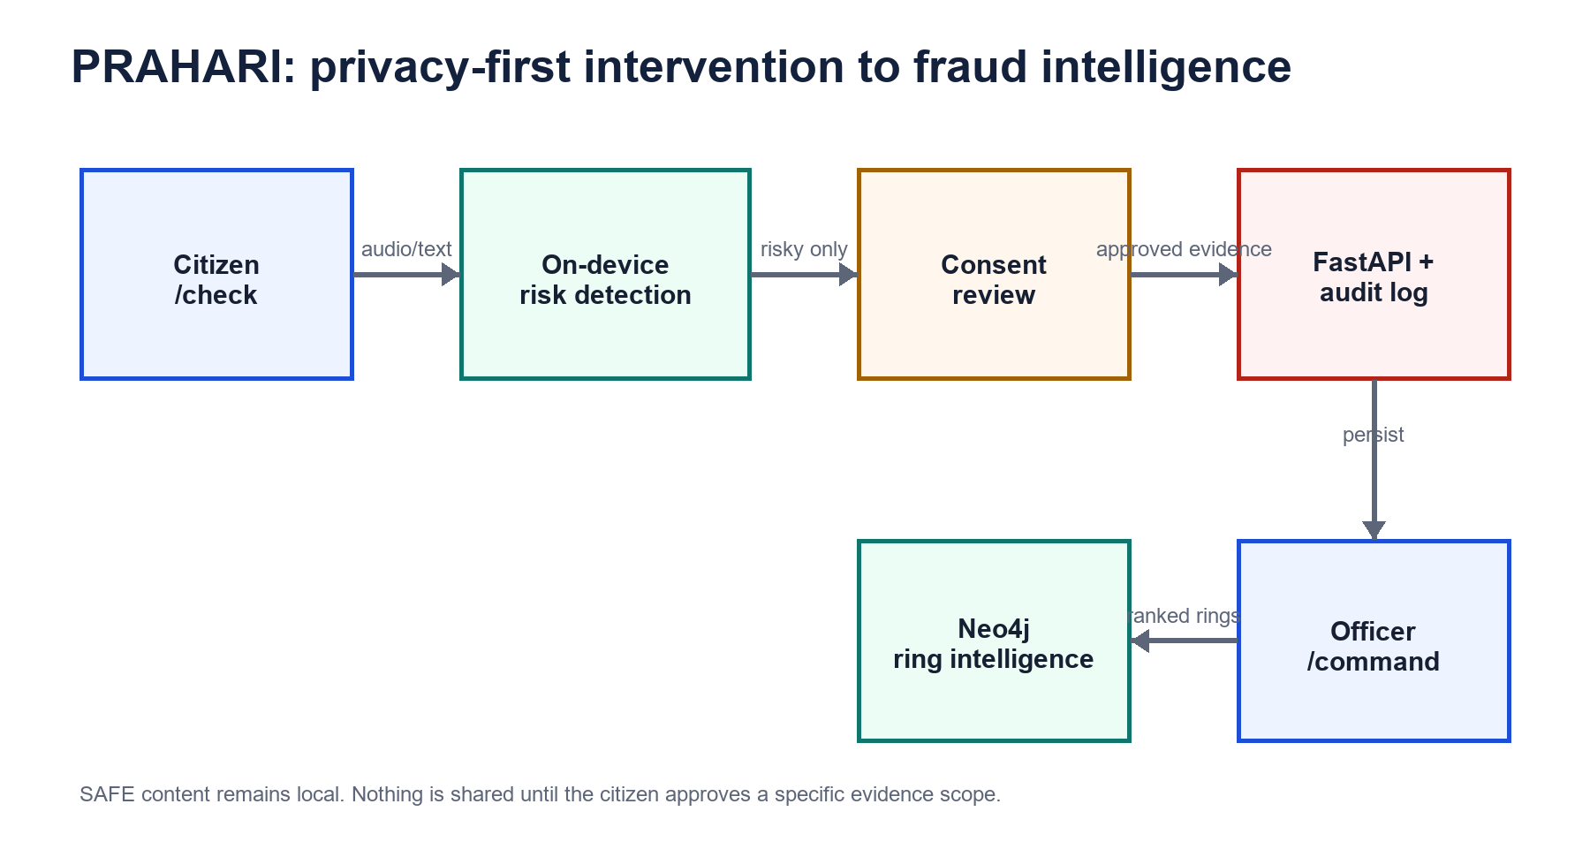
Figure 1. Device-first analysis, consent boundary, persistence, graph intelligence, and officer workflow.

Technology Stack
Layer | Technology | Role
Citizen web | Next.js 16, React 19, Tailwind CSS | Accessible live check, evidence review, intervention, and complaint drafting
Local speech | SpeechRecognition + Transformers.js Whisper | Instant browser capture and private Web Worker transcription
Detection | Mit deterministic rules + optional structured LLM | Phase detection, entities, evidence spans, fusion, and fallback
Application API | FastAPI, Pydantic, SQLAlchemy, Alembic | Consent validation, persistence, audit, lifecycle, and dashboard APIs
Data | PostgreSQL + Neo4j GDS | Incident/audit records and connected fraud infrastructure
Deployment | Docker Compose | Repeatable frontend, backend, database, and graph services

4. Citizen Experience

Common-man-first interaction
The default route asks one direct question: Is this call or message a scam? The primary option is Protect me during a call. Controls use plain language, large actions, visible privacy status, and a single critical instruction: Stop. Do not send money. The design avoids requiring an account and keeps optional reporting controls collapsed until needed.

Hybrid speech capture
- Fast mode uses browser SpeechRecognition for immediate transcription and clearly warns that the browser vendor may process audio online.
- Private mode downloads Whisper once, then transcribes short microphone segments in a Web Worker using WebGPU or WebAssembly.
- The language selector includes English and all 22 scheduled Indian languages; low-resource offline cases are labeled best-effort.
- The live demo feeds the same local analysis path and demonstrates intervention before the synthetic payment request.
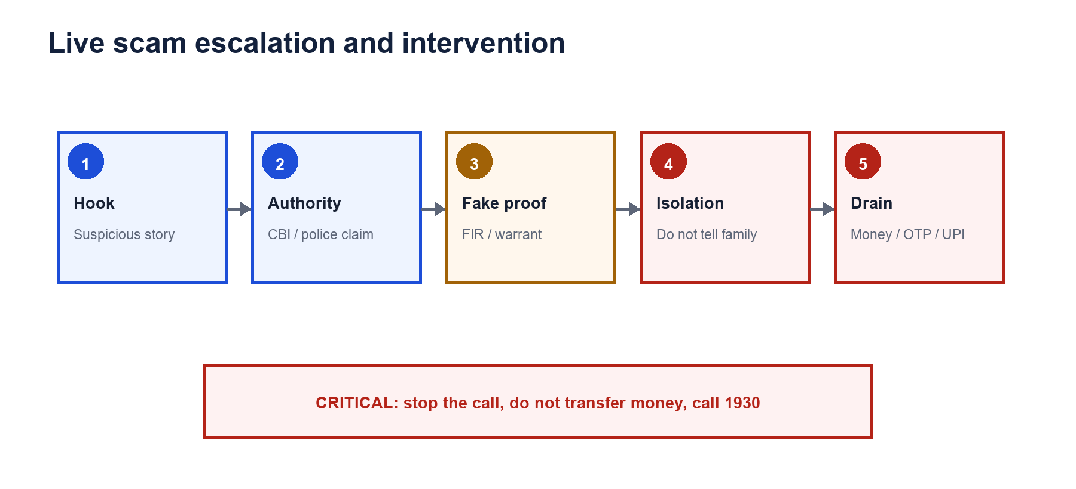
Figure 2. Progressive phase detection and citizen intervention.

5. AI/ML Detection Pipeline
Mit's module provides the detection core. A deterministic rule engine identifies authority, isolation, payment, fabricated legal evidence, urgency, and scam-hook patterns. The optional structured classifier adds phase detection, entity extraction, evidence spans, confidence, and plain-language reasoning. Calibrated fusion produces the final risk label. When the classifier is unavailable, the same API returns an offline safety verdict instead of failing.
Stage | Output | Operational value
Rules | Matched categories, evidence, score | Deterministic, fast, explainable, and offline
Structured classifier | Phases, entities, spans, confidence | Richer reasoning when a model is available
Fusion | SAFE / SUSPICIOUS / CRITICAL | Consistent intervention and persistence thresholds
Incremental analysis | Delta signals per transcript chunk | Escalates while the conversation develops

OFFLINE GUARANTEE Intermediate live chunks never require the LLM. The final path also falls back to rules-only analysis when the model is disabled, unavailable, or missing a key.

6. Privacy, Consent, and Safety
Privacy is an enforced data-flow rule rather than a claim. Text and supported speech modes are first analyzed locally. SAFE content creates no backend request. For SUSPICIOUS or CRITICAL results, the citizen reviews evidence and selects a scope before any network transmission.
Control | Implementation
Consent scopes | Selected evidence, redacted transcript, or full transcript
Local redaction | Masks Aadhaar-like, PAN-like, OTP/PIN, and long account-like values
Retention | Citizen chooses 1, 7, or 30 days; expiry is persisted and displayed
Withdrawal | Deletes the SQL incident, audit payload, and Neo4j report
Transparency | Privacy bar shows model state, analysis location, audio memory, and bytes shared
NCRP handoff | Opens the official suspect-search page and copies an identifier locally without placing it in the URL

SAFETY BOUNDARY PRAHARI is decision support. Ring evidence packages state that findings require authorized human verification and are not legal determinations.

7. Graph Intelligence
Each consented risky report is modeled as a Report node. MERGE operations collapse repeated PhoneNumber, UPI_ID, BankAccount, and ClaimedAgency identifiers, allowing independently submitted incidents to reveal shared infrastructure. Weakly Connected Components recover planted rings, while degree centrality ranks hub identifiers. New reports can join an existing ring immediately through a reused discriminative identifier.

Officer command workflow
- Review incident KPIs and the risk-ranked queue.
- Select a ring and inspect its reports, cities, agencies, and campaign early-warning index.
- Explore the graph to identify shared payment destinations and caller infrastructure.
- Download the evidence package for human review and follow-up.

8. End-to-End Workflow
Step | Citizen/system action | Data movement
1 | Capture live speech or paste suspicious text | Remains in browser memory
2 | Run local phase and risk analysis | No evidence uploaded
3 | Show critical intervention when threshold is crossed | No evidence uploaded
4 | Citizen reviews and approves an evidence scope | Only approved package is transmitted
5 | Backend analyzes, audits, and persists risky evidence | PostgreSQL incident and audit
6 | Graph ingestion links shared identifiers | Neo4j report and identifier nodes
7 | Officer dashboard highlights the joined ring | Ranked operational intelligence

9. Validation and Results
The prototype includes a reproducible 120-case synthetic English, Hindi, and Hinglish benchmark. It contains 60 scams, 30 benign examples, and 30 hard negatives. These results demonstrate prototype behavior and are not field validation.
Metric | Result | Interpretation
Scam recall | 90.0% | Detected nine in ten synthetic scams
Precision | 100.0% | No false scam labels in the benchmark
F1 score | 94.7 | Strong precision/recall balance
Benign false-positive rate | 0.0% | Benign examples stayed safe
Hard-negative critical rate | 0.0% | RBI/UPI informational content did not become critical
Detected before payment language | 90.0% | Most synthetic scams were recognized before the explicit drain phrase

Integration evidence
- Live session progression verified from SAFE to SUSPICIOUS to CRITICAL.
- All five canonical phases and highest phase 5 verified through the HTTP API.
- Consented final report verified with graph_synced=true and recovery of seeded RING-0.
- Caller number verified in the graph while the citizen number remained excluded.
- Consent withdrawal verified to remove the temporary incident and graph report.
- Frontend production build, TypeScript, focused lint, and Python compilation passed.

10. Deployment and Demonstration
Docker Compose defines PostgreSQL, Neo4j with Graph Data Science, FastAPI, and Next.js. The seeded demo script applies migrations, inserts synthetic incidents, initializes the graph schema, ingests reports, detects three planted rings, and prints the judge URLs.
Surface | URL | Purpose
Citizen check | http://localhost:3000/check | Live protection, privacy review, consent, and complaint draft
Officer command | http://localhost:3000/command | Queue, KPIs, graph, hubs, and ring intelligence
Backend API | http://localhost:8000/docs | Interactive API contract
Neo4j Browser | http://localhost:7474 | Graph inspection for technical demonstration

Three-minute judge narrative
- Run the live call demo and show the phase indicators update before the automatic stop screen.
- Return, paste the seeded CBI transcript, and emphasize that the verdict is private and 0 B has been shared.
- Approve selected evidence and show the consent receipt, retention choice, and RING-0 join.
- Open the officer command dashboard, inspect the highlighted ring and hubs, then close on the citizen-to-intelligence loop.

11. Implemented, Synthetic, and Simulated Scope
Category | Included scope
Implemented | Web routes, local risk analysis, live transcript handling, consent scopes, redaction, retention, deletion, FastAPI persistence, audit logs, Neo4j ingestion, ring APIs, officer graph, evidence package
Synthetic | Seed incidents, planted fraud rings, demo transcripts, and the 120-case benchmark
Simulated | Family Shield notification delivery
Not claimed complete | Image/PDF/audio-file extraction, production telephony carrier integration, field-validated accuracy, and multi-replica live-session storage

12. Limitations and Next Steps
- Validate accuracy on independently collected, consented, multilingual field data.
- Move live-session state from process memory to an encrypted, expiring shared store for horizontal scaling.
- Add production SIP/PSTN connectors only with explicit legal, consent, and telecom review.
- Expand private speech accuracy for low-resource Indian languages and noisy call environments.
- Integrate verified NCRP/1930 submission APIs if and when an authorized interface is available.
- Conduct accessibility, adversarial, privacy, and law-enforcement workflow evaluations before deployment.

13. Team Contributions
Contributor | Primary ownership
Ivan | Platform scaffold, database and migrations, Docker Compose, officer dashboard, integration, evidence package, load/offline checks, and release documentation
Mit | Deterministic rules, structured classifier, calibrated fusion, offline fallback, and evaluation harness
Adith | Citizen check experience, five-phase timeline, intervention, Family Shield, language and explainability UI, and complaint export
John | Neo4j ingestion, ring detection, hub ranking, ring APIs, and planted-ring validation

Conclusion
PRAHARI demonstrates a credible, working intervention architecture for digital-arrest scams. Its strongest contribution is not a single classifier or dashboard; it is the privacy-preserving connection between live citizen protection and cross-report fraud intelligence. The prototype warns early, explains why, asks permission before sharing, and gives officers a connected view of the infrastructure behind repeated scams.
FINAL POSITION Stop the scam before the money moves. Keep the citizen in control of their evidence. Turn approved signals into collective protection.

Appendix A. Key API Endpoints
Method | Endpoint | Purpose
POST | /api/analyze | Consent-gated full transcript analysis and graph sync
POST | /api/analyze/session/start | Begin an incremental live session
POST | /api/analyze/session/{id}/chunk | Analyze an intermediate or final transcript chunk
GET | /api/rings | List ranked fraud rings
GET | /api/rings/{id} | Return reports, hubs, and graph JSON
GET | /api/rings/{id}/evidence-package | Return the human-review evidence package
DELETE | /api/incidents/{id} | Withdraw consent and delete linked records

Appendix B. Repository and Reporting Links
Repository: https://github.com/ivanmathewsiby/PRAHARI
National Cyber Crime Reporting Portal: https://cybercrime.gov.in
National Cyber Crime Helpline: 1930

