Frontend Design
Requirements Specification
Labeller HMI — next generation
Version 1.6

Baseline for the frontend design of the labeller HMI. Approval by PID and Mono before the design work starts.

1 Purpose and scope 4
1.1 Out of scope 4
2 Reference material 4
3 Display and orientations 5
3.1 Six orientation states, three layouts 5
3.2 Consequences for the layout 6
4 Users and access levels 7
4.1 Access levels 7
5 Design system 8
5.1 Continuation of the existing style 8
5.2 Light and dark theme 8
5.3 Logo 8
5.4 Components to be delivered 8
6 Information architecture and navigation 11
6.1 Main menu 11
6.2 Navigation rules 11
6.3 Home screen 11
7 Standard parameter screens 13
7.1 Parameter row 13
7.2 Parameter types and their controls 13
7.3 Editing behaviour 15
8 Special screens 16
8.1 Select Format 17
8.2 Modify Format 18
8.3 Create New Format 19
8.4 Speed Test 20
8.5 IO-Test 21
8.6 Diagnosis Logs 22
8.7 Error History 23
8.8 Reporting — service done 24
8.9 Load/Store Backup — USB 25
8.10 FW-Update 26
8.11 Reporting QR — planned for later 27
8.12 Search Field 28
8.13 Create New User — Create User 29
8.14 User Management 30
8.15 Secure Code 31
8.16 Setup wizard — first start of a machine 34
8.17 Start-up screen 35
9 Icons 36
9.1 Icon list 36
10 Deliverables 39
10.1 General acceptance criteria 39
11 Open points 39

1 Purpose and scope
The visual style and the icon language of the existing design drafts are to be kept. This document does not ask for a new design direction — it asks for that direction to be carried across the complete interface.Where applicable, it should be checked if text-sizes can be increased to gain good readability on the target hardware.
This specification defines the frontend design for the HMI of the next generation labeller. It covers the complete interface: the home screen, the full menu structure, the standard parameter screens, the screens that follow their own logic instead of the parameter pattern, the icon set, and the behaviour in all display orientations.
The deliverable is a Figma design and, where possible, an HTML/CSS implementation as in the first draft.

1.1 Out of scope
- Implementation, firmware behaviour, and the wording of parameter texts.
- Marketing or brand assets beyond the logo placement described in section 5.

2 Reference material
Four inputs are provided with this specification. Where they disagree, this document decides.
Input | What it is | How binding
Menu structure (draw.io) | The complete menu tree with every screen, its parameters and the descriptions of the special screens. Red blocks mark screens that are not parameter lists. | Binding for structure and content.
Parameter list (Excel) | All parameters with ID, type, unit, range, default, show condition and access level. 214 parameters, 127 option rows. | Binding for the parameter type and therefore for the control used (toggle bar, selection list, keypad, keyboard, slider).
Clickdummy (HTML, attached) | An interactive model of the structure: every screen, every parameter, the six orientations, example wireframes of the special screens, plus a report on open points. | Binding for structure and function. NOT binding for the design — see below.
Existing prototype (HTML/CSS) | The first design draft, including colour tokens, typography and icon style. | Binding as the style reference to be continued.

Note on the clickdummy. It was built to validate the menu structure and to make the parameter data tangible, not to propose a visual design. Mono is not bound by its layout, spacing, component shapes or colour use. Where the clickdummy and Mono’s design differ, Mono’s design is what we follow — the same applies to the icons in section 9.

3 Display and orientations
Property | Value
Display size | 4.3 inch
Resolution | 800 × 480 px
Colour | Dark theme is the primary appearance; a light theme is required (see 5.2)
Input | Capacitive touch, operated with gloves
Rendering | Embedded system with limited graphics performance — no heavy effects, no large images, no or only basic animations

3.1 Six orientation states, three layouts
The parameter HMI_Orientation has six values: portrait, landscape left-hand, landscape right-hand, and an upside-down variant of each. Three layouts have to be designed; the upside-down states are the same layouts rotated by 180° and do not need separate frames, but the rotation has to be considered where an element is anchored to a screen edge.
Orientation | Canvas | Layout requirement
Portrait (standard / default) | 480 × 800 | Status bar and title at the top, navigation bar at the bottom.
Landscape LH | 800 × 480 | For left-hand operation. Only about 480 px of height, so the two bars move to the left and right edges and the content area stays usable.
Landscape RH | 800 × 480 | For right-hand operation. Same content page as landscape LH, navigation bar on the opposite side.
Portrait / Landscape upside down | as above | Same layout rotated 180°. No separate design, but it must not break.
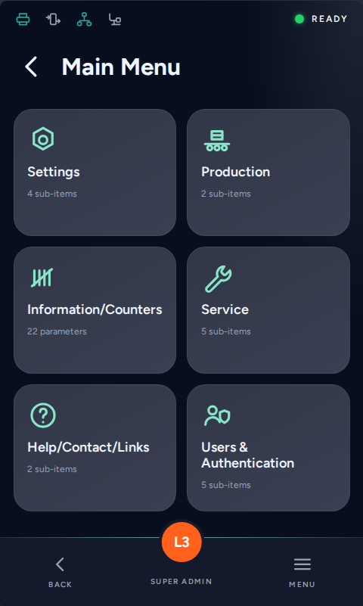
Menu in portrait — six tiles per page (example from the clickdummy, not a design proposal)
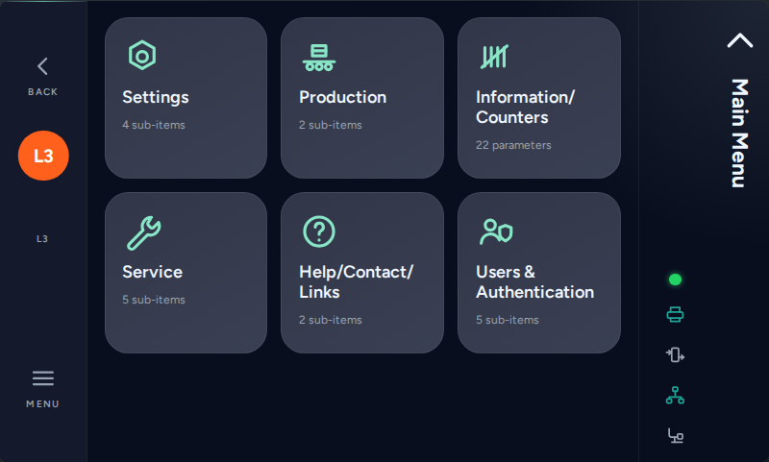
The same menu in landscape LH: both bars on the edges, three tiles per row

3.2 Consequences for the layout
- A menu level shows a maximum of six tiles per page. That limit stays. For levels with more entries, a dummy page with arrow buttons for jump-scrolling is to be designed as well — it may then show fewer tiles, as long as it is obvious that scrolling is needed.
- Touch targets: the design has to work on the display prototype and be convenient for the operator. Where possible, minimum 10 mm for primary actions and 8 mm for list rows — on this display roughly 60 px and 48 px.
- Every screen has to work in portrait and in landscape. Where a layout cannot carry the same content, the reduced version or an obvious scroll / jump function has to be designed, not left to the implementation.
- Parameter screens need a scroll function so that all rows stay reachable — not the same amount of content per view, but no content lost.

4 Users and access levels
Three personas from the previous specification remain valid: the operator (fast, little training, needs icons rather than text), the technician (wants direct access and detailed error information), and the application engineer (sets the machine up, needs search, wizards and control over what the other two see).

4.1 Access levels
Level | Who | How it is reached | Design consequence
0 | Not logged in | Default state after start or after auto log-off | No access to the menu structure. The design must show what this state looks like — it is the state the machine spends most of its time in.
1 | User | User profile | Operating, read access and a small set of parameters.
2 | Supervisor | User profile | Production settings.
3 | Admin | User profile | Machine configuration, user administration, service functions.
4 | Secure Access | Time-limited one-time code (see 8.15) — not a user profile | Temporary, for resetting the machine or for creating a new administrator when no level 3 account is reachable any more.

- The current level is visible at all times (the existing drafts solve this with the badge in the navigation bar).
- A parameter the user may not read is not shown at all; a parameter they may read but not change is shown with a lock indication.
- A screen that changes its content with the level (User Management, IO test) has to be designed in both versions.

5 Design system

5.1 Continuation of the existing style
We are happy with the first design drafts and want to build on them rather than start again. The tokens below are taken from that draft and are the starting point; refine or change them where the extended scope makes it necessary.
Token group | Values in the existing draft
Background / surfaces | #080E1E background, #313648 card, #4D5A67 form surface
Brand accent | #20A498 primary action, #88E6C6 highlight
Status | #22D464 running, #FFCC04 standby, #E8413F error, #FF601C level badge
Text | #EFF6FF primary, #98A3B2 secondary
Typography | Figtree 400/600/700 for the interface, Fira Code 400/600 for parameter values
Spacing | 4 / 8 / 12 / 16 / 24 / 32 / 48 / 60 px

Fonts must be usable without a special licence.

5.2 Light and dark theme
- Both themes are required. The dark theme is the primary / default appearance.
- Icons need a version that works on both — either one stroke icon that inherits the text colour, or a bright and a dark set.
- Status colours must stay distinguishable in both themes and must not be the only carrier of meaning.

5.3 Logo
A logo placement is to be foreseen, at minimum on the home screen. Machine branding is configurable in the firmware (parameter HMI_Logo_Selection), so the design needs a defined logo area with a defined maximum size rather than one fixed logo.

5.4 Components to be delivered
The interface is built from a small set of components that repeat on almost every screen. The table says what each one is, where it appears and which states it needs. "States" means the versions of the same component that the design has to show, so the implementation does not have to invent them: for example a list that is empty, a value that is locked, or a button while it is pressed.
Component | What it is | States needed
Status bar | Top strip with the connection / option icons and the machine state. | Ready, running, paused, warning, alarm, stand-by
Title bar | Screen title with the back control. | With and without back, long title truncated
Navigation bar | Bottom (or side) bar with back, level badge and menu. | Level 0 to 4, pressed
Menu tile | Entry to a sub-menu or a screen, icon plus label plus sub-line. | Default, pressed, disabled (option not present)
Paging control | Arrows and page indicator when a level has more than six tiles. | First, middle, last page
Parameter row | Label, current value, unit and the affordance to change it. | Default, pressed, locked (access level), read-only, changed from default, with help indicator
Group header | Separates parameter blocks inside one screen. | Default
Toggle bar | Boolean parameter, changes immediately. | On, off, disabled
Selection list | Discrete parameter. Usually 2 to 8 options — but the language selection has 26, so the component has to work as a long, scrollable list as well. | Closed, open, selected entry, long option text, scrollable list
Numeric keypad | Integer / float entry with minimum, maximum, unit and default. | Empty, valid, out of range, disabled save
Alphabetical keyboard | String entry, unfolds below the field. | Lower case, upper case, numeric layout
Slider | Range parameter with scale and stepper arrows. | Default, dragging, at minimum / maximum
Favourite marker | Marks a parameter as a favourite. The marked parameters are collected in a Favourites screen (see 6.2). | Set, not set
Parameter info | Help text belonging to a parameter. | Indicator on the row, opened
List row | Generic row for formats, files, users, log entries. | Default, selected, disabled
Table row | Multi-column row for the IO test. | Input, output, forced
Confirmation dialog | Question before a machine-changing action. | Normal, destructive
Progress / result | Long operation such as a firmware update. | Running, success, failure
Toast | Short feedback after an action. | Confirmation, rejection
Screen placeholders | What a screen shows when there is nothing to show. | Nothing stored yet, data loading, data could not be read
Modal dialog | Modal pop-up above the current screen, used for information and error messages as well as for the parameter help text (see 7.1). | Info, error, confirmation

The sketches in section 8 and the clickdummy show these components in context; the visual design of each one is Mono’s work.
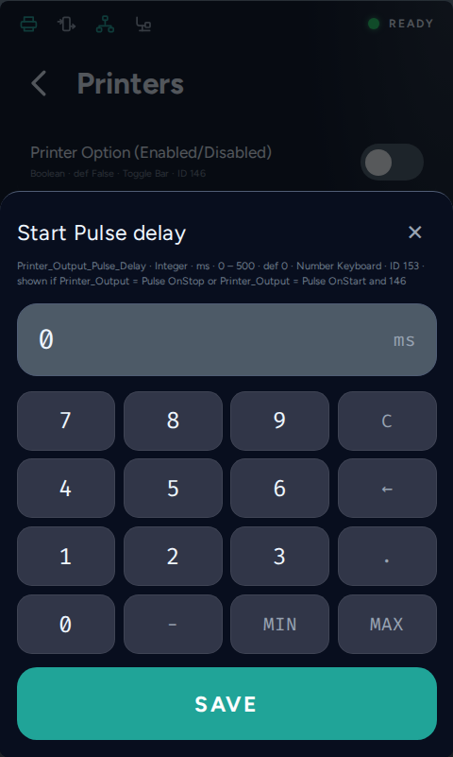
Example: parameter row, numeric keypad, unit and range in one flow (clickdummy)

6 Information architecture and navigation
The menu structure is defined by the draw.io diagram and reproduced in the clickdummy. The design does not change the structure, but it has to carry it.

6.1 Main menu
Six entries: Settings, Production, Information/Counters, Service, Help/Contact/Links, Users & Authentication. Six tiles fit on one page — this is the reference case for the tile size. The colour code of the first design draft is kept and identifies the branch a screen belongs to.

6.2 Navigation rules
- Back always returns to the screen the user came from, not to the position of the current screen in the tree. Screens that are reachable from two places must not look like two different screens.
- Linked paths: some screens are deliberately reachable from more than one place (for example the applicator block from Options and from Digital IO). The design needs a way to show such a cross-link so it does not look like a duplicate — for example by carrying the colour code of the main menu branch the screen belongs to.
- Search: parameters can be reached directly by name or ID, bypassing the tree (section 8.12). The parameter ID should therefore be visible next to the parameter itself — small and in low contrast.
- Quicklinks: the home screen carries four configurable shortcuts. They are stored as parameters (HMI_Quicklink_1–4, each holding a ParamID) and are configured in the HMI settings.
- Favourites: a parameter can be marked as a favourite on its row. The marked parameters are collected in a Favourites screen inside Settings, so an operator reaches the handful of values they touch daily without walking the tree. Favourites are a view, not a copy — changing a value there changes the parameter itself.

6.3 Home screen
The home screen is the state the machine shows during production. It carries the machine state, the device name, the start/pause control, the four quicklinks and the logo area. Error and warning states are shown here first — the existing draft already proposes an error overlay, which should be carried forward.
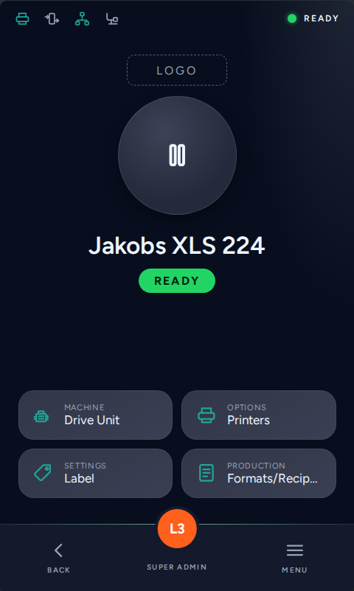
Home screen

7 Standard parameter screens
Most screens are lists of parameters. They are generated from the parameter list, so the design has to describe one pattern that works for all of them rather than individual screens.

7.1 Parameter row
- The current value is visible in the row. The user must not have to open a parameter to see its value.
- Sub-parameters are indented by one level; the hierarchy goes at most two levels deep.
- A parameter can be marked as a favourite from the row; favourites feed the quicklinks and a favourites view.
- A parameter can carry additional information (help text). The row shows an indicator; tapping it opens the text as a pop-up above the screen, so the parameter list stays visible behind it and the user returns with one tap. Because the pop-up is not bound to the row height, the text may be longer: reserve a title of up to 40 characters and a body of up to 600 characters, with the pop-up scrolling beyond that. The texts do not exist yet — use placeholder text in the design. They will be written in every selectable language. A design for the modal window is required (see the component list in 5.4).
- Rows can be conditional: a parameter is only shown when another parameter has a given value. The design needs no special state for this — the row is simply absent — but the resulting variable list length must not break the layout.
- A row can be read-only or locked by access level. Both need a visual treatment.
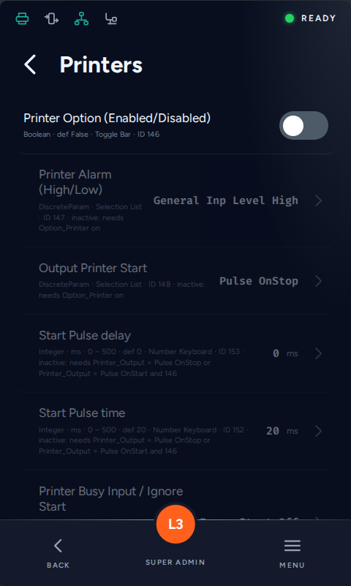
Parameter list, here with the technical meta data switched on for review purposes

7.2 Parameter types and their controls
Every parameter in the list has a type and a defined input method. The design has to cover these five controls:
Type in the parameter list | Control | Notes for the design
Boolean | Toggle bar | Changes immediately, without a confirmation step.
DiscreteParam | Selection list | Between 2 and 8 options; the option texts are translated and can be long.
Integer / Float | Numeric keypad | Minimum, maximum, unit and default are known and should be visible while typing. Values outside the range are rejected with an inline message.
String | Alphabetical keyboard | Unfolds below the field; must not cover the field itself.
Integer / Float (range parameters) | Slider | Where a range is more intuitive than a number — the existing draft already shows sliders with a scale and stepper arrows. The value being set must stay readable and must not be covered by the finger on the slider.
Action / Action Button | Button | Triggers a machine action. Needs a pressed state and, where the action moves the machine, a confirmation.
State (read only) | Value display | No input, but the value updates live.

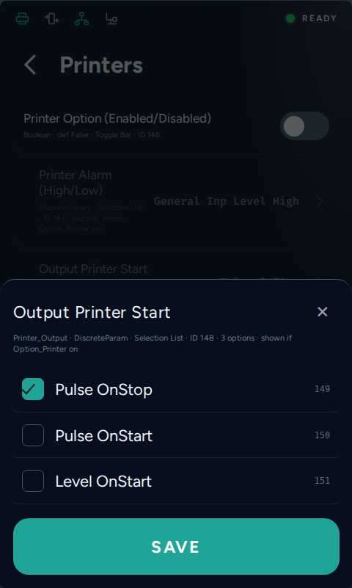
Selection list
Numeric keypad with range and unit

7.3 Editing behaviour
- Changing a value should take as few steps as possible. Toggles change directly; a value from a keypad is confirmed once, not twice.
- The screen states what happens on an invalid entry — the entry is not silently corrected.
- A changed value that differs from the default may be marked. This supports commissioning and service and is a small addition to the row.

8 Special screens
Some screens are not parameter lists. They are driven by their own logic — file systems, logs, live IO, a user database, generated codes — and the parameter list says nothing about them. They are highlighted red in the menu structure diagram.
Each of them is specified below with its purpose, the functional requirements, the most relevant acceptance criteria, and a sketch. The sketches come from the clickdummy: they show the intended content and the information hierarchy, not the visual design.
What applies to all of them: each screen also has to be designed for the moments when it has nothing to show — no format stored yet, the USB drive not plugged in, the log still empty, data being read. Destructive actions follow one shared confirmation pattern; lists need a defined row height, a scroll indication and an end-of-list marker; continuously updated values need a defined refresh rate.

8.1 Select Format
Menu position: Main Menu › Production › Formats
Purpose. Load a stored parameter set into the running machine.

Content
- Scrollable list of the format files present on the machine, one row per format.
- Per row: format name, and the metadata needed to tell two similar formats apart (suggested: date of last change, author or access level that saved it).
- The format currently loaded is marked in the list.
- Empty state when no format is stored yet.

Interaction and states
- Tapping a row selects it (single selection, no immediate effect).
- A primary action button loads the selected format.
- Loading overwrites live machine settings, so it must be confirmed in a dialog that names the format and warns that unsaved changes are lost.
- Loading is blocked while the machine is running.
Access. Level 1.
Data source. File system, not the parameter list. A format is a JSON file holding the values of the parameters marked as format relevant (production related parameters only).

Acceptance criteria
- The list shows every stored format with a name and a date; the loaded one is marked.
- Loading is only possible after an explicit confirmation naming the format.
- An empty state is designed for "no format stored yet".
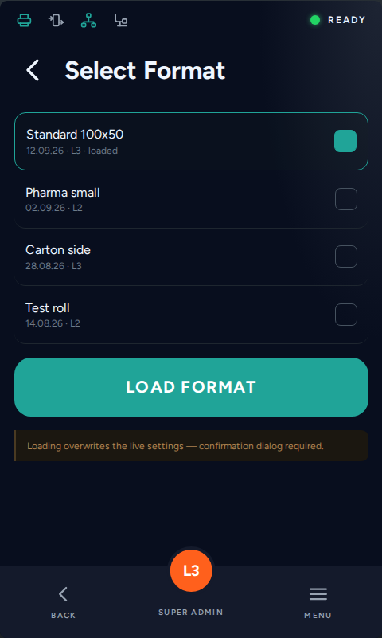
Sketch: Select Format — content and hierarchy idea, not styling

8.2 Modify Format
Menu position: Main Menu › Production › Formats
Purpose. Overwrite an existing format with the current settings.

Content
- Same list component as Select Format, but the action is "overwrite", not "load".
- Per row: format name plus date of last change, so the user sees what they are about to replace.
- The currently loaded format is marked and should be the default selection.

Interaction and states
- Selecting a row and confirming overwrites that file with the current live values.
- Confirmation dialog naming the target file — this action overwrites the stored format.
- Optional but recommended: a short diff ("12 parameters differ") before confirming, which replaces the Compare/Check screen that was dropped from the diagram.
Access. Level 2.
Data source. File system; reads the live parameter values at the moment of saving.

Acceptance criteria
- The target file is named in the confirmation before it is overwritten.
- The currently loaded format is pre-selected.
- A state is designed for "no differences to the stored file".
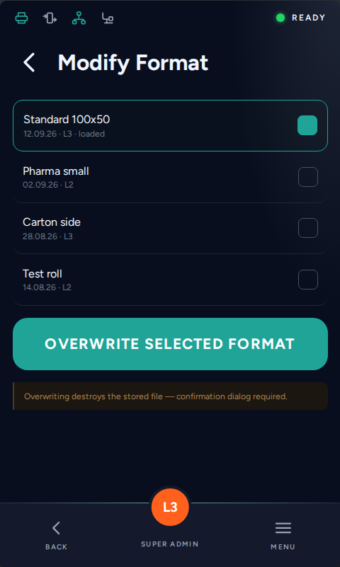
Sketch: Modify Format — content and hierarchy idea, not styling

8.3 Create New Format
Menu position: Main Menu › Production › Formats
Purpose. Store the current settings as a new format file.

Content
- One text input field for the format name, not pre-filled.
- Alphabetical keyboard, unfolding below the field.

Interaction and states
- A duplicate name is handled inline, not by a dead end — either blocked with a message or offered as "overwrite instead".
- After saving, return to Formats with a confirmation toast.
Access. Level 2.
Data source. File system. Formats are JSON files, so there is no practical limit to how many can be stored beyond the device memory, and no rule for the name — "1" is as valid as a long descriptive name.

Acceptance criteria
- A duplicate name is handled inline, not by a dead end.
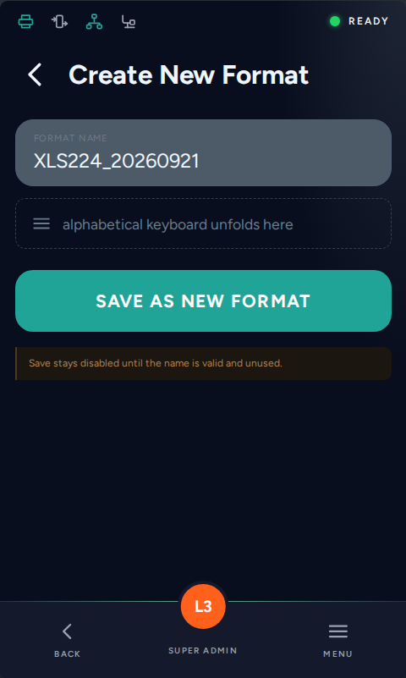
Sketch: Create New Format — content and hierarchy idea, not styling

8.4 Speed Test
Menu position: Main Menu › Service › Tests
Purpose. Verify the external encoder and show the resulting production rate.

Content
- Live value of the measured external encoder, in m/min and in Hz, refreshed once per second.
- Button to run the speed test.
- Result block: time needed for the next label dispensed / cycle, and the rated product rate in pieces per minute (Info_Calc_Product_rate, only meaningful when Calc_Product_Rate_Enable is on).

Interaction and states
- The live fields update while the screen is open; leaving the screen stops the measurement.
- No encoder signal: show "no signal" rather than 0.
- The test itself may move the machine - say so before it starts.
Access. Read from L1, running the test from L2.
Data source. Info_Speed_Test_Measured, Info_Calc_Product_rate and Button_Speed_Test from the parameter list.

Acceptance criteria
- Live values in m/min and Hz.
- A "no encoder signal" state is designed.
- The result block is visually separated from the live values.
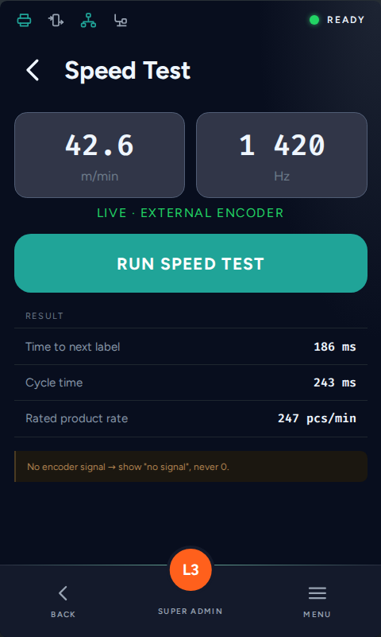
Sketch: Speed Test — content and hierarchy idea, not styling

8.5 IO-Test
Menu position: Main Menu › Service › Tests
Purpose. See the state of every digital IO and, at L3, force outputs for commissioning.

Content
- Table of all digital IOs of the MIO card and the other IO groups.
- Columns: pin name, direction (in/out), assigned function, live state.
- State shown as a clear on/off indicator, not just text — it is read at a glance while probing hardware.
- Scrollable page; grouping or a filter by IO group, since the list is long.
- The number of IOs varies by machine type and by the installed options. The design therefore delivers modular elements — row, group header, state indicator — for a scrollable list, not one fixed table.

Interaction and states
- Live update of the input states while the screen is open.
- With L3 access, outputs can be forced; a forced output must be visibly marked and must reset when the screen is left or after a timeout.
- Inputs cannot be forced — the forcing control is hidden or omitted on input rows.
- Forcing outputs can move the machine: an explicit warning and an "all outputs back to normal" action are required.
Access. Read from L1; forcing outputs L3 only.
Data source. Live IO states from the firmware. Pin assignment comes from the MIO configuration.

Acceptance criteria
- Input and output rows are distinguishable at a glance, including the live state.
- A forced output is visually marked and an "all outputs back to normal" action exists.
- The screen is designed for L1 (read only) and for L3 (forcing enabled).
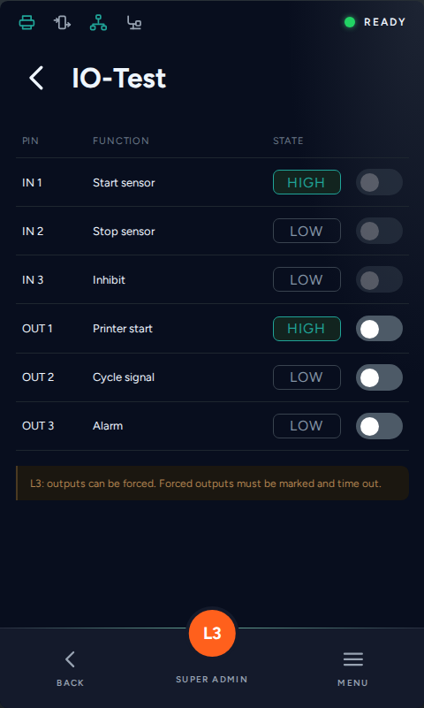
Sketch: IO-Test — content and hierarchy idea, not styling

8.6 Diagnosis Logs
Menu position: Main Menu › Service › Diagnostic Function
Purpose. Switch diagnosis recording on and review what the machine recorded since.

Content
- Toggle bar at the top of the screen that activates diagnosis recording.
- Chronological list of internal events since activation: user logins, parameter changes (old value to new value), state changes, errors.
- Per entry: timestamp, event type, user role, detail text.
- Visible indication of how long recording has been on and how much space is left.

Interaction and states
- Switching the toggle off keeps the recorded list until it is overwritten.
- Export to USB is expected.
- Old entries are overwritten automatically when the storage area is full (FIFO), without any manual action.
Access. L2 to view, L3 to activate and to clear (to be confirmed).
Data source. Log file written by the firmware. The activation state replaces the separate "Button/Switch Activate Diagnosis" screen of the previous diagram - it currently has no parameter in the list.

Acceptance criteria
- The recording toggle is the first element and its state is unambiguous.
- Event rows show timestamp, type and user role without truncation.
- A state is designed for "recording off, list empty".
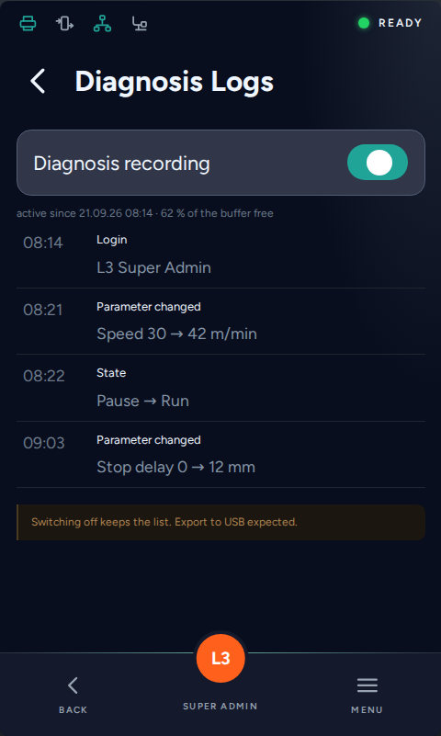
Sketch: Diagnosis Logs — content and hierarchy idea, not styling

8.7 Error History
Menu position: Main Menu › Service › Diagnostic Function
Purpose. Find out what went wrong, when, and who was logged in at the time.

Content
- Scrollable list of error messages, newest first.
- Per entry: error ID, message text, severity, timestamp, and the user role logged in at that moment.
- Search field that unfolds an alphabetical keyboard.
- Empty state and an end-of-list marker.

Interaction and states
- Search filters while typing, over ID and message text.
- A row can be opened for the full text if the message is longer than the row.
- Sorting is fixed to newest first.
- Old entries are overwritten automatically when the storage area is full (FIFO).
Access. Read from L1 (an operator has to be able to report an error); clearing L3 only.
Data source. Log file. No parameters involved.

Acceptance criteria
- The search field unfolds the alphabetical keyboard.
- An end-of-list marker and an empty state are designed.
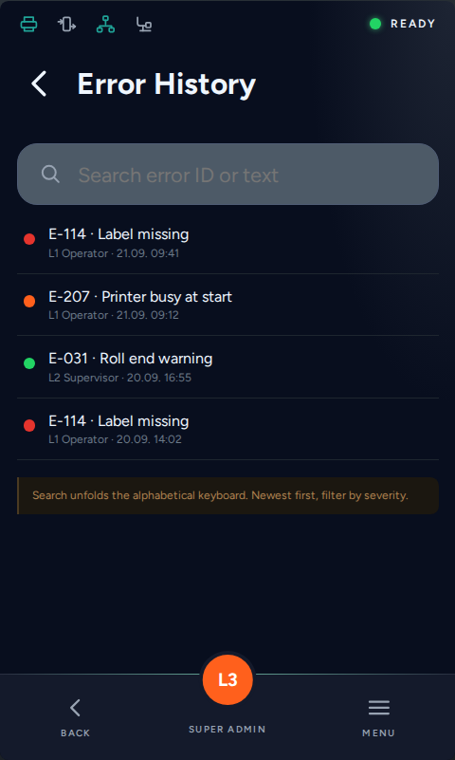
Sketch: Error History — content and hierarchy idea, not styling

8.8 Reporting — service done
Menu position: Main Menu › Service
Purpose. Close out a service visit: document what was done and reset the service counters.

Content
- Read-only block with the counters since the last service (distance, time, labels - the same values as on Information/Counters).
- Multi-line text field for the technician comment.
- Date and the logged-in user are added automatically and shown.

Interaction and states
- Commit writes a text entry into the log and resets the four "since last service" counters.
Access. L3.
Data source. Counters from the parameter list (read); the comment goes into the log file, not into a parameter.

Acceptance criteria
- Counters, comment field and the automatic date/user block are visible without scrolling.
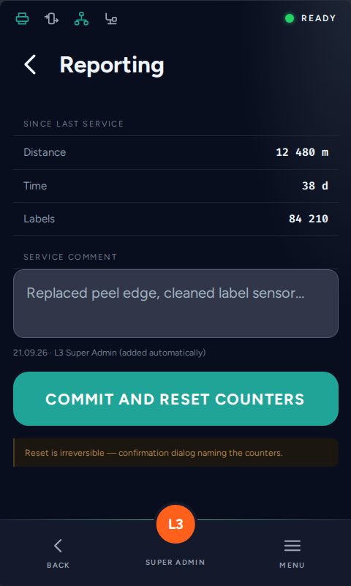
Sketch: Reporting — content and hierarchy idea, not styling

8.9 Load/Store Backup — USB
Menu position: Main Menu › Service › Files
Purpose. Write a backup to a USB drive or to the internal storage, or load one back into the machine.

Content
- File browser over the USB drive: path bar, folder rows, file rows, one level up.
- Files that are not machine backups are greyed out or filtered.
- Action button "Create backup here" for the folder currently open.
- Follow-up dialog: editable file name, pre-filled with device name + serial + date, and a choice between "Backup" (everything) and "Format" (parameter set only).

Interaction and states
- No USB drive: the screen shows an empty state, not an error dialog.
- Loading a backup is a machine-changing action - confirmation dialog, and the machine must not be running.
- Long operations need a progress state and a result message; the user must not be able to pull the drive without a warning.
Access. L3 for load, L2 for create.
Data source. USB drive or internal storage. A backup restores the same machine; a format replicates a configuration onto another machine.

Acceptance criteria
- File browser, action button and the naming dialog are designed as one flow.
- The "no USB drive" case is an empty state, not an error dialog.
- Backup and Format are selectable in the naming dialog and the difference is explained on screen.
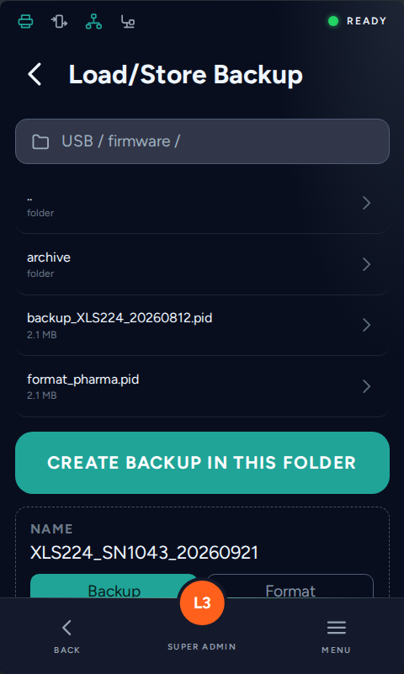
Sketch: Load/Store Backup — content and hierarchy idea, not styling

8.10 FW-Update
Menu position: Main Menu › Service › Files
Purpose. Select a firmware file from a USB drive and install it.

Content
- Same file browser component as Load/Store Backup, filtered to firmware files.
- Current firmware version and the version of the selected file, side by side.
- Clear statement of what happens during the update (machine stops, reboot).
- A separate update view showing the progress as a bar, plus the states "update successful" and "restart machine".

Interaction and states
- Install is a single, clearly separated primary action with a confirmation step.
- During the update the progress view is shown with a phase text; no back navigation.
- Result states: success with the resulting version, and failure with what the user should do next.
- A downgrade to an older firmware version is allowed.
- Firmware images are signed; the signature is verified by the secure boot process. The design needs a state for an image that is rejected because its signature is not valid.
Access. L3.
Data source. USB file system; firmware image.

Acceptance criteria
- Installed version and selected version are visible side by side before the update starts.
- The update process has its own view with a progress bar, a success state and a "restart machine" state.
- A failure state is designed, including what the user should do next.
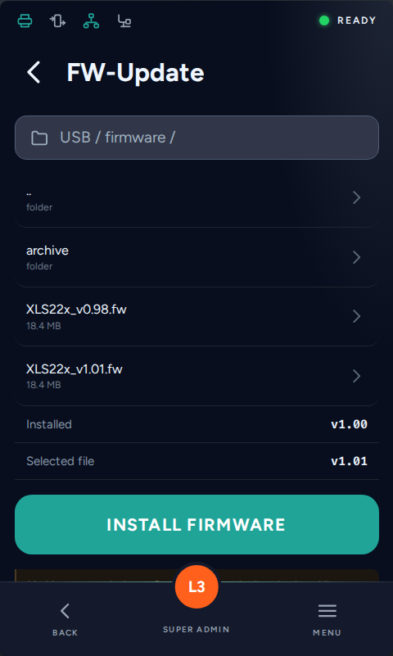
Sketch: FW-Update — content and hierarchy idea, not styling

8.11 Reporting QR — planned for later
Menu position: Main Menu › Help/Contact/Links
Purpose. Hand machine context to a service form on the phone without typing it.

Content
- Generated QR code, large enough to be scanned from about 30 cm.
- Below it, in plain text, what happens when the code is scanned.

Interaction and states
- The code is built from a URL plus machine-specific information and pre-fills a web form.
- The code must be regenerated when the underlying data changes.
Access. L1.
Data source. URL template plus machine identification. The template has to be configurable and does not exist in the parameter list yet.

Acceptance criteria
- The QR code is scannable from approximately 30 cm on the real display.
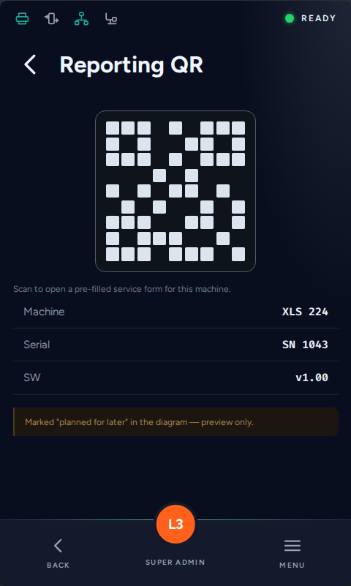
Sketch: Reporting QR — content and hierarchy idea, not styling

8.12 Search Field
Menu position: Main Menu › Help/Contact/Links
Purpose. Reach a parameter directly instead of walking the menu tree.

Content
- Search field with an unfolding alphabetical keyboard and a numeric mode for IDs.
- Result rows: parameter name, its menu path, and its current value.
- Empty state before typing, "no match" state after.

Interaction and states
- Search runs over parameter ID and name; from two characters onwards.
- Selecting a result opens the screen that contains the parameter.
- Back returns to the result list, not to the menu root.
Access. Results should be filtered by access level: a parameter the user may not read is not listed.
Data source. Parameter list. Needs a search index, including the translated names.

Acceptance criteria
- Results appear from the second character and show name, path and current value.
- Empty, no-match and too-many-results states are designed.
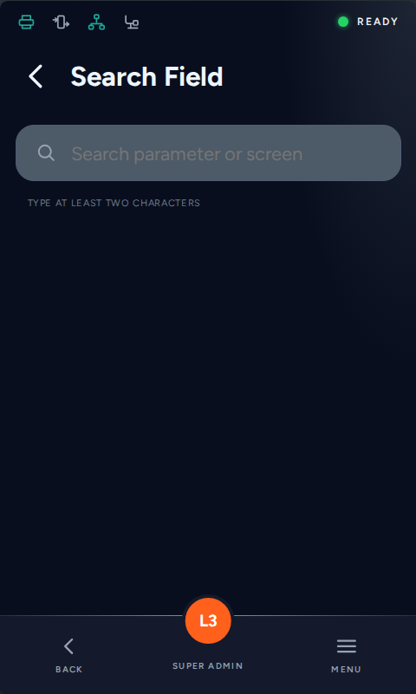
Sketch: Search Field — content and hierarchy idea, not styling

8.13 Create New User — Create User
Menu position: Main Menu › Users & Authentication
Purpose. Create a user account and store it in the secure user database.

Content
- Input fields: Name, Password, Access Level, Auto LogOff (Time), Language.
- Password field masked, with a visibility toggle and live feedback against the rules from User Settings (length, capitals, symbols, numbers).
- Access Level as a selection limited to the levels the creator may hand out.
- Language as a selection - a new user should see their own language at first login.

Interaction and states
- Save is only enabled when every rule is met; violations are shown per field, not as one dialog at the end.
- Duplicate user name is rejected inline.
- After saving, the account appears in User Management.
- Cancel must warn about losing the entry.
Access. L3 minimum to create L1/L2/L3 accounts.
Data source. Secure user database (firmware side), not the parameter list. The password rules come from User Settings (ParamID 618-627).

Acceptance criteria
- Password rules are shown and validated per field, not in one dialog at the end.
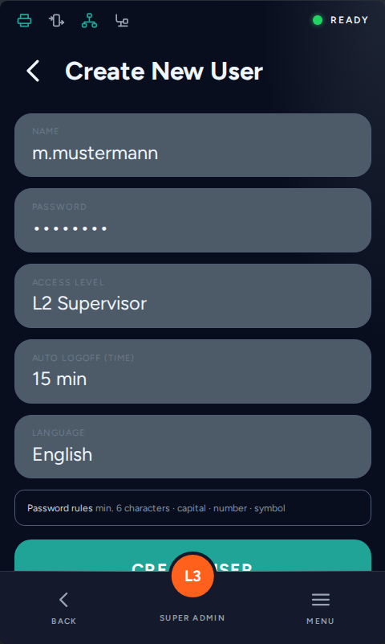
Sketch: Create New User — content and hierarchy idea, not styling

8.14 User Management
Menu position: Main Menu › Users & Authentication
Purpose. Self-service for the logged-in user, and user administration for higher levels.

Content
- The screen has two faces, decided by the level of the logged-in user.
- L1/L2: change own password, change language temporarily (value set back afterwards), disable own role.
- L3: list of enabled users with name, role and date of last password change.
- L3 per user: password, access level, auto log-off time, language, black-listed parameters, white-listed parameters, disable user.

Interaction and states
- One screen, two layouts — the frontend needs both states drawn, plus the transition when the level changes mid-session.
- "Disable own role" logs the user out; it needs a confirmation that says so.
- A temporary language change is active only while the user is logged in and is not kept over a restart.
- Users are disabled, never deleted, so the audit trail stays complete.
- The parameter black-/white-list is an entry field for parameter IDs: an operator can be granted or denied a single parameter without lifting the whole profile to a higher level.
Access. L1/L2 see only their own account. L3 sees the list and may edit levels 1, 2 and their own. Level 0 (not logged in) has no access to this screen at all.
Data source. Secure user database. Nothing here is in the parameter list.

Acceptance criteria
- Both faces of the screen are designed: self-service (L1/L2) and administration (L3).
- The temporary language change states when it will be set back.
- "Disable own role" is confirmed and explains that it logs the user out.

Open points
- Entering parameter IDs by hand is acceptable on the 4.3" display; a comfortable picker is expected later with the web server or a central management tool.
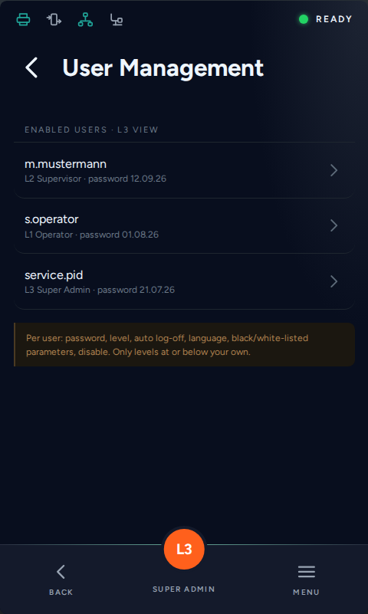
Sketch: User Management — content and hierarchy idea, not styling

8.15 Secure Code
Menu position: Main Menu › Users & Authentication
Purpose. Controlled, time-limited service access beyond the normal levels.

Content
- The branch starts with an explanation screen: what a secure code is for — resetting the machine, or creating a new administrator when the credentials of all level 3 accounts have been lost.
- The same screen states that generating a code requires an authenticated account in the partner portal, that only a limited number of codes can be issued, and that every request is logged.
- Two actions on that screen: "Generate code" leads to the QR screen described below, "Enter secure code" leads to an input mask.
- QR screen: the generated code, plus in plain text what happens when it is scanned, and the machine data carried in the link.
- Input screen: a field for the code with a numeric or alphanumeric keyboard, and the state display showing whether an elevated access is currently open and until when.

Interaction and states
- The QR code is a request to the PID partner portal. The requester logs in there, the portal checks that the account is responsible for this machine and returns a code.
- The code is typed into the labeller and opens level 4 for a limited time; it closes again by itself.
- Every request is logged in the portal, every opening and closing in the machine audit trail.
- The purpose is recovery: resetting the machine or creating a new administrator when no level 3 account is reachable any more. The data erase action is part of that recovery and needs its own confirmation flow.
- Generating a code is confirmed explicitly ("do you really want to generate a code?") because the number of codes per machine is limited.
- Security rule: the secure code screens exist on the device only. They must never be reachable through the later web server.
Access. Visible from any level. The access it grants is level 4 (Secure Access), bound to the code and its time window, not to a user profile.
Data source. URL template, machine identification, and a code check in the firmware. Backlog entries: "Parameters for Secure Code", "Parameters for hiding port of database, ports, SSH etc. (high level access) - self resetting".

Acceptance criteria
- The explanation screen makes clear why the code exists and what it grants, before any action is offered.
- Generate code and Enter secure code are two separate, clearly distinguishable paths.
- The state "elevated access open until hh:mm" is visible on the screen and in the status bar.
- The screens are marked as device-only, not available through the web server.
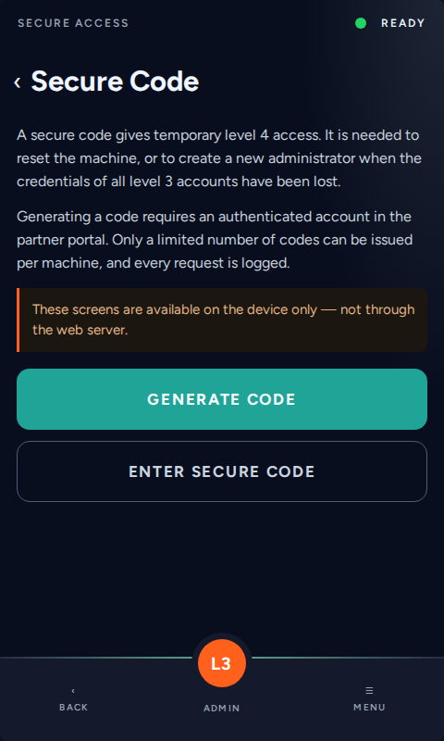
Sketch: entry screen — explanation first, then the two paths
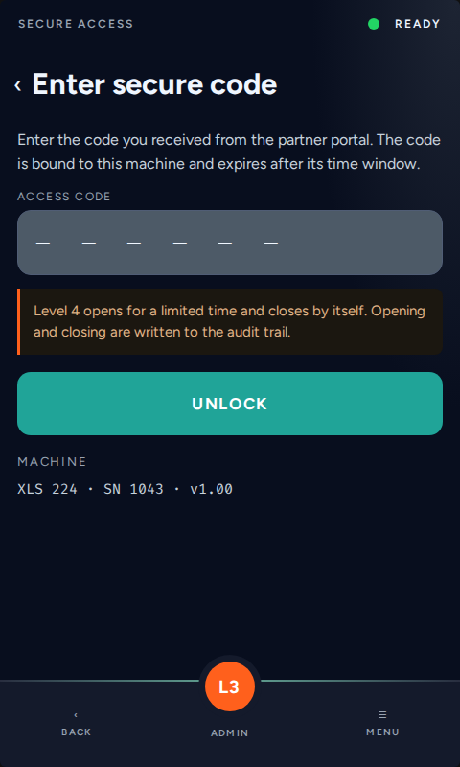
Sketch: code entry
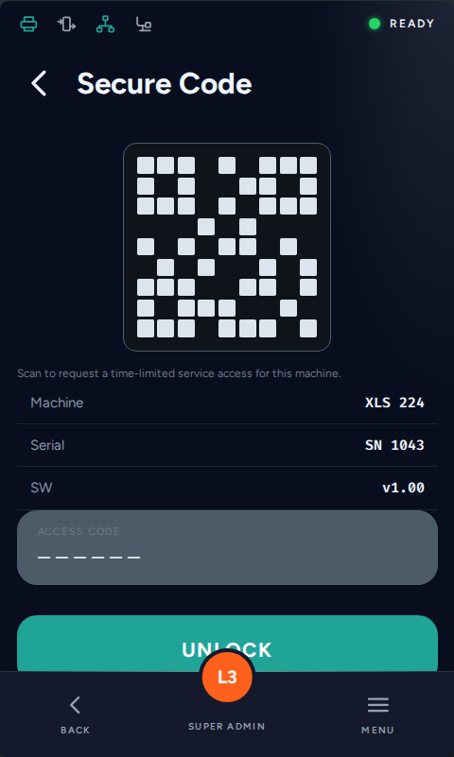
Sketch: Secure Code — content and hierarchy idea, not styling

8.16 Setup wizard — first start of a machine
New in this version. Not in the menu structure diagram yet, but part of this design round.
Purpose. Guide an application engineer through the first start of a machine so that nothing essential is left unset.

Content
- The wizard starts automatically at the very first start of a machine and can be called again from Service.
- Step 1 asks for the level 3 password and forces it to be reset — the machine must not go into production with the delivery password.
- The following steps show a list of parameters that have to be set or confirmed. The list is defined later; the design has to work for roughly 5 to 20 entries spread over several steps.
- Every step shows the progress through the sequence as a percentage and what the step is for.
- A summary at the end lists what was set.

Interaction and states
- Arrow buttons move forward and back through the steps; the user can go back without losing entries.
- A step can be skipped only if the parameter is not mandatory; skipped entries are visible in the summary.
- Parameters are edited with the same controls as everywhere else — the wizard is a frame around them, not a second editor.
Access. L3 (application engineer, service).

Acceptance criteria
- The password reset step cannot be skipped.
- Progress through the sequence is visible on every step.

8.17 Start-up screen
New in this version.
Purpose. Show the user that the machine is booting and how far along it is, instead of a blank display.

Content
- The logo configured in HMI_Logo_Selection, in the size the logo area allows.
- The device name (HMI_Device_Name) below it.
- A progress indicator that runs against the duration of the previous boots rather than jumping in steps.
- A discreet line with machine type and firmware version at the bottom.

Interaction and states
- No interaction — the screen is not operable.
- It has to work in every orientation, because the orientation is known before the boot completes.
- If the boot takes noticeably longer than usual, the progress must not stall at 99 %: design a state for "still starting".
- A state for a failed start is needed as well, with the error shown as text rather than a blank screen.
Access. None — shown before any login.
Data source. Logo and device name from the parameter list; the progress estimate comes from the firmware, measured against previous boot times.

Acceptance criteria
- Logo, device name and progress are visible without any interaction.
- The progress indicator is designed for a boot that takes longer than expected.
- The screen exists in portrait and in landscape.
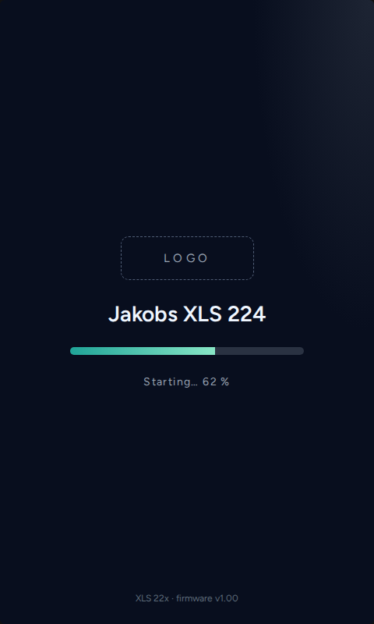
Sketch: start-up screen with logo, device name and progress

9 Icons
Icons carry more meaning than text on this interface — the operator persona relies on them. The icon language of the existing drafts is to be kept: outline icons on a 24 px grid, light stroke, single colour so they can be recoloured per state and per theme.
Where Mono has already drawn an icon for a function, that icon is used. The table below lists every icon the interface needs, together with a description of the function behind it. The SVG files delivered with this document are proposals and inspiration only — they are there so the meaning is unambiguous, not to prescribe a shape.
Attached: PID_Labeller_Icon_Set_SVG.zip — 67 SVG files, 24 × 24, stroke 1.8, currentColor.

9.1 Icon list
The artwork in the first column is the proposal delivered with this document (SVG, 24 × 24, stroke 1.8, single colour).
Icon | Name | Function / meaning | Used for
 | menu | Burger - menu entry point | Main Menu
 | home | House - home screen | UI element
 | settings | Hex nut - machine settings (a UI gear would suit as well) | Settings
 | service | Open-end wrench, single object - clearer than a wrench-plus-screwdriver pair at 24 px | Service
 | production | Box on a conveyor - production | Production
 | help | Question mark - help / contact | Help/Contact/Links
 | users | Two people - user management | UI element
 | counter | Tally marks - counting (other counter metaphors are welcome) | Information/Counters
 | machine | Labeller: frame with the label roll on top, peel arm, and a labelled product on the line | Machine
 | options | Sliders - optional assemblies / options | Options
 | interface | Plug - interfaces | Interface
 | label | Label tag - label settings | Label
 | display | HMI panel - appearance | HMI
 | unwinder | Roll as a spiral, web running AWAY from the roll | Unwinder
 | rewinder | Same roll as the unwinder, web running INTO the roll - only the arrow direction differs | Rewinder
 | drive | Blocky engine with valve cover, cooling ribs and mounting points - the drive unit | Drive Unit
 | drivecfg | The same engine with an adjustment slider - drive configuration | Drive Settings
 | start | Play triangle - start signal | Start, Start
 | stop | Square - stop signal | Stop, Stop
 | speed | Speedometer needle - speed | Speed, Speed Test
 | tandem | Two units handing over - tandem mode | Tandem
 | io | One arrow running into the module, one running out - digital inputs and outputs (an I/O lettering icon would suit as well) | Digital IO, Digital IO
 | sensor | Fork sensor beam - sensors | Sensors
 | signal | Pulse train - further IO signals | Further IO-Signals
 | network | Node tree - network | Network
 | webserver | Globe - webserver | UI element
 | can | Bus line with nodes - CAN | CAN
 | card | Plug-in card with edge connector - MIO / bus card | MIO-Card, Bus- & Network Card, MIO-Card, Bus- & Network Card
 | applicator | Pivoting applicator arm with pad - PConnector (an abstract shape or a pneumatic cylinder icon is equally welcome) | PConnector, PConnector
 | printer | Printer - printer interface | Printers
 | camera | Camera - print & code control | Control, Control
 | recipe | Parameter sheet - formats / recipes | Formats
 | batch | Stack of jobs - batch mode | Batch Mode
 | folderopen | Three stacked folders - a list of stored formats, not an opened folder | Select Format
 | save | Floppy - save format | Modify Format
 | compare | Two-way arrows - compare / check | UI element
 | files | Folder - files | Files
 | backup | Database with export arrow - backup | Load/Store Backup
 | fwupdate | Chip with up-arrow - firmware update | FW-Update
 | test | Test vessel - tests (a checkbox icon is preferred) | Tests
 | iotest | IO block (same metaphor as the IO icon) with check - IO test | IO-Test
 | applicatortest | Applicator icon with check - applicator test | Applicator Test
 | testmode | Cycle run - test mode | Test-Mode
 | diagnostic | Heartbeat trace - diagnostics | Diagnostic Function
 | activate | Power symbol | UI element
 | logs | Log sheet - diagnosis logs | Diagnosis Logs
 | history | Clock with rewind - error history / audit trail | Error History
 | report | Signed report - reporting service done | Reporting
 | listeye | List with eye - read-only parameter overview | UI element
 | modified | List with pencil - user-modified parameters | User modified Parameters
 | qr | QR code - service reporting QR | Reporting QR
 | search | Magnifier - search field | Search Field
 | lock | Padlock - write-protected parameter | UI element
 | chevron | Chevron - drill down | UI element
 | back | Chevron left - back | UI element
 | plus | Plus - add / assign quicklink | UI element
 | pause | Pause - machine pause | UI element
 | play | Play - machine run | UI element
 | alarm | Bell - alarm state (a warning triangle would suit as well) | UI element
 | authusers | Person plus shield - users and authentication | Users & Authentication
 | useradd | Person with a plus - create a new user | Create New User
 | userpolicy | Policy sheet with a padlock - password rules and directory binding | User Settings
 | usermanage | Two user entries with their data lines - manage existing users | User Management
 | securecode | QR code with a padlock - service secure code | Secure Code
 | country | Flag with a padlock - target country and the security rules that follow from it | Country Settings
 | formatnew | Format sheet with a plus - create a new format | Create New Format
 | tbd | Dashed question mark - screen not specified yet | UI element

10 Deliverables
Deliverable | Detail
Figma file | Structured by screen group, with pages for design system, components, screens and states.
HTML / CSS | Where possible, a lightweight HTML/CSS implementation of the designed screens, as delivered with the first draft.
Components | All components from 5.4 as Figma components with variants for every state.
Tokens | Colour, typography, spacing and radius as styles/variables, for both themes.
Screens | All screens of the menu structure in portrait and in both landscape layouts, dark and light.
Icons | As SVG, scalable, single colour, consistent grid and stroke.
Specification | Spacing, sizes and behaviour readable from the file (redlines or a documented token system), so the frontend can be rebuilt without asking back.
Prototype | Clickable Figma prototype covering the main paths: home → menu → parameter screen → edit → back, plus the special screens.

10.1 General acceptance criteria
- The complete menu structure of the draw.io diagram is designed.
- Touch targets and handling were checked on the provided demo display and are convenient to operate.
- All three layouts (portrait, landscape LH, landscape RH) are delivered for every screen type.
- Dark and light theme are delivered.
- Every component carries its states; empty, loading and error states exist for every screen that loads data.
- The design works within the graphics performance of the embedded system.
- Fonts and icons are free of licence restrictions for commercial use in a product.

11 Open points
Content that PID delivers during the project. None of it blocks the start of the design work — the design carries the frame, the content follows.
Topic | What is still to come from PID
Setup wizard | The list of parameters the wizard walks through, and their order.
Parameter help texts | The help texts themselves, in every selectable language. Use placeholder text in the design and keep to the lengths given in section 7.1.
Text resources | The reviewed translations. All frontend texts are maintained as text resources with their own ID ranges; German runs roughly 30 % longer than English, so every component has to be checked against its longest language.
Modal dialog | A styling suggestion for the information and error dialog is to be supplied by PID (CE).

