|  |  |  |
| --- | --- | --- |
|  | **Carátula para entrega de prácticas** | |
| Facultad de Ingeniería | | Laboratorio de docencia |

Laboratorios de computación

salas A y B

|  |  |
| --- | --- |
| *Profesor :* | Alfredo Carlon |
| *Asignatura:* | Fundamentos de programación |
| *Grupo:* | 1107 |
| *No de Práctica(s):* | 11 |
| *Integrante(s):* | Ramírez Ramírez Ana Karla||Garcia Batseba Ivanna  Despouy Pascual Paul|| Vargas Romero Mirtha Andrea  Var |
|  |  |
|  |  |
| *Semestre:* | 2018-1 |
| *Fecha de entrega:* | 29 de diciembre del 2017 |
| *Obervaciones:* |  |

CALIFICACIÓN: __________

**Practica 11. Fundamentos de programación.**

**¿Las funciones y los programas son equivalentes?**

Para comenzar la solución del problema plantearemos las definiciones de cada:

Un **programa**es un bloque compuesto con una cabecera este contiene más bloques compuestos dentro de él  y al mismo tiempo estos están conformados por funciones; el programa busca dar solución a un problema dado por el usuario y para ello realiza distintas acciones para lograrlo (estas acciones se encuentran representadas en los bloques compuestos).

Una **función** es una acción realizada en el programa.que realiza cosas específicas y puede ser llamada por un mismo programa, esta acción es realizada para resolver un problema dentro del programa

Creemos que no son equivalentes porque aunque Ud son similares en que ambas resuelven problemas se diferencian en nuestra percepción en cuanto a “ magnitud” es decir, vemos que el programa resuelve un problema realizando distintas acciones que tienen condicionantes pero la función resuelve solo un problema en específico realizando únicamente una acción.

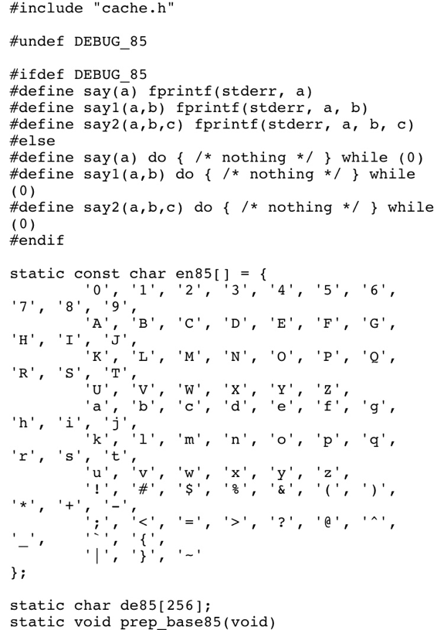CÓDIGO 1

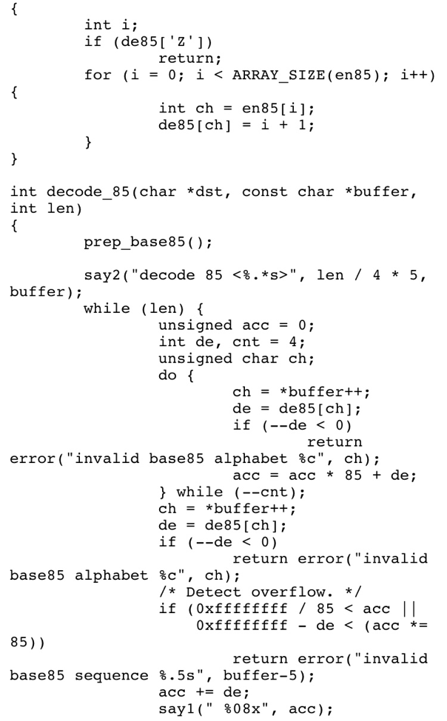

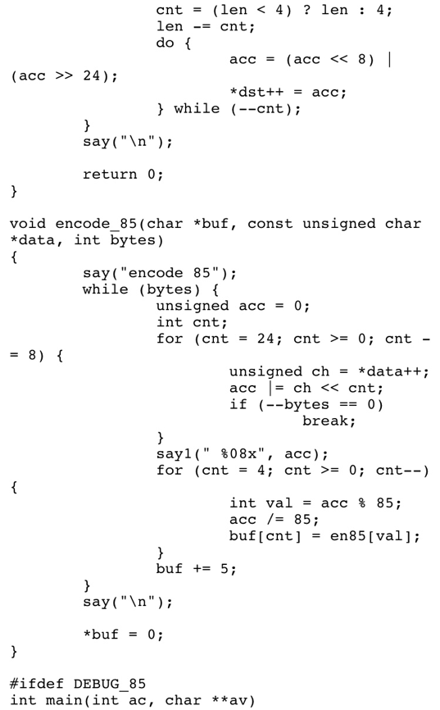

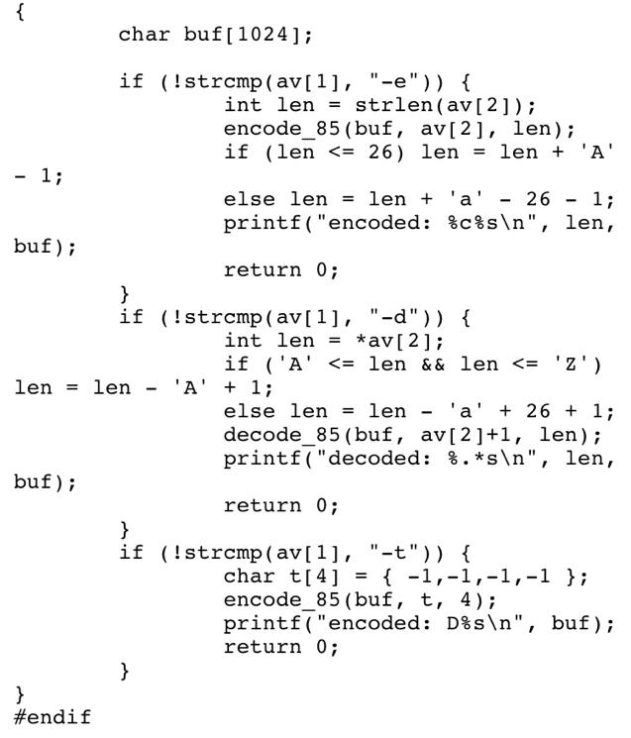

CÓDIGO 1

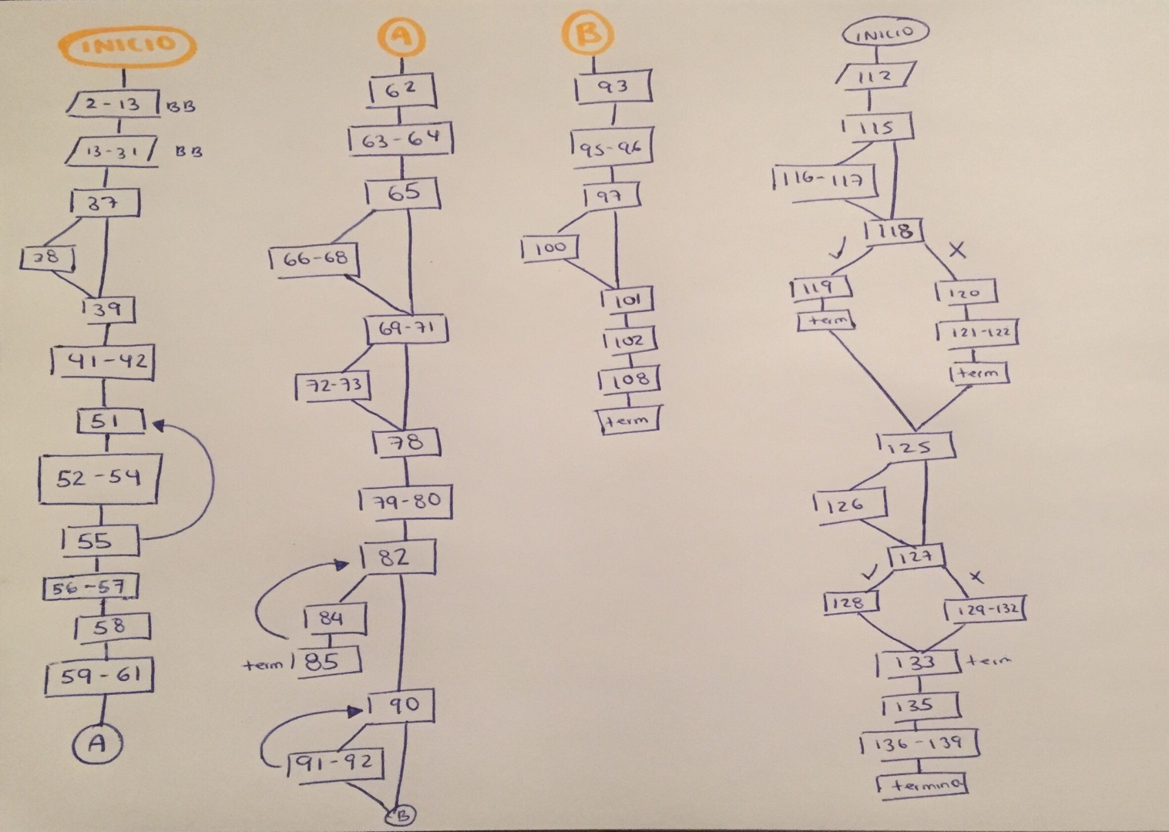

**CÓDIGO 2**

/*

* Bluetooth support for Broadcom devices

*

* Copyright (C) 2015 Intel Corporation

*

*

* This program is free software; you can redistribute it and/or modify

* it under the terms of the GNU General Public License as published by

* the Free Software Foundation; either version 2 of the License, or

* (at your option) any later version.

*

* This program is distributed in the hope that it will be useful,

* but WITHOUT ANY WARRANTY; without even the implied warranty of

* MERCHANTABILITY or FITNESS FOR A PARTICULAR PURPOSE. See the

* GNU General Public License for more details.

*

* You should have received a copy of the GNU General Public License

* along with this program; if not, write to the Free Software

* Foundation, Inc., 59 Temple Place, Suite 330, Boston, MA 02111-1307 USA

*

*/

#include <linux/module.h>

#include <linux/firmware.h>

#include <asm/unaligned.h>

#include <net/bluetooth/bluetooth.h>

#include <net/bluetooth/hci_core.h>

#include "btbcm.h"

#define VERSION "0.1"

#define BDADDR_BCM20702A0 (&(bdaddr_t) {{0x00, 0xa0, 0x02, 0x70, 0x20, 0x00}})

#define BDADDR_BCM4324B3 (&(bdaddr_t) {{0x00, 0x00, 0x00, 0xb3, 0x24, 0x43}})

#define BDADDR_BCM4330B1 (&(bdaddr_t) {{0x00, 0x00, 0x00, 0xb1, 0x30, 0x43}})

int btbcm_check_bdaddr(struct hci_dev *hdev)

{

struct hci_rp_read_bd_addr *bda;

struct sk_buff *skb;

skb = __hci_cmd_sync(hdev, HCI_OP_READ_BD_ADDR, 0, NULL,

HCI_INIT_TIMEOUT);

if (IS_ERR(skb)) {

int err = PTR_ERR(skb);

bt_dev_err(hdev, "BCM: Reading device address failed (%d)", err);

return err;

}

if (skb->len != sizeof(*bda)) {

bt_dev_err(hdev, "BCM: Device address length mismatch");

kfree_skb(skb);

return -EIO;

}

bda = (struct hci_rp_read_bd_addr *)skb->data;

/* Check if the address indicates a controller with either an

* invalid or default address. In both cases the device needs

* to be marked as not having a valid address.

*

* The address 00:20:70:02:A0:00 indicates a BCM20702A0 controller

* with no configured address.

*

* The address 43:24:B3:00:00:00 indicates a BCM4324B3 controller

* with waiting for configuration state.

*

* The address 43:30:B1:00:00:00 indicates a BCM4330B1 controller

* with waiting for configuration state.

*/

if (!bacmp(&bda->bdaddr, BDADDR_BCM20702A0) ||

!bacmp(&bda->bdaddr, BDADDR_BCM4324B3) ||

!bacmp(&bda->bdaddr, BDADDR_BCM4330B1)) {

bt_dev_info(hdev, "BCM: Using default device address (%pMR)",

&bda->bdaddr);

set_bit(HCI_QUIRK_INVALID_BDADDR, &hdev->quirks);

}

kfree_skb(skb);

return 0;

}

EXPORT_SYMBOL_GPL(btbcm_check_bdaddr);

int btbcm_set_bdaddr(struct hci_dev *hdev, const bdaddr_t *bdaddr)

{

struct sk_buff *skb;

int err;

skb = __hci_cmd_sync(hdev, 0xfc01, 6, bdaddr, HCI_INIT_TIMEOUT);

if (IS_ERR(skb)) {

err = PTR_ERR(skb);

bt_dev_err(hdev, "BCM: Change address command failed (%d)", err);

return err;

}

kfree_skb(skb);

return 0;

}

EXPORT_SYMBOL_GPL(btbcm_set_bdaddr);

int btbcm_patchram(struct hci_dev *hdev, const struct firmware *fw)

{

const struct hci_command_hdr *cmd;

const u8 *fw_ptr;

size_t fw_size;

struct sk_buff *skb;

u16 opcode;

int err = 0;

/* Start Download */

skb = __hci_cmd_sync(hdev, 0xfc2e, 0, NULL, HCI_INIT_TIMEOUT);

if (IS_ERR(skb)) {

err = PTR_ERR(skb);

bt_dev_err(hdev, "BCM: Download Minidrv command failed (%d)",

err);

goto done;

}

kfree_skb(skb);

/* 50 msec delay after Download Minidrv completes */

msleep(50);

fw_ptr = fw->data;

fw_size = fw->size;

while (fw_size >= sizeof(*cmd)) {

const u8 *cmd_param;

cmd = (struct hci_command_hdr *)fw_ptr;

fw_ptr += sizeof(*cmd);

fw_size -= sizeof(*cmd);

if (fw_size < cmd->plen) {

bt_dev_err(hdev, "BCM: Patch is corrupted");

err = -EINVAL;

goto done;

}

cmd_param = fw_ptr;

fw_ptr += cmd->plen;

fw_size -= cmd->plen;

opcode = le16_to_cpu(cmd->opcode);

skb = __hci_cmd_sync(hdev, opcode, cmd->plen, cmd_param,

HCI_INIT_TIMEOUT);

if (IS_ERR(skb)) {

err = PTR_ERR(skb);

bt_dev_err(hdev, "BCM: Patch command %04x failed (%d)",

opcode, err);

goto done;

}

kfree_skb(skb);

}

/* 250 msec delay after Launch Ram completes */

msleep(250);

done:

return err;

}

EXPORT_SYMBOL(btbcm_patchram);

static int btbcm_reset(struct hci_dev *hdev)

{

struct sk_buff *skb;

skb = __hci_cmd_sync(hdev, HCI_OP_RESET, 0, NULL, HCI_INIT_TIMEOUT);

if (IS_ERR(skb)) {

int err = PTR_ERR(skb);

bt_dev_err(hdev, "BCM: Reset failed (%d)", err);

return err;

}

kfree_skb(skb);

/* 100 msec delay for module to complete reset process */

msleep(100);

return 0;

}

static struct sk_buff *btbcm_read_local_name(struct hci_dev *hdev)

{

struct sk_buff *skb;

skb = __hci_cmd_sync(hdev, HCI_OP_READ_LOCAL_NAME, 0, NULL,

HCI_INIT_TIMEOUT);

if (IS_ERR(skb)) {

bt_dev_err(hdev, "BCM: Reading local name failed (%ld)",

PTR_ERR(skb));

return skb;

}

if (skb->len != sizeof(struct hci_rp_read_local_name)) {

bt_dev_err(hdev, "BCM: Local name length mismatch");

kfree_skb(skb);

return ERR_PTR(-EIO);

}

return skb;

}

static struct sk_buff *btbcm_read_local_version(struct hci_dev *hdev)

{

struct sk_buff *skb;

skb = __hci_cmd_sync(hdev, HCI_OP_READ_LOCAL_VERSION, 0, NULL,

HCI_INIT_TIMEOUT);

if (IS_ERR(skb)) {

bt_dev_err(hdev, "BCM: Reading local version info failed (%ld)",

PTR_ERR(skb));

return skb;

}

if (skb->len != sizeof(struct hci_rp_read_local_version)) {

bt_dev_err(hdev, "BCM: Local version length mismatch");

kfree_skb(skb);

return ERR_PTR(-EIO);

}

return skb;

}

static struct sk_buff *btbcm_read_verbose_config(struct hci_dev *hdev)

{

struct sk_buff *skb;

skb = __hci_cmd_sync(hdev, 0xfc79, 0, NULL, HCI_INIT_TIMEOUT);

if (IS_ERR(skb)) {

bt_dev_err(hdev, "BCM: Read verbose config info failed (%ld)",

PTR_ERR(skb));

return skb;

}

if (skb->len != 7) {

bt_dev_err(hdev, "BCM: Verbose config length mismatch");

kfree_skb(skb);

return ERR_PTR(-EIO);

}

return skb;

}

static struct sk_buff *btbcm_read_controller_features(struct hci_dev *hdev)

{

struct sk_buff *skb;

skb = __hci_cmd_sync(hdev, 0xfc6e, 0, NULL, HCI_INIT_TIMEOUT);

if (IS_ERR(skb)) {

bt_dev_err(hdev, "BCM: Read controller features failed (%ld)",

PTR_ERR(skb));

return skb;

}

if (skb->len != 9) {

bt_dev_err(hdev, "BCM: Controller features length mismatch");

kfree_skb(skb);

return ERR_PTR(-EIO);

}

return skb;

}

static struct sk_buff *btbcm_read_usb_product(struct hci_dev *hdev)

{

struct sk_buff *skb;

skb = __hci_cmd_sync(hdev, 0xfc5a, 0, NULL, HCI_INIT_TIMEOUT);

if (IS_ERR(skb)) {

bt_dev_err(hdev, "BCM: Read USB product info failed (%ld)",

PTR_ERR(skb));

return skb;

}

if (skb->len != 5) {

bt_dev_err(hdev, "BCM: USB product length mismatch");

kfree_skb(skb);

return ERR_PTR(-EIO);

}

return skb;

}

static int btbcm_read_info(struct hci_dev *hdev)

{

struct sk_buff *skb;

/* Read Verbose Config Version Info */

skb = btbcm_read_verbose_config(hdev);

if (IS_ERR(skb))

return PTR_ERR(skb);

bt_dev_info(hdev, "BCM: chip id %u", skb->data[1]);

kfree_skb(skb);

/* Read Controller Features */

skb = btbcm_read_controller_features(hdev);

if (IS_ERR(skb))

return PTR_ERR(skb);

bt_dev_info(hdev, "BCM: features 0x%2.2x", skb->data[1]);

kfree_skb(skb);

/* Read Local Name */

skb = btbcm_read_local_name(hdev);

if (IS_ERR(skb))

return PTR_ERR(skb);

bt_dev_info(hdev, "%s", (char *)(skb->data + 1));

kfree_skb(skb);

return 0;

}

static const struct {

u16 subver;

const char *name;

} bcm_uart_subver_table[] = {

{ 0x4103, "BCM4330B1" }, /* 002.001.003 */

{ 0x410e, "BCM43341B0" }, /* 002.001.014 */

{ 0x4406, "BCM4324B3" }, /* 002.004.006 */

{ 0x610c, "BCM4354" }, /* 003.001.012 */

{ 0x2209, "BCM43430A1" }, /* 001.002.009 */

{ 0x6119, "BCM4345C0" }, /* 003.001.025 */

{ 0x230f, "BCM4356A2" }, /* 001.003.015 */

{ }

};

int btbcm_initialize(struct hci_dev *hdev, char *fw_name, size_t len)

{

u16 subver, rev;

const char *hw_name = NULL;

struct sk_buff *skb;

struct hci_rp_read_local_version *ver;

int i, err;

/* Reset */

err = btbcm_reset(hdev);

if (err)

return err;

/* Read Local Version Info */

skb = btbcm_read_local_version(hdev);

if (IS_ERR(skb))

return PTR_ERR(skb);

ver = (struct hci_rp_read_local_version *)skb->data;

rev = le16_to_cpu(ver->hci_rev);

subver = le16_to_cpu(ver->lmp_subver);

kfree_skb(skb);

/* Read controller information */

err = btbcm_read_info(hdev);

if (err)

return err;

switch ((rev & 0xf000) >> 12) {

case 0:

case 1:

case 2:

case 3:

for (i = 0; bcm_uart_subver_table[i].name; i++) {

if (subver == bcm_uart_subver_table[i].subver) {

hw_name = bcm_uart_subver_table[i].name;

break;

}

}

snprintf(fw_name, len, "brcm/%s.hcd", hw_name ? : "BCM");

break;

default:

return 0;

}

bt_dev_info(hdev, "%s (%3.3u.%3.3u.%3.3u) build %4.4u",

hw_name ? : "BCM", (subver & 0xe000) >> 13,

(subver & 0x1f00) >> 8, (subver & 0x00ff), rev & 0x0fff);

return 0;

}

EXPORT_SYMBOL_GPL(btbcm_initialize);

int btbcm_finalize(struct hci_dev *hdev)

{

struct sk_buff *skb;

struct hci_rp_read_local_version *ver;

u16 subver, rev;

int err;

/* Reset */

err = btbcm_reset(hdev);

if (err)

return err;

/* Read Local Version Info */

skb = btbcm_read_local_version(hdev);

if (IS_ERR(skb))

return PTR_ERR(skb);

ver = (struct hci_rp_read_local_version *)skb->data;

rev = le16_to_cpu(ver->hci_rev);

subver = le16_to_cpu(ver->lmp_subver);

kfree_skb(skb);

bt_dev_info(hdev, "BCM (%3.3u.%3.3u.%3.3u) build %4.4u",

(subver & 0xe000) >> 13, (subver & 0x1f00) >> 8,

(subver & 0x00ff), rev & 0x0fff);

btbcm_check_bdaddr(hdev);

set_bit(HCI_QUIRK_STRICT_DUPLICATE_FILTER, &hdev->quirks);

return 0;

EXPORT_SYMBOL_GPL(btbcm_finalize);

static const struct {

u16 subver;

const char *name;

} bcm_usb_subver_table[] = {

{ 0x210b, "BCM43142A0" }, /* 001.001.011 */

{ 0x2112, "BCM4314A0" }, /* 001.001.018 */

{ 0x2118, "BCM20702A0" }, /* 001.001.024 */

{ 0x2126, "BCM4335A0" }, /* 001.001.038 */

{ 0x220e, "BCM20702A1" }, /* 001.002.014 */

{ 0x230f, "BCM4354A2" }, /* 001.003.015 */

{ 0x4106, "BCM4335B0" }, /* 002.001.006 */

{ 0x410e, "BCM20702B0" }, /* 002.001.014 */

{ 0x6109, "BCM4335C0" }, /* 003.001.009 */

{ 0x610c, "BCM4354" }, /* 003.001.012 */

{ }

};

int btbcm_setup_patchram(struct hci_dev *hdev)

{

char fw_name[64];

const struct firmware *fw;

u16 subver, rev, pid, vid;

const char *hw_name = NULL;

struct sk_buff *skb;

struct hci_rp_read_local_version *ver;

int i, err;

/* Reset */

err = btbcm_reset(hdev);

if (err)

return err;

/* Read Local Version Info */

skb = btbcm_read_local_version(hdev);

if (IS_ERR(skb))

return PTR_ERR(skb);

ver = (struct hci_rp_read_local_version *)skb->data;

rev = le16_to_cpu(ver->hci_rev);

subver = le16_to_cpu(ver->lmp_subver);

kfree_skb(skb);

/* Read controller information */

err = btbcm_read_info(hdev);

if (err)

return err;

switch ((rev & 0xf000) >> 12) {

case 0:

case 3:

for (i = 0; bcm_uart_subver_table[i].name; i++) {

if (subver == bcm_uart_subver_table[i].subver) {

hw_name = bcm_uart_subver_table[i].name;

break;

}

}

snprintf(fw_name, sizeof(fw_name), "brcm/%s.hcd",

hw_name ? : "BCM");

break;

case 1:

case 2:

/* Read USB Product Info */

skb = btbcm_read_usb_product(hdev);

if (IS_ERR(skb))

return PTR_ERR(skb);

vid = get_unaligned_le16(skb->data + 1);

pid = get_unaligned_le16(skb->data + 3);

kfree_skb(skb);

for (i = 0; bcm_usb_subver_table[i].name; i++) {

if (subver == bcm_usb_subver_table[i].subver) {

hw_name = bcm_usb_subver_table[i].name;

break;

}

}

snprintf(fw_name, sizeof(fw_name), "brcm/%s-%4.4x-%4.4x.hcd",

hw_name ? : "BCM", vid, pid);

break;

default:

return 0;

}

bt_dev_info(hdev, "%s (%3.3u.%3.3u.%3.3u) build %4.4u",

hw_name ? : "BCM", (subver & 0xe000) >> 13,

(subver & 0x1f00) >> 8, (subver & 0x00ff), rev & 0x0fff);

err = request_firmware(&fw, fw_name, &hdev->dev);

if (err < 0) {

bt_dev_info(hdev, "BCM: Patch %s not found", fw_name);

goto done;

}

btbcm_patchram(hdev, fw);

release_firmware(fw);

/* Reset */

err = btbcm_reset(hdev);

if (err)

return err;

/* Read Local Version Info */

skb = btbcm_read_local_version(hdev);

if (IS_ERR(skb))

return PTR_ERR(skb);

ver = (struct hci_rp_read_local_version *)skb->data;

rev = le16_to_cpu(ver->hci_rev);

subver = le16_to_cpu(ver->lmp_subver);

kfree_skb(skb);

bt_dev_info(hdev, "%s (%3.3u.%3.3u.%3.3u) build %4.4u",

hw_name ? : "BCM", (subver & 0xe000) >> 13,

(subver & 0x1f00) >> 8, (subver & 0x00ff), rev & 0x0fff);

/* Read Local Name */

skb = btbcm_read_local_name(hdev);

if (IS_ERR(skb))

return PTR_ERR(skb);

bt_dev_info(hdev, "%s", (char *)(skb->data + 1));

kfree_skb(skb);

done:

btbcm_check_bdaddr(hdev);

set_bit(HCI_QUIRK_STRICT_DUPLICATE_FILTER, &hdev->quirks);

return 0;

}

EXPORT_SYMBOL_GPL(btbcm_setup_patchram);

int btbcm_setup_apple(struct hci_dev *hdev)

{

struct sk_buff *skb;

int err;

/* Reset */

err = btbcm_reset(hdev);

if (err)

return err;

/* Read Verbose Config Version Info */

skb = btbcm_read_verbose_config(hdev);

if (!IS_ERR(skb)) {

bt_dev_info(hdev, "BCM: chip id %u build %4.4u",

skb->data[1], get_unaligned_le16(skb->data + 5));

kfree_skb(skb);

}

/* Read USB Product Info */

skb = btbcm_read_usb_product(hdev);

if (!IS_ERR(skb)) {

bt_dev_info(hdev, "BCM: product %4.4x:%4.4x",

get_unaligned_le16(skb->data + 1),

get_unaligned_le16(skb->data + 3));

kfree_skb(skb);

}

/* Read Controller Features */

skb = btbcm_read_controller_features(hdev);

if (!IS_ERR(skb)) {

bt_dev_info(hdev, "BCM: features 0x%2.2x", skb->data[1]);

kfree_skb(skb);

}

/* Read Local Name */

skb = btbcm_read_local_name(hdev);

if (!IS_ERR(skb)) {

bt_dev_info(hdev, "%s", (char *)(skb->data + 1));

kfree_skb(skb);

}

set_bit(HCI_QUIRK_STRICT_DUPLICATE_FILTER, &hdev->quirks);

return 0;

}

EXPORT_SYMBOL_GPL(btbcm_setup_apple);

MODULE_AUTHOR("Marcel Holtmann <marcel@holtmann.org>");

MODULE_DESCRIPTION("Bluetooth support for Broadcom devices ver " VERSION);

MODULE_VERSION(VERSION);

MODULE_LICENSE("GPL");