**ICE #5**

1)

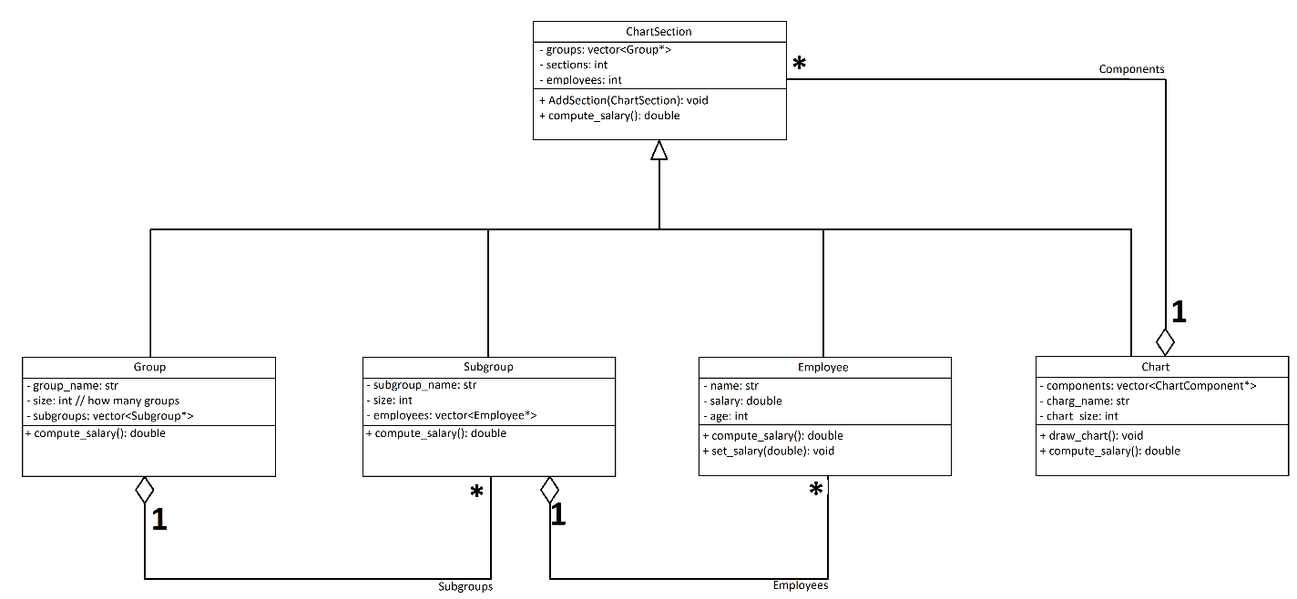

2)

// chart.h

// implementation.cpp

