**Ivan Neto**

**SID: 862228249**

**EE120A Section 021**

**Lab 3 – Combinational Logic**

**Shreya Chitturi**

**Overview**

**Overview of what was done**

* We implemented a BCD to 7 Segment LED display using common anodes. Common anodes are such that outputs are all connected to a power source. The change of an output from 1 to 0 causes the light to turn on, and thus an output = 0 means the light is on the 7 segment LED.

**A brief summary of the results**

* We implemented Behavioral Model to create this BCD to 7 Segment LED circuit. We also implemented a testbench to ensure that our behavioral model produced the correct outputs for the 7 segment LED display.

**Conclusion from the results**

* We found that all of the test cases were successful, and produced a waveform output of the simulation, which can be interpreted to find that all of the inputs produced the correct outputs.

**New Concepts**

* **BCD to 7 Segment LED display**
  + Way to decode a binary signal to turn on a 7 Segment LED display in different patterns.
* **Common Anode version**
  + Outputs are connected to constant power source
  + A current out of the output to ground turns the light on, thus output = 0 means the light is currently on in the segment.
* **Common Cathode version**
  + Outputs are connected to ground.
  + A current through the output turns the light on, thus output = 1 means the light is currently on in the segment.

**Analysis**

**Procedure**

1. Implement the behavioral model for the BCD to 7 Segment LED display.

2. Create a testbench.

3. Run the testbench simulation.

4. Analyze the output and determine whether the model works correctly.

**Figures**

All test cases

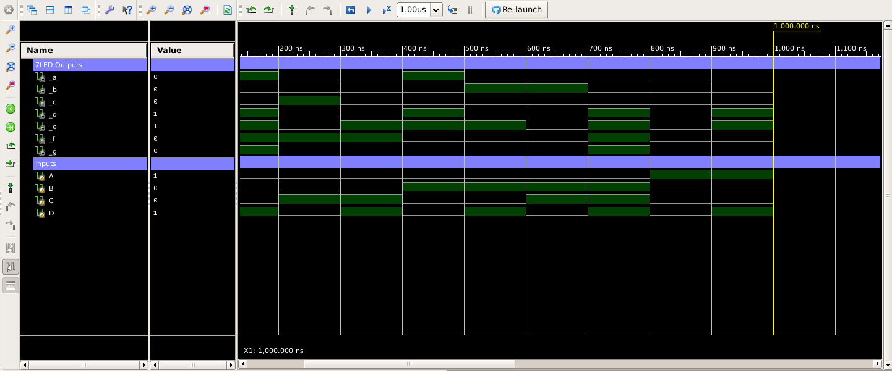

**Figure 1:** The waveform output of all of the testcases being run. The test cases were implemented separately from the design, and the correct outputs are produced.

All test cases, terminal output

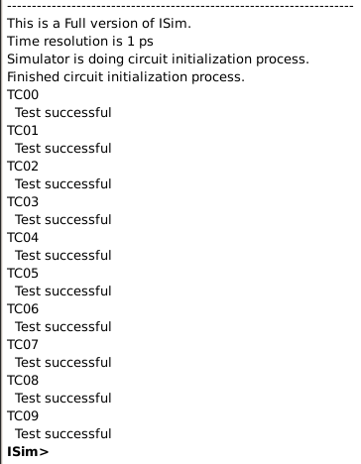Here you can see all of the test case outputs in the terminal. Observe that all test cases pass the testbench successfully, which implies that our design is correctly implemented.

**Records**

**Simulation**

* Graphical user interface

  Description automatically generated
* 

**Code**

**Behavioral Model**

**Testbench**



**UCF**

* We did not use UCF in this lab and thus we do not include that.

**Discussion**

**Does the system work according to provided specifications?**

* The system works according to provided specifications. We did not use a different behavioral model as the one provided.
* We implemented the provided behavioral model and created the rest of the test cases, from numbers 1 to 9. The correct outputs were produced and the testbench passed all test cases.

**Problems and technical issues encountered**

* A few syntactical issues were encountered, but by debugging the code we resolved all of the issues and were able to run the simulation successfully.

**Ways to improve the system**

* I would improve the system by removing the an0, an1, an2, and an3 outputs from the behavioral model, since those are not needed for a single common anode display. Since we were only working with one display, none of those inputs were needed and were discarded while writing the behavioral model code in Verilog.

**Conclusion**

* The purpose of this lab was to learn how to write Verilog code to create a model for BCD to 7 Segment LED display. In this case, we implemented a common anode version of the display.
* We created a behavioral model for our design. We further implemented a testbench and were able to pass all of the test cases, which implies that our design is correctly implemented. The waveform output demonstrates that each configuration of the select lines produces the desired outputs for each of the 7 segments.