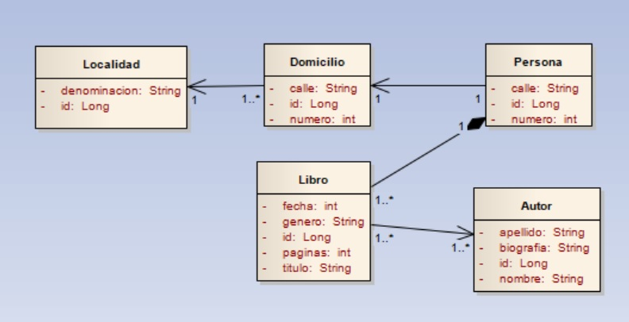

https://github.com/ivannmolina/Tp_Api_SinPaginacion_Ivan_Molina.git