Using command line create a folder in desktop named Exercise0_YourName.

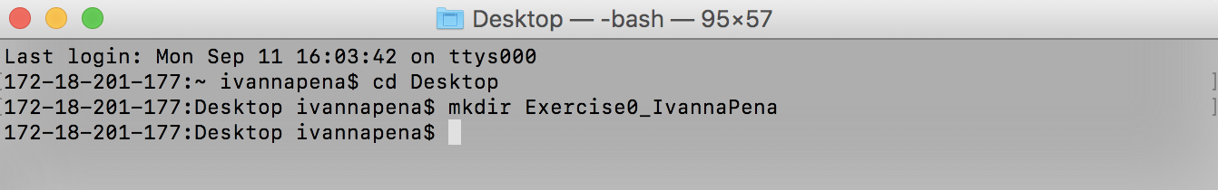

Record the errors you got

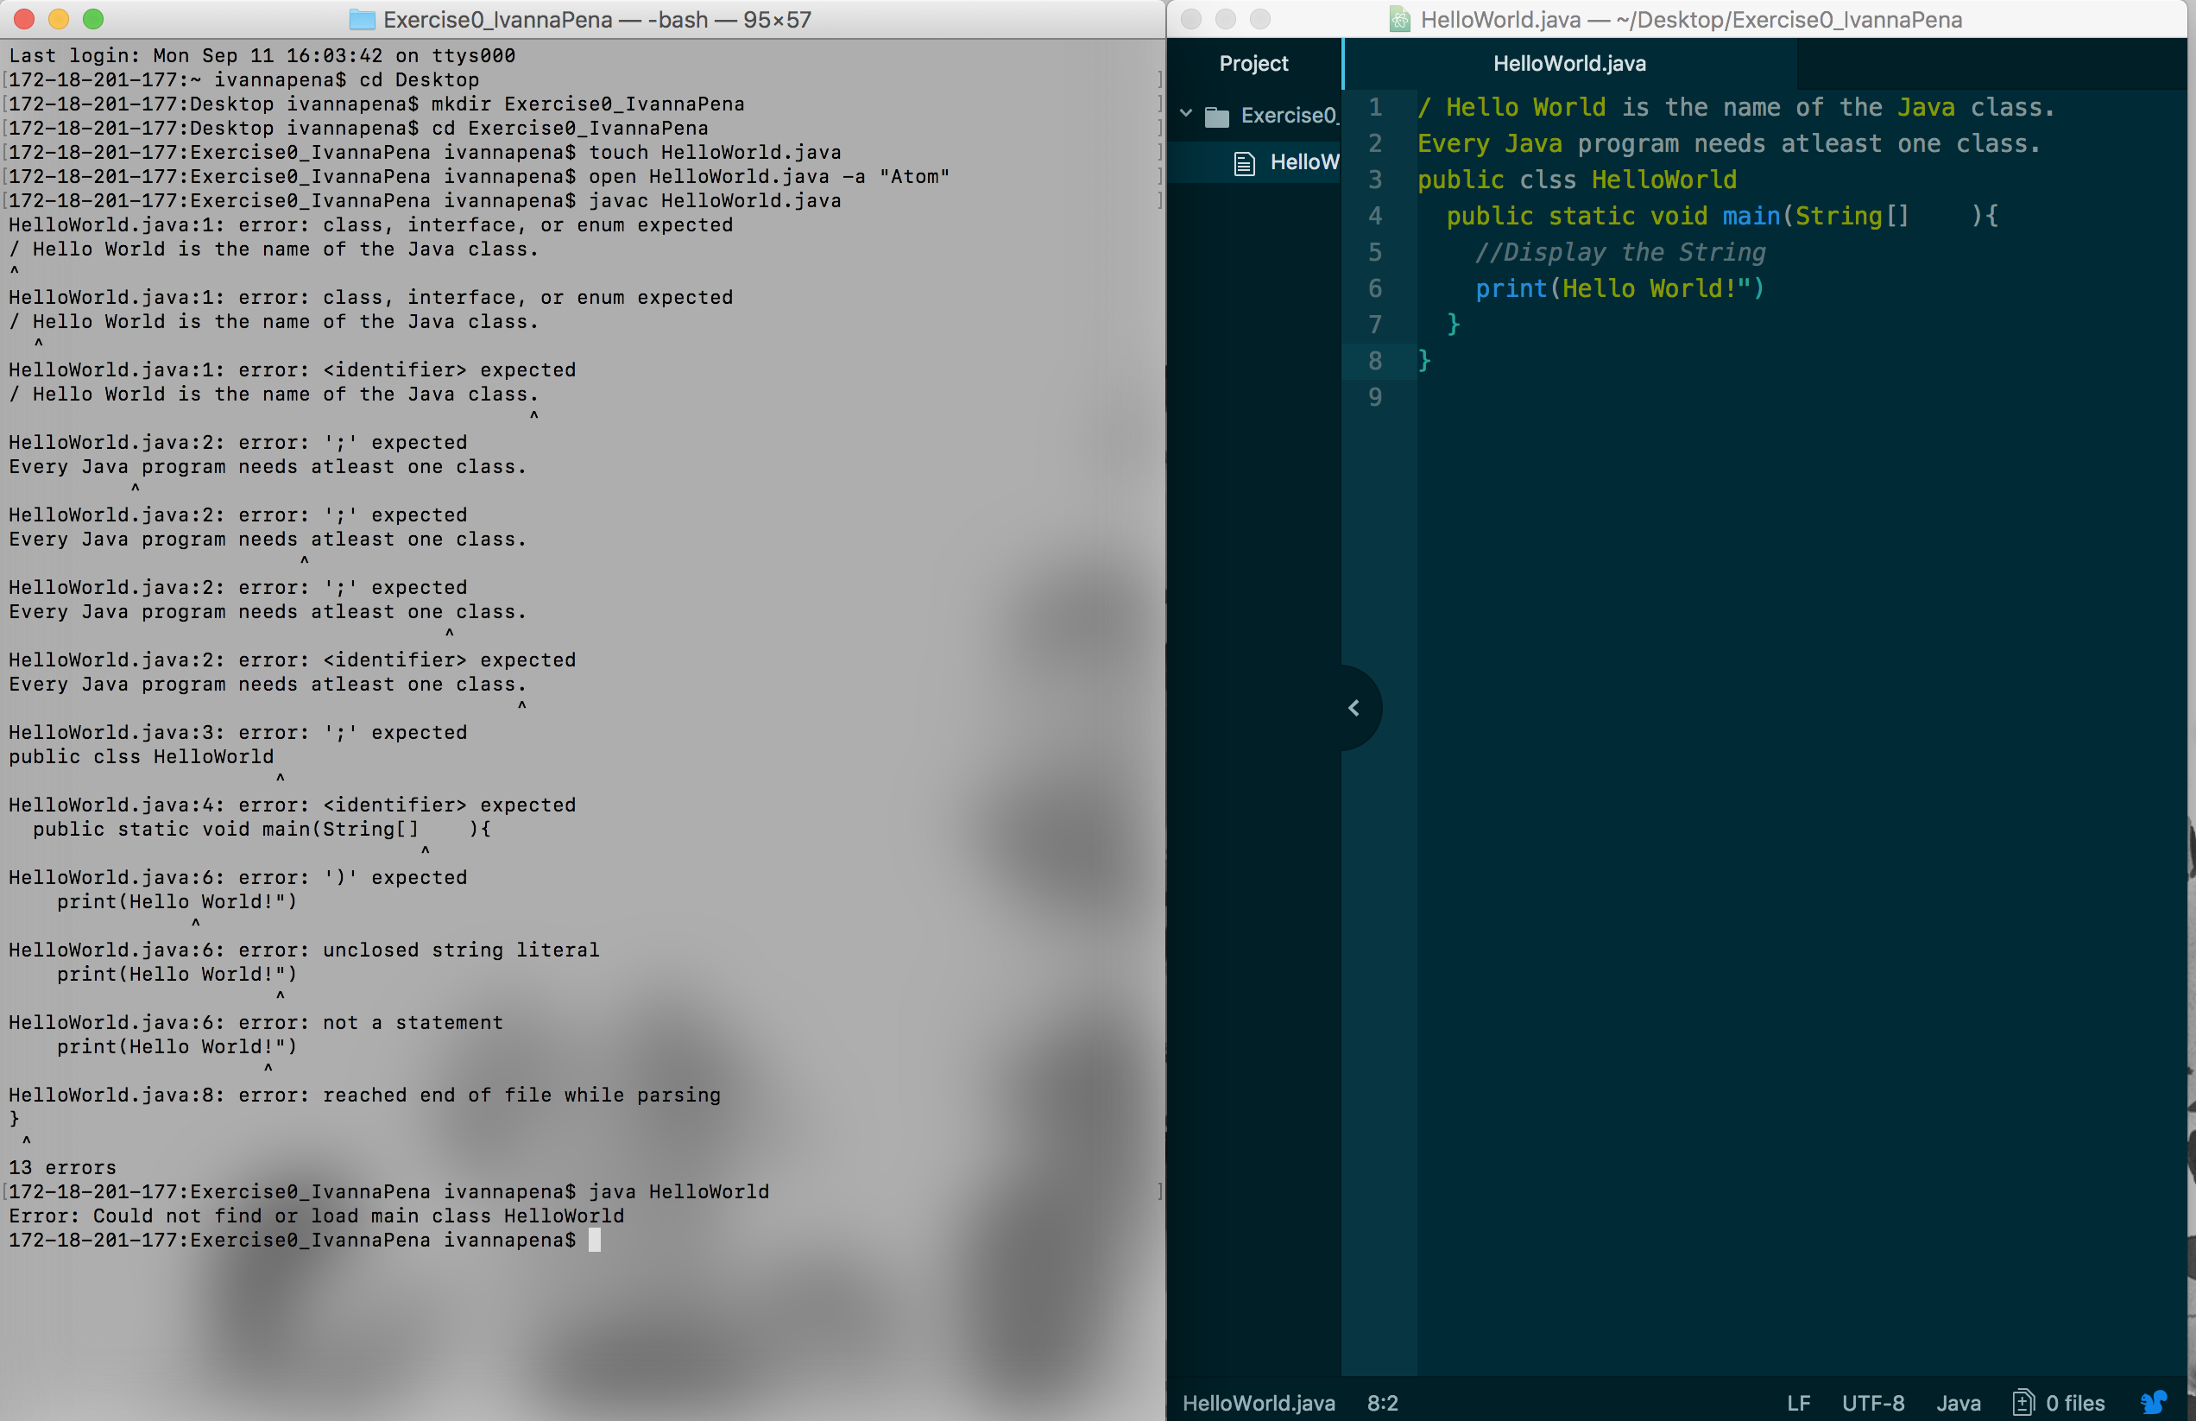

To fix the errors

* I properly commented out the first two lines
* Spelled class correctly and added a starting curly bracket
* Added args after String[] in line 4
* Used the proper print statement System.out.println and added an open quote before the string

