Creation Of LBC files for NEMO with CDO

The creation of lateral boundary netCDF files to force NEATL36 EAST2 lateral open boundary is briefly unfolded.

The aim is to interpolate the daily averaged CMEMS product from the Baltic MFC to the curvilinear grid of NEATL36 points corresponding to the EAST2 boundary. All the fields are treated as scalar in the interpolation except for the velocity field, that is further processed to be projected along the curvilinear target grid.

The procedure results into a script that leverages a combination of CDO and NCO operators.

Target Grid of EAST2 Open Boundary

The red points in the figure above represent the location of T points of East2 Open Boundary inside NEATL36 domain. The nested grid has 73 points along the Y (or jj index in the curvilinear framework) direction and 15 along the X ( ji index ), the latter being the relaxation layer. The blue points are the T point of NEATL36 domain.

Figures below show the curvilinear grid of LBC and a zoom showing the direction of normal to cell edges. The blue line indicates the section where transports (positive eastward) and temperature fluxes (only inward) are computed. The normal components are imported by static file “angles36.nc”.

|  |
| --- |
|  |
|  |

The target curvilinear grid is specified in a text file according to the CDO convention as in the example below.

Relevant Details About the Interpolation Procedure

All the fields are interpolated with the CDO bicubic (“remapbic”) method along horizontal direction and linearly along vertical direction with extrapolation (“intlevelx”). The target vertical grid is the same as in NEATL36 simulation.

cdo remapbic,${TARGET_HGRID_PATH} ${INPUT_DATASET} intp2D.nc

cdo intlevelx,level=${LEVELS} intp2D.nc intp3D.nc

To get a similar outcome as in the LBC files produced with SIREN tool, the horizontal extrapolation over the missing values is done with distance-weighted average method (“setmisstodis”).

cdo setmisstodis intp3D.nc intp3D_fill.nc

The projection of velocity field is done by scalar product of CMEMS velocity field and the normal to edges in *i* and *j* direction.

cdo -aexpr,"uo=(-1)*uo*gcost-vo*gsint;vo=uo*gsint-vo*gcost" in.nc out.nc

Comparison Against the SIREN LBC Files

The following plots show comparisons among the LBC produced by SIREN from Global simulation (left panel) the LBC file produced from CMEMS Baltic MFC with CDO, the same with xESMF and the input CMEMS dataset (right).

In the case of xESMF the horizontal filling, before interpolation, has been performed with python interface to CDO.

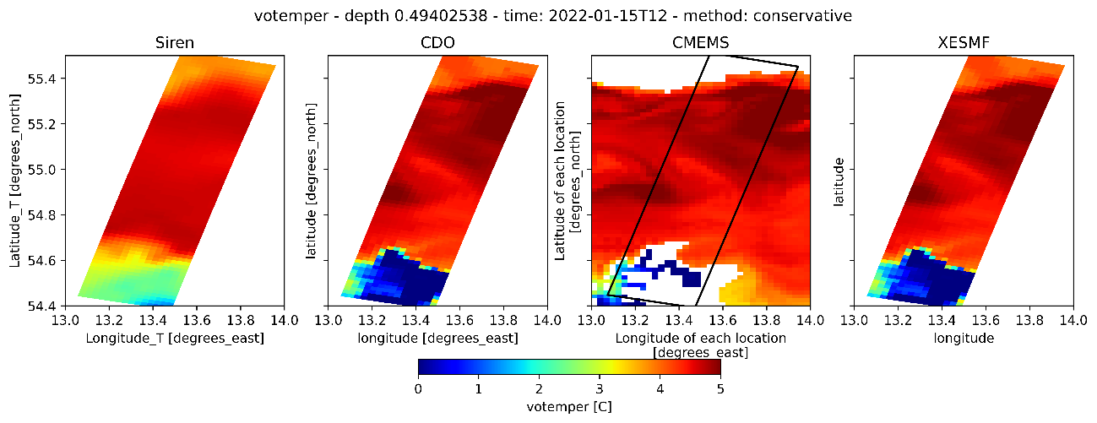

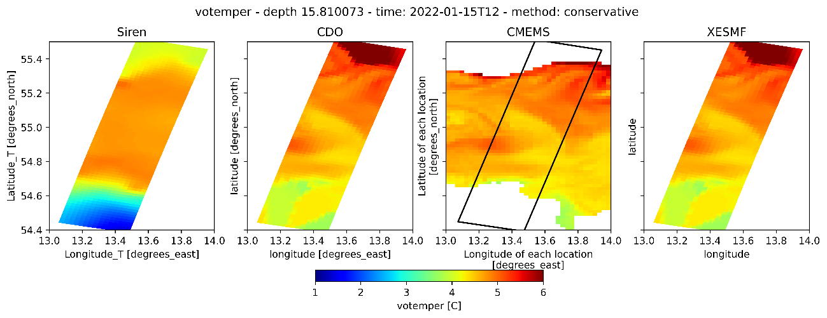

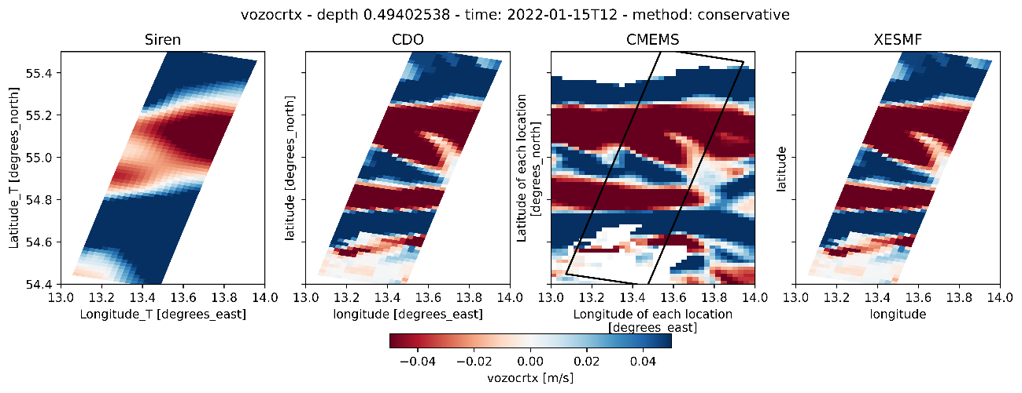

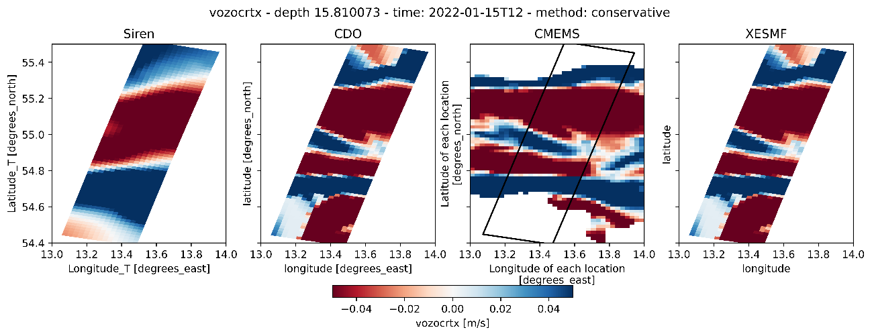

Transect Plots

The following plots are taken at the mid longitudinal value of EAST2 lateral boundary ( X = 7 in the x projected coordinate).

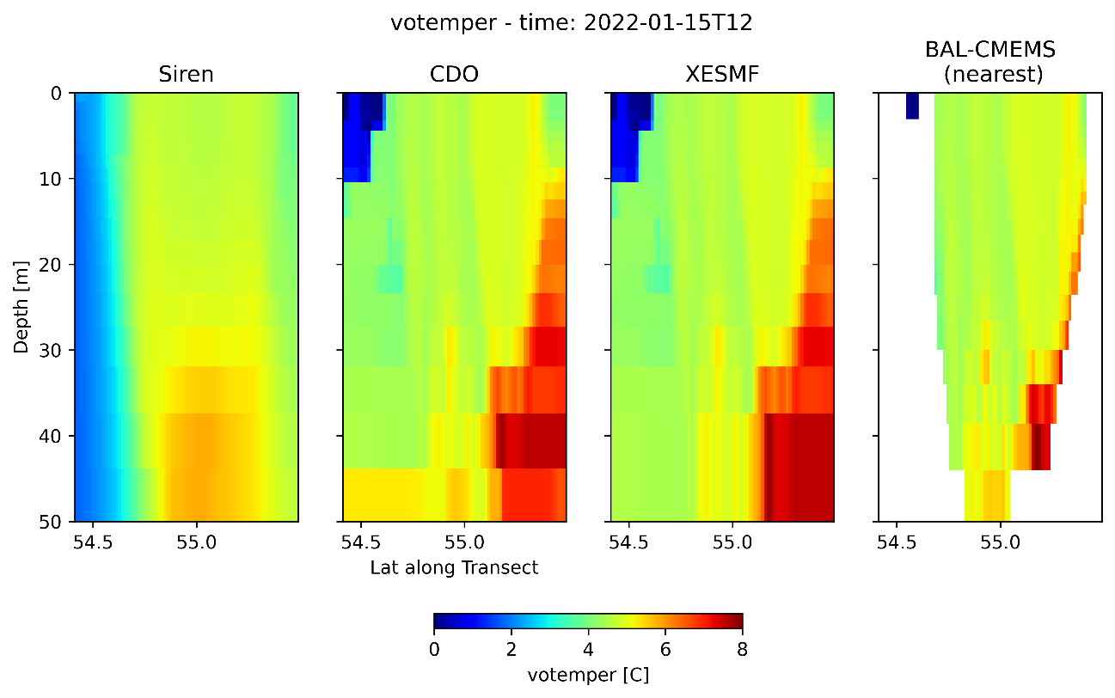

The plots below are the same as above but considering the Tmask. In the case of original CMEMS file the values are transferred to the transect line by nearest interpolation.

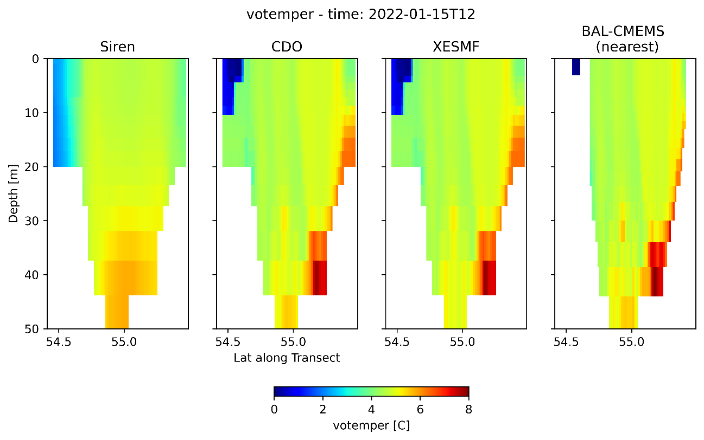

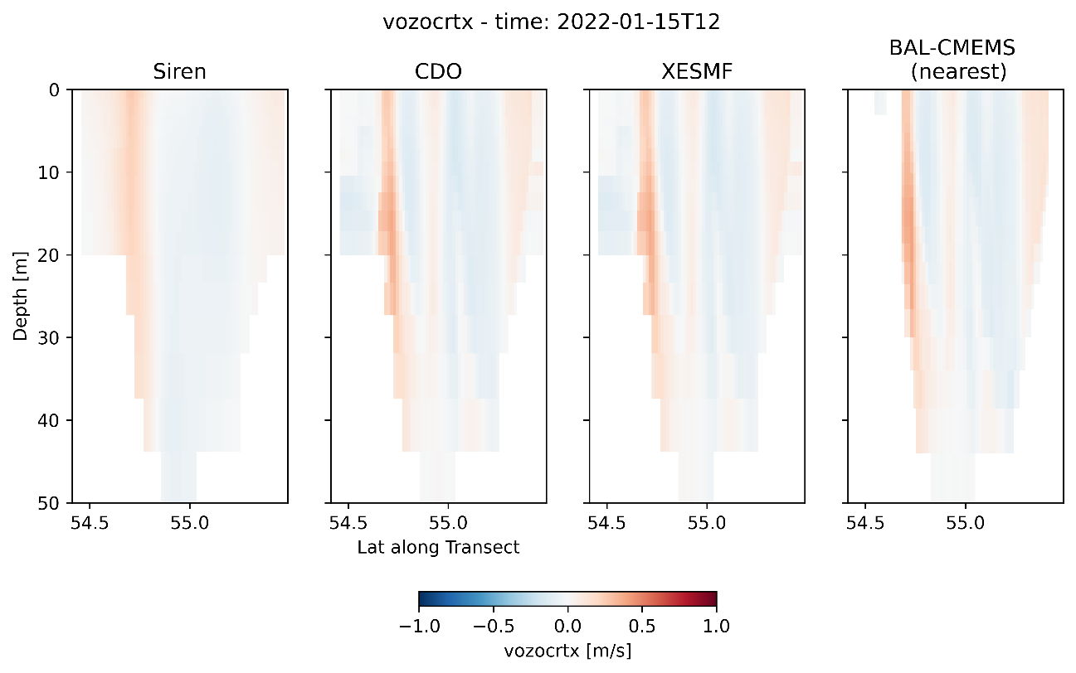

Net Transports Through East2 Boundary

The i-component of projected velocity is used to calculate the net transport through the East2 boundary. The cells areas have been built with e2u * e3u_0 scale factors. Land cells are masked with mask at U-points.

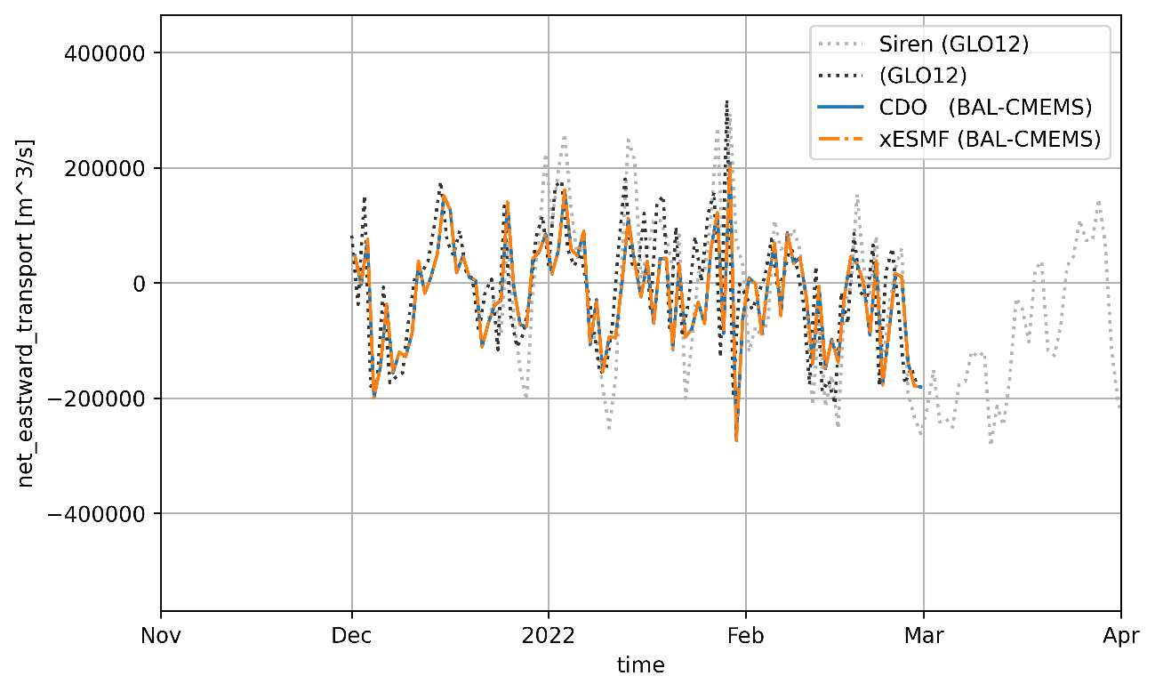

Temperature Fluxes Through Transect

The temperature fluxes have been computed through the east-most transect of East2 LBC. The flux is accounted only for inward velocity (u<0).