Notes on Interpolation of LBC (18/01/2024)

CDO

1) extrap -> 2) then interpolation

Interpolation Methods (No Vector interpolation support)

Bicubic

1st Order Conservative

xESMF

Conservative interpolation methods (variable regarded as scalars)

No Bicubic

No vector interpolation support

Estimate of conservation for scalar

Where to compute integral of a scalar? (interpolate T-mask on CMEMS grid?)

The integral of a scalar must be computed over the same area (Black Box), before extrapolating

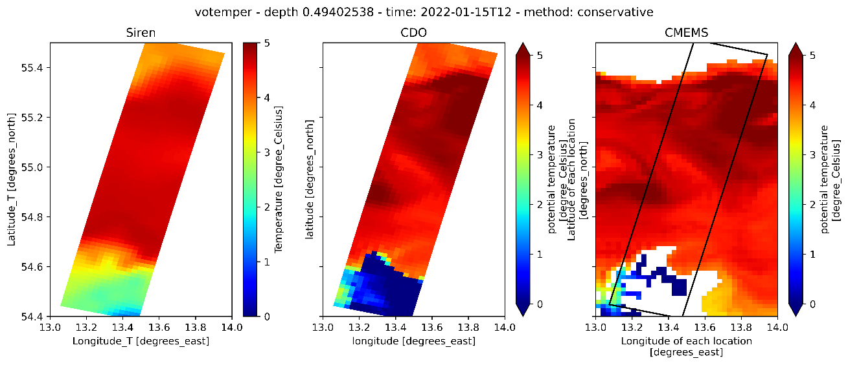

Estimate of inconsistency of Current Interpolation

Talk to Romain Escudier

Interpolation method for vector fields should keep mimetic properties (rot x div (A) = 0, grad . rot (A) = 0 ).

Estimation of interpolation inconsistency

Maps of horizontal divergence (CMEMS grid / target grid)

Maps of Vorticity (CMEMS grid / target grid)

Other option: Use the streamfunction?

CMEMS Streamfunction -> Interpolate Streamfunction on OBC grid -> Get u,v