|  |  |  |  |  |  |  |  |
| --- | --- | --- | --- | --- | --- | --- | --- |
| Name | *Rostislav Rosenov Ivanov* | | | | Date | | 04-16-2021 |
| Reference | *Predictions of stock’s value* | | | | Version | | *1* |
| Concerning fact | Stock’s information coming from Alpha Vantage API. Dataset size is different for every stock. I will be using Facebook to train my model. | | | | | | |
| Source | https://www.alphavantage.co/documentation/ | | | | | | |
| Source search profile | stock’s value | | | | | | |
|  | | | | | | |
| Origin of the data | Alpha Vantage API | | | | | | |
| rate of refreshing | Depending on amount and type of calls. Currently the rate is **daily** but could be as high as a minute. | | | | | | |
| date of the data | Today | | | | | | |
| Period the data concerns | Since a stock became public until current day | | | | | | |
| Size of data | Approx. 175 KB | | | | | | |
| rows | Currently 2441 | | columns | | 10 | |
| # Fact | Fact | | [SE] | | | | |
| Fact 1 | Date | | Datetime | | | | |
| Fact 2 | Open | | Float (USD) | | | | |
| Fact 3 | High | | Float (USD) | | | | |
| Fact 4 | Low | | Float (USD) | | | | |
| Fact 5 | Close | | Float (USD) | | | | |
| Fact 6 | Adjusted Close | | Float (USD) | | | | |
| Fact 7 | Volume | | Float (USD) | | | | |
| Fact 8 | Dividend Amount | | Float (USD) | | | | |
| Fact 9 | Split Coefficient | | Float | | | | |
| Fact 10 | RSI | | Float | | | | |
| Fact 11 | SMA weekly | | Float | | | | |
| # Dimension | Dimension | | Grainsize | | | | |
| Grain 1 | *Stock price daily* | | *Float* | | | | |
| Grain 2 | *Technical analysis* | | *Float* | | | | |
| Grain 3 | *Fundamental analysis* | | *Float* | | | | |
| Remarks:  Some useful features about Technical and Fundamental analysis might have to stay in separate datasets because historical data is missing and only one current value is returned. | | | | | | | |

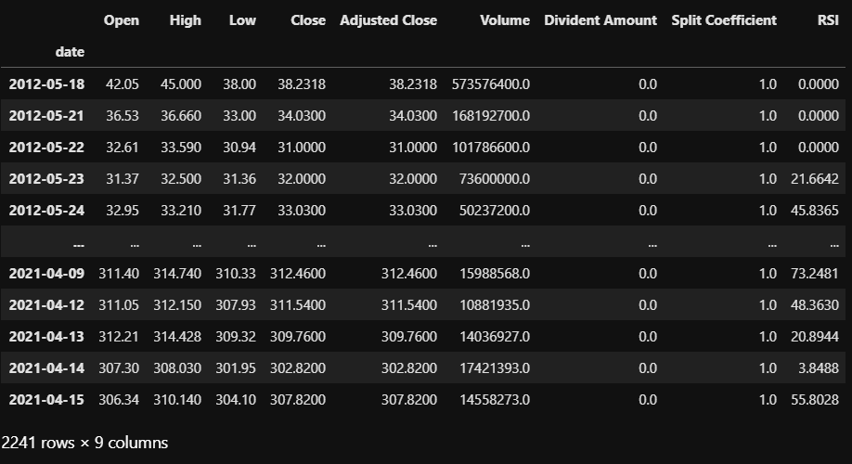

The data storage solution could be found in the notebook under Provisioning phase.