|  |
| --- |
| Fontys Hogescholen ICT |
| Project Proposal  Stock market predictions |
|  |

|  |
| --- |
| Rostislav Ivanov  Eindhoven, 10/05/2021 |

# Table of contents

Contents

Table of contents 2

Project definition 3

Background 3

Project Goal 3

Project Domain 3

Stakeholders 4

Domain Research 4

What has impact on a stock’s value? 4

How can a stock’s value be predicted? 4

What types of predictions are mostly used? 4

Exploratory Data Analysis 5

Ethical Considerations & Impact Assessment 8

Modeling 8

Evaluation 9

Deployment 9

Conclusion 9

Sources 10

# Project definition

## Background

Money is the wheel of today’s world. A person’s success is mostly related to his financial status. To earn a lot, a person must usually spend a lot of time and effort. However, there is a way to make the money work for you – that’s called investing. There are different types of investments, from trading to real estate etc. One very efficient, but very risky, type is investing in stock market. A stock’s value can either increase or decrease in a very short time and this is what makes it very risky for the buyer. That’s why the potential investment should be based on a prediction.

A stock market prediction is an attempt to forecast the future value of an individual stock. Most people have little to no knowledge about investing. That’s why such technology can help them to make the right decisions if they want to start investing.

## Project Goal

The goal of this project is to make an API that is able to predict the future value of a specific stock. The user should be able to specify a date in the near future and the API should give a response of the predicted value of a stock. Based on the outcome, the user can make the decision himself if he wants to invest in the given stock or not. This product will not operate with the user’s money, but instead just give predictions based on previous records.

## Project Domain

The domain of this project is established to be:

In order to explore this domain, the following research questions were brought forward:

* What has impact on a stock’s value?
* How can a stock be predicted?
* Which types of predictions are most common?

Also the following research methods were applied:

* Library
* Field
* Lab
* Showroom

# Stakeholders

|  |  |  |
| --- | --- | --- |
| **Name** | **Needs** | **Details** |
| Future investors | Reliable predictions on stock values |  |

# Domain Research

## What has impact on a stock’s value?

Stock market prices change on multiple factors. They change every day by market forces. In other words, share prices change because of supply and demand. If more people want to buy a stock (demand) than sell it (supply), then the price moves up. Conversely, if more people wanted to sell a stock than buy it, there would be greater supply than demand, and the price would fall. Overall, despite the multiple factors like news, history, earnings etc. the most important features that determine a stock’s value is the supply and demand.

Understanding supply and demand is easy. What is difficult to comprehend is what makes people like a particular stock and dislike another stock. This comes down to figuring out what news is positive for a company and what news is negative. There are many answers to this problem and just about any investor you ask has their own ideas and strategies.

## How can a stock’s value be predicted?

Predicting equity markets and stock movements are not easy. Market movements are almost unpredictable because of the many factors that have impact on it (some of which are not controlled by people). Yet analysts use many methods and indicators to predict market movements.

## What types of predictions are mostly used?

There are two main types of analysis: fundamental (price-to-earning, or P/E, ratio, price-to-book value, or P/B, ratio, interest rates) and technical (put-call ratio, volumes traded).

Fundamental analysis is an analysis method based on the economic fundamentals of a company i.e., to calculate the stocks intrinsic value connected with company's financial data. This technique therefore focuses on company’s financial ratios.

Unlike fundamental analysis, which attempts to evaluate a security's value based on business results such as sales and earnings, [technical analysis](https://www.investopedia.com/terms/t/technical-analyst.asp) focuses on the study of price and volume. Technical analysis is often used to generate short-term trading signals from various charting tools. The purpose of technical analysis is to identify trend changes that precede the fundamental trend and do not (yet) make sense if compared to the concurrent fundamental trend.

# Exploratory Data Analysis

In this chapter, I will describe some of my findings in the dataset. More graphs and explanations could be found in the Exploratory data analysis document that was submitted with this document.

Simple moving averages

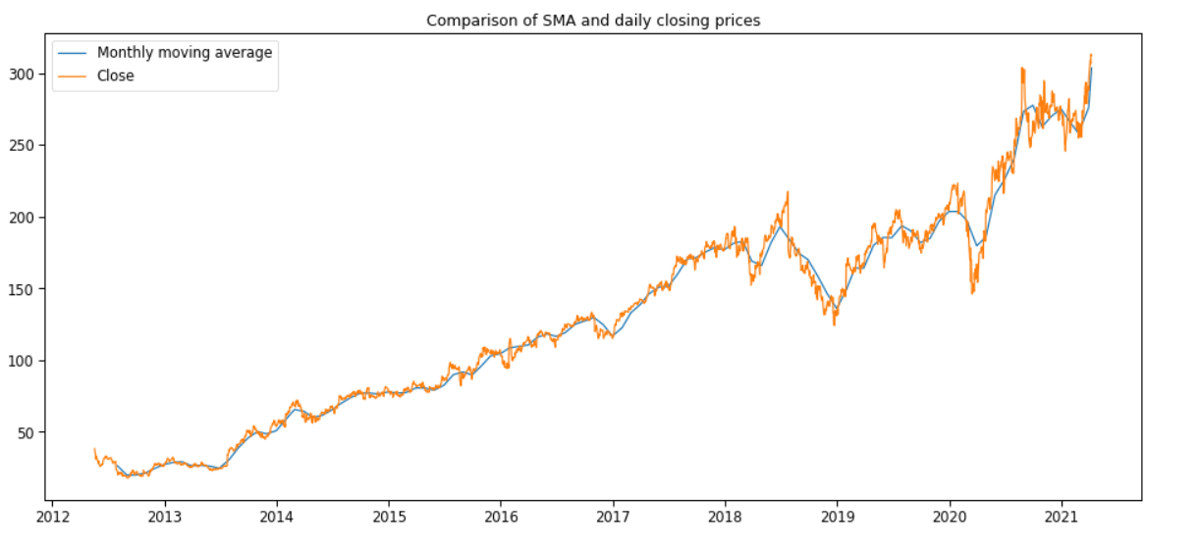

This Simple Moving Average(SMA) represents the mean of the data set for a given period. In that case the SMA's period is one month. SMAs are part of the technical analysis in predicting the future value of a stock. Such graphs can show very interesting data. For example, a change in direction of trend can be indicated by the penetration/crossover of the SMA. Generally a buy signal is generated when a price breaks above the moving average and sell signal is generated by a price break below the moving average. It is added confirmation when the moving average line turns in the direction of the price trend. When there is a high increase or decrease in a short period of time the SMA does not catch up immediately. That is because it uses average monthly values. Owing to this fact the Monthly SMA is good choice for long term predictions but less good for short term ones. Instead, a weekly SMA can be better for short term predictions because it is more sensitive to change in trends. The difference between both SMA could be found in the EDA.

Heatmap with relations

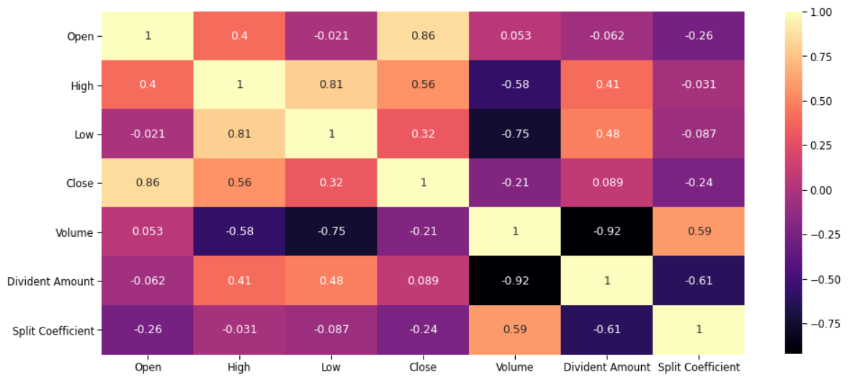

The closer to 1 the correlation is the more positively correlated they are, that is as one increases so does the other and the closer to 1 the stronger this relationship is. It is noticeable that the correlation between High and Low is 0.81, which mean that they have a quite strong relation. What I found interesting is that these values change drastically every day when new data comes from the API which means that such heatmaps can not always be trustworthy for everything they have.

For example, such correlation could also be visualized with correlation diagram.

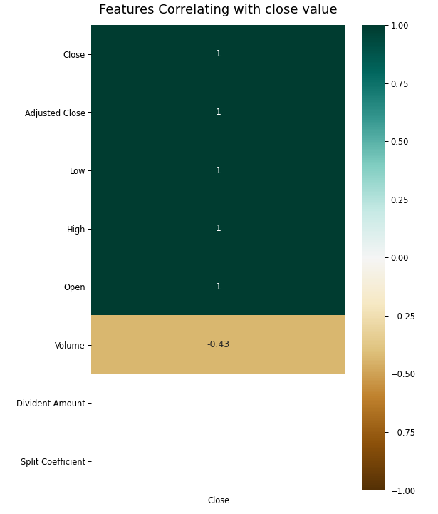

Both state that Volume is not important to the closing price. However, the research told us that volume is a big part of the technical analysis when predicting a price for a stock. Below we can see why Volume is important, despite what the graphs above suggest.

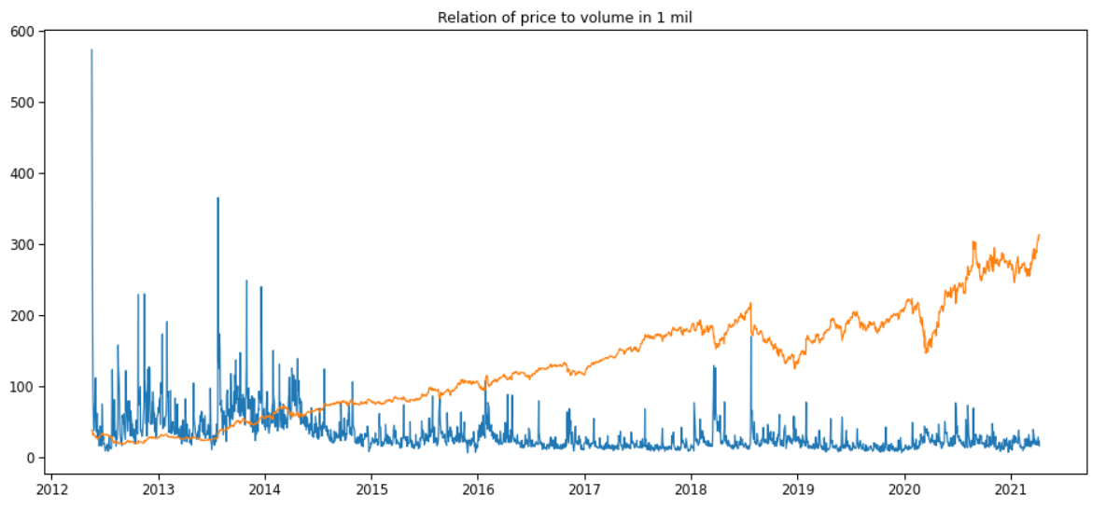

As expected, on the graph we can see that when there is a drastic change in the volume there is big impact on the price which either increases or decreases. That confirms the fact that Volume is an important feature when predicting the price. Same goes for the lack of attention to dividend amount and split coefficient. The result of the research I have done for them on how they affect the price could be found in the EDA.

# Ethical Considerations & Impact Assessment

These topics are explained in the Full scan Technology Impact document which could be found in the submission.

# Modeling

The label that will be predicted is continuously changing numeric value. Therefore, a Linear Regression model should be the most suitable for this project.

After the actual implementation of the modeling phase I found that linear regression does not really work good for this purpose. I have used three models and the linear regression one was the least accurate on r squared score. The second one was decision tree regressor model which had an accuracy of 0.57 on the test data and the LSTM model which had an accuracy of 0.92. The LSTM model worked really well on the test data. The picture below shows the difference between the real closing price and the predicted one from the model.

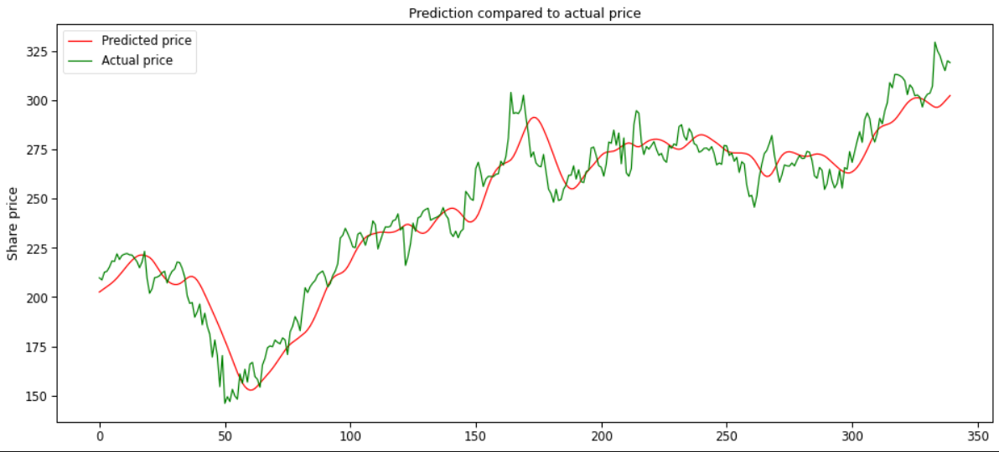

I tried to document a couple of future days to see how the model will do on real life scenario. It did have some good predictions, but the model unfortunately cannot take into account many factors like news and others that have a huge impact on the stock’s price.

# Evaluation

This chapter explains how we will assess the performance of the project and what for which features it will be optimized.

After the model is done, its performance is going to be tested with regression evaluation metrics, R2 score on the dataset that will be used for testing.

Also, there might be a possibility for a confusion matrix. A new label could be added with how the price have changed which would be either positive or negative. The output of the model will be the future value of a given stock and possibly the change between the current and the future value. I consider a false *increase* output to be more dangerous than a false *decrease* output for the following reasons:

* A false increase output can cause a user to invest an amount of money to the stock and lose significant percentage of his investment.
* A false decrease, on the other hand, will most likely not make the user invest in the given stock, hence he will not profit from the increase, but at least he will not have lost any money.

# Deployment

The model must be usable in a web environment. It will be possible for the user to input the stock he is interested in and the period for the prediction. The API will respond with the possible future value of the stock. The UI will be simple so that it is user-friendly. An attached document of the deployment recommendation could be found in the submission.

# Conclusion

To conclude, the execution of this project and its performance will not be an easy task because of the many features that have impact on the predicted label. Nevertheless, with the variety of prediction analysis that are already invented and with the help of machine learning, I am confident that the final product should serve its purpose and help people with no knowledge in finding the right stocks to invest in.

# Sources

1. <https://www.disnat.com/en/learning/trading-basics/stock-basics/what-causes-stock-prices-to-change>
2. <https://www.investopedia.com/articles/basics/04/100804.asp>
3. <https://www.businesstoday.in/moneytoday/investment/predict-stock-markets-shares-movement-invest/story/20321.html>
4. <https://www.researchgate.net/publication/333470711_The_Integration_of_Fundamental_and_Technical_Analysis_in_Predicting_the_Stock_Price/link/5da0110392851c6b4bcb715d/download>
5. <https://www.investopedia.com/terms/t/technicalanalysis.asp>
6. <https://www.investopedia.com/articles/investing/091015/how-dividends-affect-stock-prices.asp>
7. <https://www.investopedia.com/ask/answers/what-stock-split-why-do-stocks-split/>