|  |
| --- |
| Fontys Hogescholen ICT |
| Results document  Stock market predictions |
|  |

|  |
| --- |
| Rostislav Ivanov  Eindhoven, 10/05/2021 |

## Introduction

To finish this project, I have used three different models – Linear Regression, Decision Tree Regressor and Long short-term memory(LSTM) model. I have evaluated each one of them based on R squared and the results could be found below.

## Linear Regression model

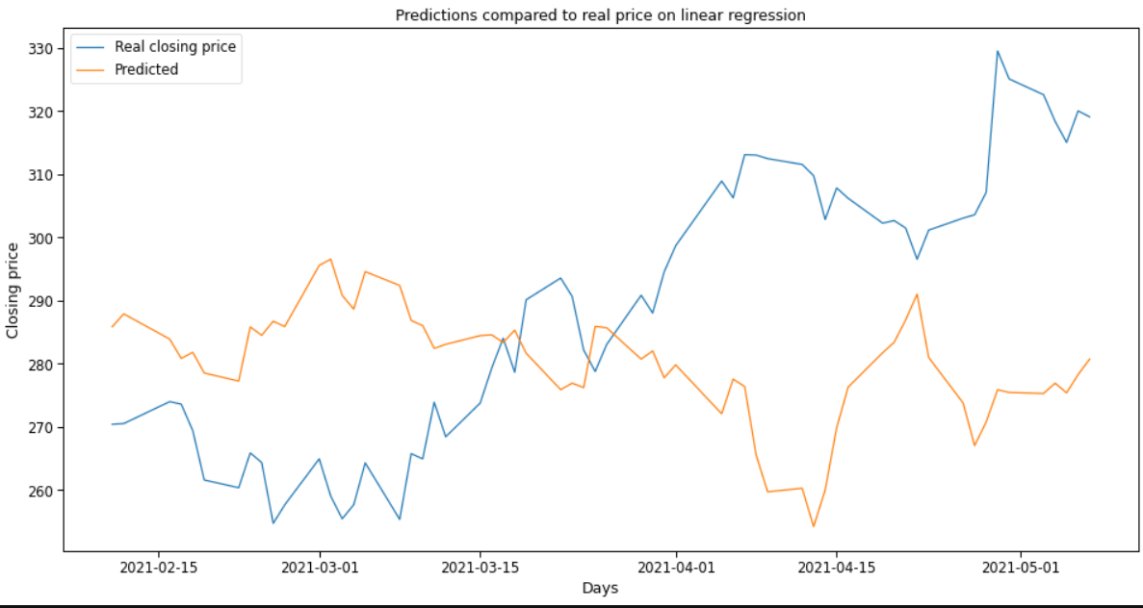

The LR model’s performance was worse. Its r squared score was evaluated at:



In other words, this model was not good for making such predictions, but I still had to try to make sure of that.

## Decision tree regressor

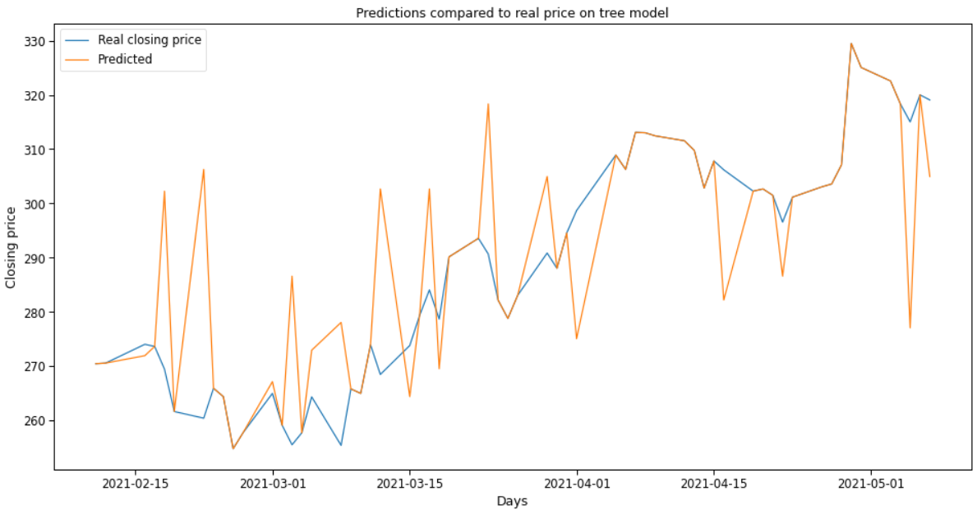

The tree’s model performance was sometimes pretty accurate, but in many cases, it had predictions that could really mislead the user with very overpriced predictions. Its score was at: 

Overall, not too bad but still not good enough to be trusted with one’s money.

## LSTM model

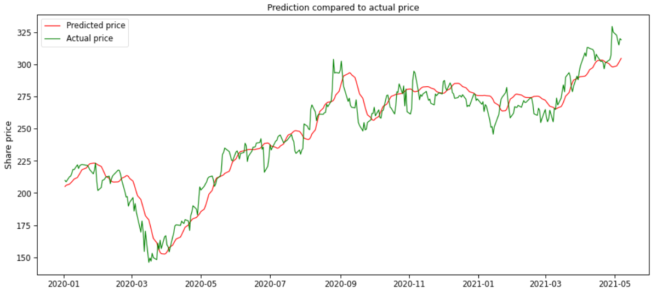

The LSTM model’s performance was undoubtfully the best among the others. We can see that in long term the forecast looks almost exactly like the actual curve of the price.

The r squared score can prove that.



Which is the best in comparison to the others.

## Conclusion

To conclude this document, I believe that the LSTM model would be the most suitable to make the most accurate predictions. I have done several researches on this topic and indeed the LSTM model is the most used one for making stock market predictions and in the evaluation above we can see the reason for that.