BirdEye Tool
Support Operating Procedure

Overview
BirdsEye is a browser-based CRM toolbar that embeds directly into Kustomer. It connects Kustomer to the Scentbird CRM via GraphQL API, eliminating the need to switch between tabs for common workflows.

Getting Started

Installation
- Install the Tampermonkey browser extension (Chrome, Edge, or Firefox).

https://chromewebstore.google.com/detail/tampermonkey/dhdgffkkebhmkfjojejmpbldmpobfkfo?hl=en

- Open Tampermonkey dashboard → Utilities → Import from File → select the BirdsEye script.
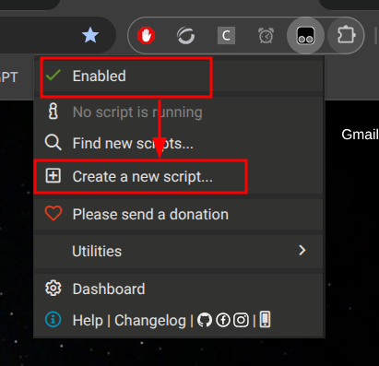

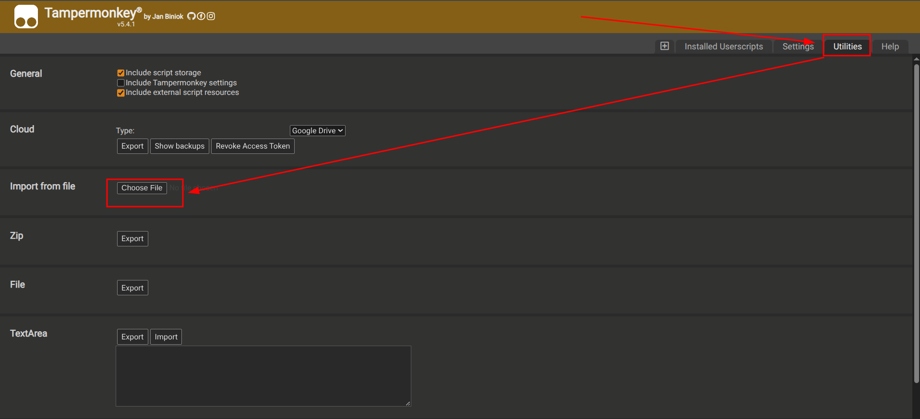
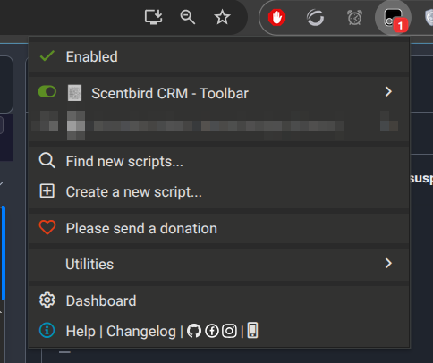

3. Add permissions and enable pop-ups.

Step 1: Enable Developer Mode — go to chrome://extensions in your browser→ toggle Developer mode → Tampermonkey Details → allow file URLs
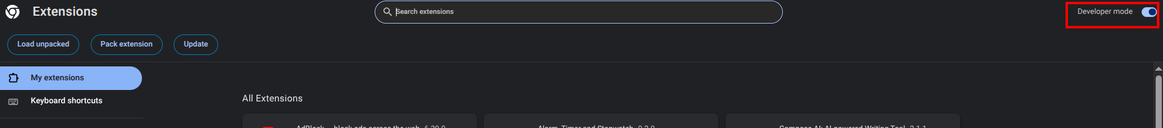
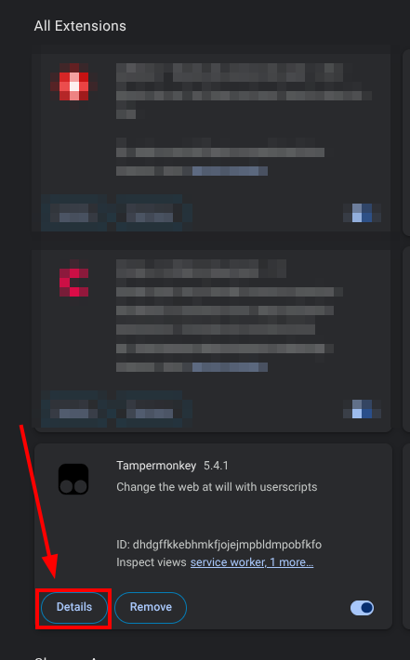
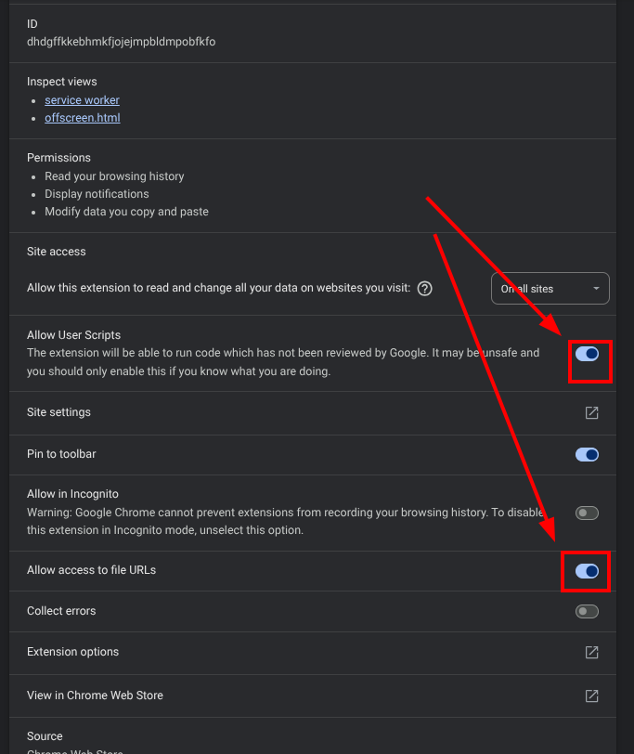

Step 2: Allow Pop-ups for Kustomer — chrome://settings/content/popups → add [*.]kustomerapp.com.
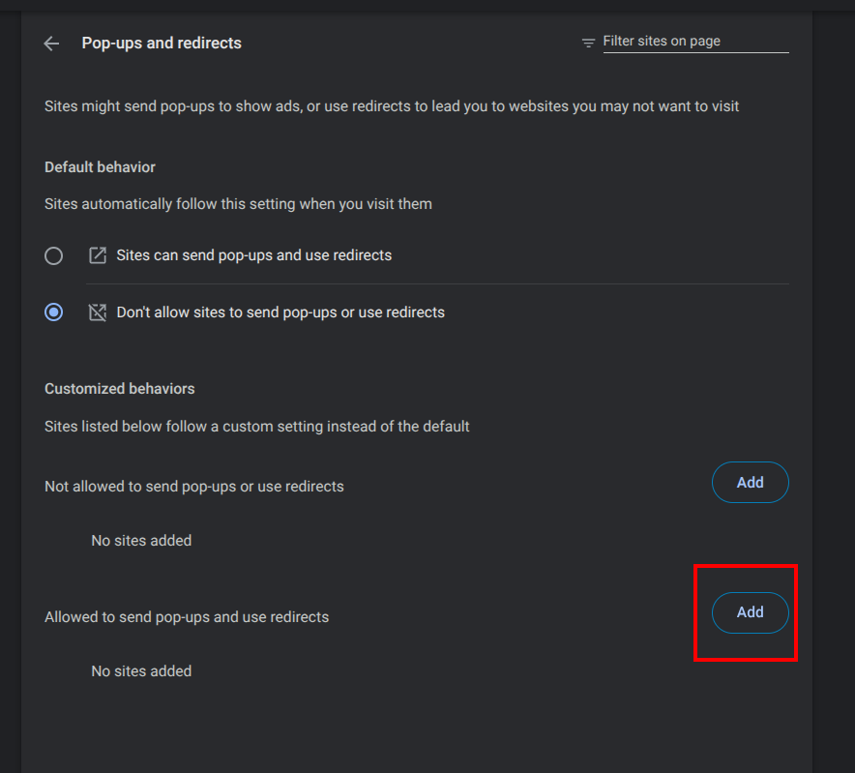
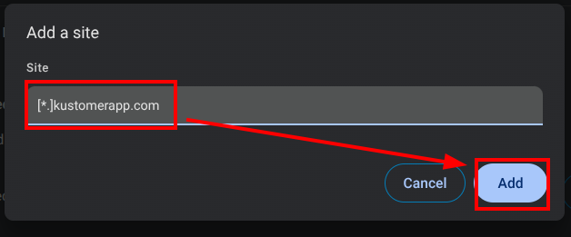

Navigate to any customer ticket in Kustomer — the toolbar appears automatically below the customer card header.
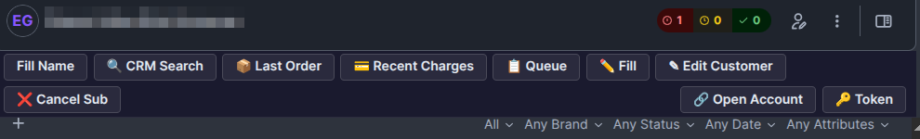

Token Setup
- Log into the Scentbird CRM (crm.scentbird.com).
- In CRM, press 🔑 Token, and copy the contents.
- In Kustomer, click 🔑 Token in the toolbar → paste → Save.
- The token is validated automatically on page load. If expired, the Token button shows "⚠ Token Expired" — repeat steps 2–3.
Note: API requests go directly from your browser to the CRM using the same credentials you use when browsing the CRM manually.
If Cloudflare blocks access, the Token button shows "⚠ CRM Captcha" in amber — open CRM in your browser to solve the challenge.

Toolbar Buttons
The toolbar contains the following buttons, accessible on every customer ticket:
Button | Function
Fill Name | Pulls the customer's name from CRM and applies it to the Kustomer profile
🔍 CRM Search | Search CRM by name, email, or address — apply results to Kustomer
📦 Last Order | View recent orders with products, tracking, status, and action buttons
💳 Recent Charges | Full charge breakdown with auto-generated bill explanations
✏️ Fill | Auto-fill template variables from live CRM data (with month picker)
✎ Edit Customer | Change email, gender, or shipping address
❌ Cancel Sub | Cancel subscription, refund, delete account, manage fraud blocklist
📋 Queue | View and manage the customer's subscription queue
🌐 Open Account | Open the customer's Scentbird account in a new tab
🔑 Token | Manage CRM bearer token

User Info Bar
Appears automatically below the toolbar when a customer is loaded. Tags are organized into three outlined groups:

Group 1 — Status: Subscription status with date, billing date (BD), and gender (♂ Colognes / ♀ Perfumes). Scheduled Cancellation tag appears in red if applicable.
Group 2 — Plan & Add-ons: Plan name (e.g. "2 fragrances", "Bimonthly") plus active add-ons: Case, Samples, Candle, Car Scent, Diffuser.
Group 3 — Warnings: Only appears when warnings exist. Shows "⚠ Addr Updated" (amber) if shipping address changed, "⚠ Fraud" (red) if blocklisted, "⚠ Chargeback" (red) if chargeback found on the account.
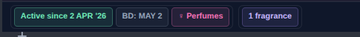

Feature Details

CRM Search
Use when: Customer wrote from a different email, or you need to find their Scentbird account.
Select text on the page (name, email, address) → click 🔍 CRM Search (or press Ctrl+Shift+Q).
The search panel opens with the selected text pre-filled and results loading.
Results show: name, email, ID, address, subscription status, and a preview of the last order.
Click Apply to Kustomer to set the email as primary and auto-fill the customer name.
Click Open Profile to open the CRM profile in a new tab.
Tip: If you select new text and click the button again while the panel is open, it updates the search without closing.
Note: Drift (non-Scentbird) accounts are grayed out and cannot be applied. Filter Active toggles between showing all results or only Active + Unpaid accounts.
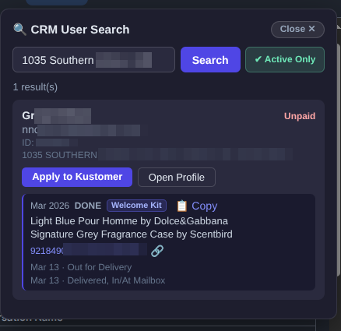

Last Orders
Use when: You need to check order contents, tracking status, or take action on an order.
Click 📦 Last Order → panel shows recent orders grouped by month.
Each order shows: month/year, warehouse status, product names, tracking number with link, last 2 carrier events.
Tags appear for: Welcome Kit, Samples, Case.
Replacement orders appear below their parent order.

Action buttons on each order:
Button | Action
🔄 Replace | Opens the replacement form
❌ Cancel Order | Cancels the order with a reason and posts a CRM comment
⏸ Hold | Places the order on hold (pending/unprocessed orders)
▶ Unhold | Releases a held order
📋 Copy | Copies all product names to clipboard

At the bottom of the panel: 📦 Custom Shipment button
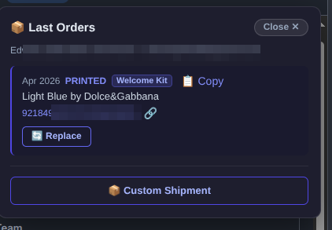

Replacements
Use when: Customer needs a replacement shipment.
From the Last Orders panel, click 🔄 Replace on the relevant order.
Select: reason, order type (BOM), items to replace. Use 🔍 Search Product to add different products.
Check "Pictures provided" and "Address confirmed" as applicable.
If any selected product has an upcharge, the confirm button is locked until the upcharge is billed (see Upcharge Billing).
Click Confirm Replacement.

What happens on submit:
Replacement order is created in CRM.
Auto-generated CRM comment is deleted and replaced with: "Replacement - [Reason] - [Month Year]" plus pictures/address status and optional additional comment.
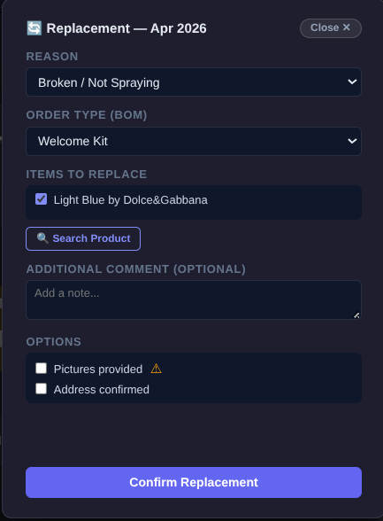
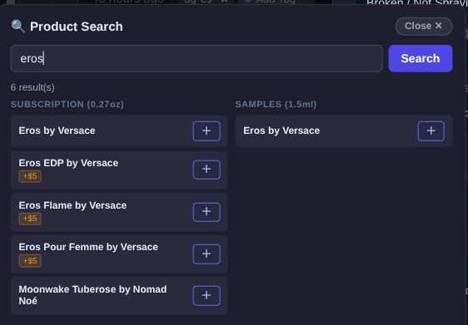

Custom Shipments
Use when: Customer needs a custom shipment.
From the Last Orders panel, click 📦 Custom Shipment at the bottom.
Select: reason (Skipped Shipment, Backorder, Multiple Charge, Promo Offer), BOM, shipment month/year.
Add products via Search Product.
The form shows available credits. If more credits are needed, the confirmation dialog shows how many will be added automatically.
If any product has an upcharge, the confirm button is locked until billed (see Upcharge Billing).
Click Create Custom Shipment → review confirmation → Confirm.

What happens on confirm:
- Credits are auto-added if insufficient (with comment "Added for Custom Shipment").
- Custom shipment order is created in CRM.
- Auto-generated CRM comment is deleted and replaced with: "Custom Shipment - [Reason] - [Month Year]" plus credits added line if applicable.

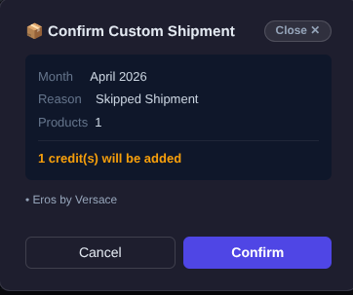
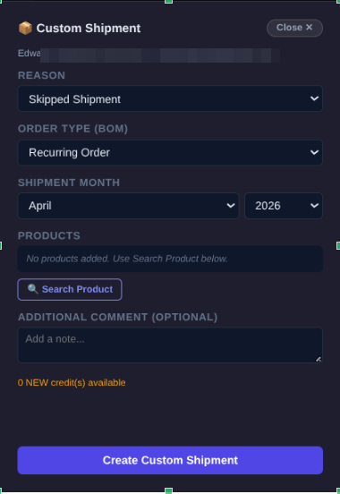

Upcharge Billing
Use when: A product with a premium upcharge is added to a Replacement or Custom Shipment.
When a product with an upcharge price is added, the confirm button is disabled and an amber warning appears showing the total upcharge amount.

- 💳 Bill Upcharge — opens a charge confirmation modal showing each upcharge product and total. Fires the charge mutation. On success (PAID), the confirm button is re-enabled.
- Billed Already — skips the charge and re-enables the confirm button. Use when the upcharge was already billed previously, in applicable cases.

The upcharge total updates dynamically as products are checked/unchecked.
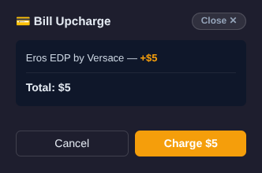

Edit Customer
Use when: You need to update the customer's email, gender, or shipping address.
Click ✎ Edit Customer to open the panel with three sections:

Email Update
Type the new email and click Update. A comment is posted: "Email updated to [new email]".

Gender Change
Select Male (Colognes) or Female (Perfumes) from the dropdown and click Update. There will be a small pop-up window for 5 seconds – this is authentification, no need to do anything. It will close automatically.
A comment is posted: "Gender updated to Male/Female". The info bar gender tag updates on refresh.

Address Change
Click "📍 Update Address" — there will be a small pop-up window for 5 seconds – this is authentification, no need to do anything. It will close automatically.
Once authenticated, the address search field appears.
Start typing the new address — autocomplete suggestions appear.
Select the correct address from the suggestions.
Review the selected address and click Save Address.
The address is validated and updated. A comment is posted: "Address updated to [full address]".
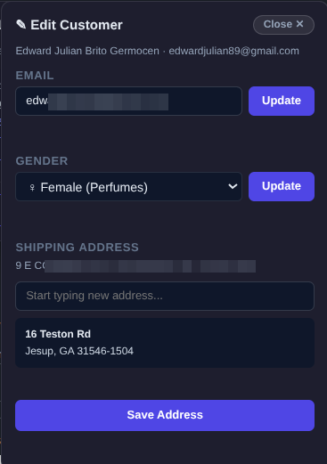

Cancel Subscription
Use when: Customer wants to cancel their subscription, or you need to refund a previous order
- Click ❌ Cancel Sub → panel shows customer info and last subscription order.
- If refundable, click 💰 Refund to open the refund charges panel.
- Click Cancel Subscription (disabled if already cancelled).

Additional actions in the Cancel Sub panel:
Button | Action
🗑 Delete Payment Methods | Removes all payment methods on file. Posts comment "Billing method removed".
🗑 Delete Account | Chains: delete payment methods → disable email. For full account deactivation.
🚫 Blocklist (Fraud) | Toggles fraud DECLINE/DEFAULT status. Posts comment.

Refund
Use when: Customer needs a refund for a recent charge.
From the Cancel Sub panel, click 💰 Refund on the order.
The Refund Charges panel shows charges with per-line-item detail.
Click Refund $X.XX → confirmation shows: date, payment method, credit breakdown, total.
Click Refund to confirm.

Refund eligibility: orders in SHIPPED, DELIVERED, PRINTED, or DONE status are non-refundable and the button is disabled.
Multiple refunds in one session show a Total Refunded row at the bottom with a copy button.
Note: Refunds are full — all credits and unrefunded line items for the charge. Already-refunded items are automatically skipped.
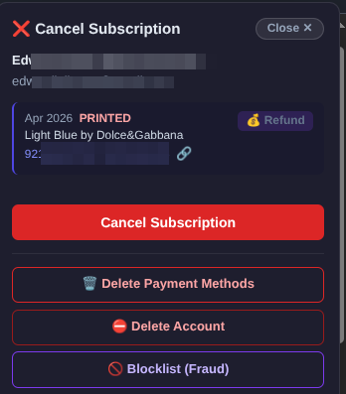
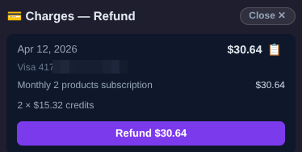

Recent Charges
Use when: Customer is asking about a charge, or you need to explain their bill.
- Click 💳 Recent Charges → panel shows all charges from the most recent billing month.
- Failed charges appear first (compacted, red section).
- Successful charges show: total amount, payment method, per-line-item breakdown, refund status.
- Bill Explanation at the bottom — a pre-written, copy-ready breakdown. Supports USD, GBP (£), and charge grouping by 10-day proximity.

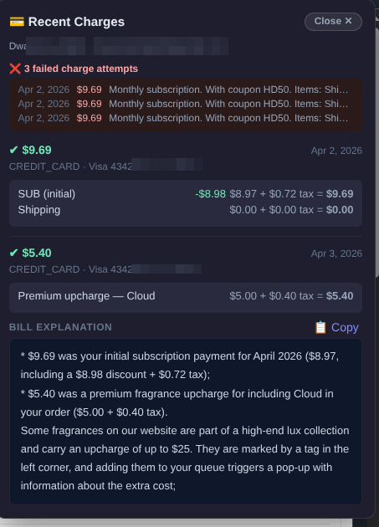

Queue
Use when: You need to check or modify the customer's upcoming subscription queue.
Click 📋 Queue to view the subscription queue with filled months, color-coded order status, upcharge indicators, per-product copy buttons, and a Copy All button. Products can be deleted from the queue (uses customer-side API authentication).
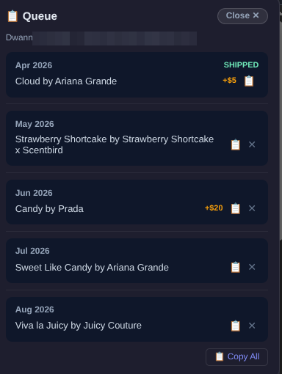

Fill (Variable Auto-Fill)
Use when: You have a macro template in the composer with [VARIABLE] tokens.
Insert your macro template with [VARIABLE] tokens.

Click ✏️ Fill → a dropdown appears: "Current Month" or "Previous Month".

Select which month's order data to use. The script resolves all tokens and copies the result to clipboard.

Select all text in the reply field → paste (Ctrl+V) to replace.

Example usage:
You have a macro like this:

I'm sorry to hear that you haven't received your package for the month of [MONTH]. I understand how excited you were for your order and how disappointing it must have been for it to never arrive. Please, let me help out.

After reviewing your account, I see that the package was marked as delivered by our carrier on [DATE] ([TRACKING]). However, it is entirely possible that the package was lost or misdelivered.

Edward, please know that you are not responsible for the carrier error. To resolve this issue for you, I would be happy to arrange a replacement shipment, containing:
[FRAGRANCE]

Before sending the package, I would like to confirm that the address we have on file for you is correct and complete. Could you please verify the address for me?
[ADDRESS]

I look forward to hearing back from you soon.

After pressing “FILL”, you can simply paste – everything in [ ] brackets is applied automatically from CRM customer and order data.

Available variables:
Variable | Resolves to | Example
[ADDRESS] | Customer's shipping address | 123 Main St, New York, NY 10001
[DATE] | Last tracking event date | March 15th
[FRAGRANCE] | Product names (one per line) | Cloud by Ariana Grande
[MONTH] | Order month | February
[TRACKING] | Order tracking link | 1Z999AA10123456784
[BD] | Billing date | 15th
[BD-1] | Billing date minus 1 day | 14th
[DATE_SUBSCRIBED] | Subscription start date | March 30th
[DATE_CANCELLED] | Cancellation date | January 22nd
[TOTAL_REFUNDED] | Cumulative refund total (session) | $45.67
Note: For Welcome Kit orders, [FRAGRANCE] automatically adds "Signature Grey Fragrance Case (welcome gift)" as an additional line.

Common Workflows

Delivered, Not Received (DNR)
Click 📦 Last Order → identify the correct order, check tracking status.
Check the info bar for address indicator (✔ or ⚠).
Insert your custom macro with variables→ click ✏️ Fill → choose Current/Previous Month.
Paste the filled content into the composer.
Once address is confirmed, click 🔄 Replace to create the replacement. CRM comment is automatically posted.

Cancel & Refund
Click ❌ Cancel Sub.
If refundable, click 💰 Refund → review charges → confirm refund.
Click Cancel Subscription.
All CRM comments are posted automatically.

Customer Wrote From a Different Email
Select the customer's name or address from the ticket body.
Click 🔍 CRM Search → find the correct account.
Click Apply to Kustomer → email and name are updated on the Kustomer profile.
Proceed with the ticket as normal — all toolbar functions now show the correct customer.

Address Change
Click ✎ Edit Customer.
Click "📍 Update Address" → authenticate via popup.
Type the new address → select from autocomplete → Save Address.
Address is validated and updated. Comment is posted automatically.

Custom Shipment for Skipped Month
Click 📦 Last Order → scroll to bottom → click 📦 Custom Shipment.
Select reason "Skipped Shipment", pick the month, add products.
Review credit status in the confirmation dialog. Credits are added automatically if needed.
Confirm → shipment created, comment posted.

Troubleshooting
Issue | Cause | Fix
"No token" on button click | Token expired or not set | Click 🔑 Token → paste a fresh token from CRM
"⚠ Token Expired" on toolbar | Token validation failed | Same as above
"⚠ CRM Captcha" on toolbar | Cloudflare challenge required | Open CRM in browser, solve the captcha, then retry
"No email" on button click | No email in Kustomer profile | Use CRM Search to find and apply the account
Stale data after an action | Cache not refreshed | Navigate away and back
Auth popup doesn't close | DataDome challenge in popup | Complete the challenge in the popup window, then retry

