ENGINEERING BLUEPRINT / VERSION 0.7

Number-System Universe Construction Blueprint
An engineering blueprint from abstract number systems to dynamic spatial realisation
13 October 2026 • Team Unicorn • Exploratory / unverified

The Whole Number-System Universe Blueprint
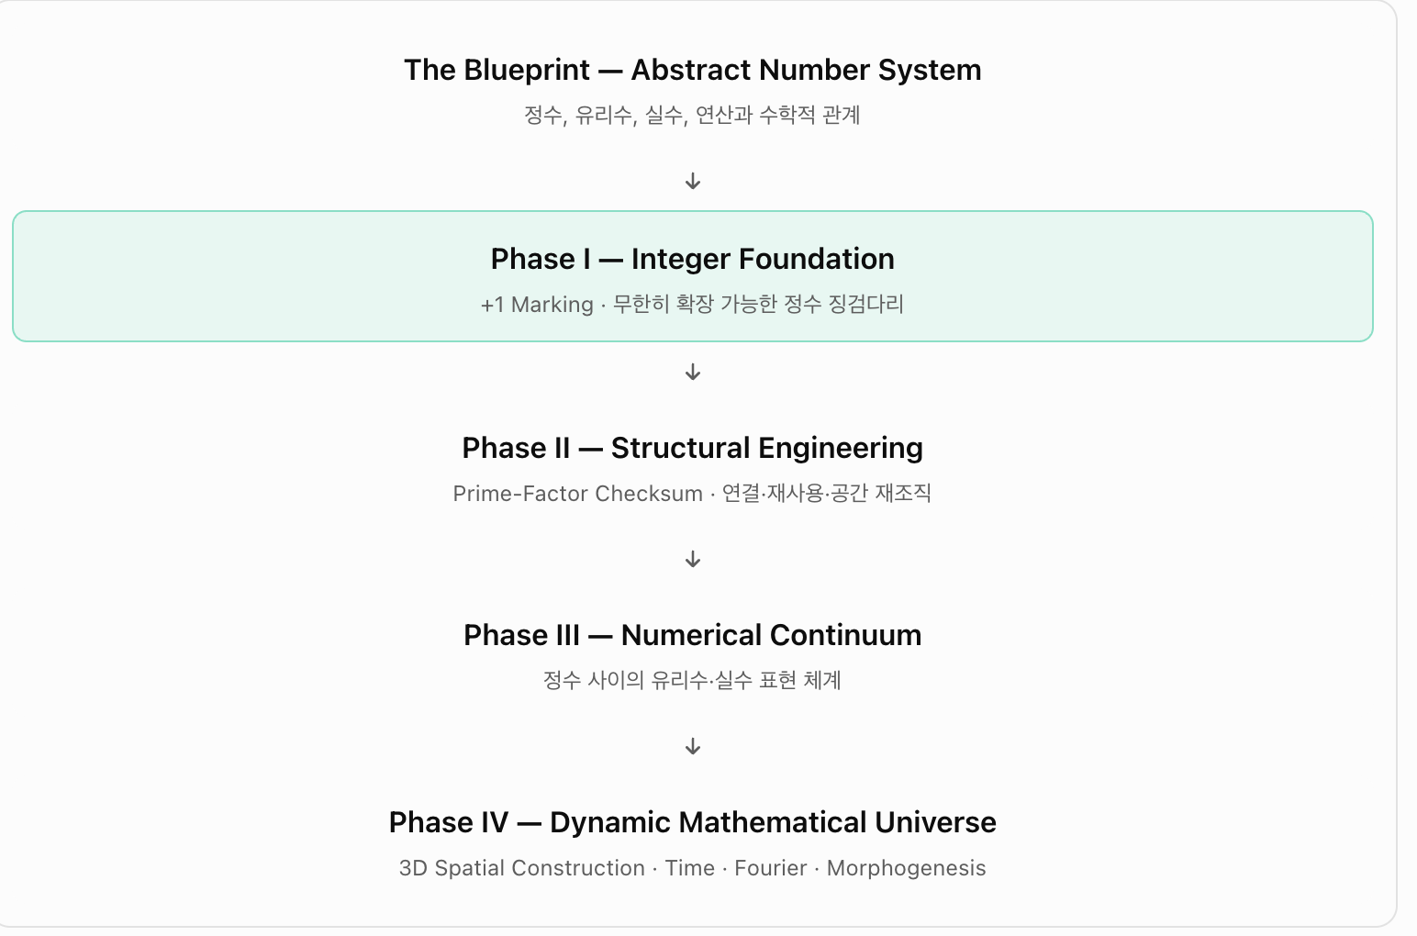
Original user-supplied blueprint image, 13 October 2026; phase labels and framing preserved.
The overarching objective is an engineering realisation of an already-defined abstract number system. The integer stepping-stone line is its foundation—not the completed numerical universe.
Layer | Blueprint wording | Implementation meaning
The Blueprint — Abstract Number System | Integers, rationals, reals, operations and relations | The logical specification of what is to be represented
Phase I — Integer Foundation | +1 marking; unbounded integer stepping stones | Successor markers, correct labels, unlimited extension
Phase II — Structural Engineering | Prime-factor checksum; links, reuse, rearrangement | Cumulative certificates, layout and management
Phase III — Numerical Continuum | Rational and real representations between integers | Lazy interval access; division and completeness
Phase IV — Dynamic Mathematical Universe | 3D construction, time, Fourier, morphogenesis | Dynamical spatial implementation and propagation

Sequence of layers versus concurrent construction
These phases specify logical layers, not four strictly serial milestones. Successor marking (I), inherited structural certification (II), and time-dependent gait/feedback (IV) operate concurrently from the outset. The numerical continuum (III) needs separately specified representations and completeness rules before it can be implemented.

Construction process: Team Unicorn Relay
Operation | Assignment | Acceptance criterion
설계 / Design | Pre-known destination n; choose leg count, candidate prime leg labels, phase, cadence and manufacturing cost | No hard-coded prime success rule
이동·인증 / Transit | Travel across and audit the previously certified prefix 0..n−1 using inherited certificates | 0/1 exceptions; cache invariants
+1 마킹 / Marking | Final successor +1 from n−1 to n | Exactly one new marker
실수 구간 / Interval | Mark interval [n−1,n] as potentially addressable | Promise of representation, not creation of reals
귀환·개선 / Handover | Return performance, audit, control and layout information for next generation | Include return and redesign cost

Spatial and informational stack
Layer | Role
1D number line | The visible integer markers and exact successor order
Prime-factor graph | Inherited certificates, multiplicative relationships and caches
3D placement | Cubic placement and spherical expansion as testable hybrid components
4D dynamics | Separate elapsed time τ from generation index t; Fourier and feedback
HQ memory | Inherited state, design updates, time/coordination/entropy cost

Non-negotiable mathematical constraints
- The build implements representations of mathematical numbers; it does not create their mathematical existence.
- Infinity means no fixed finite extension limit, not completion of infinitely many individual markers in finite time.
- Integer markers alone do not implement the real continuum: representation and completion rules are additional.
- The leg count k need not be prime; prime-labelled individual legs do not imply stride equals prime value.
- Report wall-time, operation count, communication, re-layout, coordination and validation separately.

Next engineering milestones
- M1 Implement successor marking with genuinely inherited arithmetic certificates.
- M2 Introduce in-flight feedback using distance remaining to a known target.
- M3 Compare prime/composite/shuffled leg labels and 1–10-second vs 1–1M-target experiments.
- M4 Compare cubic/spherical/hybrid layouts under identical certified workloads.
- M5 Compare physical return, information-only relay and distributed HQ, including generational learning.

