ENGINEERING BLUEPRINT / VERSION 0.7

Generative Principles of a Self-Expanding Integer Universe — Research Proposal
Whole number-system universe construction / release 0.7
13 October 2026 • Team Unicorn • Exploratory / unverified

The Whole Number-System Universe Blueprint
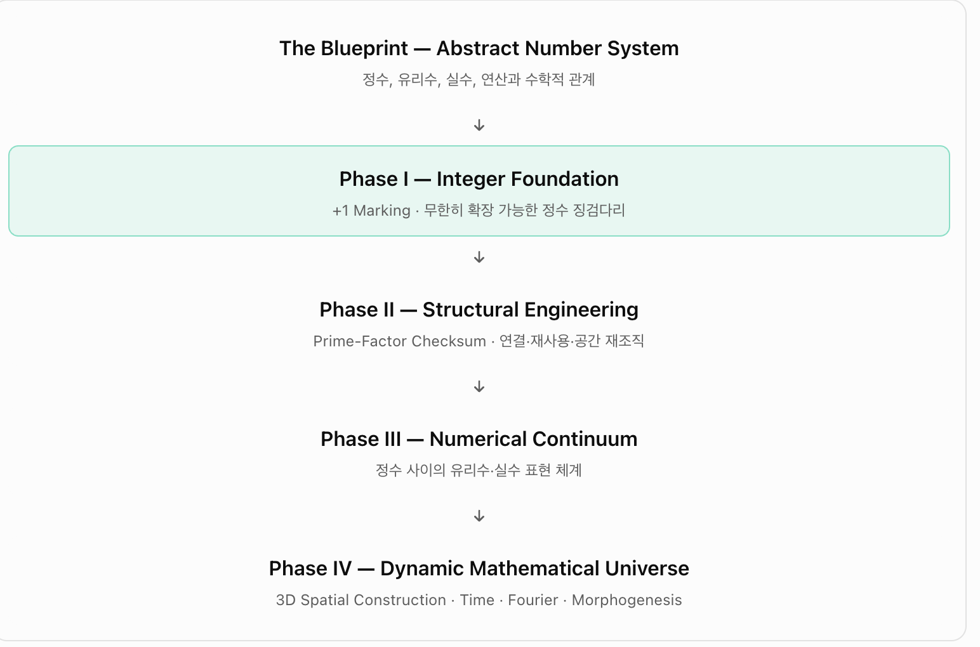
Original user-supplied blueprint image, 13 October 2026; phase labels and framing preserved.
The overarching objective is an engineering realisation of an already-defined abstract number system. The integer stepping-stone line is its foundation—not the completed numerical universe.
Layer | Blueprint wording | Implementation meaning
The Blueprint — Abstract Number System | Integers, rationals, reals, operations and relations | The logical specification of what is to be represented
Phase I — Integer Foundation | +1 marking; unbounded integer stepping stones | Successor markers, correct labels, unlimited extension
Phase II — Structural Engineering | Prime-factor checksum; links, reuse, rearrangement | Cumulative certificates, layout and management
Phase III — Numerical Continuum | Rational and real representations between integers | Lazy interval access; division and completeness
Phase IV — Dynamic Mathematical Universe | 3D construction, time, Fourier, morphogenesis | Dynamical spatial implementation and propagation

Sequence of layers versus concurrent construction
These phases specify logical layers, not four strictly serial milestones. Successor marking (I), inherited structural certification (II), and time-dependent gait/feedback (IV) operate concurrently from the outset. The numerical continuum (III) needs separately specified representations and completeness rules before it can be implemented.

Construction process: Team Unicorn Relay
Operation | Assignment | Acceptance criterion
설계 / Design | Pre-known destination n; choose leg count, candidate prime leg labels, phase, cadence and manufacturing cost | No hard-coded prime success rule
이동·인증 / Transit | Travel across and audit the previously certified prefix 0..n−1 using inherited certificates | 0/1 exceptions; cache invariants
+1 마킹 / Marking | Final successor +1 from n−1 to n | Exactly one new marker
실수 구간 / Interval | Mark interval [n−1,n] as potentially addressable | Promise of representation, not creation of reals
귀환·개선 / Handover | Return performance, audit, control and layout information for next generation | Include return and redesign cost

Spatial and informational stack
Layer | Role
1D number line | The visible integer markers and exact successor order
Prime-factor graph | Inherited certificates, multiplicative relationships and caches
3D placement | Cubic placement and spherical expansion as testable hybrid components
4D dynamics | Separate elapsed time τ from generation index t; Fourier and feedback
HQ memory | Inherited state, design updates, time/coordination/entropy cost

Non-negotiable mathematical constraints
- The build implements representations of mathematical numbers; it does not create their mathematical existence.
- Infinity means no fixed finite extension limit, not completion of infinitely many individual markers in finite time.
- Integer markers alone do not implement the real continuum: representation and completion rules are additional.
- The leg count k need not be prime; prime-labelled individual legs do not imply stride equals prime value.
- Report wall-time, operation count, communication, re-layout, coordination and validation separately.

Next engineering milestones
- M1 Implement successor marking with genuinely inherited arithmetic certificates.
- M2 Introduce in-flight feedback using distance remaining to a known target.
- M3 Compare prime/composite/shuffled leg labels and 1–10-second vs 1–1M-target experiments.
- M4 Compare cubic/spherical/hybrid layouts under identical certified workloads.
- M5 Compare physical return, information-only relay and distributed HQ, including generational learning.

Research programme retained from v0.6

0. Purpose and non-negotiable scope
This project is an engineering thought experiment about implementing an already-defined abstract number system in a physical or physically constrained spatial model. It neither creates numbers nor aims to prove the existence of primes. Its initial civil-engineering phase is to lay successive integer stepping stones 1, 2, 3, … without omission. Zero serves as the origin and negative integers are deliberately deferred.
Team Unicorn is the construction crew, NOT a party hunting for prime numbers. Each unicorn certifies or reconstructs the existing integer foundation and marks one new successor position. Prime factorisation is a possible implementation and integrity tool, not the destination.
Infinity is an unbounded scalability objective: the process should admit any finite N without claiming to complete infinitely many physical placements in finite time.

1. Research question and success criteria
Question: Given constraints on elapsed time, storage, communication, coordination and spatial layout, what self-propagating engineering architecture can faithfully instantiate finite prefixes of the abstract number system and continue expanding without a fixed endpoint?
Success means: no missing or duplicated integer markers, preserved arithmetic identity, low lifetime construction cost, valid reuse of inherited certificates and scalable extensions. It does not require a new prime-number law.
- HQ knows the exact destination before designing each unicorn; destination-aware implementation must not be confused with discovery or search.
- Separate mathematical consistency, model performance and empirical physical plausibility.

2. The two missions of the Unicorn Relay
Let Uₙ denote the unicorn assigned to place stone n. It receives the predecessor’s terminal marker n−1 and inherited state Hₙ. HQ knows target n before birth and configures the unicorn accordingly.
Mission A — Inherited Constructive Checksum: while travelling from the origin towards n−1, Uₙ makes use of inherited evidence to reconstruct, compose or certify the arithmetic integrity of integer locations 1,…,n−1. It does not have to factor every old integer afresh.
Mission B — Successor Marking: Uₙ makes the final +1 successor move and places a provisional stone at n. Certification of n may be completed by HQ or the next unicorn. It returns information to improve the following design.

3. Leg architecture, gait and destination-aware inverse design
The number of legs k is a free optimisation variable and need NOT be prime. The idea that an individually numbered leg represents a prime is a hypothesis about primitive components. No law is yet known that identifies the prime label with stride length, cadence, power or phase.
HQ optimises for the known target n using inherited information, leg architecture, cadences fᵢ, phases φᵢ, coordination topology and bounded work per second. Whole-body displacement may be written D(T)=∫₀ᵀv_g(τ)dτ, where the propulsion/contact rule defining v_g must be independently specified and tested.
The wave identity v=λf describes phase velocity. Applied to locomotion, λ_eff must mean net progress per complete gait cycle and f_eff the cycle frequency; wave speed must not silently be equated with body velocity.

4. Feedback and generational self-optimisation
Loop 1, in-flight gait feedback: respond to phase mismatch, progress and destination error by adjusting limb timing during the journey.
Loop 2, HQ feedback: after return, incorporate observed verification cost, actual travel time, interference, relayout overhead and reliability into the next unicorn’s design.
Loop 3, meta-optimisation: change the rule by which HQ designs and manufactures unicorns. Evaluate improvement on comparable tasks rather than assuming every successor must be absolutely cheaper.

5. Hybrid spatial architecture: spherical frontier, cubic interior
Spherical baseline: propagate isotropically from an origin and observe the resulting wavefront. A spherical wavefront under isotropic speed is geometric, not proof of globally minimal cost.
Cubic baseline: encode integer locations and successor/multiplicative edges in a 3D lattice and measure routing, locality and storage overhead. Complete prime-exponent coordinates are infinite-dimensional; a three-dimensional embedding necessarily changes what is made explicit.
Hybrid hypothesis: an outward spherical construction frontier combined with an interior cubic or graph-based canonical representation. Existing integer identities remain unchanged, while coordinates, caches and connections may undergo retrospective reorganisation.

6. Marker placement and latent real intervals
Marking n and n+1 can make the interval [n,n+1] addressable for subsequent lazy rendering in the engineering model. It does not bring real numbers into mathematical existence.
Rational intervals require explicit division/fraction representation; representing the full real continuum requires an account of limits or completion. This is a future engineering layer, not an automatic consequence of prime factorisation.

7. Cost, coordination and entropy accounting
Account separately for manufacturing, outbound motion, inherited certificate checking, coordination, control, global/local relayout, memory, return journey and redesign. Avoid combining unlike physical units without explicit weights.
C_total = C_birth + C_travel + C_verify + C_coord + C_feedback + C_relayout + C_storage + C_return + C_meta.
One experimental coordination functional is C_coord=ηET+μ∫Mismatch(τ)dτ where E counts actual coordinated pairs. An all-to-all scheme has E=k(k−1)/2; this is a controller-topology choice, not a universal law.
Shannon entropy applies only after a probability model for spatial arrangements or agent states is defined. Thermodynamic entropy needs an actual physical implementation and environment. Unique factorisation is not automatically compression or lower heat dissipation.

8. Arithmetic and computational invariants
The new marker is exactly one successor beyond the inherited frontier. After finishing n, the system certifies a complete prefix 1,…,n without skipped or duplicated labels.
For n≥2, unique prime factorisation gives a canonical multiplicative representation. One is the multiplicative identity and zero is not prime-factorised. A proof of primality for n need only test certified prime divisors up to √n; it does not require refactoring the whole prefix.
Dirichlet-series Fourier methods and the Bohr lift give a rigorous connection between multiplication and frequency-space representation. They do not supply a physical limb dynamics or a three-dimensional wave mechanism by themselves.

9. Experimental work packages
- WP1 — Integer foundation: implement a correct +1 marker sequence with reusable certification cache.
- WP2 — Gait dynamics: remove the assumption “prime label equals stride”; test well-defined contact and propulsion laws.
- WP3 — Coordination: vary leg count, pair topology, control effort, delay and disturbance recovery.
- WP4 — HQ relay: compare inherited knowledge, scheduled births, physical return and information-only handover.
- WP5 — Spatial implementation: compare spherical, cubic and hybrid structures at equal arithmetic workload.
- WP6 — Arithmetic controls: contrast prime-labelled, composite-labelled and shuffled labels on held-out targets.

10. Falsification conditions and scope of claim
The absence of a prime-specific signature under a prime-blind gait law is a legitimate negative result. A prime effect created by writing the prime value directly into stride or cadence cannot be counted as discovery.
Serial physical round trips at bounded speed create cumulative travel on the order of N². Report this bottleneck rather than hiding it behind parallel HQ activity. Distinguish remote information transfer from literal return and track their different cost models.
Distinguish a lazily addressable continuum from physical placement of uncountably many numbers. Do not claim empirical cosmology or a novel number-theoretic theorem without independent evidence.

11. Historical and source record
4 October 2024: Beauty of Prime Numbers and the unicorn/footprints metaphor. 17 November 2024: RH–NTZ Mapping proposal. In 2025: Chronodynamism and morphogenesis discussions. October 2026: the Team Unicorn Relay, integer-foundation construction and engineering reframing.
Simulation sources: Gait Lab 0.2 (time horizons and coordination), 0.3 (99 known destinations), Fourier 0.4 (phase-frequency search and Fourier divisibility), Scale 0.5 (up to 1 million targets), Feedback 0.6 and Feedback 0.6.1 (independent coordination price). The companion model and results report documents assumptions and numerical outcomes.

