**1.**

**name:** pizza

**ingredients:** eggs,mayonnaise,flour,salt,sausage,cheese,tomato

**description:** mix the eggs, mayonnaise, flour and a little salt well with a whisk.Pour the dough into the pan (non-stick) in which the pizza will be prepared.Spread the ketchup carefully over the surface of the dough.On top, do not skimp, sprinkle everything with grated cheese.Delicious and flavorful homemade pizza is ready in the pan!Enjoy your meal!

**photo:** [**https://www.e-pizza.com.ua/data_resized/b/3/a/5/3/b3a5331251d99eea0812131bb0b38b1c7d671805.jpeg**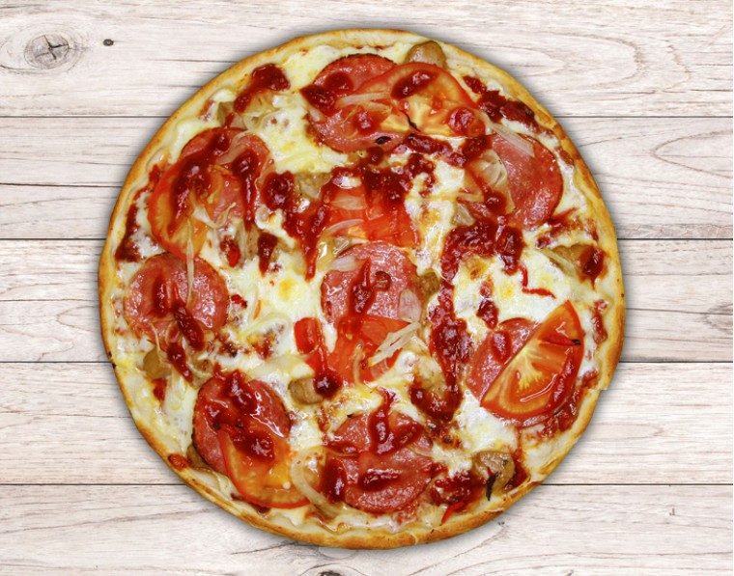](https://www.e-pizza.com.ua/data_resized/b/3/a/5/3/b3a5331251d99eea0812131bb0b38b1c7d671805.jpeg#)

**2.**

**name:** Quick prawn, coconut & tomato curry

**ingredients:** 2 tbsp vegetable oil,1 medium onion , thinly sliced, 2 garlic cloves, sliced, 1 green chilli, eseeded and sliced,3 tbsp curry paste, 1 tbsp tomato purée,200ml vegetable stock, 200ml coconut cream, 350g raw prawn, coriander sprigs and rice, to serve

**description:** Heat the oil in a large frying pan. Fry the onion, garlic and half the chilli for 5 mins or until softened. Add the curry paste and cook for 1 min more. Add the tomato purée, stock and coconut cream. Simmer on medium heat for 10 mins, then add the prawns. Cook for 3 mins or until they turn opaque. Scatter on the remaining green chillies and coriander sprigs, then serve with rice.

**photo:**https://www.bbcgoodfood.com/sites/default/files/styles/recipe/public/recipe_images/recipe-image-legacy-id--837507_11.jpg?itok=vjHUIg-s 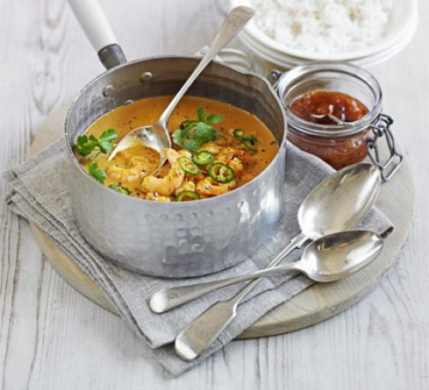

**3.**

**name:** mango pudding

**ingredients:** 1 large ripe mango, 6 scoops vanilla, ice cream, 2 tbsp thick cream, 3 passion fruits

**description:** Peel and dice a large ripe mango; whizz to a purée in a food processor. Add 6 scoops of vanilla ice cream and 2 tbsp thick cream and whizz again. Spoon into bowls and scoop ½ passion fruit over each.

**photo:** **https://www.bbcgoodfood.com/sites/default/files/styles/recipe/public/recipe_images/recipe-image-legacy-id--659451_11.jpg?itok=sxlsHWa6** 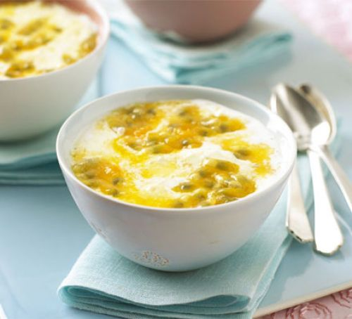

**4.**

**name:** bean & chorizo chilli

**ingredients** : 100g chorizo, sliced, 350g tub fresh tomato and chilli sauce, 400g can kidney beans, rinsed and drained, 400g can chickpea, rinsed and drained, rice and natural yogurt, or jacket potatoes and soured cream.

**Description:** Dry-fry the chorizo for a few mins in a non-stick frying pan until crisp. Carefully pour off any fat from the pan, then tip in the sauce and beans with 100ml water. Bring to a simmer, cover, then lower the heat and bubble for 10 mins. Spoon over rice and serve with yogurt.

**Photo:** 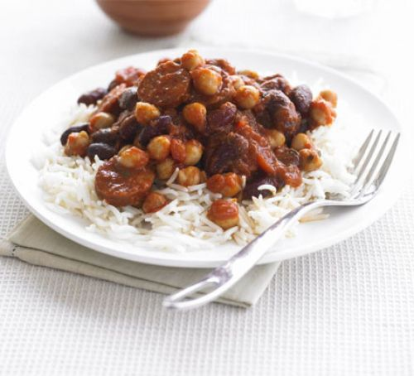

[**https://www.bbcgoodfood.com/sites/default/files/styles/recipe/public/recipe_images/recipe-image-legacy-id--513575_11.jpg?itok=qr-Kakur**](https://www.bbcgoodfood.com/sites/default/files/styles/recipe/public/recipe_images/recipe-image-legacy-id--513575_11.jpg?itok=qr-Kakur)

**5.**

**name:** Shortbread

**ingredients:** butter, caster sugar, plus extra to finish, plain flour

**Description:** Heat the oven to 190C/375F/Gas 5. Beat the butter and the sugar together until smooth. Stir in the flour to get a smooth paste. Turn on to a work surface and gently roll out until the paste is 1cm/½in thick. Cut into rounds or fingers and place onto a baking tray. Sprinkle with caster sugar and chill in the fridge for 20 minutes. Bake in the oven for 15-20 minutes, or until pale golden-brown. Set aside to cool on a wire rack.

**Photo:** **https://ichef.bbci.co.uk/food/ic/food_16x9_1600/recipes/shortbread_1290_16x9.jpg**

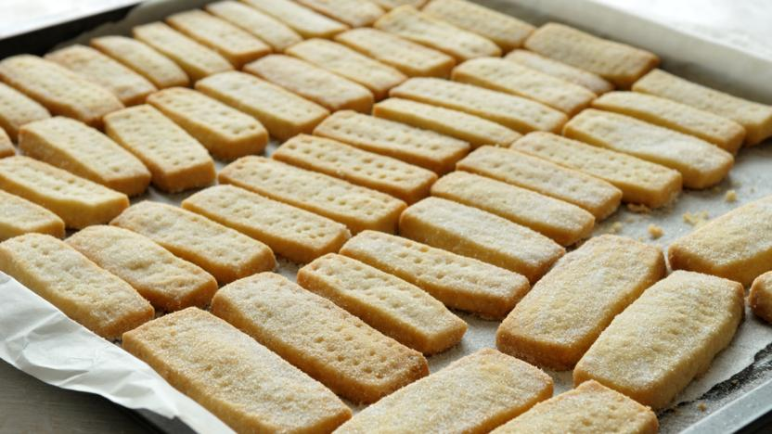

**6.**

**Name:** Smoothie

**Ingredients:** banana, berries, milk, orange

**Description:** Place all ingredients in a blender. Put the lid on tightly. Blend until smooth. If too thick, add 1/2 cup cold water and blend again. Refrigerate leftovers within 2 hours.

**Photo:** **https://foodhero.org/sites/default/files/recipe-imgs/Banana%20Berry%20Smoothie.jpg**

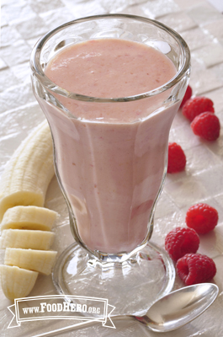

7.

**Name:** Yogurt

**Ingredients:** yogurt, fruit

**Description:** Add yogurt and juice to a clean jar or other container with a lid. Close lid and shake.

Serve cold.Refrigerate leftovers within 2 hours.

**Photo:** [**https://foodhero.org/sites/default/files/recipe-imgs/FH%20Drinkable%20Yogurt.png**](https://foodhero.org/sites/default/files/recipe-imgs/FH%20Drinkable%20Yogurt.png)

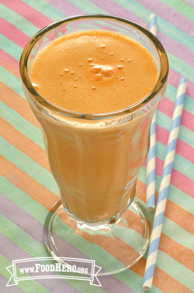

**8.**

**Name:** Salad

**Ingredients:** carrots, pepper, raisins, craisins

**Description:** Combine carrots, peppers, raisins and sunflower seeds in a bowl. Combine orange juice, vegetable oil, soy sauce, ground ginger, garlic powder and honey or sugar in a jar. Cover and shake to blend. Add the oriental salad dressing or your favorite salad dressing. Stir to blend. Refrigerate for a few hours to blend flavors. Refrigerate leftovers within 2 hours.

**Photo:** **https://foodhero.org/sites/default/files/recipe-imgs/Oriental%20carrot%20salad_DSC0962.jpg**

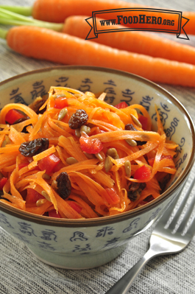

**9.**

**Name:**

**Ingredients:** beef, carrot, diced, onion, diced, celery, diced, garlic, water, tomatoes, barley, pepper

**Description:** In large sauce pot, cook ground beef over medium heat. Drain fat. Add carrots, onion, celery, and garlic; stir often and cook for about 5 minutes. Add 8 cups of water, bouillon, tomatoes with juice, barley, and pepper. Bring to a boil. Cover and reduce heat to a low boil. Cook for about 30 minutes or until barley is as tender as you like it. Serve immediately. Refrigerate leftovers within 2 hours.

**Photo:** **https://foodhero.org/sites/default/files/recipe-imgs/Beef%20Barley%20soup_DSC3110.jpg**

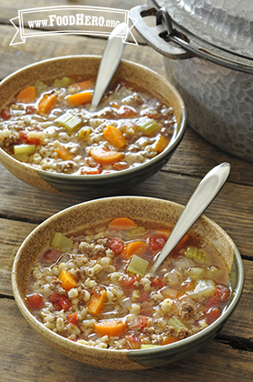

**10.**

**Name:** Sandwiches

**Ingredients:** apple, butter, raisins

**Description:** Wash the apple under cool running water and dry. Cut in half from the stem down and lay each half cut-side down on a cutting board. Slice each half into 6 half-round slices and cut out the core.2. Spread 1/2 teaspoon of peanut butter on one side of each apple slice. 3. Put 4 to 6 raisins on top of the peanut butter on one apple slice. Top with another apple slice, peanut-butter side down. Squeeze gently. Continue with remaining apple slices.

**Photo:** **https://foodhero.org/sites/default/files/recipe-imgs/apple_sandwiches_v_watermarked.jpg**

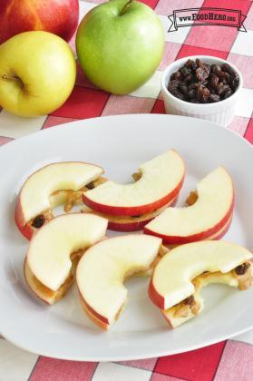

<https://foodhero.org/recipes/apple-sandwiches>