**CS 590 – PARALLEL AND DISTRIBUTED COMPUTING**

**HOMEWORK 5**

**Name:** Ivan Sangines Escrig

**ID#:** 968606

**Instructor:** Dr. Mahmood

**Date:** December 1, 2018

**TABLE OF CONTENT**

**INTRODUCTION** 3

**SCREENSHOTS:** 4

**CONCLUSION:** 6

**INTRODUCTION**

The porpuse of this assignment is to keep practicing Task Parallel library, as well as get to know and understand how LU Decomposition work. In order to do that, we are asked to first implement the LU Decomposition code as a sequential program and then try to improve it by parallelizing it.

**SCREEN SHOTS:**

The first part of this assignment was to implement the LU Decomposition code as a sequentian program. Once that part was done, we were asked to make it work for any size and number of blocks we wanted. In order to do that, I came up with this formulas in order to have the correct blocks size once we provide the nomber of blocks we want. If the sqrt on the blocks_Size is a decimal number, the final result will be null. That is because the matrix cannot be divided in that exact number of blocks, there would be some blocks with empty data.

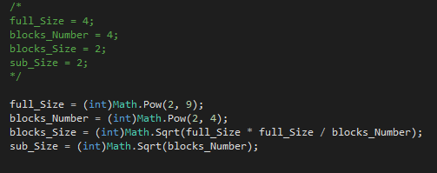

After Parallelizing the LU Decomposition, I have created a matrix with the following data:

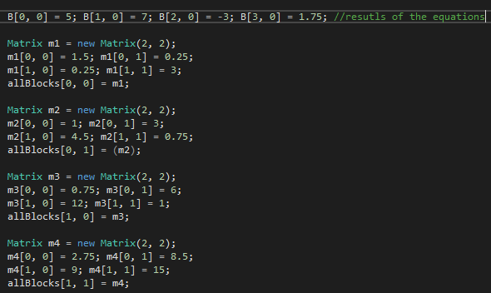

The correct result for that matrix was computed by worldfram alpha, which gave me a result of:



As we can see on the following images, once I compute the matrix using Parallelized LU Decomposition, I obtain the correct result, which means the logic is correct and ready to try the code for larger matrixs.

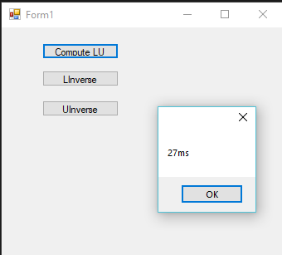 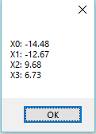

The last part of the assignment was to try our Parallelized LU Decomposition in a larger matrix and see what distributions of blocks obtains a faster result. In order to show those results, I have created a graph in Excel. The same number of blocks was computed five times and I end up choosing the fastest time out of the 5 trials:

**Conclusion:**

After completing this assignment I was able to understand better how LU Decomposition works in order to produce the correct results for a system of equations. Also, after doing this assignment and parallelizing the LU Decomposition, as we can see in the result, the fastest block distribution in order to solve a 512*512 matrix is 16 blocks.

The results showed a time of 24817ms for a distribution of 16 blocks (128x128), which was the fastest time. It was surprising for me since at the beginning of this assignment I thought that having more blocks would mean an increment of the result speed.

This assignment helped me to understand better how to parallelize programs and to learn more about the LU Decomposition.