**CS 590 – PARALLEL AND DISTRIBUTED COMPUTING**

**HOMEWORK 8**

**Name:** Ivan Sangines Escrig

**ID#:** 968606

**Instructor:** Dr. Mahmood

**Date:** December 15, 2018

**TABLE OF CONTENT**

**INTRODUCTION** 3

**SCREENSHOTS:** 4

**CONCLUSION:** 7

**INTRODUCTION**

The porpuse of this assignment is to practice and get to know how WCF works. In order to do that, we will try to convert the GA algorithm to a WCF provect and apply it to the salesman problem.

After multiple attempts, I was able to make it work for just the first part of the assignment. I could not make the part about sharing informations between threads work.

**SCREEN SHOTS:**

WCF hosted in a webpage, not in a windows App:

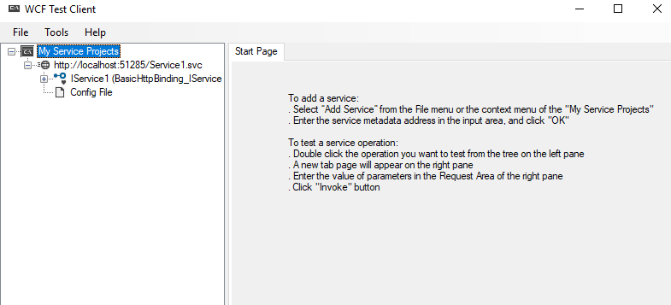

Initializing path to be solve using GA algorithm in a WCF service hosted on a web page, using single thread:

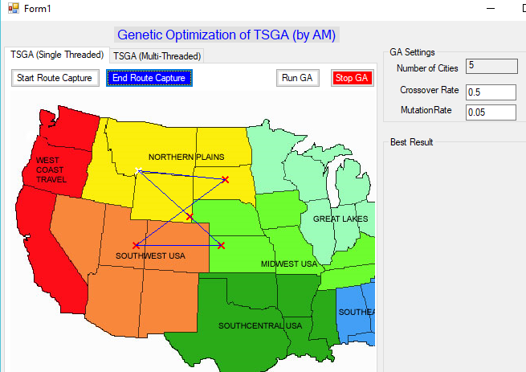

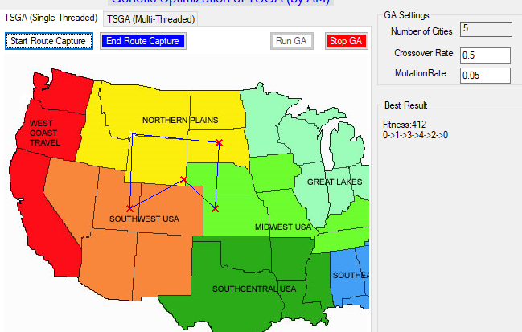

Same problem but using multithreading and different data:

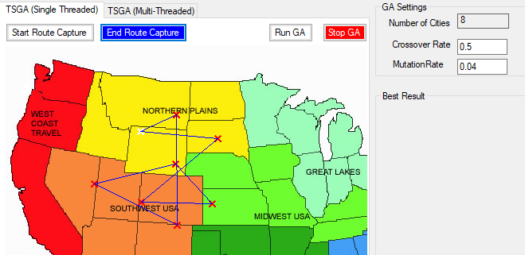

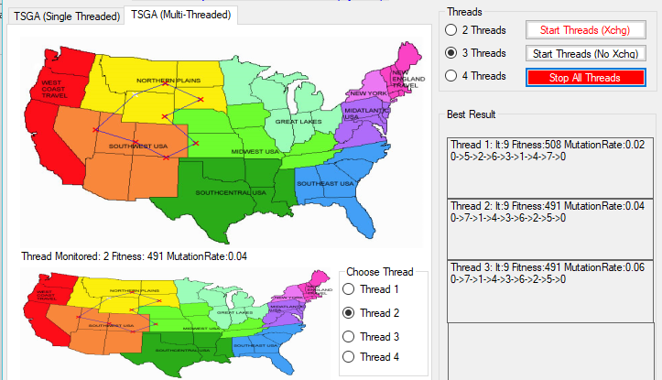

**Conclusion:**

After completing this assignment I was able to understand better how WCF work. Even though I was not able to complete this assignment 100%, after doing the first part, this assignment taught me how servers are created and hosted in a web page and how to connect the service via proxy with the clients.